Corners of houses without moisture and mold
Na základě výzkumu vznikl patent. Tvůrce patentu. Elektronický obvod. Odvod tepla Konvekcí.
Based on the research and development of new technologies and prediction of the behavior of building structures using multidimensional thermal field modeling and thermal imaging diagnostics in building physics, a patent was created at the Institute of Civil Engineering, that can prevent condensation and mold growth on the inner surface of thermal bridges.
The inspiration for this discovery came from the time of doctoral studies of the creator doc. Ing. Miloš Kalousek, Ph.D., who at that time solved the nonbranch task of heat cooling of electronic circuit without the possibility heat convection. It was an electronic board in satellite in the Space, where there is no air to heat convection, and therefore a special board was used, which contained thin copper foils inside, which diverted the conduct heat to the perimeter metal structure outside of the cooled electronic chips.

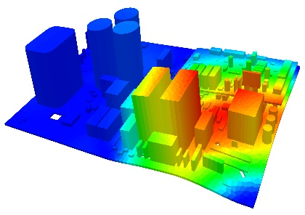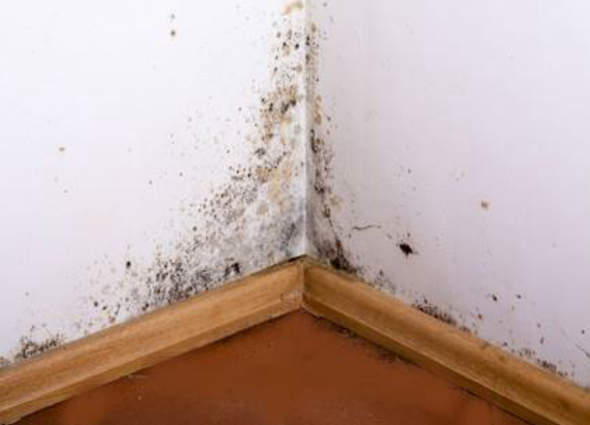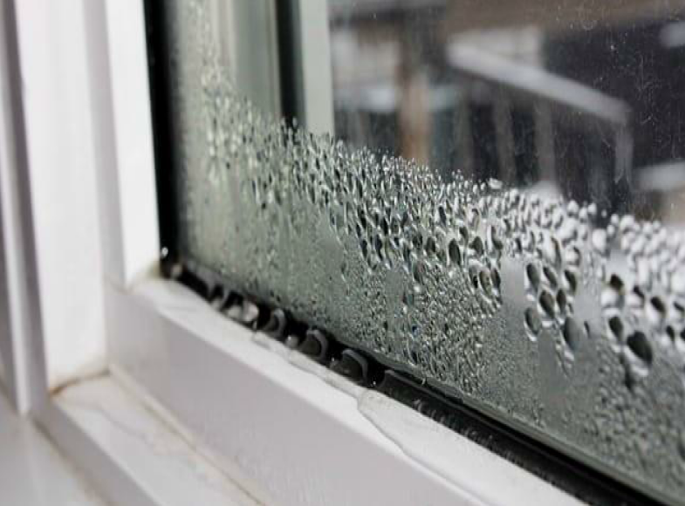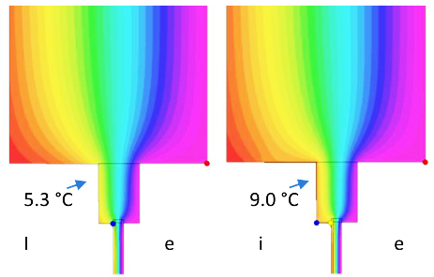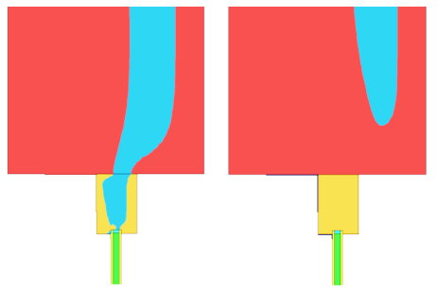

This "passive heater" also works on this principle in the form of a thermally conductive layer (e.g. sheet of metal), which is applied to the inner surface of the structure in the area of the critical point of the thermal bridge, or under plaster. It conduct heat from the surrounding part of the structure, where the temperature is higher to a place with a lower temperature. This passive heating ensures that the local temperature rises above the dew point and causes non condensation of water vapor and subsequent formation of mould. Because the structure is passively heated to the depth, the structure cannot get water vapor even under the surface. The surface of the structure treated in this way works simultaneously as a water vapor barrier.
The correct functioning of the patented idea has already been proven in practice in many places of thermal bridges (including problematic corners). After its application, the negative consequences of thermal bridges no longer manifest themselves, even in lowest external temperatures.

In cooperation with Masaryk University, in February 2020 we managed to test this method at the J.G. Mendel Polar Antarctic Station on James Ross Island, in room No. 119 - bedroom, where mould was formed as a result of the thermal bridge in the place of the horizontal lower corner between the floor and the wall. The existence of a thermal bridge at this site was also proved by numerical simulation and the thermal bridge was revealed in the original project documentation (from 2001). Its origin and subsequent manifestation of mould was caused by designing the construction of the wooden supporting element, when thermal bridges were not yet dealt with in such detail. For the next scientific expedition, a more extensive application of this method is being prepared in other rooms in the station. At the same time, the construction of the new station on Nelson Island is being designed, where the operation experience of the first one, which has more than 15 years of operation, should be used.

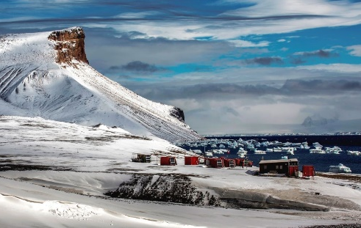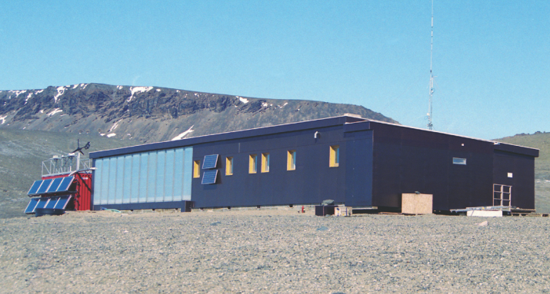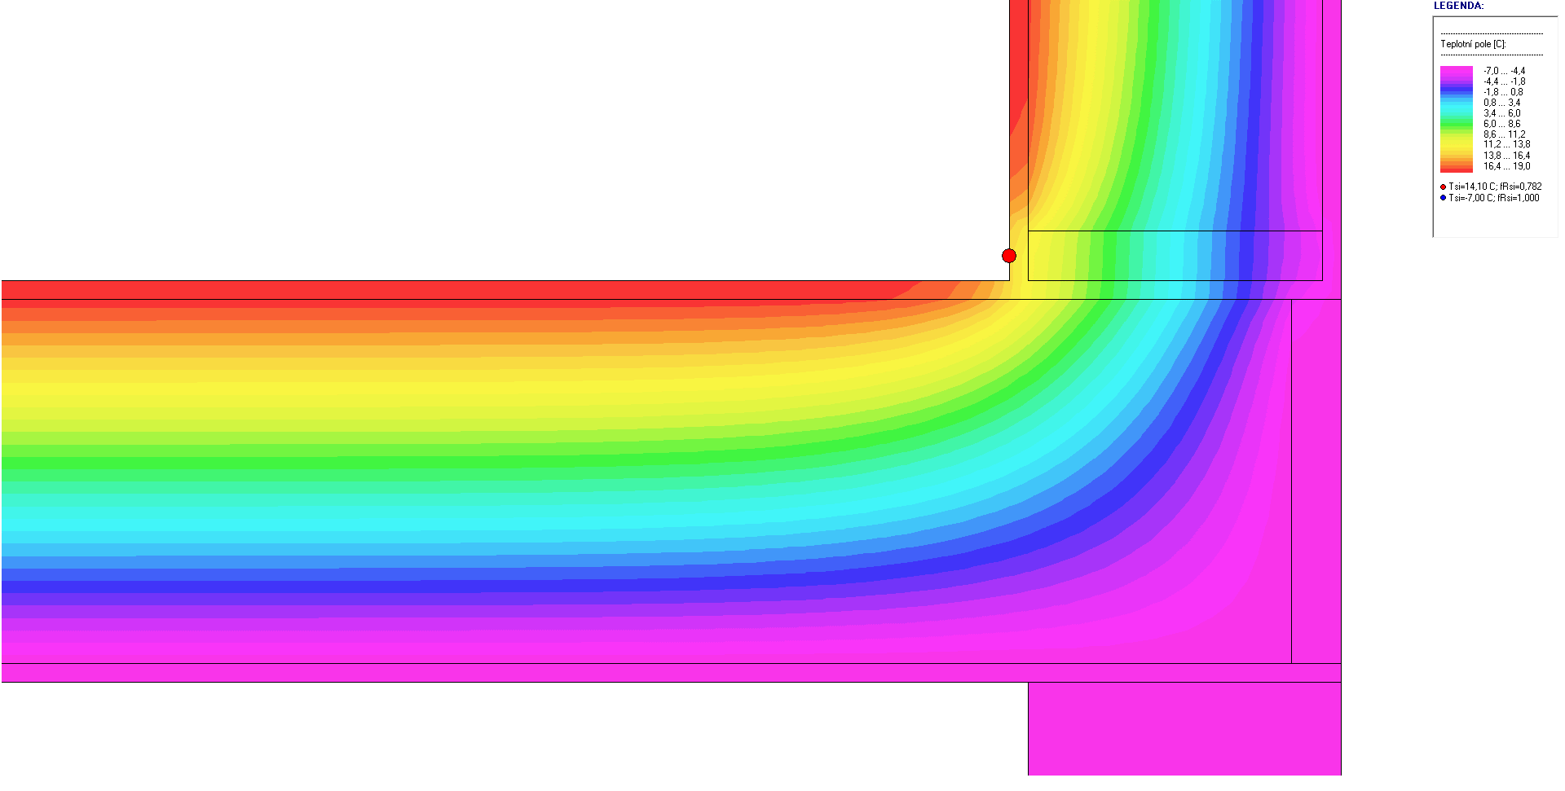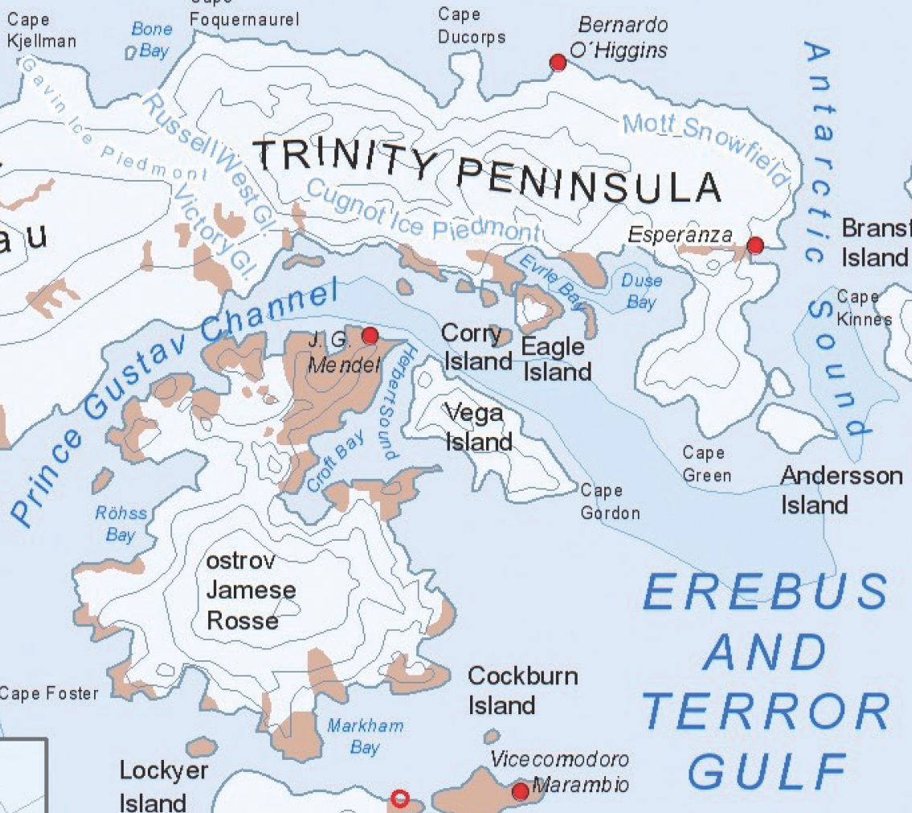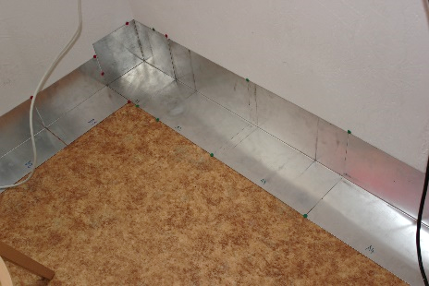

Practical use of this method is also in other buildings in the Czech Republic that show critical thermal bridges, including the formation of condensation and mould, and yet due to monument protection they cannot be insulated from the outside.
Similarly, as in the case of opaque peripheral building structures, the application of this method also verifies the increase of surface temperature (also around 5 Kelvins) in the case of application in contact with the frame of the windows and on the connection joint of the window frame with the wall structure.

