Institute of Physical Engineering, Faculty of Mechanical Engineering, Brno University of Technology
Applications of Secondary ion mass spectrometry
Habilitation Thesis

Ing. Petr Bábor, Ph.D.
Brno 2023

Dedication
I dedicate this work to my wife and my parents.

Acknowledgment
At this point, I would like to thank many people who were inspiring me and helping me during my work at university. First of all, I would like to thank Prof. Tomáš Šikola for his unceasing support and for creating opportunities to realize myself, for the friendly atmosphere at the Institute of Physical Engineering and last but not least for the fact that I can still be part of his great team and do the applied science without obstacles. Furthermore, I would like to thank all the members of the SIMS Group who helped me in my journey of discovering the world of ions. Last but not least, thanks belong to Prof. Hidde Brongersma, who helped me to get oriented in that world of ions, and Prof. Marc Willinger, and Zhu-Jun Wang who introduce me to the world of wavy catalytic chemical reactions, and Doc. Miroslav Kolíbal, Prof. Petr Dub, and Prof. Jiří Spousta for his comments on the text.

Abstract
This thesis deals with applications of secondary ion mass spectrometry (SIMS) method in science and industry. It presents the selected work of the author in this field and is part of his application for the title of Associate Professor at the Brno University of Technology. The brief introduction of the SIMS method and its selected applications are accompanied by the comments of author’s contributions represented by nine selected papers. The papers discuss various aspects of SIMS analysis of scientific and industrial samples in different modes such as depth profiling, quantitative analysis, 2D/3D imaging, real-time observation, and tomographic analysis. The instruments on which the analyses were performed are also briefly introduced.

Key words
SIMS, ions, ion interaction, LEIS, scattering, sputtering, mass analysers, TOF, FIB, tomography, depth profiling, ion imaging

Content

1 Introduction 1
2 Brief overview of SIMS 3
2.1 Basics of SIMS 3
2.2 Phenomenon of sputtering 5
3 Applications of SIMS method 7
3.1 Depth profiling 7
3.2 Quantitative analysis 15
3.3 2D imaging 16
3.4 3D depth profiling by TOF-SIMS 21
3.5 FIB-SIMS tomography and correlative analysis 23
4 Conclusion 27
References 29
List of Commented papers 33
Commented paper 1 35
Commented paper 2 43
Commented paper 3 55
Commented paper 4 61
Commented paper 5 69
Commented paper 6 85
Commented paper 7 95
Commented paper 8 107
Commented paper 9 117

Introduction

Since time immemorial, humankind has been trying to understand the world it lives in, motivated by curiosity to be sure, but also by the desire to do things better with greater efficiency and added value. This has brought benefits to humankind that today we can hardly imagine life without. We live in an informational and technological society in which there is increasing pressure to be innovative in order to ensure sustainable development. Innovations would not be possible without technological advances that require analytical tools to understand the processes used and to subsequently improve them. Many tools have been developed by mankind in the past and they are becoming increasingly sophisticated and specialised. One such a tool (method) is SIMS (Secondary Ion Mass Spectrometry).
The history of the SIMS method began in 1910, when British physicist J. J. Thomson observed a release of positive ions and neutral atoms from a solid surface induced by ion bombardment [1]. Since this time, when his experiments were carried out primarily to learn about the nature of matter, their importance has shifted to the analysis of various materials used in science and industry. The development of this method was accelerated by the requirement of the electronics industry to measure low concentrations of dopants in silicon wafers. SIMS has become dominant in this field of analysis and, thanks to the continuous improvement of instruments, has begun to be applied in other fields of human activities, such as biology, pharmacy, etc. Thus, various modifications of this method with different mass analysers have been developed. Commercially, the most widely used is time-of-flight mass analyser, which utilizes a pulsed ion beam. The most important contributions to the development of this type of analyser were made by Prof. Benninghoven and his team, originally from the University of Münster [2]. New and continuously improved instruments have expanded the application portfolio. The identification of the various elements is not a problem for the method today, but considerable difficulty is experienced in identifying more complex organic molecules, but even in this area a significant progress has been made in the last few years. Standard analysers can be upgraded with a newly developed orbitrap mass analyser, which has several orders of magnitude higher mass resolution and is also equipped with an argon collision chamber to allow predictable fragmentation and subsequent identification of sputtered molecules [3]. Understandably, the sensitivity of this analyser is lower, and therefore imaging of the distribution of an already identified molecule is still performed by the time-of-flight analyser. The current development of nanotechnology requires increasing the lateral resolution, which has already reached a physical limit (~10 nm) in the case of the helium microscope [4]. Other instruments are approaching it.
The SIMS method is currently used because of its high sensitivity and the possibility of elemental 2D/3D imaging. With the use of cluster ions, 3D imaging of even organic molecules is possible, for example in the case of OLED displays [5]. Due to the high sensitivity of the method, it is possible to perform 2D analysis on large areas with a high density of measurement points at measurement times that are up to several orders of magnitude lower than that of other surface analysis methods. Its extreme surface sensitivity is also an important feature. Almost 100% of the signal comes from the upper atomic layer. Due to this surface sensitivity and its ability to analyse large areas, it is often used in solving various adhesion problems, contamination traces, and other problems in the industry. The SIMS method is generally considered to be destructive. This characteristic often unjustifiably disqualifies the method, even before the actual measurement. In the case of analyzing the composition of unstable surfaces using the static SIMS method, its destructiveness may be lower than that of other methods (Auger microscopy, photoelectron spectrometry), which, on the other hand, are generally considered non-destructive. Although one ion causes more destruction than one electron of the same energy, sometimes more than a thousand electrons per ion are needed to obtain the same information. This is due to the several orders of magnitude higher sensitivity of the SIMS method than those mentioned above. The destruction of a sample caused by thousands of electrons can then be higher than that caused by a single ion. Electrons can cause higher heating of the sample or even a contamination trace on the sample surface. The most problematic feature of the SIMS method, which limits its wider use, is the difficulty in quantifying elemental concentration. This is obviously not true for the analysis of trace elements in various matrices, where concentrations up to ~1% are linearly dependent on the signal [6]. In this case, the only complication is to obtain a calibration sample. For concentrations higher than ~1%, the situation is more complicated and samples have to be treated individually. Unfortunately, in some cases, obtaining quantitative information is fundamentally impossible due to the non-linear and non-monotonic response of the signal to concentration. In this case, considerable experience is needed to correctly interpret the measured data.
This thesis is focused on selected applications of the SIMS method in science and industry that the author and his students have encountered so far. The SIMS method is introduced briefly in terms of basic principles and terminology. The phenomenon of sputtering is also described. This is followed by the various applications of the SIMS method organized according to a characteristic measurement mode. In Chapter 3.1, Depth profiling, the procedure for obtaining the elemental distribution as a function of the depth from the sample surface, is described. The instruments on which the author of this thesis made measurements are very briefly introduced, including the first SIMS instrument he developed at IPE FME BUT Brno. Topically, the annotated papers Nos. 1-4 belong to this area. Chapter 3.2, Quantitative analysis, follows with the commented paper No. 5. Chapter 3.3, 2D imaging, discusses in more detail unpublished results in the field of catalytic reactions and the development of an UHV-SEM instrument. 2D imaging is also discussed in the commented papers No. 6 and 7. This is followed by Chapter 3.4, 3D profiling, with application in the analysis of advanced ceramic materials for the production of bulletproof vests (commented paper No. 8). The last chapter is devoted to 2D/3D correlative analysis by FIB-SIMS and other methods such as NanoXCT and FIB-SEM that has been used for failure analysis in the semiconductor industry.

Brief overview of SIMS

This chapter briefly introduces the basic principles of the SIMS (Secondary Ion Mass Spectrometry) method, its strengths, and weaknesses. It also shortly discusses the phenomenon of sputtering, the understanding of which is crucial for the processing and interpretation of measured data.

Basics of SIMS

The SIMS method [2] uses the energy beam of ionized particles (0.2 keV - 30 keV) to erode the surface of the studied material by sputtering. The sputtered particles carry information about the studied surface of the material. A certain fraction of these particles is ionized during sputtering (Figure 2.1). These so-called secondary ions are analysed using a mass filter. During ion solid interaction, electrons and photons area also emitted. Electrons are often used for sample imaging by the use of scanning with the primary beam. During scanning with the primary ion beam, the secondary ion beam can be monitored to obtain the elemental spatial distribution of the material or complex structures under study.
Figure 2.1: Physical principle of SIMS method.
The SIMS method has some properties that are difficult to achieve with other known methods for studying surfaces and thin films [6]. The low detection limit allows one particle in a million to be detected. The sensitivity is even up to three orders of magnitude higher when certain elements are analysed in a proper matrix. SIMS allows detection of all elements including their isotopes, 3D analysis (depth resolution below 1 nm [7], [8]). This method is surface sensitive at low primary ion currents. Like all methods, SIMS has its drawbacks. SIMS is destructive; measurements cannot be repeated on the same part of the sample. In some cases, elements with similar masses cannot be distinguished from each other, and the sensitivity of the method decreases with increasing depth resolution. Large differences in ionisation probabilities for the same elements in different solid matrices require standards for more accurate quantitative analysis.
The development of the SIMS method was driven by the demand for accurate measurements of semiconductor samples with high sensitivity to trace elements. However, the method is now also used in other fields, e.g. to study organic compounds [9], [13b].
The equipment for the SIMS method consists of several basic parts - a primary ion source, a sample manipulator, a mass filter, possibly an energy filter, and an ion detector.
Duoplasmatron ion sources, electron collision sources, surface ionisation sources producing cesium or alkali metal ions, and sources extracting ions by high electrostatic field from liquid metals are often used as ion beam sources. Ion beam sources are often supplemented by an appropriate mass filtration to avoid the implantation of impurities into the sample. Energy filtration of primary ions is sometimes used to reduce the aberration of the focusing optics.
The sample to be analysed is placed on a manipulator allowing the angle of incidence of the ions and the location of the analysis to be varied. When the sample is bombarded, the surface particles are sputtered in all half-space directions. The ionized particles are extracted and focused into the inlet aperture of the analyser using a system of electrostatic lenses. The use of optics at the inlet of an analyser increases the throughput of the system as it can increase the solid acceptance angle from which the ions are processed by the system. The transmissivity of the analyser is also affected by the potential of the sample, which depends on the surface conductivity. The potential distribution on the sample surface may also increase or decrease the actual emission of secondary ions. The energy distribution of the sputtered particles has a maximum in the region around 10 eV [10], but in the high energy part of the monoatomic ions, in particular, can reach energies in the order of hundreds of eV. Extraction optics accelerates the low energy secondary ions to energies suitable for the type of mass the spectrometer used. Mass analysis can be performed using a quadrupole or magnetic analyser. For a quadrupole analyser, these energies are in the order of tens of eV, and for a magnetic sector analyser, the energies can reach up to units of keV [11]. If we want to analyse high energy particles using a quadrupole analyser, the extraction optics must in turn slow down these particles. Nowadays, analysers based on time of flight spectrometers are widely used. The choice of an ion detector depends on the magnitude of the secondary ion signal, with Faraday probes being used at higher currents and electron multiplier detectors at lower currents.

Phenomenon of sputtering

When the surface of a sample is bombarded with ions of sufficient energy, electrons, photons and surface particles are emitted in ionized, neutral, or excited state [10], [12]. Most of the sputtered particles are neutral, some are ionized, and only a fraction of the ions is detected.
When studying sputtering, it is necessary to take into account phenomena affecting not only the properties of the sputtered particles but also changes in the composition of the sputtered material [13]. Among the most important ones are atom mixing, matrix effect, preferential sputtering, effects of surface binding energy, Gibbs surface segregation, change in surface topography [14], diffusion [15], and chemical forces.
The description of these processes requires the introduction of the following quantities [16]:
- Sputtering coefficient defined as the number of sputtered atoms per primary ion.
- Ion yield defined as the number of secondary ions per primary ion.
- Ionization efficiency is the ratio of sputtered ionized atoms to the total number of sputtered particles (atoms and ions of a given species).
When ions with energies of units of keV collide with the target atoms, cascading collisions occur (Figure 2.2). The incident primary ions penetrate below the surface and cause the mixing of atoms [17] in the surface layer, the thickness of which is proportional to the energy of the incident ions. The momentum and energy of the primary ions is transferred differently to the individual atoms. The mixing of atoms is anisotropic ("recoil mixing") after direct collisions of primary particles with sample atoms, and is isotropic ("cascade mixing") in the next stage [18]. The movement of atoms is enhanced by ion-induced diffusion. This diffusion is thermally activated by the bombardment of the sample and enhanced by the higher concentration of vacancies and defects. Mixing of atoms can also be enhanced by a strong chemical gradient present near the sample surface, and Gibbs segregation of atoms may occur as a result.
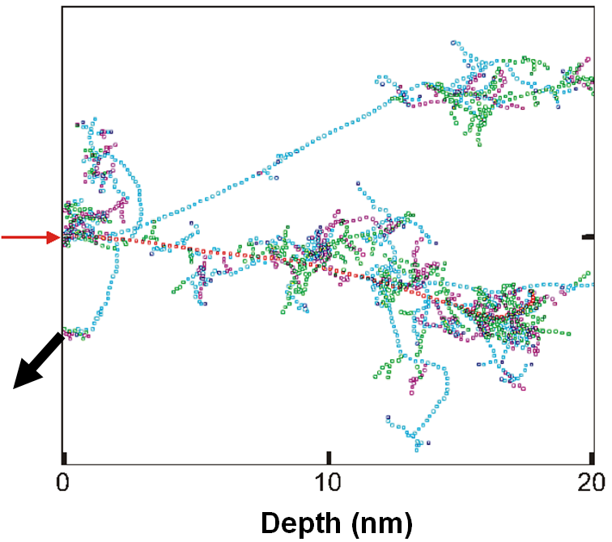
Figure 2.2: Collision cascade simulated by the SRIM code [19], every point represents the collision event of atoms. The red arrow shows the direction of the primary ion and the black arrow represents one sputtered atom.
When sputtering multicomponent materials, the sputtering coefficients of the individual components are different. As a result, one of the components enriches the surface while another is preferentially sputtered. If the surface is charged, the electric field causes the electropositive elements to migrate towards the surface during bombardment, so they are more rapidly (preferentially) sputtered in time, in contrast to the electronegative elements, which in turn migrate to lower regions of the mixed layer. Another reason for preferential sputtering is the different mass of atoms in the sample, the so-called mass effect. Atoms with low mass gain high velocity, making them more mobile and easier to reach the surface, where they can also be preferentially sputtered.
When analysing by SIMS, the influence of the matrix effect on the resulting measured spectra should always be kept in mind. The matrix effect is a general concept explaining the difference in sensitivity of the method to a particular element (dopant) depending on the material matrix it is in. These variations in sensitivity may be due to a change in the ionisation efficiency or in the sputtering coefficient. The ion yield is different for different combinations of dopants with matrices and cannot be predicted in general. The ion yield is strongly influenced by surface chemical bonds. When reactive primary ions O₂⁺ and Cs⁺ are used, the ionic yield increases. The experimentally verified dependencies of the sputtering parameters can be applied with little variation in dopant concentrations in the matrices.
The ionization efficiency depends strongly on the amount of oxygen [20] within the material and on its surface. It is generally assumed that the ion yield depends more systematically on the ionization potential when the surface is fully oxidized. The presence of oxide on the surface increases the yield of positive ions and also reduces the matrix effect. The oxide layer can be artificially maintained during sputtering by using a higher partial pressure of oxygen or by the perpendicular impact of primary ions, in which oxygen is less sputtered. The presence of other electronegative elements such as N, Cl, F on the surface has a similar effect, although not as pronounced, as oxygen. Ionization is strongly influenced by surface chemical bonds.
The surface charging effect causes changes in the transmissivity of the measuring device and changes in the ionization probability. This effect can be eliminated by neutralizing the surface under study with electrons, by depositing a thin layer of gold or by using a beam with O₂⁻ ions.
As the angle of incidence of the ions (measured from the normal to the sample surface) increases, the sputtering coefficient increases up to angles around 70° and then decreases steeply. Increasing the angle of incidence from zero to 60° increases the sputtering coefficient for silicon by the order of magnitude. Conversely, the ion yield decreases with the increasing angle. In the quantitative analysis of oxides on Si, it is preferable, if possible, to sputter at an angle of 60°, for which the sputter coefficients of oxides and Si are similar, resulting from that, no additional correction for sputter angle is necessary.
Mass spectra often contain particles made up of clumps of atoms, called clusters. The sputtering of these particles is explained by two mechanisms [21]. The first one assumes that clusters are formed after sputtering of individual atoms, which may originate from different locations of the analysed surface (Atomic Combination Model). This process results in the vast majority of two- to three-atom clusters (molecules); the probability of forming a molecule with a higher number of atoms is minimal. The molecules formed in this way also have a narrower energy distribution. The second model assumes that the clusters are emitted directly from the sample matrix, thus preserving the three-dimensional arrangement of atoms in the sample (Direct Emission Model). If an ionized multi-atom molecule is detected, then it is very likely that the bonds contained in the molecule are also present on the surface of the studied sample. This makes the SIMS method considered chemically sensitive.

Applications of SIMS method
This chapter discusses some aspects of SIMS analysis of various scientific and industrial samples in different applications employing different analytical modes such as depth profiling, quantitative analysis, 2D/3D imaging, real-time observation, and tomographic analysis, etc. The instruments on which the analyses were performed are also briefly introduced.

Depth profiling

Depth profiling is used to determine the concentration of atoms/elements as a function of depth from the surface [22], [23] but also to determine the depth profile of multilayered structures. If the secondary ions are recorded as a function of lateral position, it is possible to perform so-called 3D profiling. Depth profiling is mainly used to determine concentrations in the range 10¹³ - 10²⁰ atoms/cm³ to depths of up to tens of micrometers. The depth profile of a given element is obtained by measuring the current of its secondary ions while sputtering. The concentration can be expressed as a function of the time of sputtering or the depth below the surface.
Although the secondary ions come from at most two or three surface atomic layers, the sputtered ions do not carry information only from this depth. The signal is influenced by a number of effects, such as atomic mixing, that cause only a thin layer of a particular element to appear thicker in the depth profile (Figure 3.1).
Quantification of this inaccuracy, which is defined as the depth resolution, can be done using the measured width of a sharp interface or a very thin layer, the so-called delta layer. In the latter case, the resolution is not affected by the matrix effect [24].
a)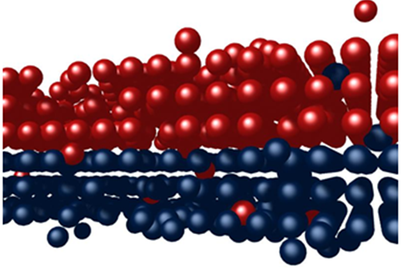 b)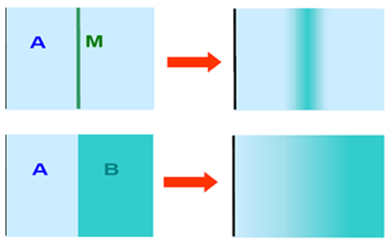
Figure 3.1: a) Schematic representation of atom mixing. b) Schematic shows how the thin layer and the sharp interface between two layers appear in the measured depth profile.
Depth calibration - when measuring the depth profile, we obtain the time dependence of the secondary ion current of a chosen mass. The calibration of the time axis to depth can be done by measuring the depth of the crater formed during the sputtering process. For this purpose, for example, a profilometer or a suitable optical method can be used. When sputtering a multi-layered material, it is desirable to take into account the different sputtering rates of the individual layers. The assumption of uniform sputtering may not always be sufficiently accurate. Different sputtering rates may also be caused by different chemical arrangements.
The initial stages of sputtering are difficult to define, especially when O₂⁺ ions are used. Oxygen is very reactive and changes the chemical composition of the surface layer. Components with high sputtering coefficients are preferentially sputtered; the resulting deficiency is then compensated by their diffusion to the surface. After some time, an equilibrium between diffusion and sputtering is established. This unstable phase of sputtering makes systematic errors in the depth profile difficult to remove. At higher primary beam energies, this non-equilibrium state is shorter. [25]
Instrumental drift (especially the instability of the primary ion current) has a non-negligible effect on the depth profile. For this reason, it is advisable to make measurements for shorter times. An important parameter for sputtering is the lifetime of a single layer [26]. This is mainly determined by the sputtering coefficient and the primary ion current density. Before measurements, it is necessary to estimate this parameter in order to optimally set the experimental conditions.
During depth profiling, it is very important that the sputtering is as uniform as possible, i.e., the beam current density varies minimally with a position on the sample. This can be achieved, for example, by a large beam diameter, but it is preferable to scan the beam. In this context, it is necessary to mention the so-called crater effect. Uneven sputtering creates an inappropriately shaped crater in the sample, and the depth profile is degraded by ions originating from the crater walls. This effect must be suppressed as much as possible. If it is possible to deflect the beam, the so-called "gating" technique can be used to detect ions originating only from a certain region of the crater bottom. This can be achieved, for example, by switching off the ion detector when the beam is outside a predefined area of the crater floor ('electronic gating'). Another way of selecting secondary ions is to use extraction optics, which can be designed to pass ions originating only from a specific region of the sample ('optical gating'). The depth resolution is the best when both methods are used simultaneously. However, this leads to a reduction in the overall signal.
As already mentioned, the mixing of atoms caused by the impact of high-energy primary ions also reduces the depth resolution. An 'altered layer' is formed, the thickness of which increases with higher primary ion energy. The penetration of individual atoms to different depths also depends on their masses. For energies in the order of keV, the thickness of the mixed layer is a few units of nm. Although the measured secondary ions leave the surface from at most the top three atomic layers, they carry information about atoms originally coming from depths of up to tens of atomic layers as a result of mixing. This effect makes the interfaces appear apparently wider in-depth profiling. At larger angles of incidence, ions penetrate to shallower depths from the surface, and the depth resolution is higher. When O₂⁺ or Cs⁺ primary ions are used, the surface coverage of these elements decreases with an increasing angle on incidence, dramatically reducing the ionization probability and therefore the overall detected signal.
Commented paper 1 and 2: Depth resolution enhancement – TOF-LEIS + SIMS
(Nucl. Inst. and Meth. B 2011, 269(3), 369–373 and Thin Solid Films 2013, 540, 96–105)
The first two commented papers deal with a new way to eliminate mixing phenomena and depth resolution enhancement using a combination of SIMS and TOF-LEIS method (Time of Flight Low Energy Ion Scattering). A new way to reduce the influence of ion mixing in-depth profiling using ion sputtering is based on the fact that the TOF-LEIS method allows to observe the in-depth composition of the sample. With an increasing depth, the depth resolution of this method also decreases due to multiple collisions of scattered ions. However, for our condition at a depth of about 2 nm, the decrease in the resolution due to multiple collisions is less than the ion mixing influence during sputtering. Thus, the TOF-LEIS method can “see” the layer interface before it is mixed by the primary ions. The reflected ions are thus able to see the interface through the altered layer more sharply than the sputtered ions detected by SIMS. The experiments demonstrating this resolution improvement were published in the first commented paper. The measurements were performed on an in-house-built combined SIMS and TOF-LEIS device developed by the author.
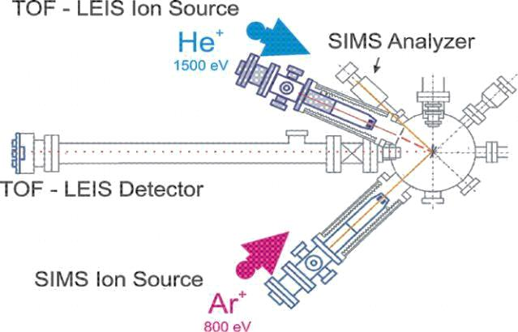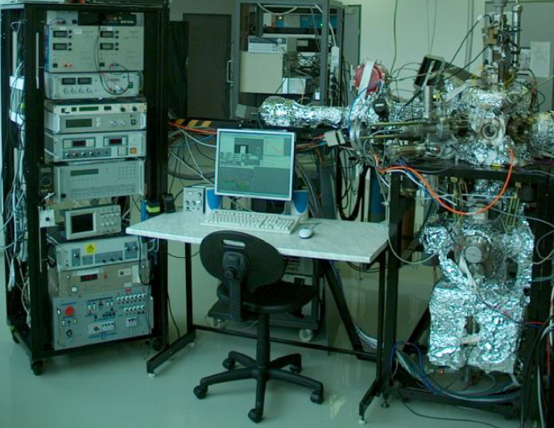
Figure 3.2: Schematic of an in-house-built combined SIMS-LEIS instrument and its photograph at IPE FME BUT Brno laboratory.
During the development of this instrument, a round-robin experiment was carried out. The aim of this experiment was to compare the depth resolution of different commercial SIMS instruments from IONTOF, HORIBA, and CAMECA companies with different types of mass analysers and our in-house-built TOF-LEIS-SIMS. MoSi multilayer samples were used for comparison, and the best depth resolution was achieved on the in-house-built device. Afterwards, further testing of our instrument was carried out and clearly demonstrated the advantages of parallel depth profiling by SIMS and TOF-LEIS methods in terms of ion mixing elimination. Subsequently, an additional advantage of this approach in terms of eliminating the matrix effect in SIMS depth profiles using TOF-LEIS profiles was discovered for two-component multilayers. This issue is discussed in more detail in the Ph.D. thesis of Radek Duda [27], and it is briefly outlined in the following text.
Figure 3.3 shows a depth profile of the MoSi multilayer measured by SIMS. During each measurement point, a portion of the multilayer was sputtered off, and then the scattering spectrum was measured by TOF-LEIS. Based on these TOF-LEIS spectra, the depth profiles were reconstructed using the He⁺ ions scattered on the sputtered sample surface and under the altered layer. These profiles show that the profile reconstructed from the region below the altered layer has better depth resolution, whereas the profile reconstructed from the sputtered sample surface shows worse depth resolution due to ion mixing. Comparing the SIMS and TOF-LEIS profiles, it is clear that the SIMS profile is greatly affected by the matrix effect. The Si profile here seemingly shows more layers than the sample actually had. This SIMS profile was converted to a relative quantitative profile using the relationships below, in which the parameter p (see eq. 3.5) had to be found.
Secondary ion current during SIMS profiling is given by
 | $$J_{sec.}^{±}=J_{prim.}c Yβ^{±} f,$$ | (3.1)
where $J_{prim.}$ is the primary ion current, $c$ is the concentration of the element of interest in the sample, $Y$ is the sputtering coefficient, $β^{±}$ is the ion yield for positive and negative ions, and $f$ is the collection efficiency of the mass spectrometer.
Relative concentration $relc_{Mo}$ is given by:
 | $$\text{rel}c_{Mo}=\frac{c_{Mo}}{c_{Mo}+c_{Si}},$$ | (3.2)
where $c_{Mo}$ a $c_{Si}$ are absolute concentrations of molibdenum and silicon in the two component sample. These concentrations can be expressed using the relation (3.1):
 | $c_{Mo}=\frac{J_{Mo}^{±}}{J_{prim.}Y_{Mo}β_{Mo}^{±}f}$ and $c_{Si}=\frac{J_{Si}^{±}}{J_{prim.}Y_{Mo}β_{Si}^{±}f}$ , | (3.3)
where $J_{Mo}^{±}$ and $J_{Si}^{±}$ are secondary currents of Mo⁺ and Si⁺ ions. By inserting into the relation (3.2) we can get:
 | $$\text{rel}c_{Mo}=\frac{\left(\frac{J_{Mo}^{±}}{Y_{Mo}β_{Mo}^{±}}\right)}{\frac{J_{Mo}^{±}}{Y_{Mo}β_{Mo}^{±}}+\frac{J_{Si}^{±}}{Y_{Si}β_{Si}^{±}}}=\frac{J_{Mo}^{±}}{J_{Mo}^{±}+pJ_{Si}^{±}},$$ | (3.4)
where
 | $$p=\frac{Y_{Mo}β_{Mo}^{±}}{Y_{Si}β_{Si}^{±}}.$$ | (3.5)
Similarly we can get relation for re$lc_{Si}$:
 | $$\text{rel}c_{Si}=\frac{pJ_{Si}^{±}}{pJ_{Si}^{±}+J_{Mo}^{±}}.$$ | (3.6)
The parameter p defined by relation (3.5) cannot be determined from the SIMS measurement alone because it contains the ratio of the ionization probabilities of the Si⁺ and Mo⁺ secondary ions. However, if the parameter p is varied, then for a certain value of p (best fit) the SIMS profile is identical to the TOF-LEIS profile (Figure 3.3c). The TOF-LEIS method detects simultaneously neutralized and ionized scattered He atoms and therefore does not depend on ionization processes (matrix effects) like the SIMS method. In this way, it is possible to obtain the ratio of ionization probabilities (once the sputtering yield is established by depth calibration) for Si⁺ and Mo⁺ secondary ions. The agreement between the two profiles proves that the TOF-LEIS method is quantitative and can be used to study the ionization mechanisms of the SIMS method.
The author of this thesis proposed a way of combining the SIMS method with the TOF-LEIS method and made a major contribution to the development of the combined SIMS and TOF-LEIS instrument, including the design of the vacuum parts and the development of the necessary electronics and software for the acquisition of the measured data.
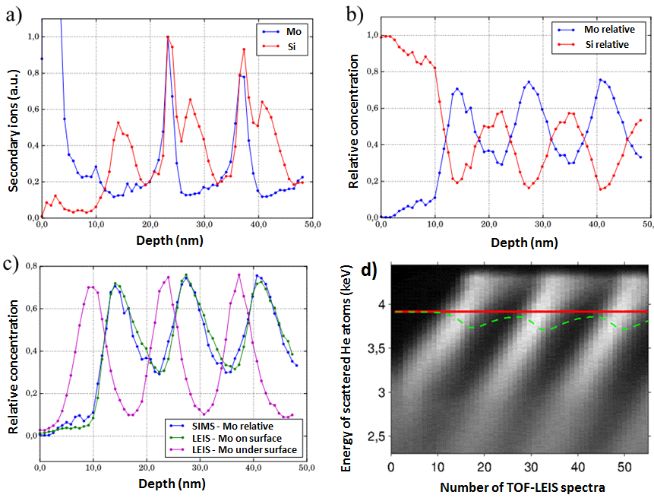
Figure 3.3: Comparison of the SIMS and LEIS profiles taken parallel during sputtering. a) SIMS profile as measured with a matrix effect. b) Relative SIMS profile corrected using the parameter p. c) Comparison of the relative SIMS and LEIS profiles taken at the surface and under the altered layer. d) LEIS spectra displayed as a bitmap. Above the red line, the altered layer is presented and the green line shows the data from the same depth under the surface. Sputtering was done by Ar⁺ ions with 1 keV energy and secondary ions were detected by a quadrupole mass analyser (SIMS). He⁺ ion beam with an energy of 5 keV was used for scattering (TOF-LEIS). These profiles have already been presented and discussed in more detail in the Ph.D. thesis of Radek Duda, supervised by the author [27].
Commented paper 3: Sensitivity testing of a novel SIMS instrument using implantation profiles
(Surface and Interface Analysis 2014, 46(S1))
Within the UnivSEM project, in cooperation with TESCAN Brno company, a new TOF-SIMS device developed by TOFWERK was tested. The TOF-SIMS was installed in a high vacuum electron microscope from TESCAN. This device allows to measure the mass of secondary ions by time-of-flight measurements. It is an orthogonal mass analyser that utilizes a continuous beam of primary ions (no need for primary beam chopping). The time-of-flight measurement is performed using the secondary ion beam chopping. The secondary ions are continuously transported from the sample area by an extraction optics to an analyser. They are accelerated by a high-voltage pulse orthogonally to their original velocity and subsequently directed to an electrostatic mirror and detected.
These accelerated ions move significantly faster than the extracted ions in the extraction optics. Before all the accelerated particles are detected, another dose of ions is moved in front of the deflection electrode, followed by another accelerating high-voltage pulse. This principle allows the detection of a large portion of the secondary ions passed through the extraction optics. However, due to the design of the long extraction optics composed of many electrodes, it is difficult to extract all the ions. The geometry of the analyser, which must be optimized with respect to the pulse timing, obviously plays an important role. These aspects, together with the low ionization probability during Ga ion sputtering, lead to a lower sensitivity of this device. Therefore, it was necessary to measure the resulting sensitivity (detection limits). Selected elements implanted in a silicon crystal were used for testing. By evaluating the detection limits, it was possible to conclude that the sensitivity of this device is approximately two orders of magnitude lower than the IONTOF TOF-SIMS5 device and four orders of magnitude lower than the CAMECA IMS 4F device. Fred Stevie, regarded by the SIMS community as the legendary author of the well-known book on depth profiling [28], also participated together with the author of this dissertation in this testing at Brno.
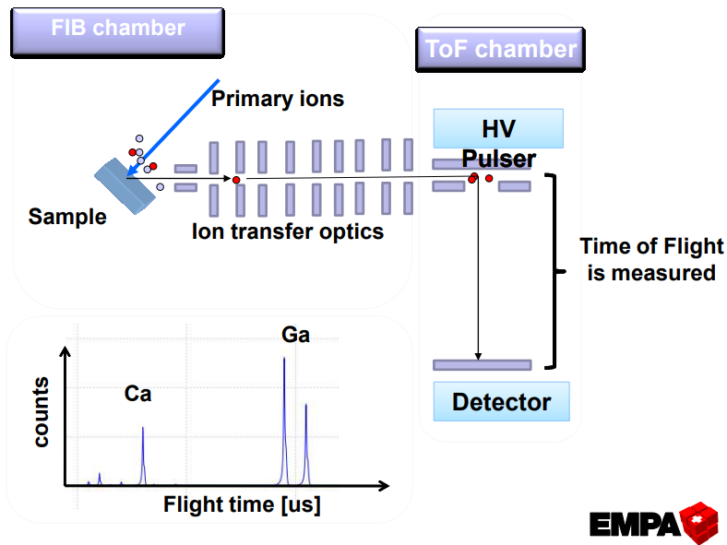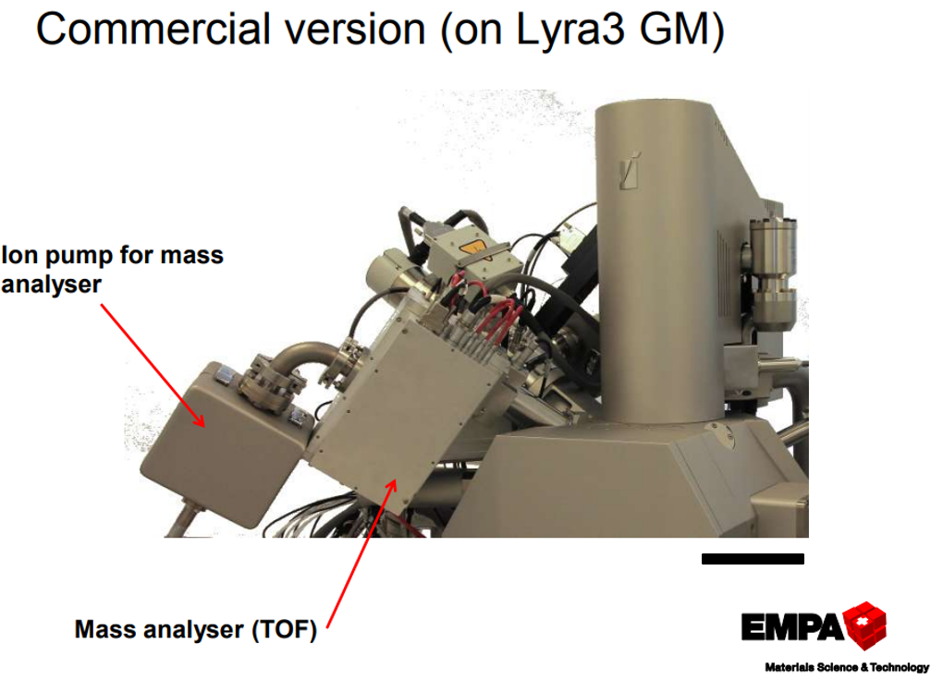
Figure 3.4: Schematic of orthogonal TOF-SIMS developed by TOFWERK Company (left) and on the right, the installation in the scanning electron microscope of TESCAN company(right). The TOF-SIMS analyser was also tested by the EMPA (Switzerland). Scale bar is 30 cm. Adapted from [29].
Commented paper 4: Depth profiling as a tool for thickness measurement of homoepitaxial layers
(Journal of Alloys and Compounds 2019, 789)
SIMS depth profiling has been used extensively in the electronics industry for several decades, especially in the field of the quantitative dopant analysis. It dominates in this area because most other methods have difficulties in offering sufficient sensitivity to a given dopant concentration. The method has also found its application in many other areas in thin film analysis, either in terms of matrix composition or contamination.
Among scientists, the SIMS method is often regarded as a tool for depth measurements, but this is not practically the case. The thickness of the layers usually has to be calibrated by other methods, such as a mechanical profilometer, which measures the depth of a sputtered crater. If multilayers with different sputtering coefficients are measured, it is often necessary to measure the thickness of the individual layers, then to determine the sputtering coefficients, and afterwards to convert the sputtering time to the depth. The measurement error of the thickness is affected by the roughness caused by the sputtering. In such cases, it is better to measure the depth by another method, e.g., by taking a focused ion beam section and imaging with a scanning or transmission electron microscope.
As an example of measuring the thickness using the SIMS method the commented paper 4 was selected. It deals with measuring the thickness of a homo-epitaxial layer, which cannot be measured in electron microscopes due to a lack of contrast. A new method for determining the thickness of grown homo-epitaxial high resistivity SiC layers on conducting SiC substrates by scanning confocal Raman spectroscopy (SCRS) was developed. The SIMS method in combination with a mechanical depth profilometer was used by the author of this thesis to verify the SCRS measurements. It was possible due to the vanadium doping of SiC layer deposited on an undoped the SiC substrate.

TOF SIMS5 instrument
The latter experiment and the experiments reported in the following text were performed on the TOF-SIMS5 device from IONTOF Company developed by Prof. A. Benninghoven. To better interpret these experiments, it is helpful to present this device in a little more detail. Thanks to the time-of-flight approach to secondary ion analysis, this instrument has become dominant in the SIMS community over the last twenty years. The instrument has found wide applications not only in the semiconductor industry but also in fields such as biology and pharmacy, among others. A schematic drawing of this instrument is shown in Figure 3.5.
a)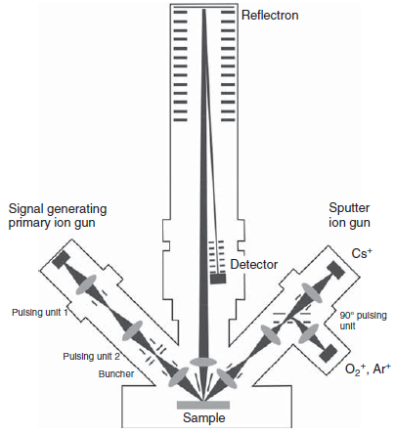 b) 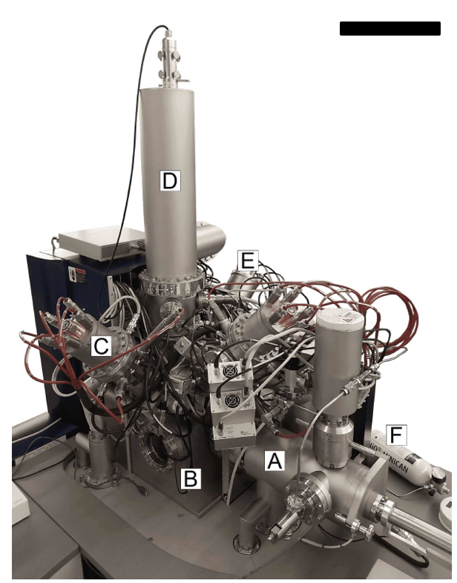
Figure 3.5: a) Schematic of the TOF-SIMS5 developed by IONTOF, adapted from [30]. b) a photo of CEITEC BUT TOF.SIMS5 instrument is shown. A – loadlock chamber; B – main chamber; C – primary ion gun; D – time-of-flight mass spectrometer equipped with reflectron; E – sputter gun; F – gas feeding system. Scale bar is 50 cm. Adapted from [31].
The TOF-SIMS5 instrument at CEITEC BUT Brno is equipped with five ion sources (guns). The primary ion source is a liquid metal bismuth source (hereafter referred to as LMIG, Liquide Metal Ion Gun). A cluster ion source can also be used as a primary ion source, allowing the formation of oxygen and argon clusters with energies up to 20 keV. The other two oxygen and cesium ion sources are designed for sputtering during depth profiling. The last source is a gallium ion (FIB) source and is used for sample sectioning or tomographic measurements. The LMIG allows mass filtering of ions and so-called bunching, which reduces ion pulses from 20 ns to below 1 ns. As a result, mass resolution close to 10 000 (m/Δm) can be achieved. The high mass resolution mode is called the spectrometric mode. The temporal focusing of the primary ions in the pulse has a negative effect on spatial focusing. The lateral resolution in this mode is around 10 µm. If this bunching is turned off, the mass resolution goes down to units of thousands, and the lateral resolution is around 1 μm. If a higher lateral resolution approaching 100 nm is needed, the source extraction current must be reduced and a new focusing performed. The drop in the sample current needs to be compensated by an increased pulse width up to 100 ns. This setting is called the fast imaging mode. As a result of the large pulse width, the mass resolution drops to 100. It is impossible to set the instrument to achieve its maximum mass and lateral resolution at maximum sensitivity. All modes always require some compromise between these parameters. They can be shown as the vertices of a triangle (Figure 3.6). The operator defines which vertices will be approached. The combination of higher lateral and mass resolution is called the burst mode, which splits the pulse of primary ions into several shorter immediately consecutive pulses. Recently, delay extraction mode measurements have also been improved, with mass resolution in the order of thousands and high lateral resolution. This mode performs ion extraction after the primary ions have reached the sample surface and is less sensitive in the low mass region.
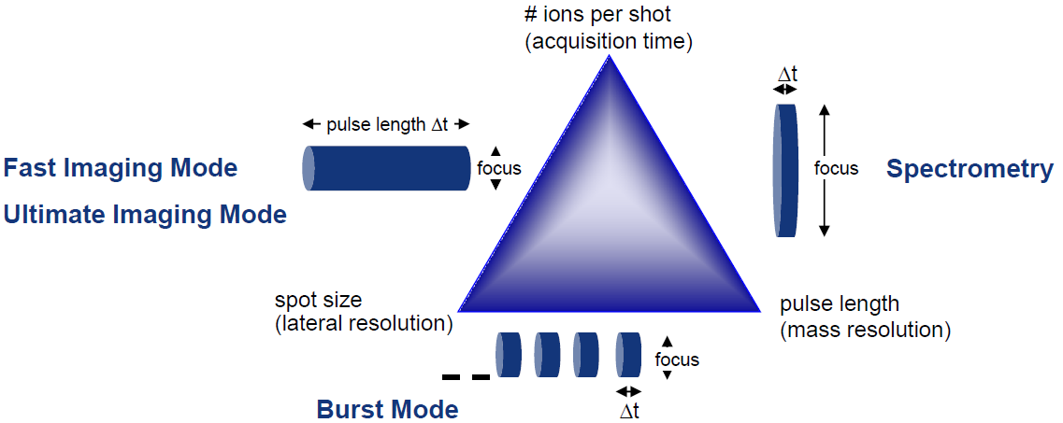
Figure 3.6: Schematic view of the experimental parameters related to available analytical modes for TOF-SIMS5 instruments [32].
A great advantage of the TOF-SIMS5 is the post-processing of the measured data. Peak identification in the spectrum can be performed after the measurement. For devices with a quadrupole analyser or magnetic sector analyser, the measured masses must be preselected before imaging and the measurement time increases with the number of masses. This complicates the analysis in the case of a sample with unknown composition. This advantage is considered essential for the TOF-SIMS5 and it is probably the reason for the high popularity of this instrument.

Quantitative analysis

Generally, quantification of the composition of an analysed material using relevant parameters from the literature is possible to achieve with an error from 40% to 5%; higher accuracy requires the use of standards and calibration of a particular instrument [33]. One of the most critical parameters for quantification is the ionization efficiency, i.e., the ratio of secondary ions of a given species to the total number of these sputtered particles. The ionization potential and the electron affinity have the most significant influence on the ionization efficiency. However, these parameters are rarely known for molecules. The ionization efficiency varies by up to four orders of magnitude for individual elements [10]. The probability of an electron loss is higher for electropositive elements. This is further increased by the use of O₂⁺ primary ions; these elements are then analysed as positive ions. For the analysis of electronegative elements, especially those that have a high electron affinity, the electropositive properties of Cs⁺ primary ions are often used, and then we detect elements as negative ions. The yield of secondary ions is strongly influenced by the ratio of ionization potentials of the investigated element and the matrix element. If the analysed element has a similar ionization potential as the matrix element, the probability of electron gain and loss is the same. The parameters of the instrument used, namely the transmittance, the sensitivity of the detector, and the properties of the primary beam, have a significant effect on quantification as well.
There are several basic approaches to quantification [22]. Among the most important are quantification using relative sensitivity factors (RSF), internal identifiers, detection of MCs⁺ ions (M - any element), and a range of standards with different concentrations of impurities. A reliable quantitative analysis can only be performed with these methods at impurity concentrations up to 1% in the matrix. At higher concentrations, different nonlinear effects occur with trends that are difficult to predict.
Commented paper 5: Quantitative analysis of Cu implanted in Zr-Nb nanoscale multilayers
(Acta Materialia 2021, 202, 317–330)
This commented paper discusses the mechanisms of grain boundary stresses. A mathematical method for the fundamental understanding of the deformation mechanisms in metallic multilayers subjected to radiation damage was developed. A theoretical description of these mechanisms is beyond the scientific scope of this disertation and therefore, only quantitative measurements of implant profiles done by the author using SIMS is briefly discussed. The quantitative analysis of implantation profiles is performed using calibration samples with known implantation doses. The preparation of calibration samples for SIMS methods is often performed by implanting selected ions into a given matrix. This is done on devices called implanters, which ionise and accelerate ions of the selected elements to energies ranging from hundreds to thousands of keV. With implanters, the total number of ions implanted in the sample can be controlled using the beam current and the implantation time. Knowing the total dose in atoms/cm², the depth profile measured by SIMS can be calibrated using the RSF factors. In the commented paper 5, the implantation depth profile of copper in Zr-Nb multilayers was measured.
In addition to dopants, matrix elements can also be quantitatively analysed in most cases, even when the dependence of the secondary ion current on the concentration is nonlinear. If dopants in matrices with different stoichiometric ratios are analysed, the dependence of the RSF on this ratio must be determined. This issue was addressed by the author of this thesis and his student in the analysis of dopants in Al_{x}Ga_{1-x}N layers for ON SEMICONDUCTOR Company and is described in detail in his bachelor thesis [34].

2D imaging

The greatest advantage of the SIMS method is its sensitivity and low detection limits. Sometimes, the measured signal can be too large and must be suppressed to avoid saturation of the detector. In the case of imaging with high lateral resolution, it is not the case. However, the signal is still sufficient to perform a rapid analysis of the elemental distribution on the sample surface. In the TOF-SIMS5 instrument, the primary bismuth ion beam is scanned over a selected region of interest (ROI) during 2D imaging. At each point of the image, the spectrum of the secondary ions over the selected mass range is always measured. The user specifies how many primary beam pulses are used for the spectrum. Of course, the appropriate measurement mode must be chosen according to the dimensions of the objects to be studied. If the dimensions are small (<3 µm) the imaging mode with the minimum ion beam width should be selected. The fast imaging mode often does not provide sufficient mass resolution and the so-called delayed extraction mode should be used.
This delayed extraction mode is a relatively new and helpful mode implemented in the TOF-SIMS5 software several years ago and is worth explaining in more detail. By default, primary ions impact the sample when the extraction voltage is turned on to achieve maximum sensitivity, but the extraction voltage causes an inhomogeneous potential distribution around the ion impact site and this has a negative effect on the focusing of the primary ions. In the delayed extraction mode, the extraction voltage is applied only after the last primary ion in the pulse has impacted. At this time, the secondary ions have already moved away from the sample and are between the extraction optics and the sample (light ions may already be out of range of the extraction optics as they are the fastest). After the extraction voltage is switched on, the secondary ions are directed towards the analyser. This leads to a reduction in the temporal uncertainty caused by the large width of the primary pulse, which significantly increases the mass resolution (>1 000). This leads to a reduction of the detected signal further, especially for the low mass ions that are the fastest moving and move out of the region of possible detection before the extraction is switched on. These measurements are more time-consuming but help to identify the sample composition because they allow the identification of mass interferences at high lateral resolution. If individual peaks are identified and mass interferences are excluded, the delayed extraction mode can be turned off and the sample can be measured using the fast imaging. The delayed extraction mode is also advantageous for samples that are not flat. Non-flat samples cause distortion of the extraction potential and this leads to a significant sensitivity reduction in areas of the sample that do not have a plane perpendicular to the axis of the extraction optics.
SIMS and SEM – real-time observation of catalytic reaction
The advantages of the SIMS method for 2D imaging of surface composition become apparent when measuring the catalytic oxidation of carbon monoxide to carbon dioxide. This reaction, together with other important catalytic reactions, is still under intensive investigation. In 2007, Gerhard Ertl was awarded the Nobel Prize for the study of this catalytic reaction. This reaction is essential not only for automotive catalysts but also, for example, in hydrogen production, where it is used to remove CO from the production process. The reaction has been studied by author's collaborators Marc Willinger and Zhu-Jun Wang from ETH Zurich, who have observed it using environmental XPS and SEM at pressures in the order of hundreds of Pa. Subsequently, we have started activities towards spectroscopic imaging of catalytic reaction and the results are discussed in the following text.
The oxidation of CO takes place on the surface of platinum. Both components - carbon monoxide (CO) and oxygen (O₂) - adsorb to it and subsequently react to form carbon dioxide (CO₂) molecules. The reaction can be summarised in the simplest way as follows:
 | 2CO + O₂ → 2CO₂. | (3.7)
The real situation is much more complex. According to the article [35], an important struggle of reactants starts when the molecules hit the metal surface. Both CO and O₂ compete for a free adsorption site on the surface that would allow them to anchor there. Each molecule behaves quite differently. The stable oxygen molecule - O₂ - is dissociated on the surface into its atomic components - O. For this reason, it requires two adsorption sites. The whole process is called dissociative chemisorption because the original molecule is broken down and a bond with the surface between its components is formed. The oxygen forms a relatively rarefied adsorbent layer that does not prevent the eventual adsorption of CO molecules. On the other hand, CO molecules require only one adsorption site. They form a dense layer of adsorbent that prevents the adsorption of oxygen. CO covered platinum has a reduced catalytic ability and is so-called poisoned by carbon monoxide. Even when the CO gas is prevented from entering, only a weak desorption occurs at room temperature. The poisoning can only be effectively removed by heating to a higher temperature when thermal desorption occurs [36].
The catalytic oxidation of CO on the platinum surface can vary significantly depending on conditions such as the partial pressures of the reactants in the chamber. If a small amount of CO is introduced into the chamber, all the molecules of this gas, immediately after adsorption onto the substrate, react with the oxygen that covers the entire surface. Such a reaction is, therefore, completely dependent on the pressure of CO. The reaction does not depend on the structure surface, since the CO adsorption coefficient is almost constant at low pressures. If one increases the CO pressure linearly, the reaction rate will also increase linearly and so will the CO₂ formation [37]. If the gas pressure rises to a sufficient level, the dependence mentioned above will no longer be valid and the rate of CO₂ formation will reach its maximum. This is due to the fact that a significant amount of adsorbed oxygen is already consumed within the reaction and has to re-adsorb on the surface. The reaction rate thus becomes limited by the adsorption rate of oxygen. The adsorption coefficients for O₂ and CO vary significantly at high pressures depending on the surface structure. Depending on the surface structure, the reaction can, for example, be in two different states under the same external conditions, where oscillations are generated by repeated transitions between them [37].
After initial struggles with sample purity and in setting up suitable experimental conditions, we were able to observe this oscillatory nature of the reaction first in an ultrahigh vacuum scanning electron microscope (UHV-SEM). This device was developed by the author and his students (Michal Páleníček, Tomáš Axman, Roman Skladaný) together with the TESCAN company specifically to observe the physical processes and the formation of nanostructures in real-time. The device was developed within the Amispec project and a second prototype was instaled to IPE FME BUT Brno (Figure 3.7). During the development, a high vacuum electron column was adapted to an ultra-high vacuum environment. The electron detectors were adapted to work in UHV and the effect of light radiation during sample heating on the secondary electron current was also minimized. As a result, it is possible to observe the surface of samples at temperatures as high as 1 300 °C. At the same time, a sample heater was developed to allow heating under the electron column to temperatures approaching 2 000 °C. This was important for an easy cleaning of the platinum surface, which was heated to temperatures approaching the melting point (1 768 °C) in an oxygen atmosphere. It takes only a few tens of minutes to clean such a sample.
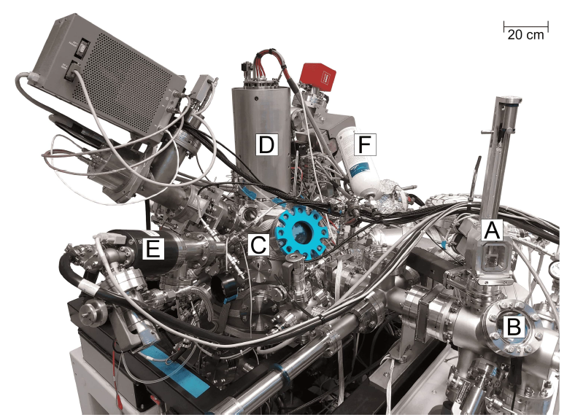
Figure 3.7: UHV-SEM instrument at IPE FME BUT. A – airlock chamber; B – loadlock chamber; C – main chamber; D – electron column; E – sputter gun; F – gas feeding system.
Figure 3.8 shows the platinum surface and grain boundaries measured by UHV-SEM. The central grain is active in terms of oscillatory reactions. A more detailed description of this experiment is in the diploma thesis of Marcel Janák [31]. Based on further experiments in the thesis of Antonín Jaros [38], it can be concluded that the darker bands are probably regions with adsorbed oxygen and the lighter ones with adsorbed carbon monoxide. Both diploma theses were supervised by the author. The reaction in the UHV-SEM environment lasts for approximately one hour and changes its character in time. Gradually, the disordered areas change to a spiral shape that slowly weakens until the reaction is completely terminated. Why this happens is not yet known.
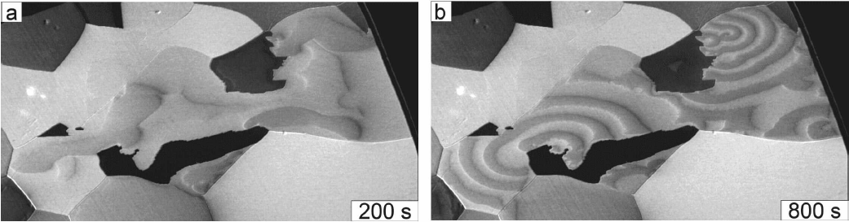
Figure 3.8: Temporal evolution of rotating spirals on the Pt(4,1,10) surface at T = 170 °C measured by UHV-SEM, p_{CO} = 3.0 · 10⁻⁴ Pa, p_{O2} = 1.5 · 10⁻³ Pa. Bright areas are probably covered by CO; dark areas might be covered by oxygen. In a) the evolution of the waves at the beginning of the experiment is shown, and in b) the formation of the spiral waves is depicted.
The same sample from Figure 3.8 was transferred to TOF-SIMS5, where it was observed under similar conditions using 2D imaging. During imaging, the primary ion current is ~5 pA. For at least the first few tens of minutes, the experiment is run in the static SIMS mode in which most of the ions impact the sample where no other ions have impacted before. The original plan for the experiment was to measure at least one image of the spatial distribution. We assumed that the surface would be modified by the primary ions so that the reaction could not be measured in real-time. It turned out that the reaction could be observed in real-time and under longer time scales (up to several hours) than in the case of UHV-SEM. Only a few experiments have been performed so far and we have not been able to form the spiral shape of the reaction waves yet. Obviously, the impact of ions modifies the platinum surface. To what extent this modification is permanent or whether reconstruction occurs during sputtering on a heated (~170 °C) surface will be the subject of further study. However, Figure 3.9 shows that it is possible not only to observe the distribution of reactants as a function of grain orientation but also in real-time, as shown in Figure 3.10. The same experiment has been performed in the NanoSAM device, which allows measuring the surface composition by Auger spectroscopy. However, it has been found that this method has a temporal resolution of several hours in 2D imaging, whereas the same quality image can be made by SIMS in 5 s. This makes it impossible to observe the reactions in real-time by the Auger method. Moreover, in the point mode SEM measurements, the electron beam effects are very significant and the beam needs to be defocused to a diameter of tens of micrometers to reduce the effect to a minimum. This experiment with the NanoSAM device is described in the bachelor thesis of Dominik Hrůza [39].
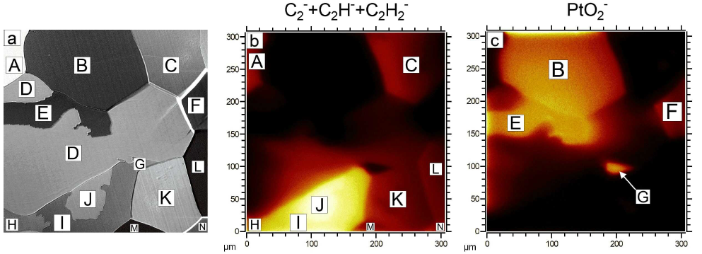
Figure 3.9: Map of an examined Pt sample. a – electron micrograph with labelled grains (A-N). The grain D is an active Pt(4,1,10); b – TOF-SIMS map of CO covered grains. CO coverage is proportional to C₂⁻+C₂H⁻+C₂H₂⁻ signal; c - TOF-SIMS map of oxygen covered grains. Oxygen coverage is proportional to the PtO₂⁻ signal. The area analysed in b) and c) is the same as in a).
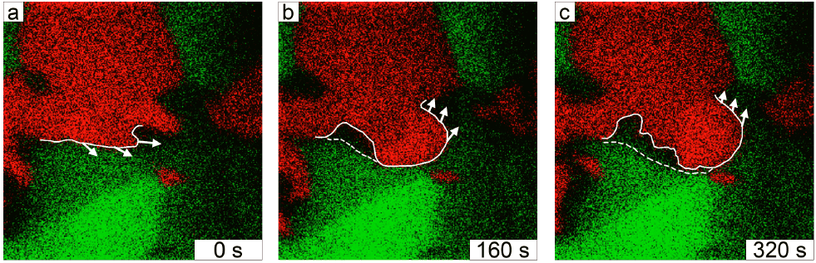
Figure 3.10: Temporal evolution of patterns observed on an active Pt(4,1,10) grain at T = 170 °C, p_{CO} = 3.0 · 10⁻⁴ Pa, p_{O2} = 1.5 · 10⁻³ Pa. Green areas are covered by CO; red areas are covered by oxygen. The electron micrograph of the sample for easier identification of grain boundaries is displayed in Figure 3.9a. A full white line highlights the moving wavefront; white arrows indicate the direction in which the wave proceeds between frames; a dashed white line delimits the area almost without chemisorbed reactants. The field of view is the same as in Figure 3.9.
In general, the SIMS method is considered to be destructive in contrast to Auger the spectroscopy, which is considered to be non-destructive. As we show here, in this case the opposite is true. In Auger analysis at high electron current, the sample can be heated by up to tens of degrees depending on the material at the point of an primary electron impact [40] and, in addition, CO molecules can be decomposed by electrons. This is because the primary electron current is in the order of tens of nA while the primary ion current is in the order of pA. Thus, due to its high sensitivity and small primary ion current, SIMS is able to monitor this reaction in real time much better than Auger spectroscopy. These live images with the chemical contrast are therefore truly unique and have not yet been published in the literature.
It is proposed to observe this reaction also in the HV SEM (TESCAN) equipped with the orthogonal TOF.SIMS TOFWERK device described earlier. However, this version of the SIMS is two orders of magnitude less sensitive, and therefore it is likely that the reaction could not be observed in real time, but it would be possible to first develop the spiral waves with the SEM and then make one 2D SIMS measurements. In this way, it would be possible to assign the SE contrast unambiguously to the surface composition (identifying the composition of the dark and bright parts of the waves).
Commented paper 6: Surface termination study
(Carbon 2021, 176, 642–649)
While the previous work has only been published in non-impact papers so far, the following two examples of 2D SIMS imaging have already been published in high impact journals. The first paper focuses on electron emission from H-terminated diamond enhanced by polypyrrole grafting. The measurements using the NanoSAM ultrahigh vacuum electron microscope and SIMS were carried out at CEITEC BUT Brno. The aim of the measurements was to compare the effect of surface termination performed by polypyrrole coverage and subsequent nanoshaving by SPM. Surfaces prepared in this way were heated and the secondary electron emission was measured, then the surface composition was studied by 2D TOF-SIMS under the same conditions. It was shown that by surface treatment using electrochemically grown polypyrrole the secondary-electron emission and photoelectron emission from boron-doped diamond is enhanced even above the intensity of electron emission from the hydrogen-terminated surface with negative electron affinity. This enhancement is stable in air for at least one month and it persists also in vacuum after thermal annealing. A model of the electron emission enhancement was also provided.
Commented paper 7: High-resolution imaging
(Nano Research 2017, 10(6), 2046–2055)
Another article using 2D SIMS is entitled High-resolution characterization of hexagonal boron nitride coatings exposed to aqueous and air oxidative environments. In this work, we have studied the stability of mono and multilayer h-BN stacks exposed to H₂O₂ and atmospheric conditions. Our experiments revealed that monolayer h-BN is similarly inefficient as graphene as a protective coating when exposed to H₂O₂. Multilayer h-BN offered a good degree of protection. Monolayer h-BN was found to be ineffective in an air atmosphere as well. Even a 10–15 layers-thick h-BN stack could not completely protect the surface of the metal under consideration. By combining Auger electron spectroscopy and secondary ion mass spectrometry techniques, we observed that oxygen could diffuse through the grain boundaries of the h-BN stack to reach the metallic substrate. Fortunately, because of the diffusive nature of the process, the oxidized area did not increase with time once a saturated state was reached. This makes multilayer (not monolayer) h-BN a suitable long-term oxidation barrier.

3D depth profiling by TOF-SIMS

3D SIMS depth profiling (imaging) can be performed by repeated 2D imaging at different sample depths. During 2D imaging, sputtering occurs and each subsequent 2D image comes from an increasing depth. However, in the case of TOF-SIMS, the sputtering rate (maximal sputtered depth) is limited by the primary beam current. If the sputtering is performed only with primary pulsed beams (TOF-SIMS), the maximum depth of analysis is in the order of tens of nm (ROI tens of μm²), for larger ROIs in the order of hundreds of µm² an assisting ion source must be used. This is usually an oxygen or cesium ion beam source, which can also help to increase the secondary ion yield. Therefore, 3D imaging with a TOF-SIMS5 instrument is done in the so-called dual beam mode. While the assisting ion beam is forming a crater, the primary beam is progressively analysing the crater bottom. The area analysed is generally smaller than the area sputtered by the assisting ion beam source. This approach also provides gating of the signal from crater walls. When sputtering with an assisting ion beam source, the secondary ions are not analysed, this leads to a lower overall signal and this is why the TOF-SIMS method is approximately two orders of magnitude less sensitive than methods working with a single continuous oxygen or cesium primary ion beam.
The acquisition of the 2D images from an increasing depth provides three-dimensional data. The raw data file contains each point of analysis of the digitally scanned beam with its X, Y, and Z coordinates and a mass spectrum, subsequently; the TOF.SIMS5 software enables various analytical and visual reconstructions to be made (Figure 3.11 on the left). Figure 3.11 (on the right) shows an example of the reconstruction of the oxygen distribution in a transistor. This method of 3D imaging is particularly suitable for samples whose surface is flat and the individual constituents are sputtered uniformly. In this figure, it is possible to observe a change in the depth of the gate oxide. This is misleading due to the curved surface and different sputtering rates, hence the resulting reconstruction is distorted. A compensation for the different sputtering rates and curved surface can be made by measuring the topography before each 2D maping and adjusting the resulting reconstruction accordingly [41], or by performing tomographic 3D imaging, which is described in the last chapter.
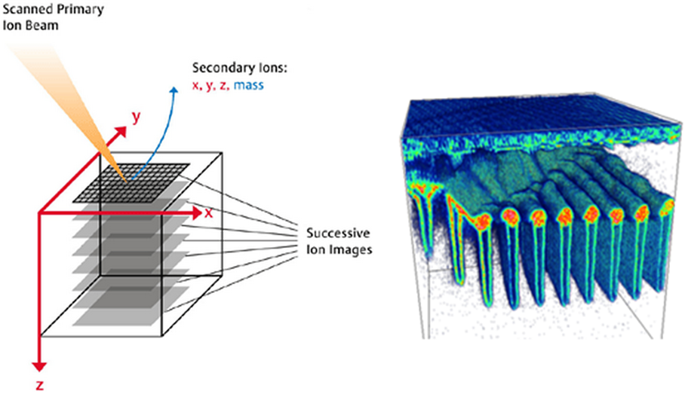
Figure 3.11: Schematic representation of individual 2D maps in space (left), where the entire mass spectrum is measured for each point. By selecting a single mass of oxygen, 3D reconstructions of its distribution in a transistor can be created for a selected volume (300x300x15 µm³, right).

Commented paper 8: 2D & 3D TOF-SIMS analysis of the spinel in an alumina matrix
(Materials Characterization 2019, 148(April 2018), 252–258)
In commented paper 8, the TOF-SIMS method is utilized for visualization of the phase and chemical compositions of advanced ceramic materials. The study of the phase and chemical composition is often limited to localized 2D methods and their sensitivity to local changes. Analysed alumina as the most used ceramic materials was doped by MgO to prevent abnormal grain growth to allow annihilation of pores pinned at grain boundaries. The phase equilibria of Al₂O₃-MgO has been widely studied and discussed. However, the chemical composition of spinel (MgAl₂O₄) in three dimensions has never been described. Spinel was formed during the sintering of Al₂O₃-MgO powder. 2D & 3D TOF-SIMS quantitative identification of the spinel grains in an alumina matrix was discussed.
We successfully measured the formation of spinel in the alumina for different concentration of MgO using 3D TOF-SIMS imaging. The presented analytical method allowed the characterization of advanced ceramic materials in volume and provided the study of grain formation and contamination. The analysis by TOF-SIMS revealed a high homogeneity of MgO distribution in the green body after ball milling and no MgO rich areas were observed. After sintering at 1 700 °C for 30 min, the majority of MgO was present in the form of MgAl₂O₄ (spinel), which was confirmed by XRD analysis and by the Mg⁺/Al⁺ ratio in observed grains. The majority of spinel grains has a volume below 1 μm³; however, also the grains with a volume of tens of μm³ were present. Sodium impurities presented in the starting powder were concentrated nearby or in the spinel grains. See Figure 3.12.

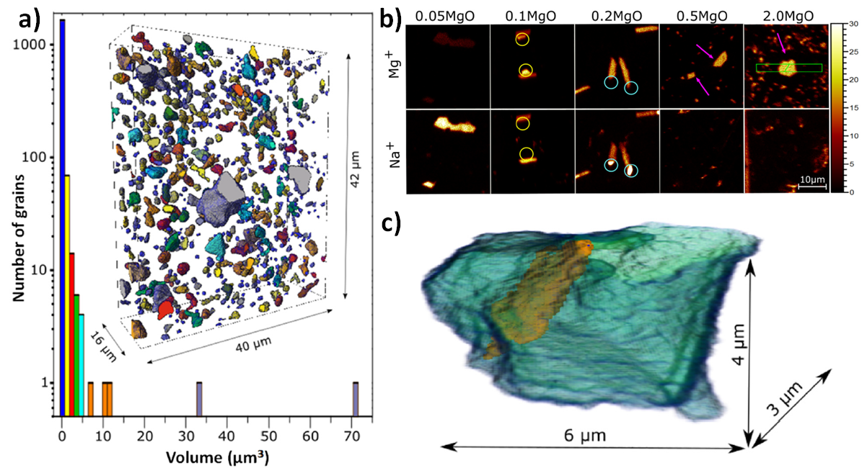
Figure 3.12: a) Spinel grain size distribution in sintered alumina measured by TOF-SIMS. 3D render was colorized according to the volume of grains. b) Analysis of the samples with distinct starting MgO concentrations. The colored circles highlight the differences between Mg and Na concentration distributions in grains. c) The 3D model of a spinel grain reconstructed with the Mg signal (transparent blue) clearly shows the position of Na contamination (brown).

FIB-SIMS tomography and correlative analysis

When solving complex technical problems, the application of one analytical method is often not enough. Each analytical method has its own limits, which the operator must consider when selecting a suitable method. Parameters such as resolution, sensitivity, quantitative analysis capability, destructiveness, etc., are crucial. If the selected method does not provide sufficient information about the sample to be analysed, additional information should be obtained, ideally from the same area of the sample. Subsequently, all the information should be displayed in a form that is complementary to each other. This synergy renders the conclusions of the analysis more useful. Moreover, by choosing the appropriate order of the applied methods, the analysis can be more focused on the problem to be solved. We call this approach the correlative analysis.
In this last chapter, a correlative failure analysis of semiconductor industrial samples employing X-rays and Focused Ion Beams (FIB) will be discussed. These analytical procedures were developed in collaboration with the company TESCAN and Fraunhofer Institute in Dresden. Defects in the so-called TSV structures were analysed. Here, TSV means Through Silicon Via and is used to connect the circuits on the front and back of a silicon wafer. When testing these circuits, defective TSVs were identified and the analysis aimed to find the cause of this malfunction identified. The defective TSV was observed with a camera in the infrared spectrum during testing to identify areas where higher thermal stresses occurred due to TSV defects. An identified TSV was cut out of the silicon wafer and measured using X-ray tomography at the Fraunhofer Institute. Further investigations, including 3D data reconstruction, were carried out by our student Karel Vařeka under the supervision of the author of this work within the international CoolPromo project. This issue is discussed in detail in his master thesis [42]. His thesis presentation was awarded as the second best for the year 2021 by the student section of the Academic Senate at BUT.
Karel Vařeka created 3D reconstructions of the TSV from the X-ray tomography (NanoXCT) images in Avizo software and simulated a cross-section of the specimen (Figure 3.13 a), which was then fabricated using Ga-FIB in TOF-SIMS5 at specific angle and depth suitable for SIMS measurements (Figure 3.13b).
- 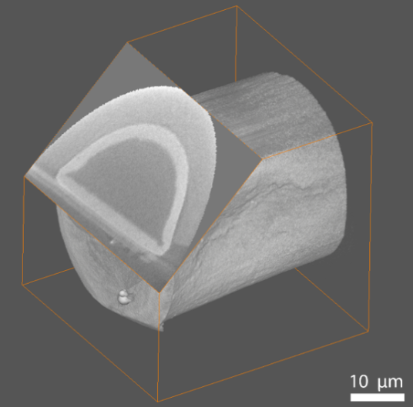 b) 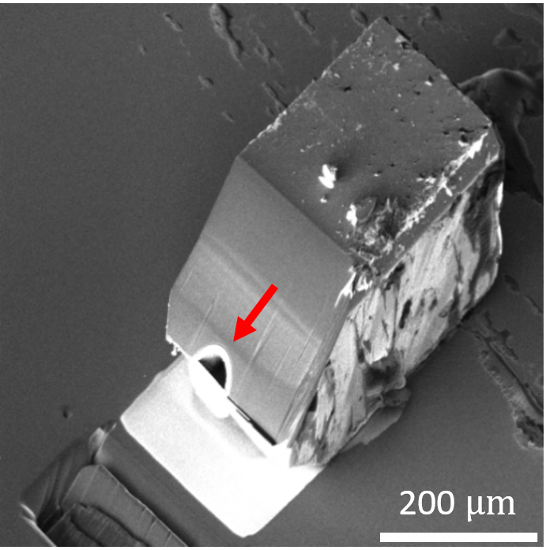
Figure 3.13: a) Preview of the TSV Cu core cross-section reconstructed (simulated) using NanoXCT data in the Avizo software. b) Image of the same TSV sample placed on a silicon wafer after FIB sectioning acquired by secondary electrons and Ga ion beam. The TSV core (marked by red arrow) is surrounded by silicon.
The cut was made at an angle of 45° from the horizontal plane. This geometry provides a view of the cross-sections of the different layers of the protective barrier and the core of the TSV sample itself and was found to be the most suitable in terms of the secondary ions signal intensity.
Subsequently, SIMS mapping of the cross-section surfaces was performed in several sections of the sample. The acquisition time of the 2D images was in the order of several hours to detect potential low concentration contaminations in the TSV. Such a long time would be difficult to use for measuring tens of cross-sections in the FIB-SIMS tomographic mode, but thanks to the 3D information from the NanoXCT, the tomographic mode of the FIB-SIMS method is not absolutely necessary to get an insight into the spatial distribution of elements. The selected images are shown below. The results (Figure 3.14) revealed the contamination of trace elements Ca, K, C, S, Cl and Na. The intense copper signal at the edges of the core is attributed to the presence of copper oxide, which increases the positive yield of secondary ions.
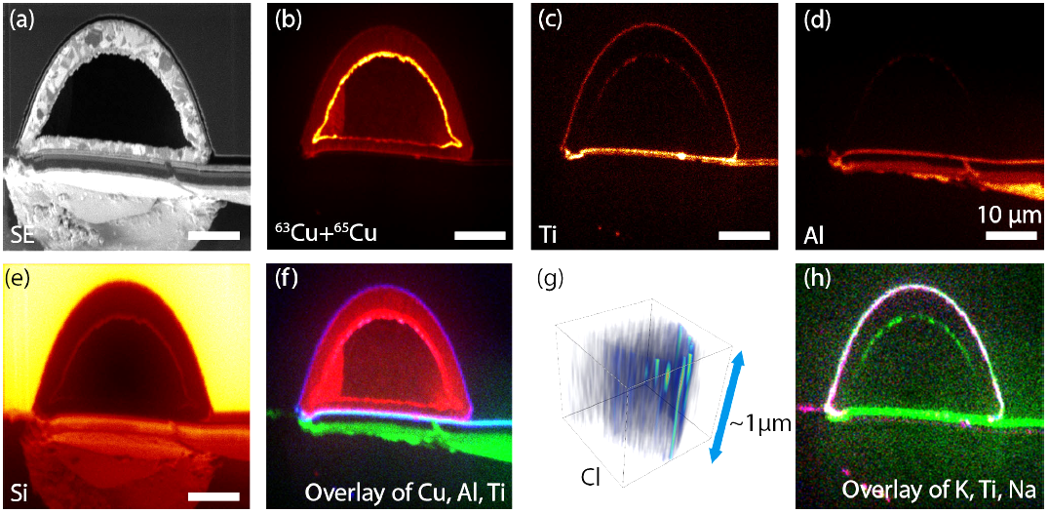
Figure 3.14: TOF-SIMS results of the TSV cross-section. (a) SE image acquired by Bi⁺ ions, (b) signal of Cu isotopes, (c) Ti, (d) Al, and (e) Si, (f) RGB overlay of Cu (red). Al (green) and Ti (blue); (g) represents Cl distribution resulting from depth profiling on the TSV cross-section through A 1 µm depth, (h) overlay of Ti (green), K (red), and Na (blue) signal. The scale bar in all 2D images is 10 μm.
Figure 3.15 shows a 3D section of the copper part of the TSV sample correlatively combined with a 2D copper map obtained by SIMS. This analytical approach combines the strengths of the two methods, i.e., the non-destructive extraction of the copper shape used to determine the cross-section location, the chemical analysis and sensitivity of the SIMS method. By correlative imaging with 2D FIB-SIMS5 and 3D NanoXCT methods, the location of the contaminated interface was successfully identified. The contamination elements were overlapped with a TiN diffusion barrier layer in the 2D image due to insufficient lateral resolution. The TiN layer is only a few tens of nanometers thick and it was not clear whether the contamination was located between the silicon and the TiN layer, or between the TiN layer and the Cu layer. Using the shape of the Cu layer at the bubble site and the position of the TiN layer, it was possible to conclude that contamination is present between the TiN anti-diffusion layer and the copper part of the TSV and is likely caused by contaminants in the solution used in the electrochemical deposition of copper.
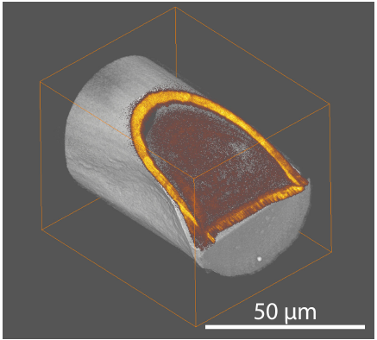
Figure 3.15: Correlative image of NanoXCT data with a copper signal from the TOF-SIMS5 microscope.
Scanning Electron Microscopy (SEM) images and Electron Dispersive X-ray Spectroscopy (EDS) analysis were also taken at the site of the cut. SEM has a resolution of a few nanometres, whereas the EDS method has a resolution of ~300 nm. Mathematical processing can be used to produce an image that shows the chemical composition (EDS image) of the sample while simultaneously showing the details visible in the electron micrograph (Figure 3.16).
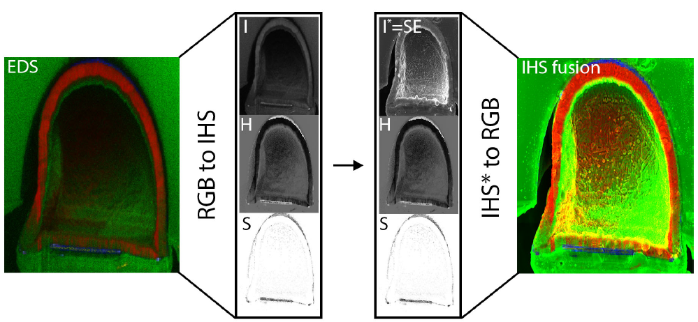
Figure 3.16: Intensity-Hue-Saturation image fusion method (IHS). Representation of high resolution SEM image of the sample cross-section merged with SIMS data. In the IHS sharpening, the intensity channel of the SIMS image is replaced by the SEM image.
If the sample is sequentially and transversely sectioned using a gallium ion beam and SIMS analysis is performed on each cross-section, a tomographic image of the sample can be created (FIB-SIMS). The design and relative positions of the ion sources in the chamber of the TOF-SIMS5 microscope are shown in Figure 3.17. A focused ion beam containing Ga⁺ ions produces a cross-section at the 45° angle, and the cross-sectional area is analysed using Bi⁺ or Bi₃⁺ ions also at the 45° angle from the original sample plane. The axes of both ion beam sources are perpendicular to each other. Another ion beam source for a signal enhancement is the so called Dual ion beam (oxygen/cesium).
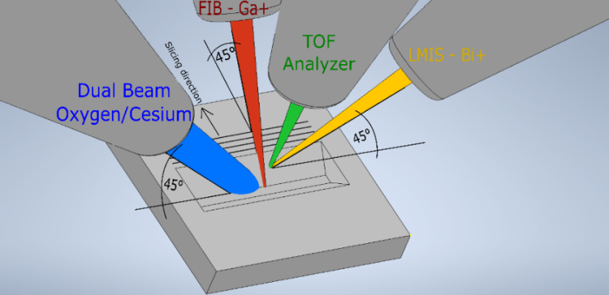
Figure 3.17: Schematic of all ion sources including the time-of-flight analyser extraction electrode in the TOF-SIMS5 instrument during FIB-SIMS experiments.
The thickness of a single Ga⁺ FIB slice is ~2 μm to keep the time-consuming measurements in mind. Each newly formed section should be sputtered with cesium or oxygen ions prior to the analysis cycle to increase the secondary ion yield. This also removes a large amount of gallium from the surface of the section and makes the chemical contrast more pronounced. Tomographic measurements using the TOF-SIMS method were also performed on TSV samples (Figure 3.18). The measurement time was 24 h. Reconstruction into a 3D model was performed in Avizo.
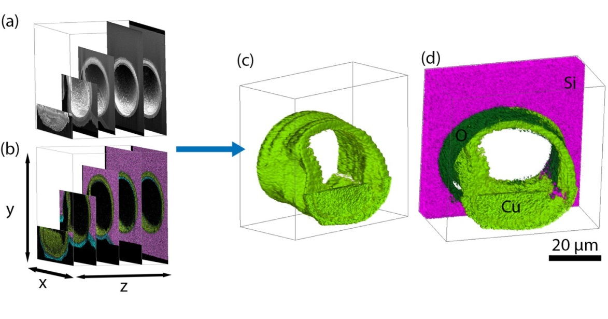
Figure 3.18: 3D Computer reconstruction of 50 FIB-SIMS sections of the TSV structure.
The last Figure 3.19 shows the 3D representation of the TSV using several techniques as NanoXCT, FIB-SEM, and FIB-SIMS. This tomographic approach was also used to localize and chemically analyse the 1000 nm particles that were present in the TiN diffusion barrier region and caused the TSV malfunction; unfortunately, permission to publish these results has not been granted yet.
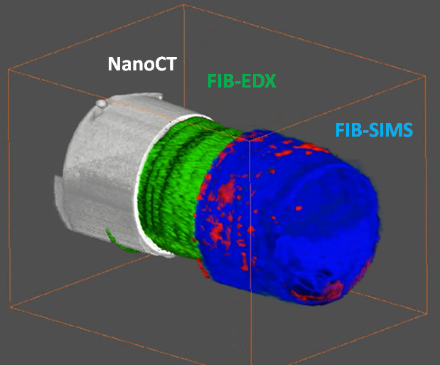
Figure 3.19: 3D tomographic visualization of the TSV structure using NanoXCT (left), FIB-EDX (center) and FIB-SIMS (right). The diameter of the TSV is ~50 μm.

Conclusion

In this thesis, the SIMS method was briefly described and its broad application portfolio in basic research and industry was outlined. While describing the various applications, emphasis was placed on presenting the individual contributions of the author and his students in the field of the spectral ion analysis for both scientific and industrial applications. Although the selected publications are from different scientific fields, their common thread is the use of the SIMS method. These publications are commented in the text with emphasis on the individual contributions of the author, which was realized specifically with the SIMS method.
The author of this thesis has been working with the SIMS method for more than twenty years. At the end of the 1990s, when there was no commercial instrument for the SIMS method in the Czech Republic, he devoted himself to the development of his own SIMS instrument. He used quadrupole analyser and an ion source, which, after the necessary modifications and installation in a complex UHV system at the IPE FME BUT Brno, was controlled using his own software. This instrument was comparable to commercial instruments in terms of the depth resolution (commented paper No. 2), but its wider use was limited by its low mass resolution. Another experiment performed on this instrument and described in this thesis was the parallel depth profiling using TOF LEIS-SIMS (commented paper No. 1). The integration of the TOF-LEIS instrument and the SIMS instrument into a single vacuum chamber made it possible to improve the depth resolution during sputtering by utilizing scattered ions and suppressing the influence of the mixed layer.
The author's experience was used, among other things, to integrate the TOF-SIMS (TOFWERK) instrument into a TESCAN microscopes (commented paper No. 3). In the early 20s, the author was involved in the establishment of the CEITEC BUT project, in the framework of which the commercial TOF-SIMS5 device from IONTOF was purchased. From the fourth to the nine commented paper, this device was used. In these papers, the previous author`s experience in mass spectroscopy was reassessed. In addition to a broader scientific collaboration, this instrument has opened up new opportunities for collaboration with industry. These were mostly for a failure analysis of various components in the automotive, electrical, glass, and other industries. Among the customers to that the TOF-SIMS5 instrument has helped in solving technological problems are companies such as CONTINENTAL, HELLA, SWOBODA, ABB, U. S. STEEL KOŠICE, SISECAM, AVX, SCHOTT, SCHWIZER, and others. In some cases, it has been possible to dramatically reduce the waste rates of manufactured parts or restart a stopped serial production. The author has had a long-standing cooperation with ON SEMICONDUCTOR, and thanks to this instrument, it was possible to deepen it and implement two projects of TAČR, where the author was the principal investigator for BUT. Currently, within the framework of TAČR and NCK projects, he also leads collaborations with TESCAN, MEOPTA, and CRYTUR.
In the case of TESCAN, the development of the UHV-SEM microscope took place within the Amispec project, where the author coordinated its development at BUT. Two prototypes of the microscope have been produced, one of which has been donated to BUT and is used for the real time in-situ experiments on graphene growth and catalytic conversion of CO to CO₂ presented in Chapter 3.3. A scintillator X-ray camera is being developed in collaboration with CRYTUR, where the author's team performs an analysis related to scintillator quality. Thin films resistant to high laser powers are being developed in collaboration with MEOPTA. Here, the application of the SIMS method is the key method due to its high sensitivity and thus the ability to measure elemental distributions in areas in the order of hundreds of nm² to units of cm². There are limits to publish the results of collaboration with the industry due to the protection of know-how (IPR). However, the involvement of students in these collaborations is possible as well as beneficial in terms of their education; sometimes, even before completing their final theses, students become members of the companies' development teams. Thus, under the guidance of the author, more than 15 final diploma theses of the students have been produced on the basis of cooperation with companies. One of the students received an Industrial company award for the development of an ultra-vacuum version of the secondary electron detector.
Thanks to the author's experience and the state-of-the-art instrumentation in CEITEC BUT Brno laboratories, there is, also a useful collaboration with universities, among which the collaboration with ETH Zurich in the field of catalytic reactions has dominated during the last year. The selected articles also include authors from other collaborating institutions. Further collaborations is also currently underway with the IKTS Fraunhofer Institute in Dresden in the field of a correlative tomographic imaging and the use of SIMS, NanoXCT, and other methods.
In addition to the issues related to the SIMS method, the author also has been involved with the observation of the behavior of nanostructures in real-time and at elevated temperatures using an electron microscope. This includes, for example, the etching of silica by gold nanoparticles, which is described in detail in the last commented paper No. 9 (RSC Adv. 2015, 5(123), 101726-101731). The combination of SEM and SIMS methods in the real-time observation of catalytic reactions, which was discussed in Chapter 3.3, provides a unique insight into the dynamics of processes occurring on the surface of catalysts, and this is a direction that the author would like to pursue scientifically in the future.
The author of this thesis leads a “SIMS group” at the Institute of Physical Engineering, Faculty of Mechanical Engineering at Brno University of Technology. At present, the SIMS group counts 3 postdocs, 4 Ph.D. students, 5 master, and bachelor students. In the field of ion spectroscopies, the author was a co-supervisor of one Ph.D. student, 15 master students, and 17 bachelor students, who successfully defended their theses. The experience of the author in research and industrial cooperation is utilized in courses and lectures organized for students of the Physical Engineering and Nanotechnology. The author delivered “Vacuum physics and technologies” course and partly a course „Diagnostics of nanostructures“, “Microscopies and Spectroscopies”, “Preparation of low dimensional structures“, and „Precision mechanics“. Author is also involved in the courses “Physics I”, “Physics II” for the students of Mechanical Engineering.

References

[1] THOMSON, J.J. LXXXIII. Rays of positive electricity. The London, Edinburgh, and Dublin Philosophical Magazine and Journal of Science [online]. 1910, 20(118), 752–767. ISSN 1941-5982. Available at: doi:10.1080/14786441008636962
[2] BENINGHOVEN, A. Secondary ion mass spectrometry – basics concepts, instrumental aspects, applications and trends. Volume 86. NY: John Wiley & Sons, 1987.
[3] PIRKL, Alexander, Rudolf MOELLERS, Henrik ARLINGHAUS, Felix KOLLMER, Ewald NIEHUIS, Alexander MAKAROV, Stevan HORNING, Melissa PASSARELLI, Rasmus HAVELUND, Paulina RAKOWSKA, Alan RACE, Alexander G. SHARD, Andy WEST, Peter MARSHALL, Carla F. NEWMAN, Morgan ALEXANDER, Colin DOLLERY and Ian S. GILMORE. A Novel Hybrid Dual Analyzer SIMS Instrument for Improved Surface and 3D-Analysis. Microscopy and Microanalysis [online]. 2016, 22(S3), 340–341. ISSN 1431-9276. Available at: doi:10.1017/s1431927616002555
[4] WIRTZ, Tom, Olivier DE CASTRO, Jean Nicolas AUDINOT and Patrick PHILIPP. Imaging and Analytics on the Helium Ion Microscope. Annual Review of Analytical Chemistry [online]. 2019, 12, 523–543. ISSN 19361335. Available at: doi:10.1146/annurev-anchem-061318-115457
[5] BAEK, Ji Young, Chang Min CHOI, Sang Ju LEE, Boo Ki MIN, Hwa Seung KANG, Dong Chul CHOO, Ji Yeong SUNG, Jong Sung JIN and Myoung Choul CHOI. ToF-SIMS of OLED materials using argon gas cluster ion Beam: A promising approach for OLED inspection. Applied Surface Science [online]. 2020, 507, 144887. ISSN 01694332. Available at: doi:10.1016/j.apsusc.2019.144887
[6] BARSHICK, M. Ch., D. C. DUCKWORTH and D. H. SMITH. Inorganic mass spectrometry – fundamentals and applications. New York: Marcel Dekker, NY, 2000.
[7] DOWSETT, M. G., T. J. ORMSBY, G. A. COOKE and D. P. CHU. Ultralow energy secondary ion mass spectrometry and transient yields at the silicon surface. J. Vac. Sci. Technol. B. 1998, 16(1).
[8] LEE, H., H. K. KIM, K. J. KIM and D. W. MOON. Subnanometre depth resolution in sputter depth profiling of Si layers using grazing-incident low-energy O2+ and Ar+ ions. Surf. Interface Anal. 2003, 36, 259–263.
[9] DUCKWORTH, H. E., R. C. BARBER and V. S. VENDATASUBRAMANIAN. Mass spectroscopy. second edi. London, NY: Cambridge University Press, 1986.
[10] BEHRISCH, R. and K. WITTMAACK. Sputtering by particle bombardment I, II, III vol. 47, 52, 64. Berlin: Springer Verlag, 1991.
[11] DAWSON, P. H. Quadrupole mass spectrometry and its applications. Amsterodam, NY: Elsevier Scientific Publishing Company, 1976.
[12] BEHRISCH, R., W. HEILAND, W. POSCHENRIEDER, P. STAIB and H. VERBEEK. Ion surface interaction, sputtering and related phenomena, Gordon and Breach Science Publishers. London, NY: Gordon and Breach Science Publishers, 1973.
[13] SMENTKOWSKI, Vincent S. Trends in sputtering. Progress in Surface Science [online]. 2000, 64(1–2), 1–58. ISSN 00796816. Available at: doi:10.1016/S0079-6816(99)00021-0
[14] KIRIAKIDIS, G., G. CARTER and J. L. WHITTON. Erosion and growth of solids stimulated by atom and ion beams. Boston: Martinus Nijhoff Publishers, 1986.
[15] LAETER, J. R. de. Applications of inorganic mass spectrometry. New York: John Wiley & Sons, Inc., 2001.
[16] CARTER, G. and J. S. COLLIGON. Ion bombardment of solids. London: Heinemann Educational Books, 1968.
[17] CZANDERNA, W. A. and D.M. HERCULES. Ion spectroscopies for surface analysis. London: Plenum Press, NY, 1992.
[18] NASTASI, M., J. W. MAYER and J. K. HIRVONEN. Ion-solid interactions: fundamentals and applications. Cambridge: Cambridge University Press, 1996.
[19] ZIEGLER, J. F., J. P. BIERSACK and M. D. ZIEGLER. SRIM - The Stopping and Range of Ions in Matter. Chester, Maryland: SRIM Co., 2008. ISBN 978-0-9654207-1-6.
[20] BROWN, E. K. Topics in secondary ion mass spectrometry. Phoenix, 1996. Arizona State University.
[21] ALCORN, R. L. Surface collisionally activated dissociation on secondary ion mass spectrometry. Phoenix, 1989. Arizona State University.
[22] WILSON, R. G., F. A. STEVIE and C. W. MAGEE. Secondary Ion Mass Spectrometry – a practical handbook for depth profiling and bulk analysis. New Jersey: John Wiley & Sons, Inc., 1989.
[23] OECHSNER, H. Thin film and depth profile analysis. Berlin: Springer Verlag, 1984.
[24] MOON, D. W., J. Y. WON, K. J. KIM, H. J. KIM, H. J. KANG and M. PETRAVIC. GaAs delta-doped layers in Si for evaluation of SIMS depth resolution. Surface and Interface Analysis [online]. 2000, 29(6), 362–368. ISSN 01422421. Available at: doi:10.1002/1096-9918(200006)29:6<362::AID-SIA864>3.0.CO;2-A
[25] HUES, S. M. Effects of oxygen adsorption and temperature on depth resolution in secondary ion mass spectrometry. Phoenix, 1986. Arizona State University.
[26] VICKERMAN, J. C., A. BROWN and N. M. REED. Secondary ion mass spectrometry – principles and applications. Oxford: Clarendon Press Oxford, 1989.
[27] DUDA, Radek. Analysis of Nanostructures by TOF-LEIS [online]. Brno, 2015. Brno University of Technology. Available at: https://www.vut.cz/studenti/zav-prace/detail/89368
[28] STEVIE, Fred. Secondary Ion Mass Spectrometry: Applications for Depth Profiling and Surface Characterization. New York: Momentum Press, 2015. ISBN 1606505882.
[29] WHITBY, James. SEM/FIB with TOF-SIMS: Introduction and Application Examples [online]. Available at: http://efug.imec.be/EFUG2012_01_Whitby.pdf
[30] HEIDE, P. Secondary ion mass spectrometry an introduction to principles and practices. NY: John Wiley & Sons, Inc., 2014.
[31] JANÁK, Marcel. SEMICONDUCTOR DIAGNOSTICS AND MONITORING OF CHEMICAL REACTIONS BY SIMS METHOD [online]. 2021. Available at: https://www.vut.cz/studenti/zav-prace/detail/133054
[32] KOLLMER, F. and W. PAUL. Use of delayed extraction and working on insulators [online]. 2019. Available at: www.iontof.com
[33] CHEREPIN, V. T. Secondary ion mass spectroscopy of solid surfaces. Utrecht: VNU Science Press, 1987.
[34] JANÁK, M. Kalibrace metody SIMS pomocí implantačních profilů [online]. Brno, 2019. Brno University of Telchnology. Available at: https://www.vut.cz/studenti/zav-prace/detail/117577
[35] ERTL, Gerhard. Oscillatory Kinetics and Spatio-Temporal Self-Organization in Reactions at Solid Surfaces. Science [online]. 1991, 254(5039), 1750–1755. Available at: doi:10.1126/science.254.5039.1750
[36] IMBIHL, Ronald and Gerhard ERTL. Oscillatory Kinetics in Heterogeneous Catalysis. Chemical Reviews [online]. 1995, 95(3), 697–733. ISSN 15206890. Available at: doi:10.1021/cr00035a012
[37] ERTL, G. Oscillatory Catalytic Reactions at Single-Crystal Surfaces. Advances in Catalysis [online]. 1990, 37(C), 213–277. ISSN 03600564. Available at: doi:10.1016/S0360-0564(08)60366-1
[38] JAROŠ, Antonín. Studium oxidace oxidu uhelnatého na platině pomocí UHV-SEM [online]. Brno, 2021. Brno University of Technology. Available at: https://www.vut.cz/studenti/zav-prace/detail/133060
[39] HRŮZA, Dominik. Studium oxidace oxidu uhelnatého na platině Augerovou spektroskopií [online]. Brno, 2021. Brno University of Technology. Available at: doi:https://www.vut.cz/studenti/zav-prace/detail/133062
[40] GRANT, J. T. and D. BRIGGS. Surface Analysis by Auger and X-ray Photoelectron Spectroscopy. Chichester: IM Publications, 2003. ISBN 1-901019-04-7.
[41] ROBINSON, Michael A., Daniel J. GRAHAM and David G. CASTNER. ToF-SIMS depth profiling of cells: Z-correction, 3D imaging, and sputter rate of individual NIH/3T3 fibroblasts. Analytical Chemistry [online]. 2012, 84(11), 4880–4885. ISSN 00032700. Available at: doi:10.1021/ac300480g
[42] VAŘEKA, Karel. Korelativní tomografie [online]. Brno, 2021. Brno University of Technology. Available at: https://www.vut.cz/studenti/zav-prace/detail/133055

List of Commented papers

Commented paper 1
BÁBOR, P, R. DUDA, S. PRŮŠA, T. MATLOCHA, M. KOLÍBAL, J. ČECHAL, M. URBÁNEK
a T. ŠIKOLA. Depth resolution enhancement by combined DSIMS and TOF-LEIS profiling. Nuclear Instruments and Methods in Physics Research Section B: Beam Interactions with Materials and Atoms [online]. 2011, 269(3), 369–373 [vid. 2014-02-04]. ISSN 0168583X. Available at: doi:10.1016/j.nimb.2010.11.087
(IF = 1.2, Citations 4)
Commented paper 2
BER, B., P. BÁBOR, P.N. BRUNKOV, P. CHAPON, M.N. DROZDOV, R. DUDA, D. KAZANTSEV, V.N. POLKOVNIKOV, P. YUNIN and A. TOLSTOGOUZOV. Sputter depth profiling of Mo/B4C/Si and Mo/Si multilayer nanostructures: A round-robin characterization by different techniques. Thin Solid Films [online]. 2013, 540, 96–105 [vid. 2014-06-06]. ISSN 00406090. Available at: doi:10.1016/j.tsf.2013.05.154
(IF = 2.0, Citations 20)
Commented paper 3
STEVIE, F.A., L. SEDLÁČEK, P. BÁBOR, J. JIRUŠE, E. PRINCIPE and K. KLOSOVÁ. FIB-SIMS Quantification using TOF-SIMS with Ar and Xe plasma sources. Surface and Interface Analysis [online]. 2014, 46(S1). ISSN 10969918. Available at: doi:10.1002/sia.5483
(IF = 1.6, Citations 8)
Commented paper 4
KUNC, J., M. REJHON, V. DĚDIČ and P. BÁBOR. Thickness of sublimation grown SiC layers measured by scanning Raman spectroscopy. Journal of Alloys and Compounds [online]. 2019, 789. ISSN 09258388. Available at: doi:10.1016/j.jallcom.2019.02.305
(IF = 4.6, Citations 2)
Commented paper 5
DAGHBOUJ, N., M. CALLISTI, H. S. SEN, M. KARLIK, J. ČECH, M. VRONKA, V. HAVRÁNEK, J. ČAPEK, P. MINÁRIK, P. BÁBOR and T. POLCAR. Interphase boundary layer-dominated strain mechanisms in Cu+ implanted Zr-Nb nanoscale multilayers. Acta Materialia [online]. 2021, 202, 317–330. ISSN 13596454. Available at: doi:10.1016/j.actamat.2020.10.072
(IF = 7.6, Citations 10)
Commented paper 6
UKRAINTSEV, E., A. KROMKA, W. JANSSEN, K. HAENEN, D. TAKEUCHI, P. BÁBOR and B. REZEK. Electron emission from H-terminated diamond enhanced by polypyrrole grafting. Carbon [online]. 2021, 176, 642–649. ISSN 00086223. Available at: doi:10.1016/j.carbon.2020.12.043

(IF = 8.8, Citations 2)

Commented paper 7
JIANG, L., N. XIAO, B. WANG, E. GRUSTAN-GUTIERREZ, X. JING, P. BÁBOR, M. KOLÍBAL, G. LU, T. WU, H. WANG, F. HUI, Y. SHI, B. SONG, X. XIE and M. LANZA. High-resolution characterization of hexagonal boron nitride coatings exposed to aqueous and air oxidative environments. Nano Research [online]. 2017, 10(6), 2046–2055. ISSN 19980000. Available at: doi:10.1007/s12274-016-1393-2
(IF = 8.1, Citations 16)
Commented paper 8
HOLEŇÁK, R., T. SPUSTA, M. POTOČEK, D. SALAMON, T. ŠIKOLA and P. BÁBOR. 3D localization of spinel (MgAl₂O₄) and sodium contamination in alumina by TOF-SIMS. Materials Characterization [online]. 2019, 148(April 2018), 252–258. ISSN 10445803. Available at: doi:10.1016/j.matchar.2018.12.019
(IF = 3.5, Citations 1)
Commented paper 9
BÁBOR P., R. DUDA, J. POLČÁK, S. PRŮŠA, M. POTOČEK, P. VARGA, J. ČECHAL and T. ŠIKOLA. Real-time observation of self-limiting SiO 2 /Si decomposition catalysed by gold silicide droplets. RSC Adv. [online]. 2015, 5(123), 101726–101731. ISSN 2046-2069. Available at: doi:10.1039/C5RA19472E
(IF = 3.3, Citations 9)

Commented paper 1

BÁBOR, P, R. DUDA, S. PRŮŠA, T. MATLOCHA, M. KOLÍBAL, J. ČECHAL, M. URBÁNEK
a T. ŠIKOLA. Depth resolution enhancement by combined DSIMS and TOF-LEIS profiling. Nuclear Instruments and Methods in Physics Research Section B: Beam Interactions with Materials and Atoms [online]. 2011, 269(3), 369–373 [vid. 2014-02-04]. ISSN 0168583X. Available at: doi:10.1016/j.nimb.2010.11.087
(IF = 1.2, Citations 4)

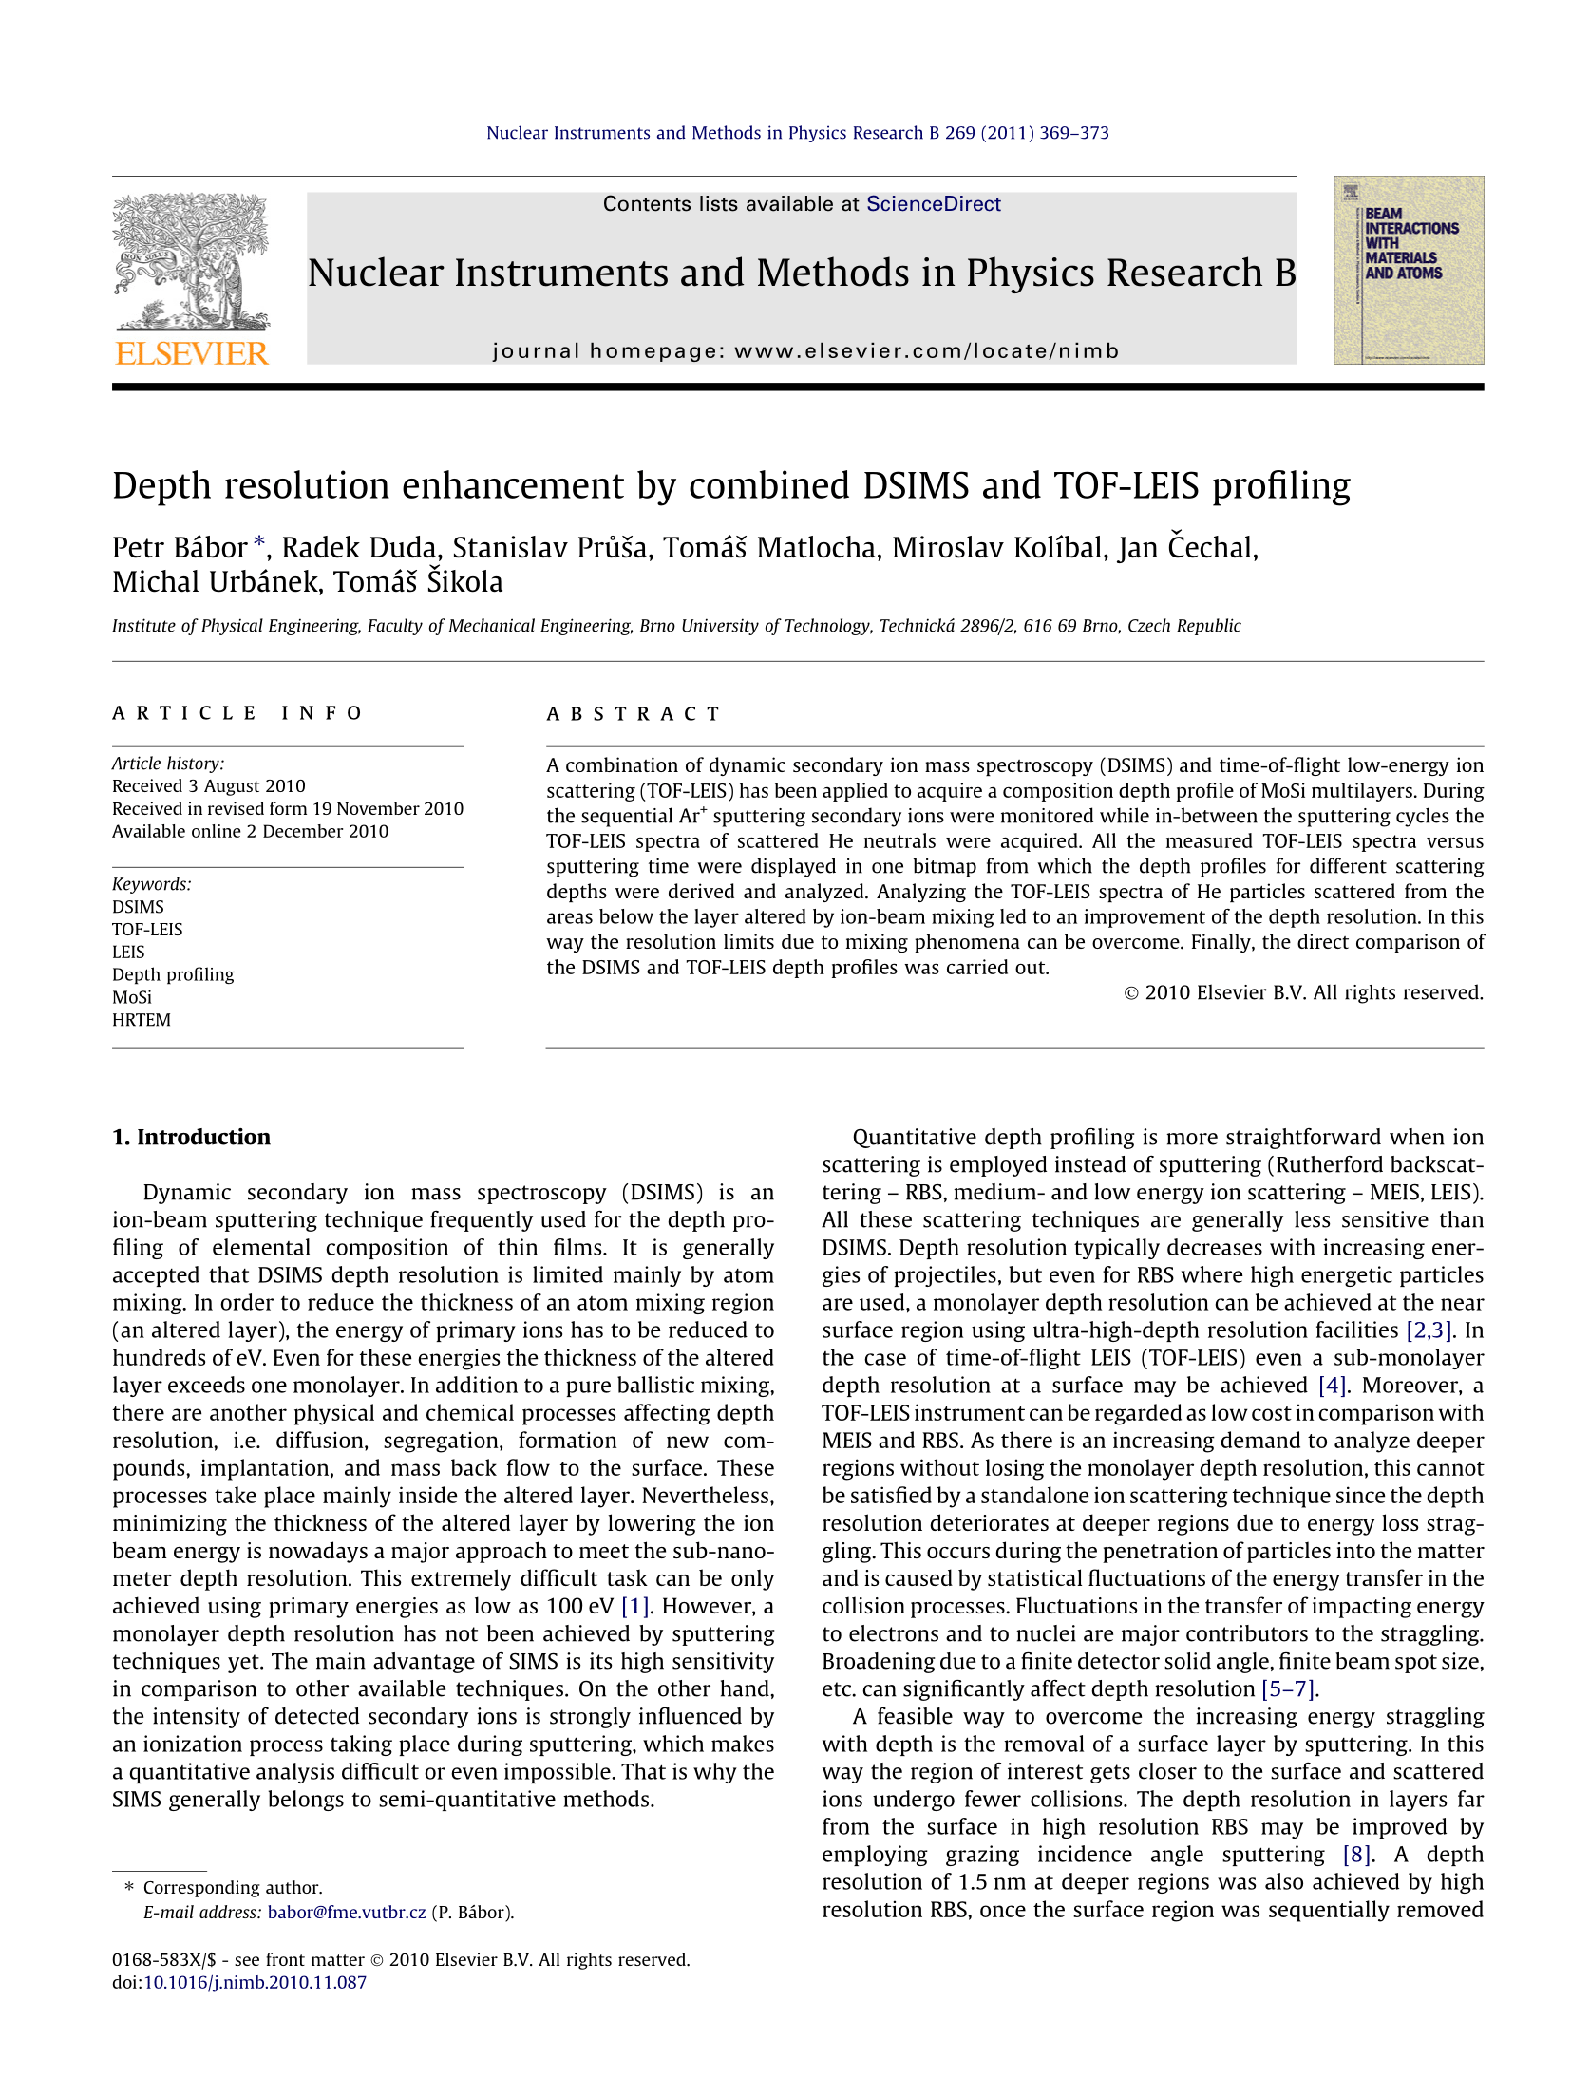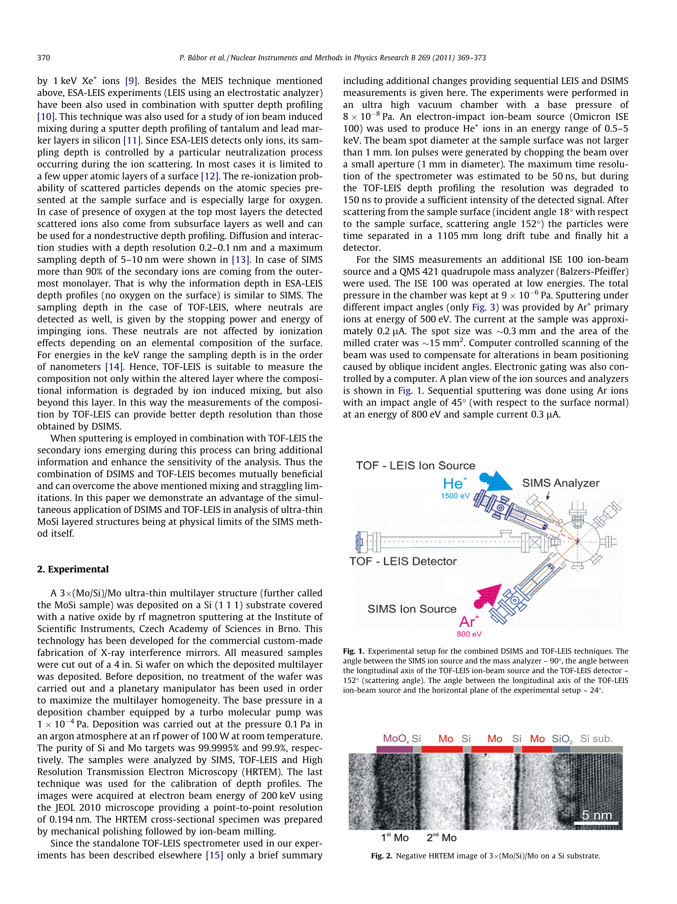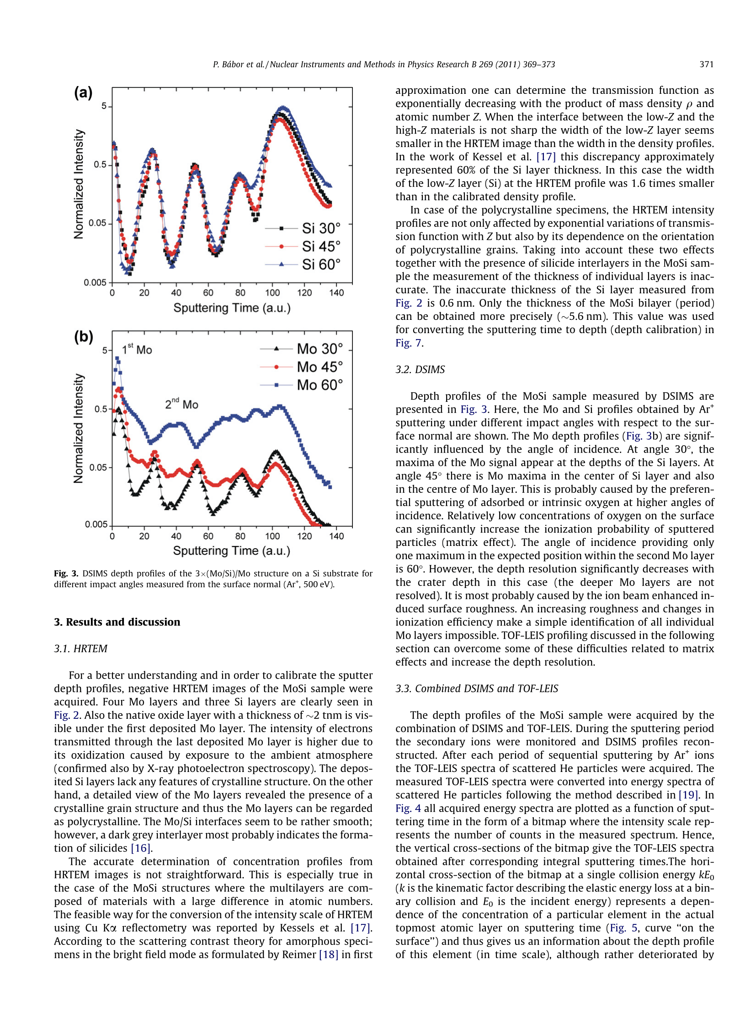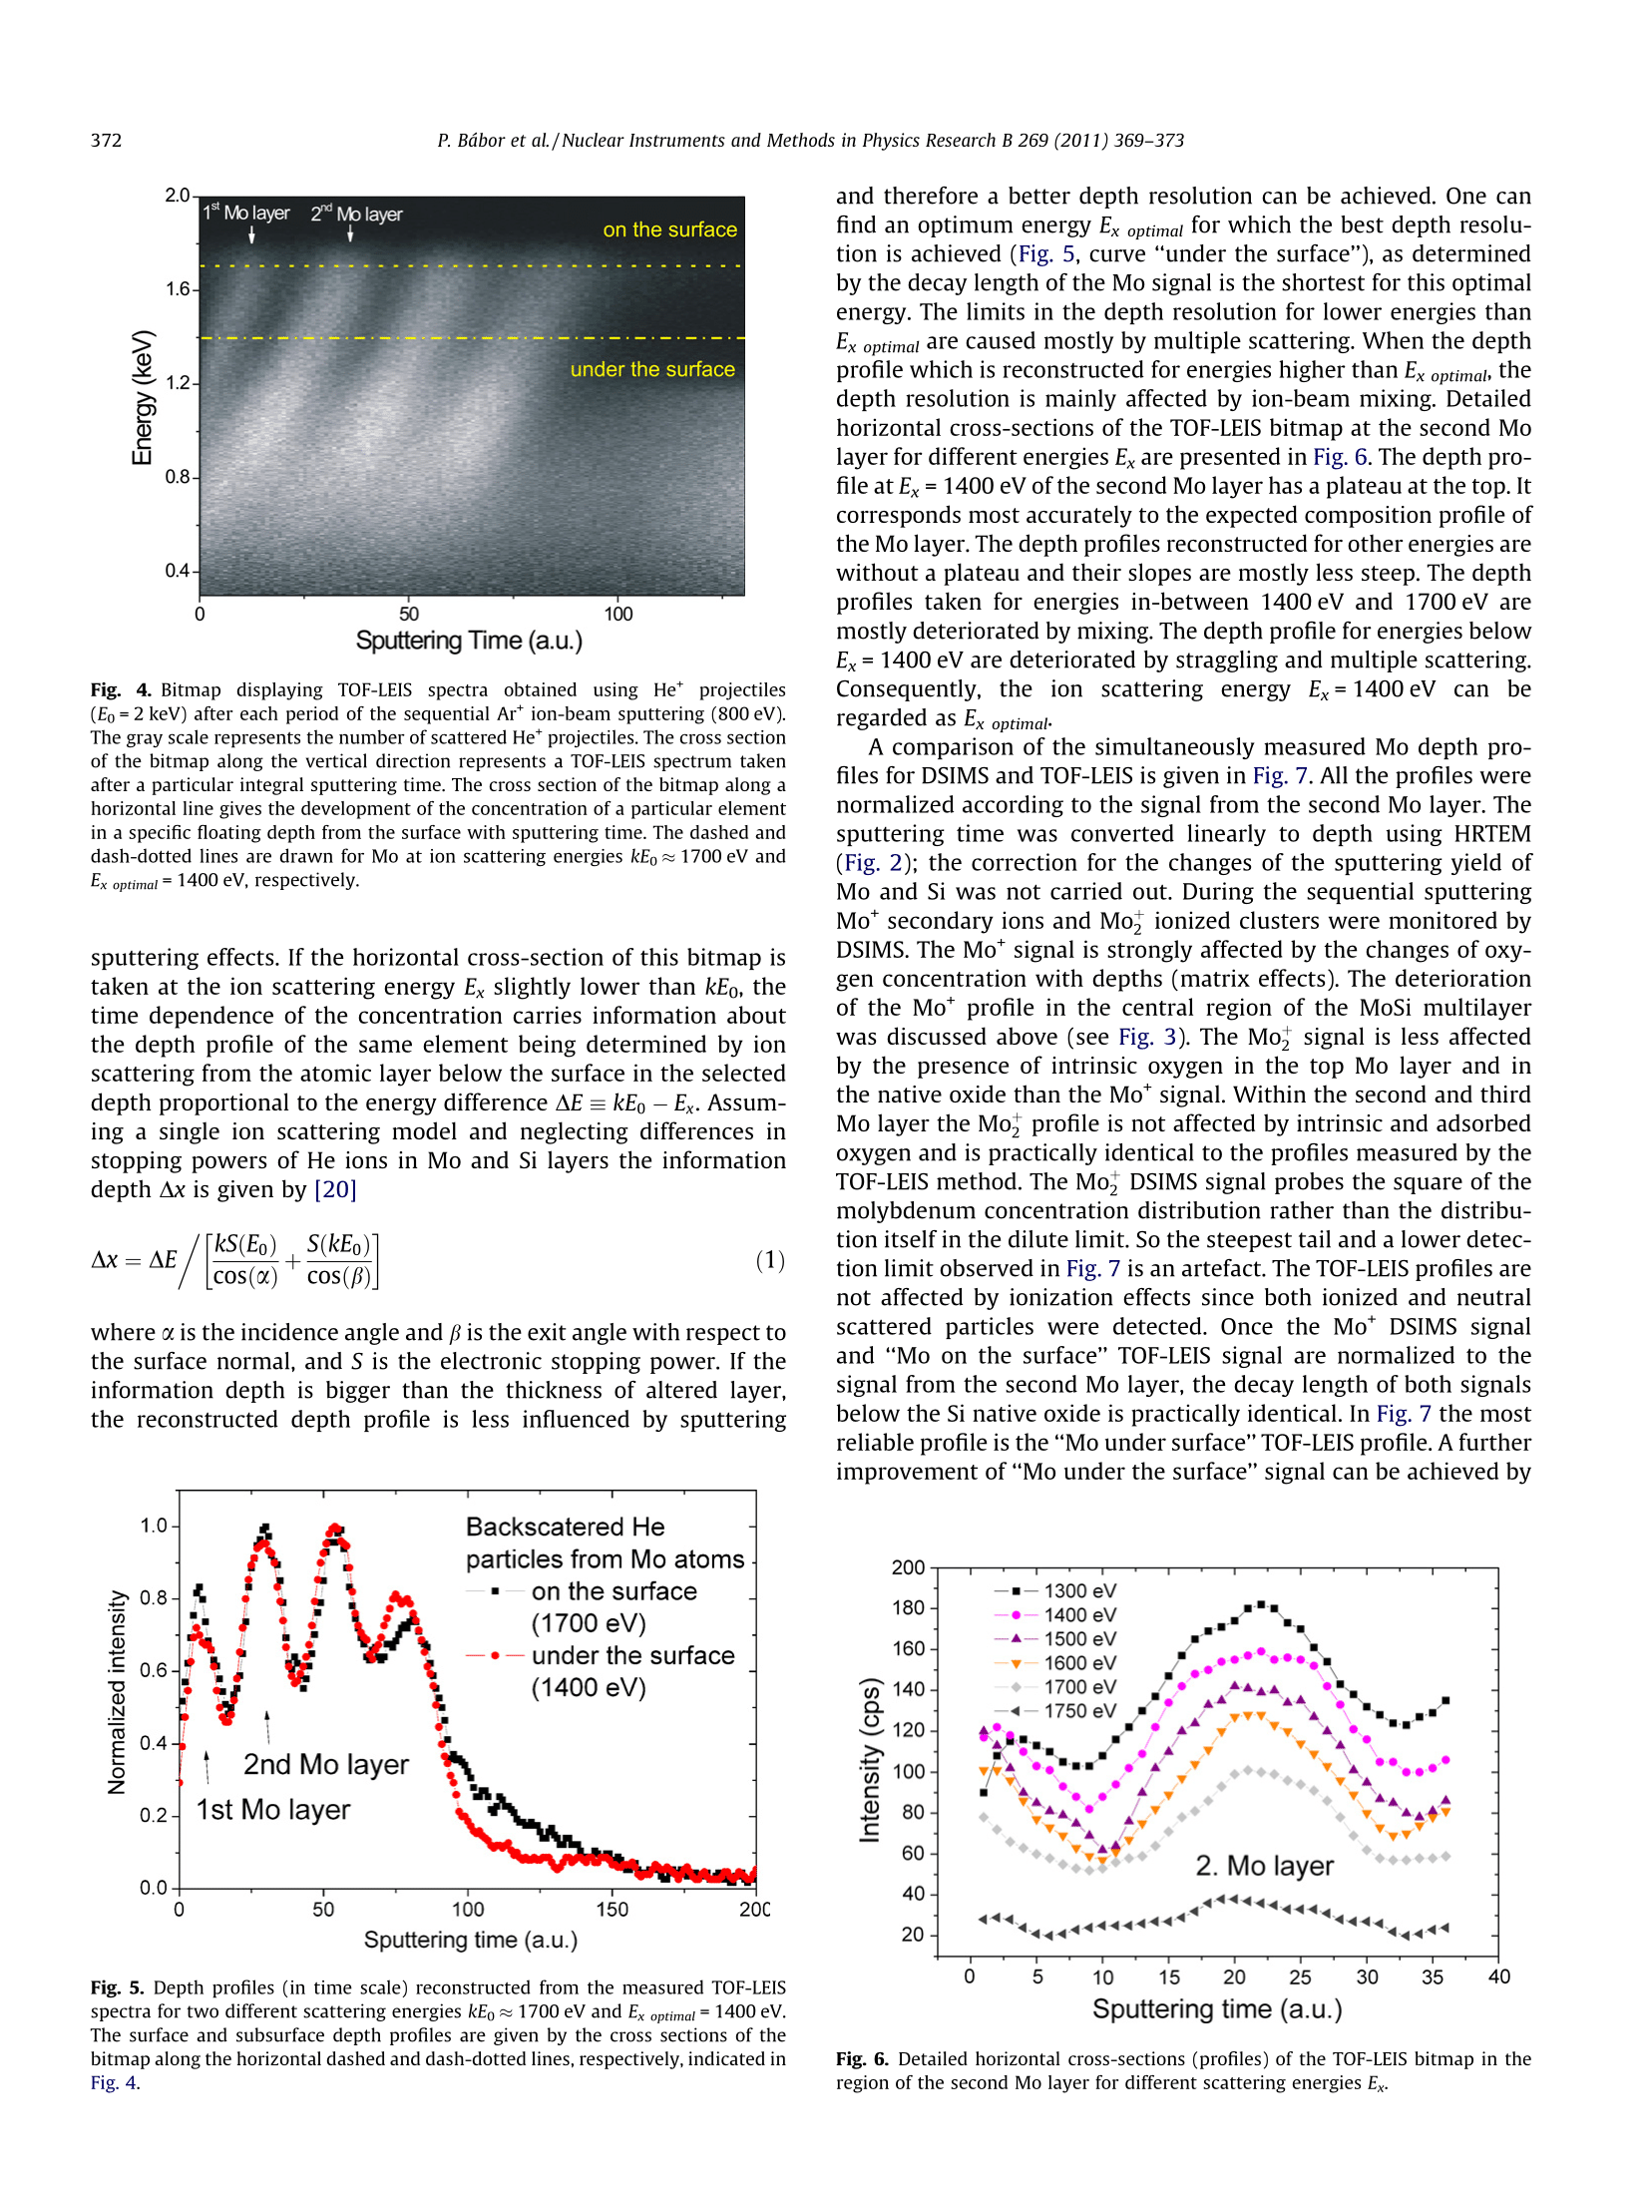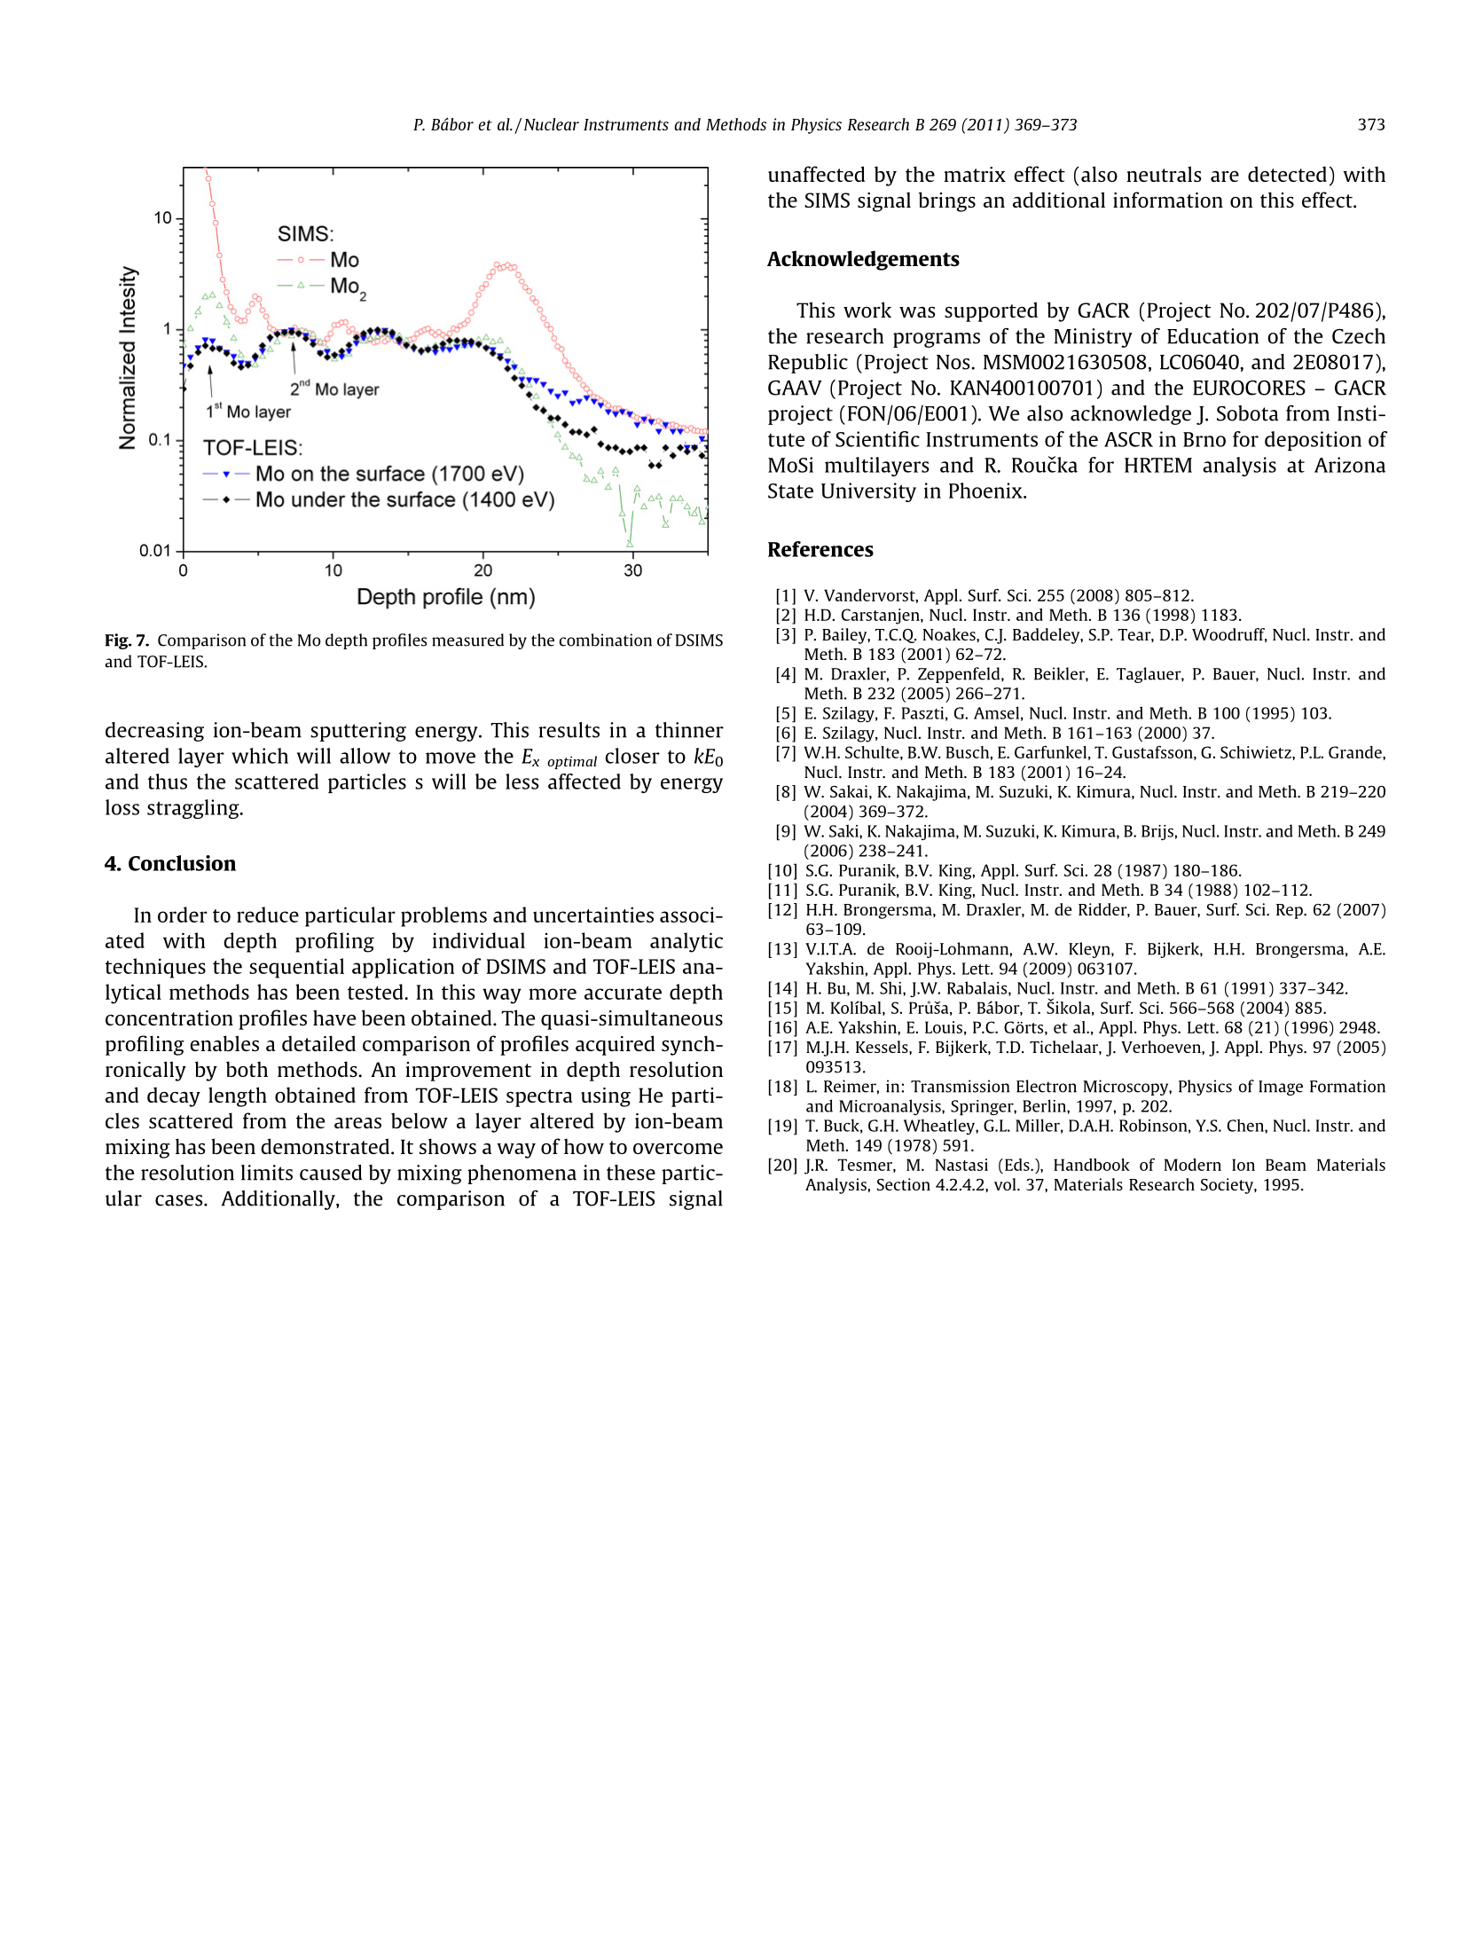

Commented paper 2

BER, B., P. BÁBOR, P.N. BRUNKOV, P. CHAPON, M.N. DROZDOV, R. DUDA, D. KAZANTSEV, V.N. POLKOVNIKOV, P. YUNIN and A. TOLSTOGOUZOV. Sputter depth profiling of Mo/B4C/Si and Mo/Si multilayer nanostructures: A round-robin characterization by different techniques. Thin Solid Films [online]. 2013, 540, 96–105 [vid. 2014-06-06]. ISSN 00406090. Available at: doi:10.1016/j.tsf.2013.05.154
(IF = 2.0, Citations 20)

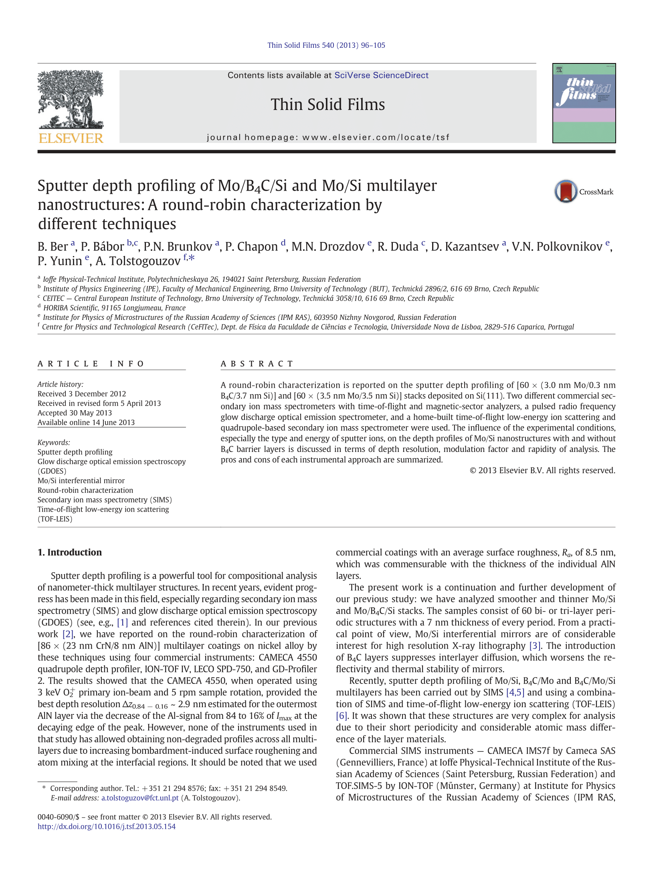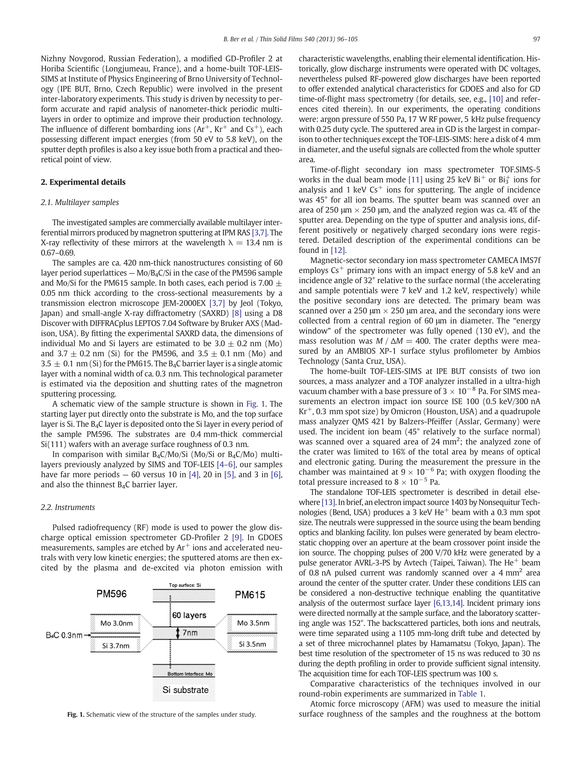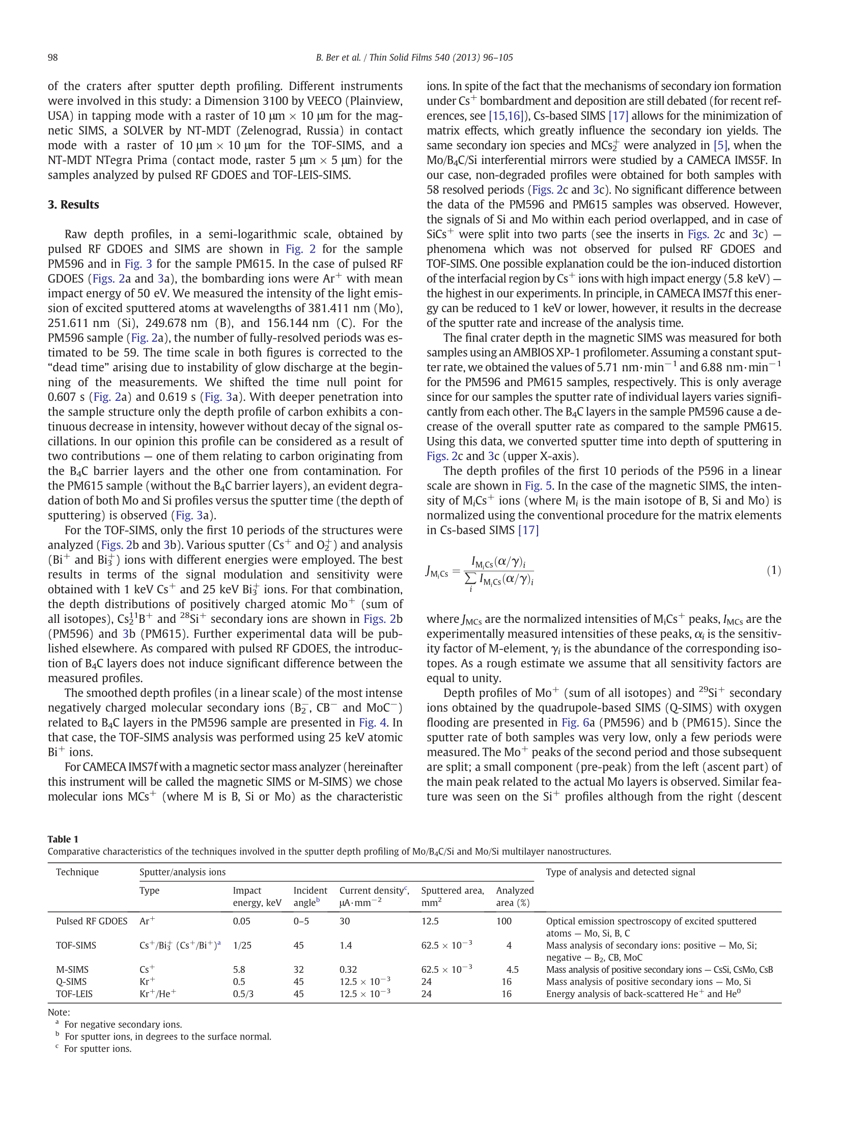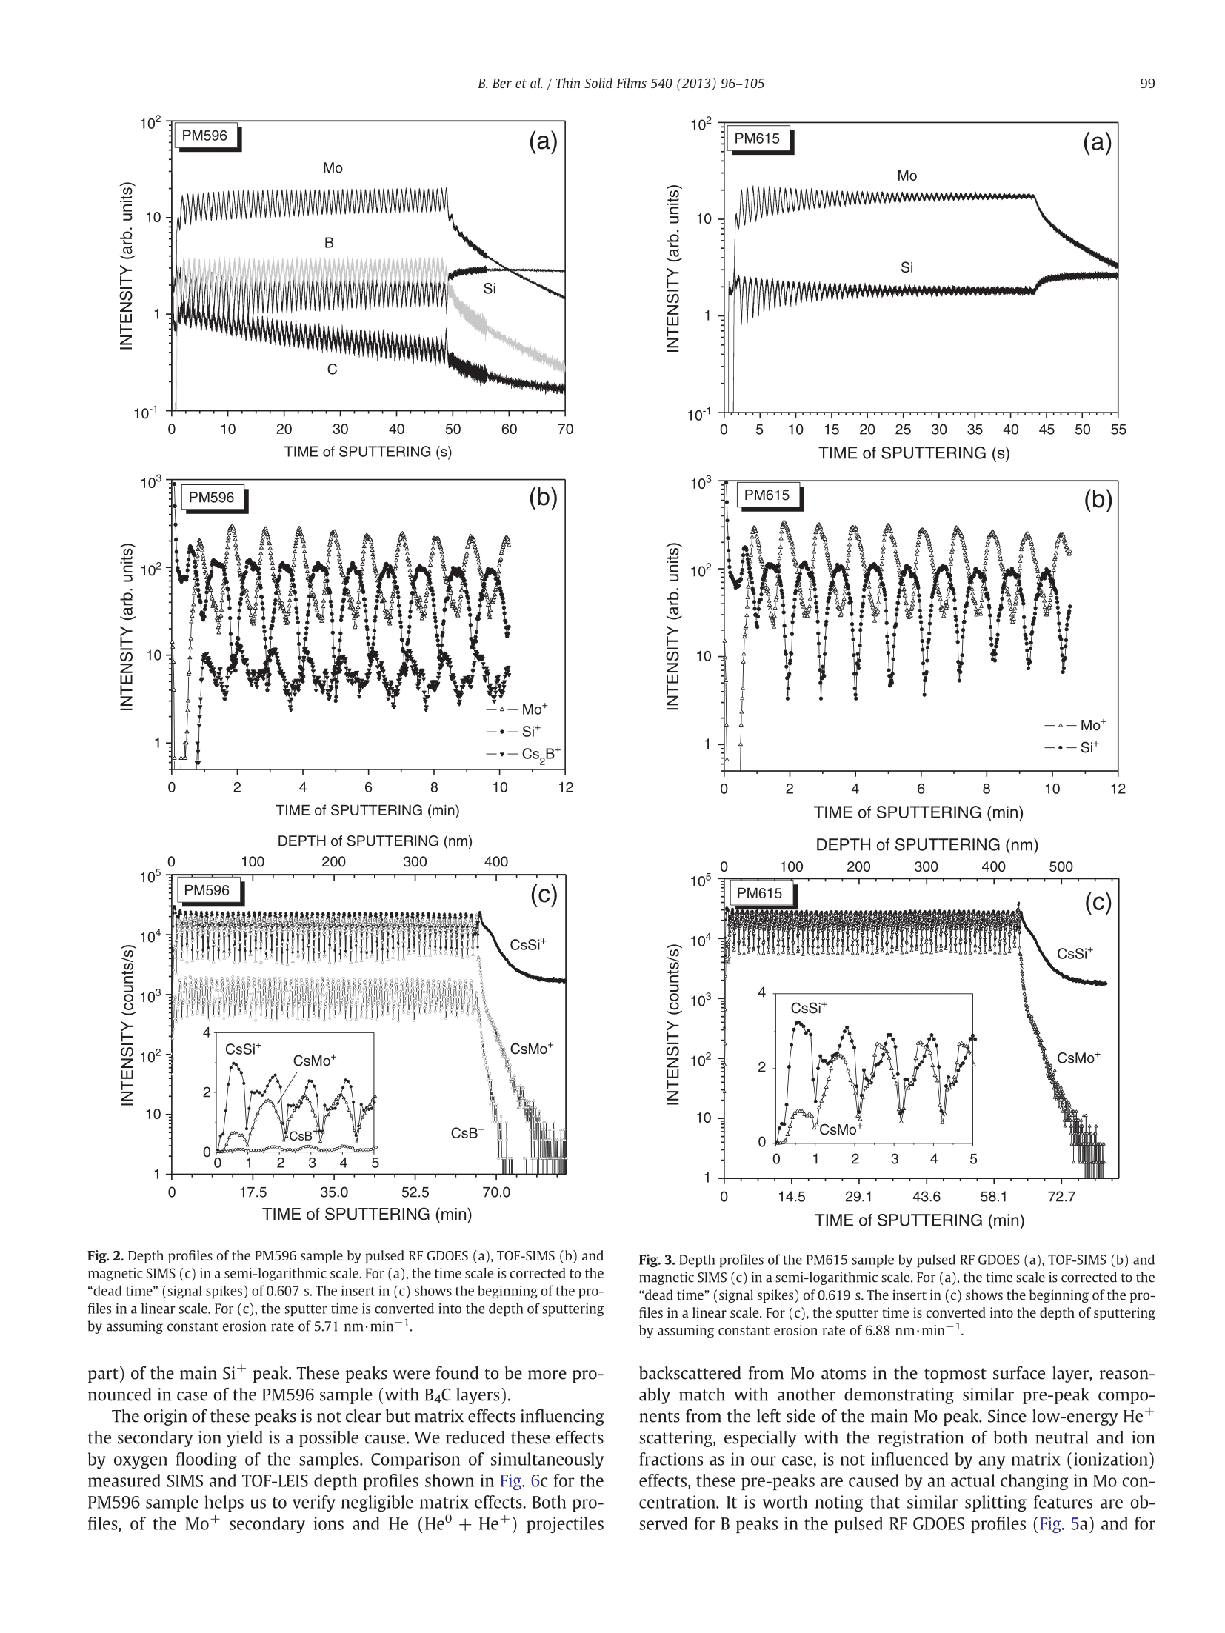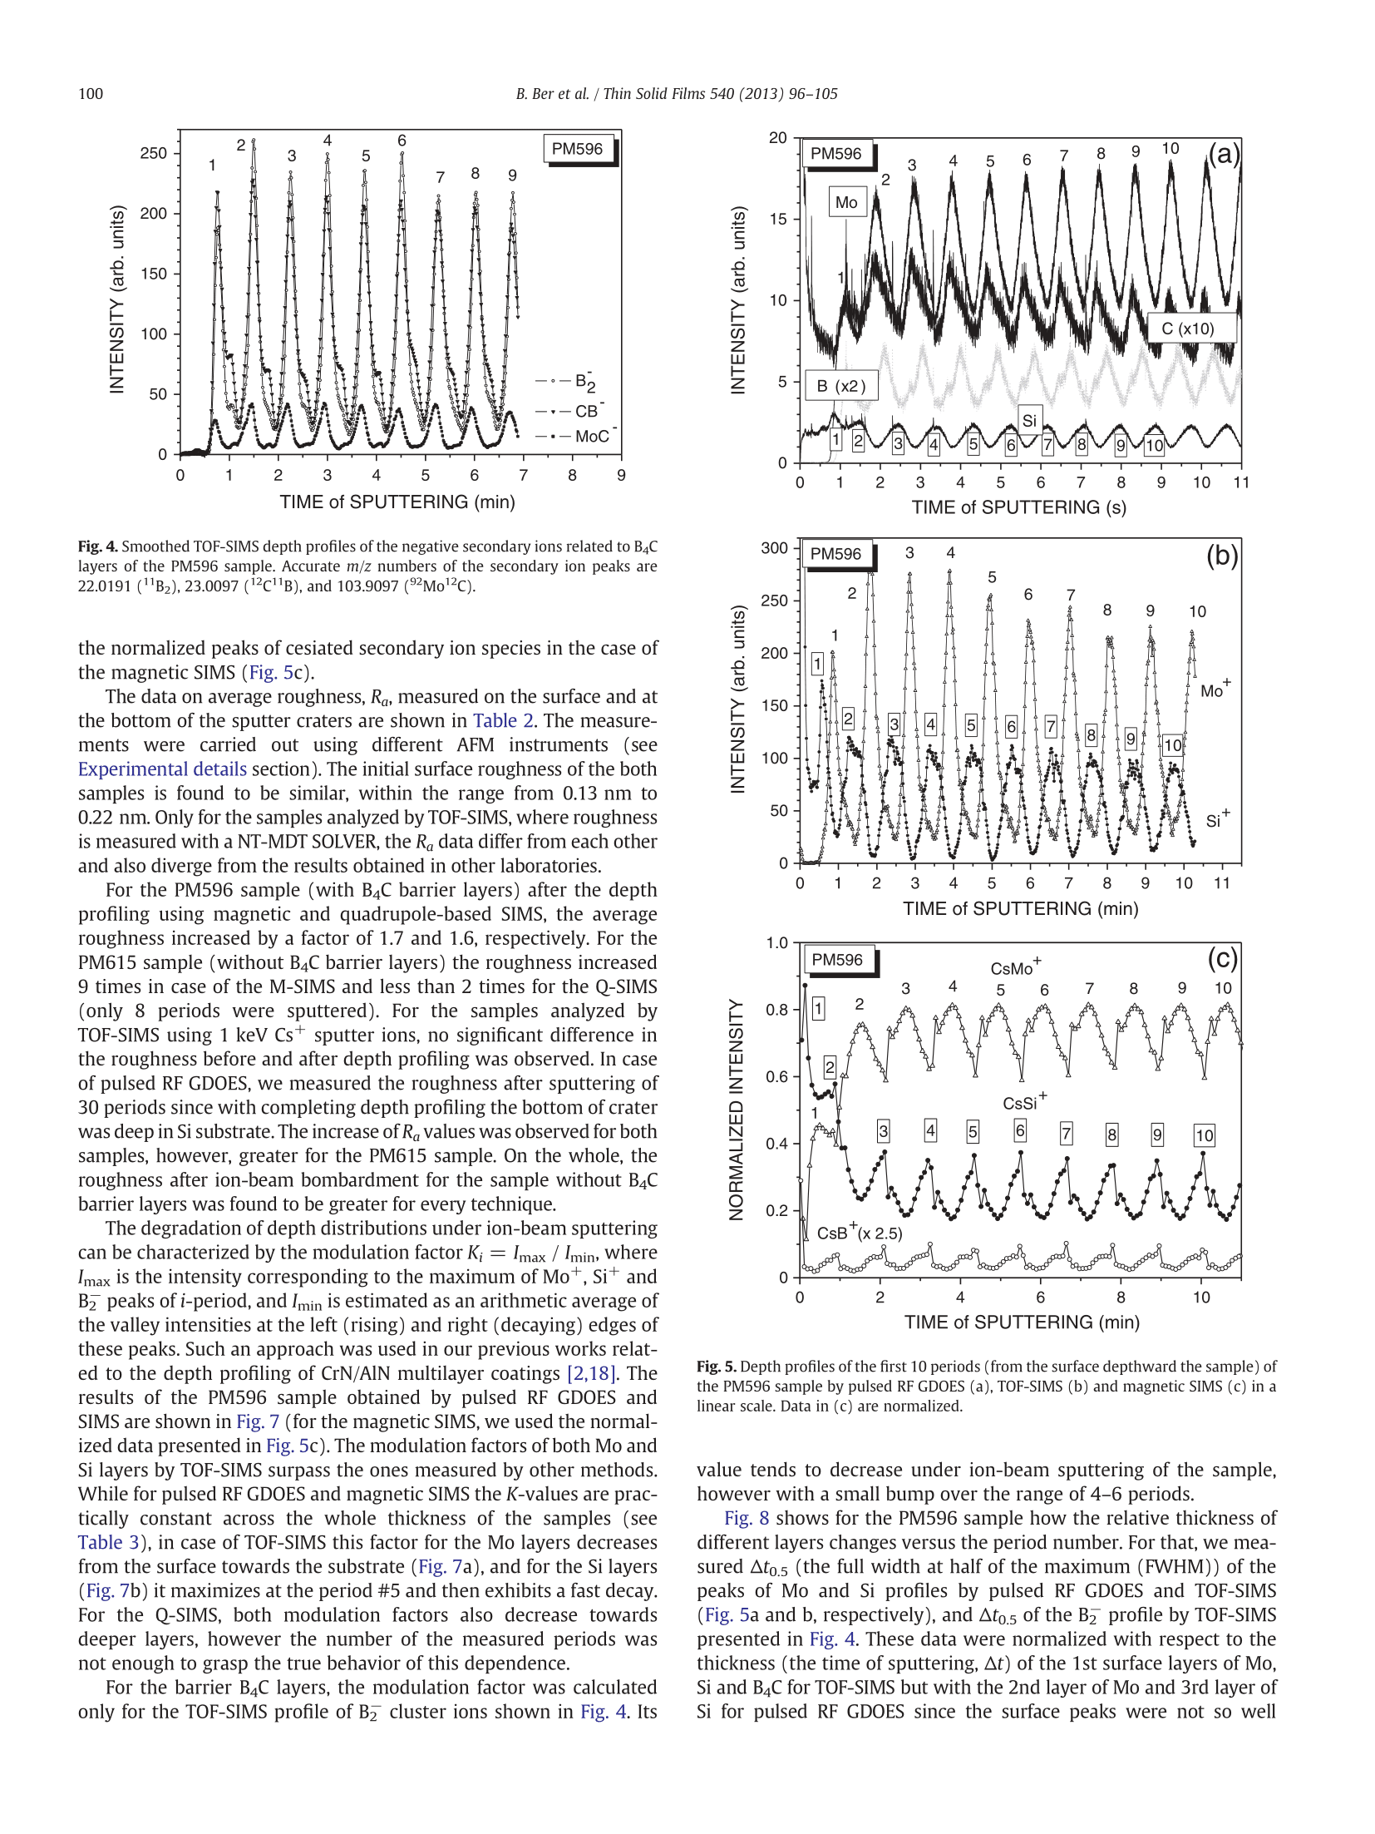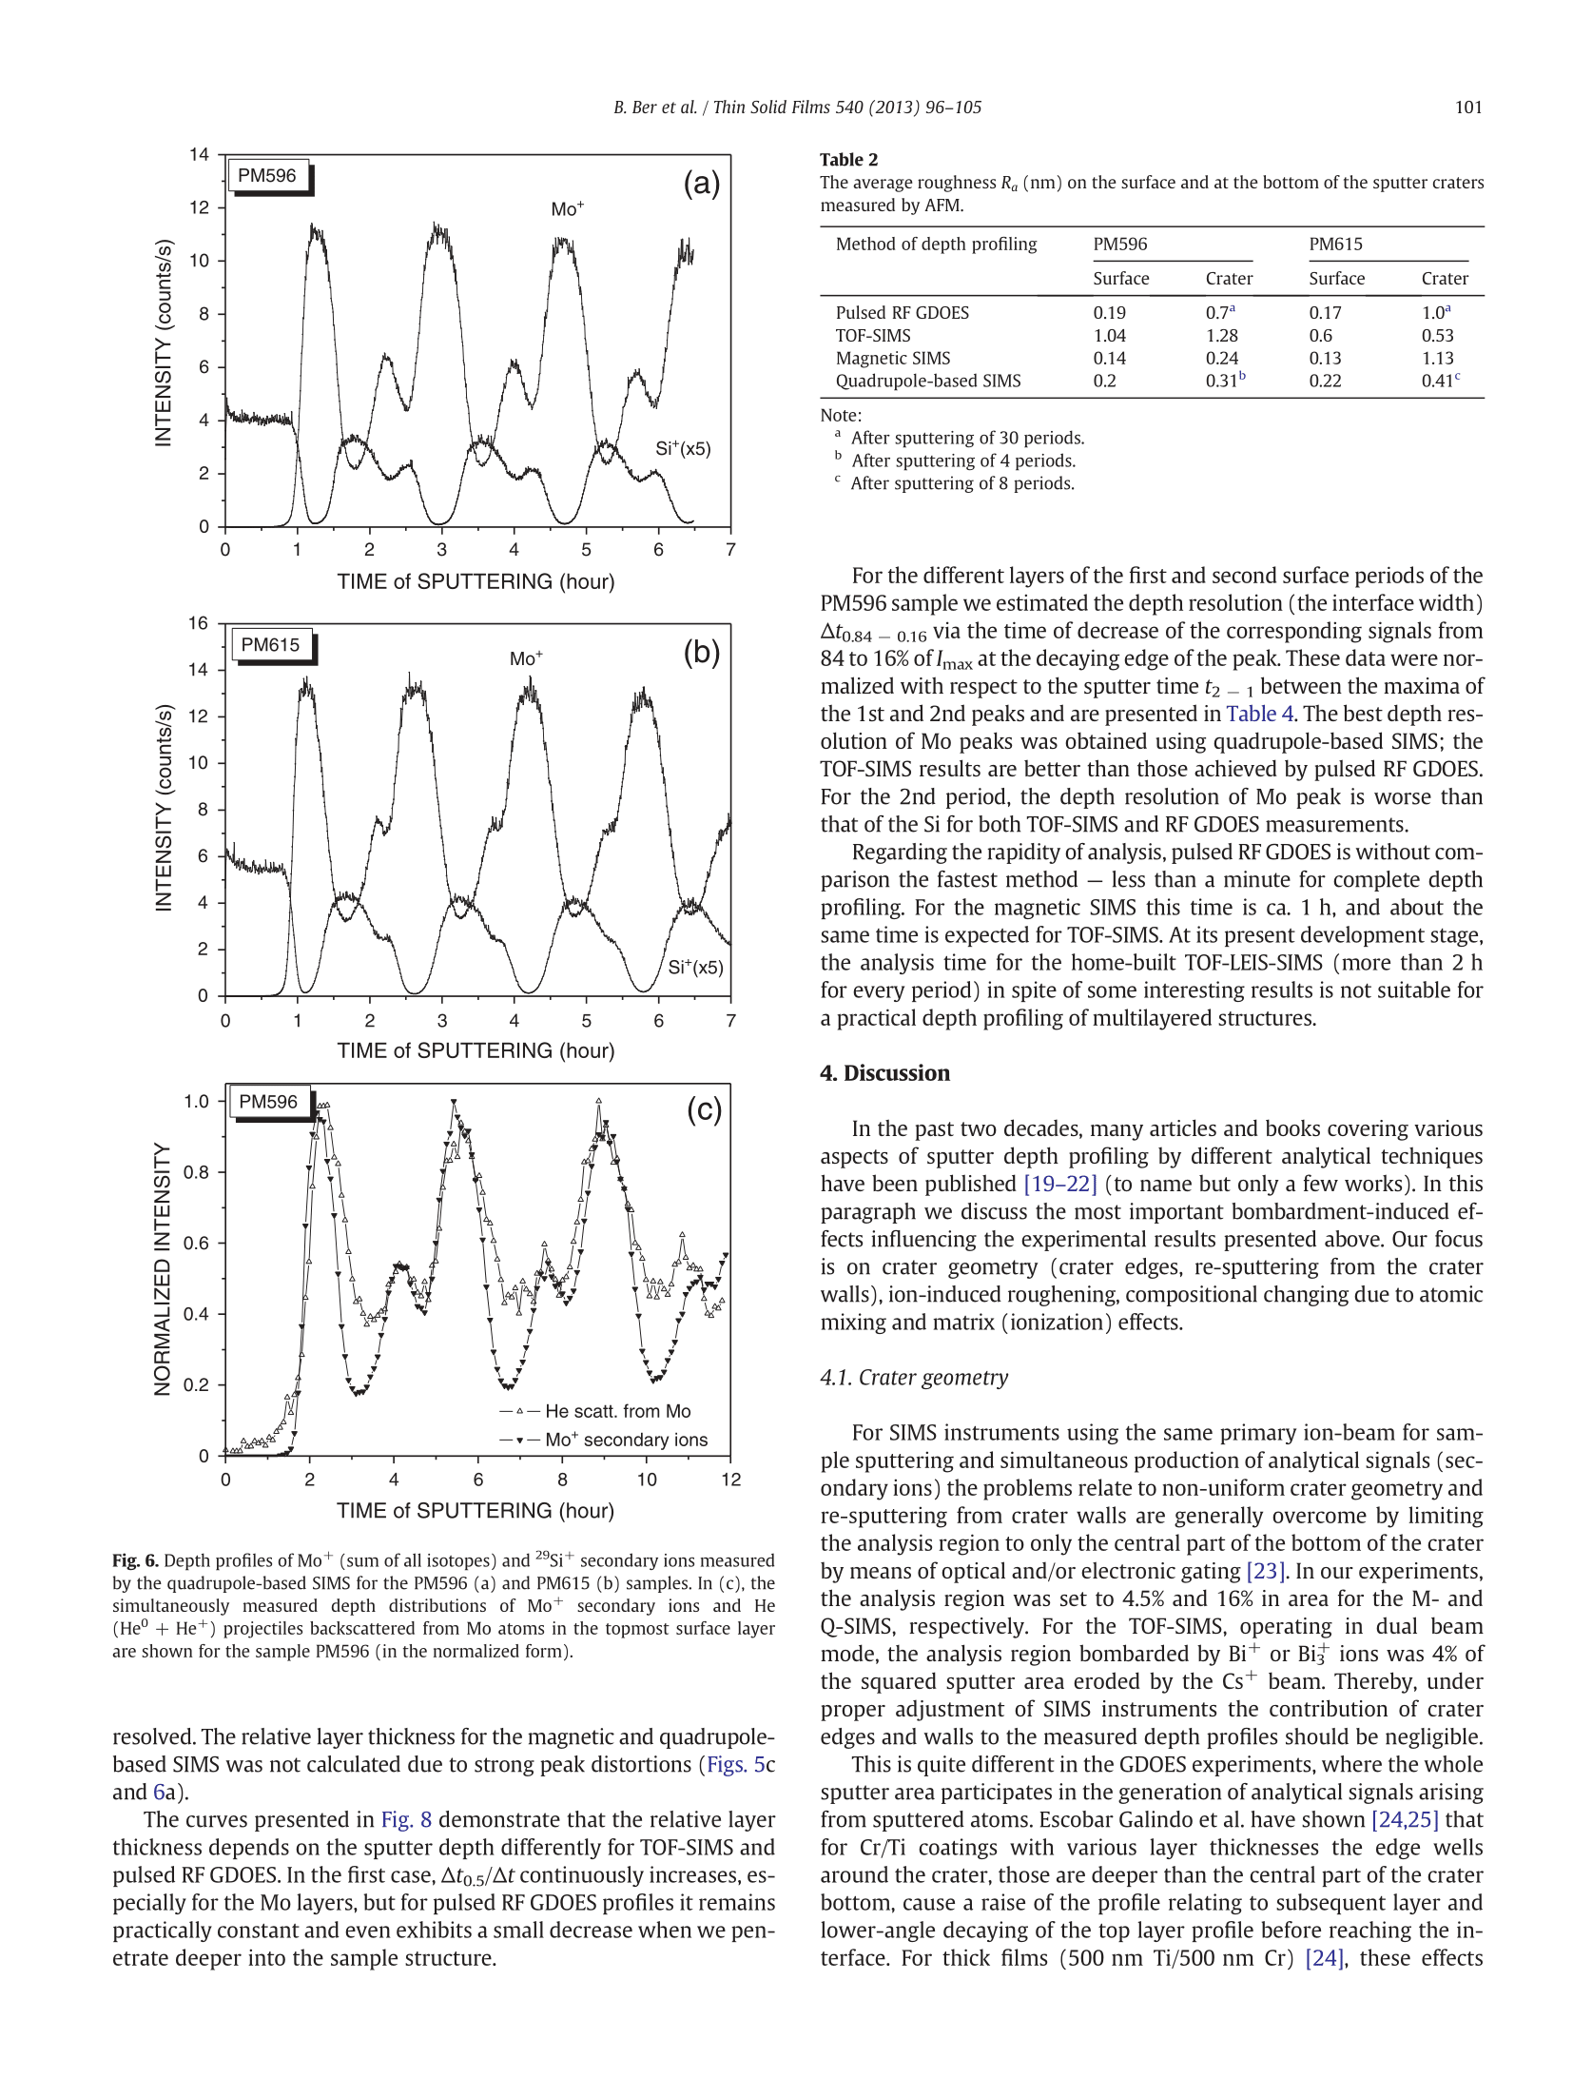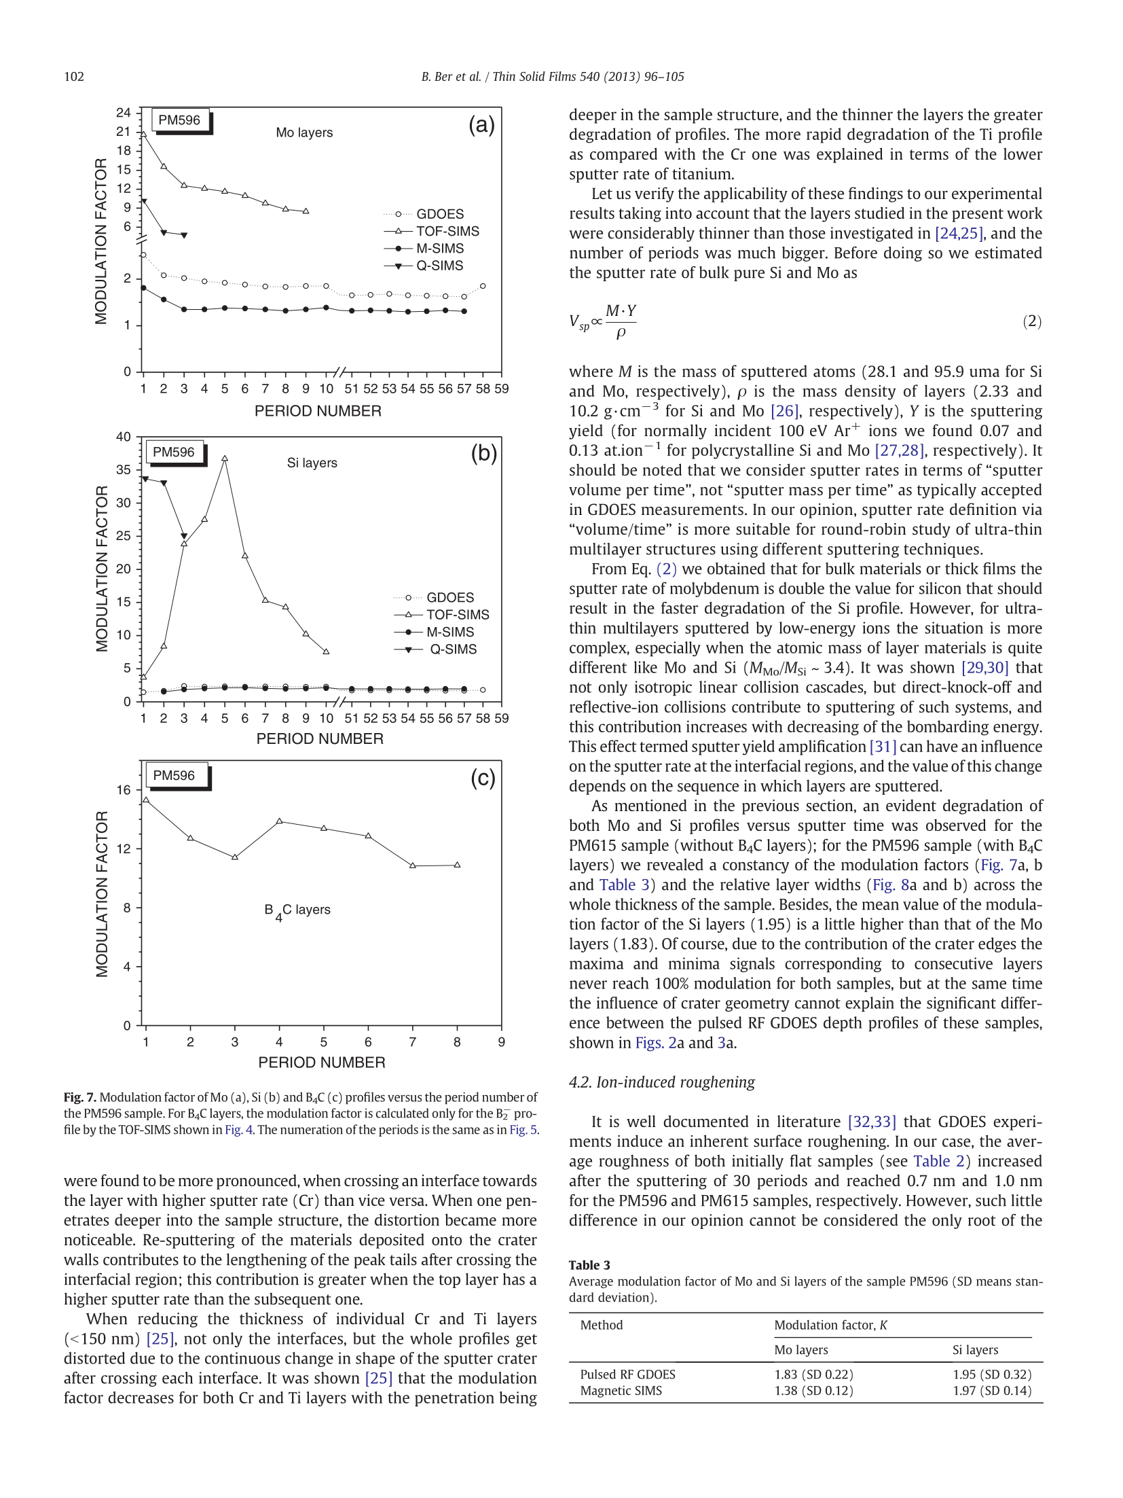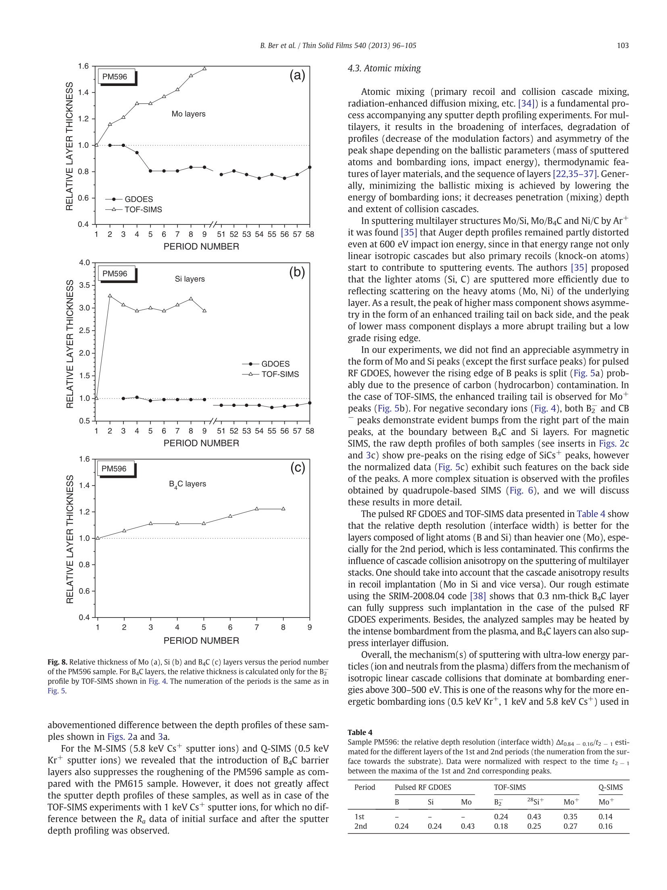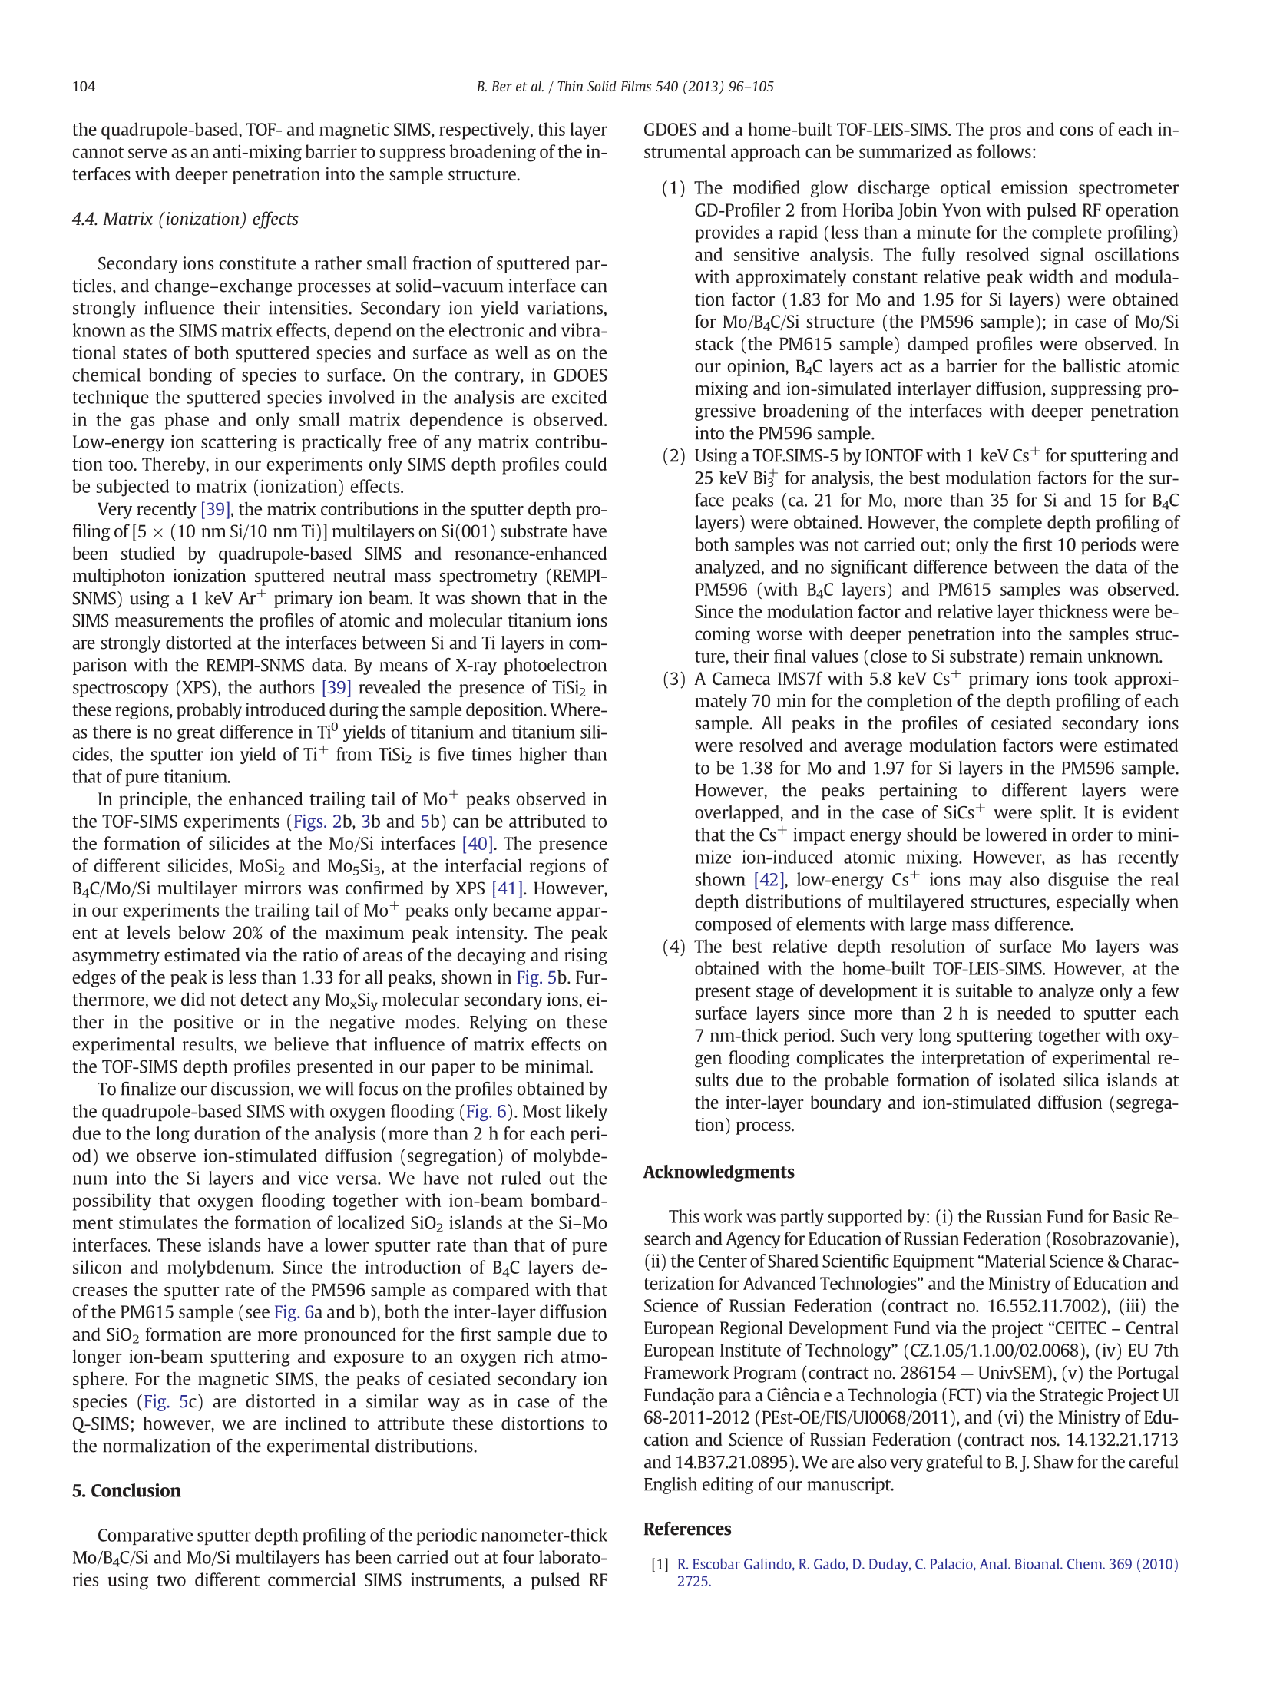

Commented paper 3

STEVIE, F.A., L. SEDLÁČEK, P. BÁBOR, J. JIRUŠE, E. PRINCIPE and K. KLOSOVÁ. FIB-SIMS Quantification using TOF-SIMS with Ar and Xe plasma sources. Surface and Interface Analysis [online]. 2014, 46(S1). ISSN 10969918. Available at: doi:10.1002/sia.5483

(IF = 1.6, Citations 8)

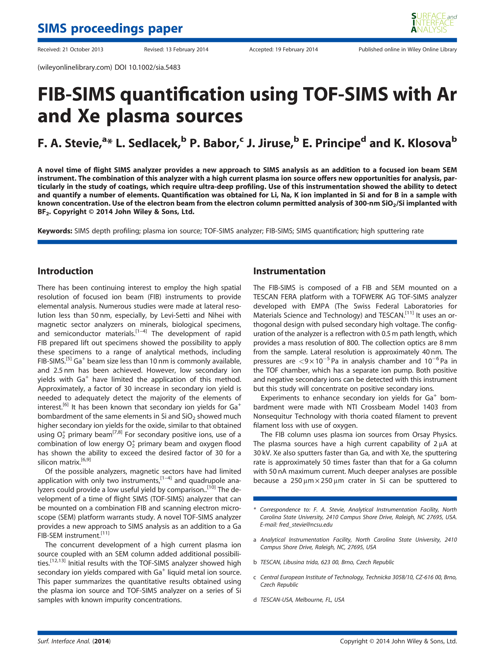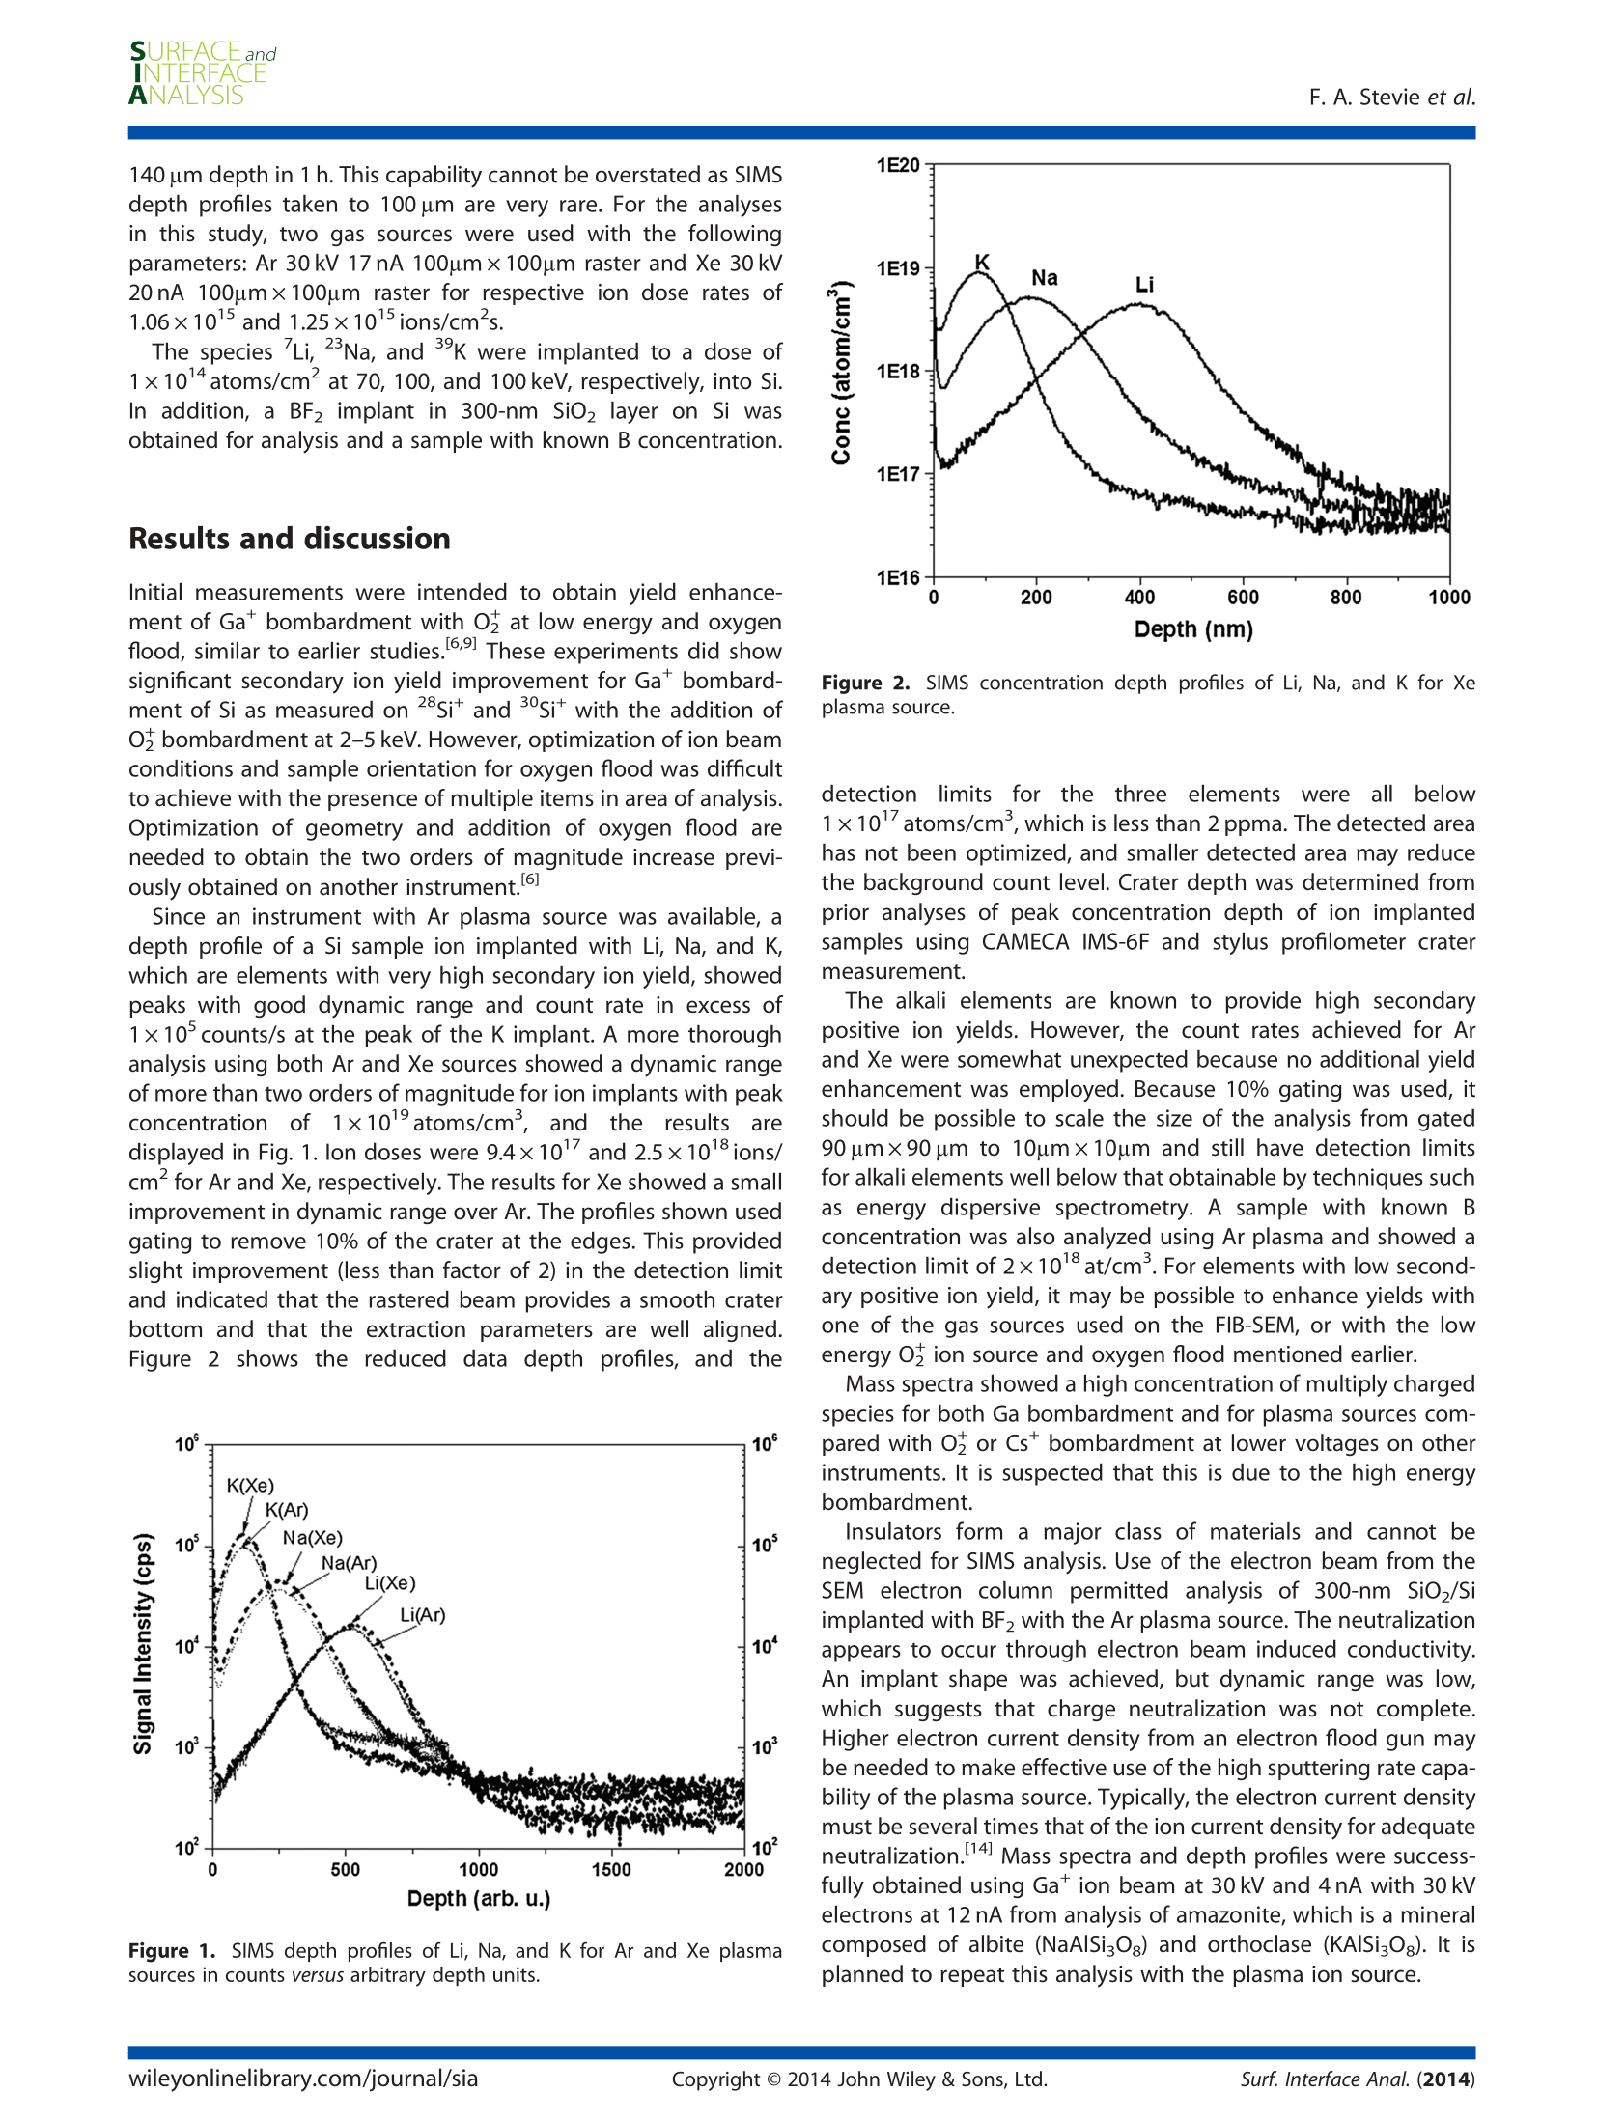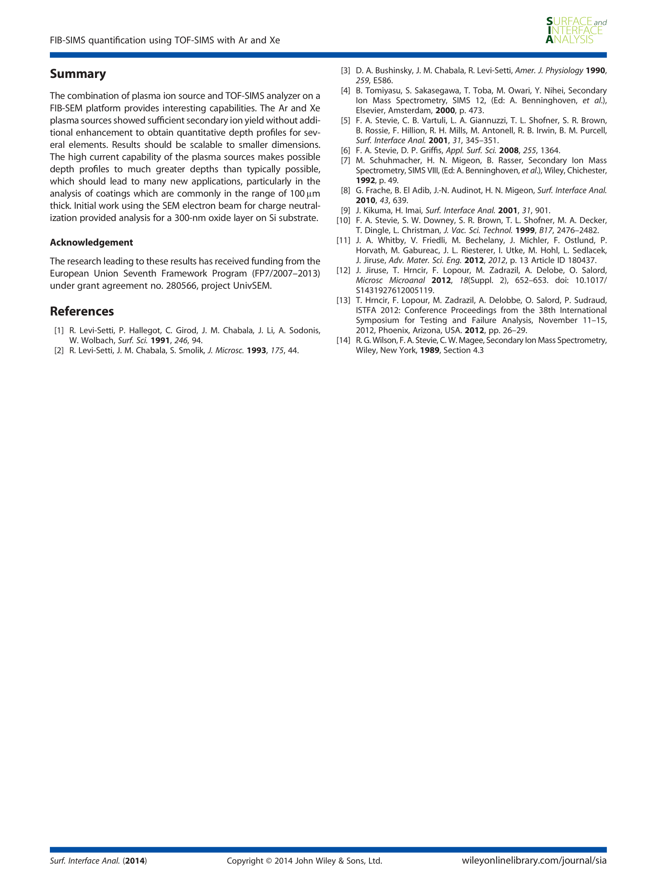

Commented paper 4

KUNC, J., M. REJHON, V. DĚDIČ and P. BÁBOR. Thickness of sublimation grown SiC layers measured by scanning Raman spectroscopy. Journal of Alloys and Compounds [online]. 2019, 789. ISSN 09258388. Available at: doi:10.1016/j.jallcom.2019.02.305

¨
(IF = 4.6, Citations 2)

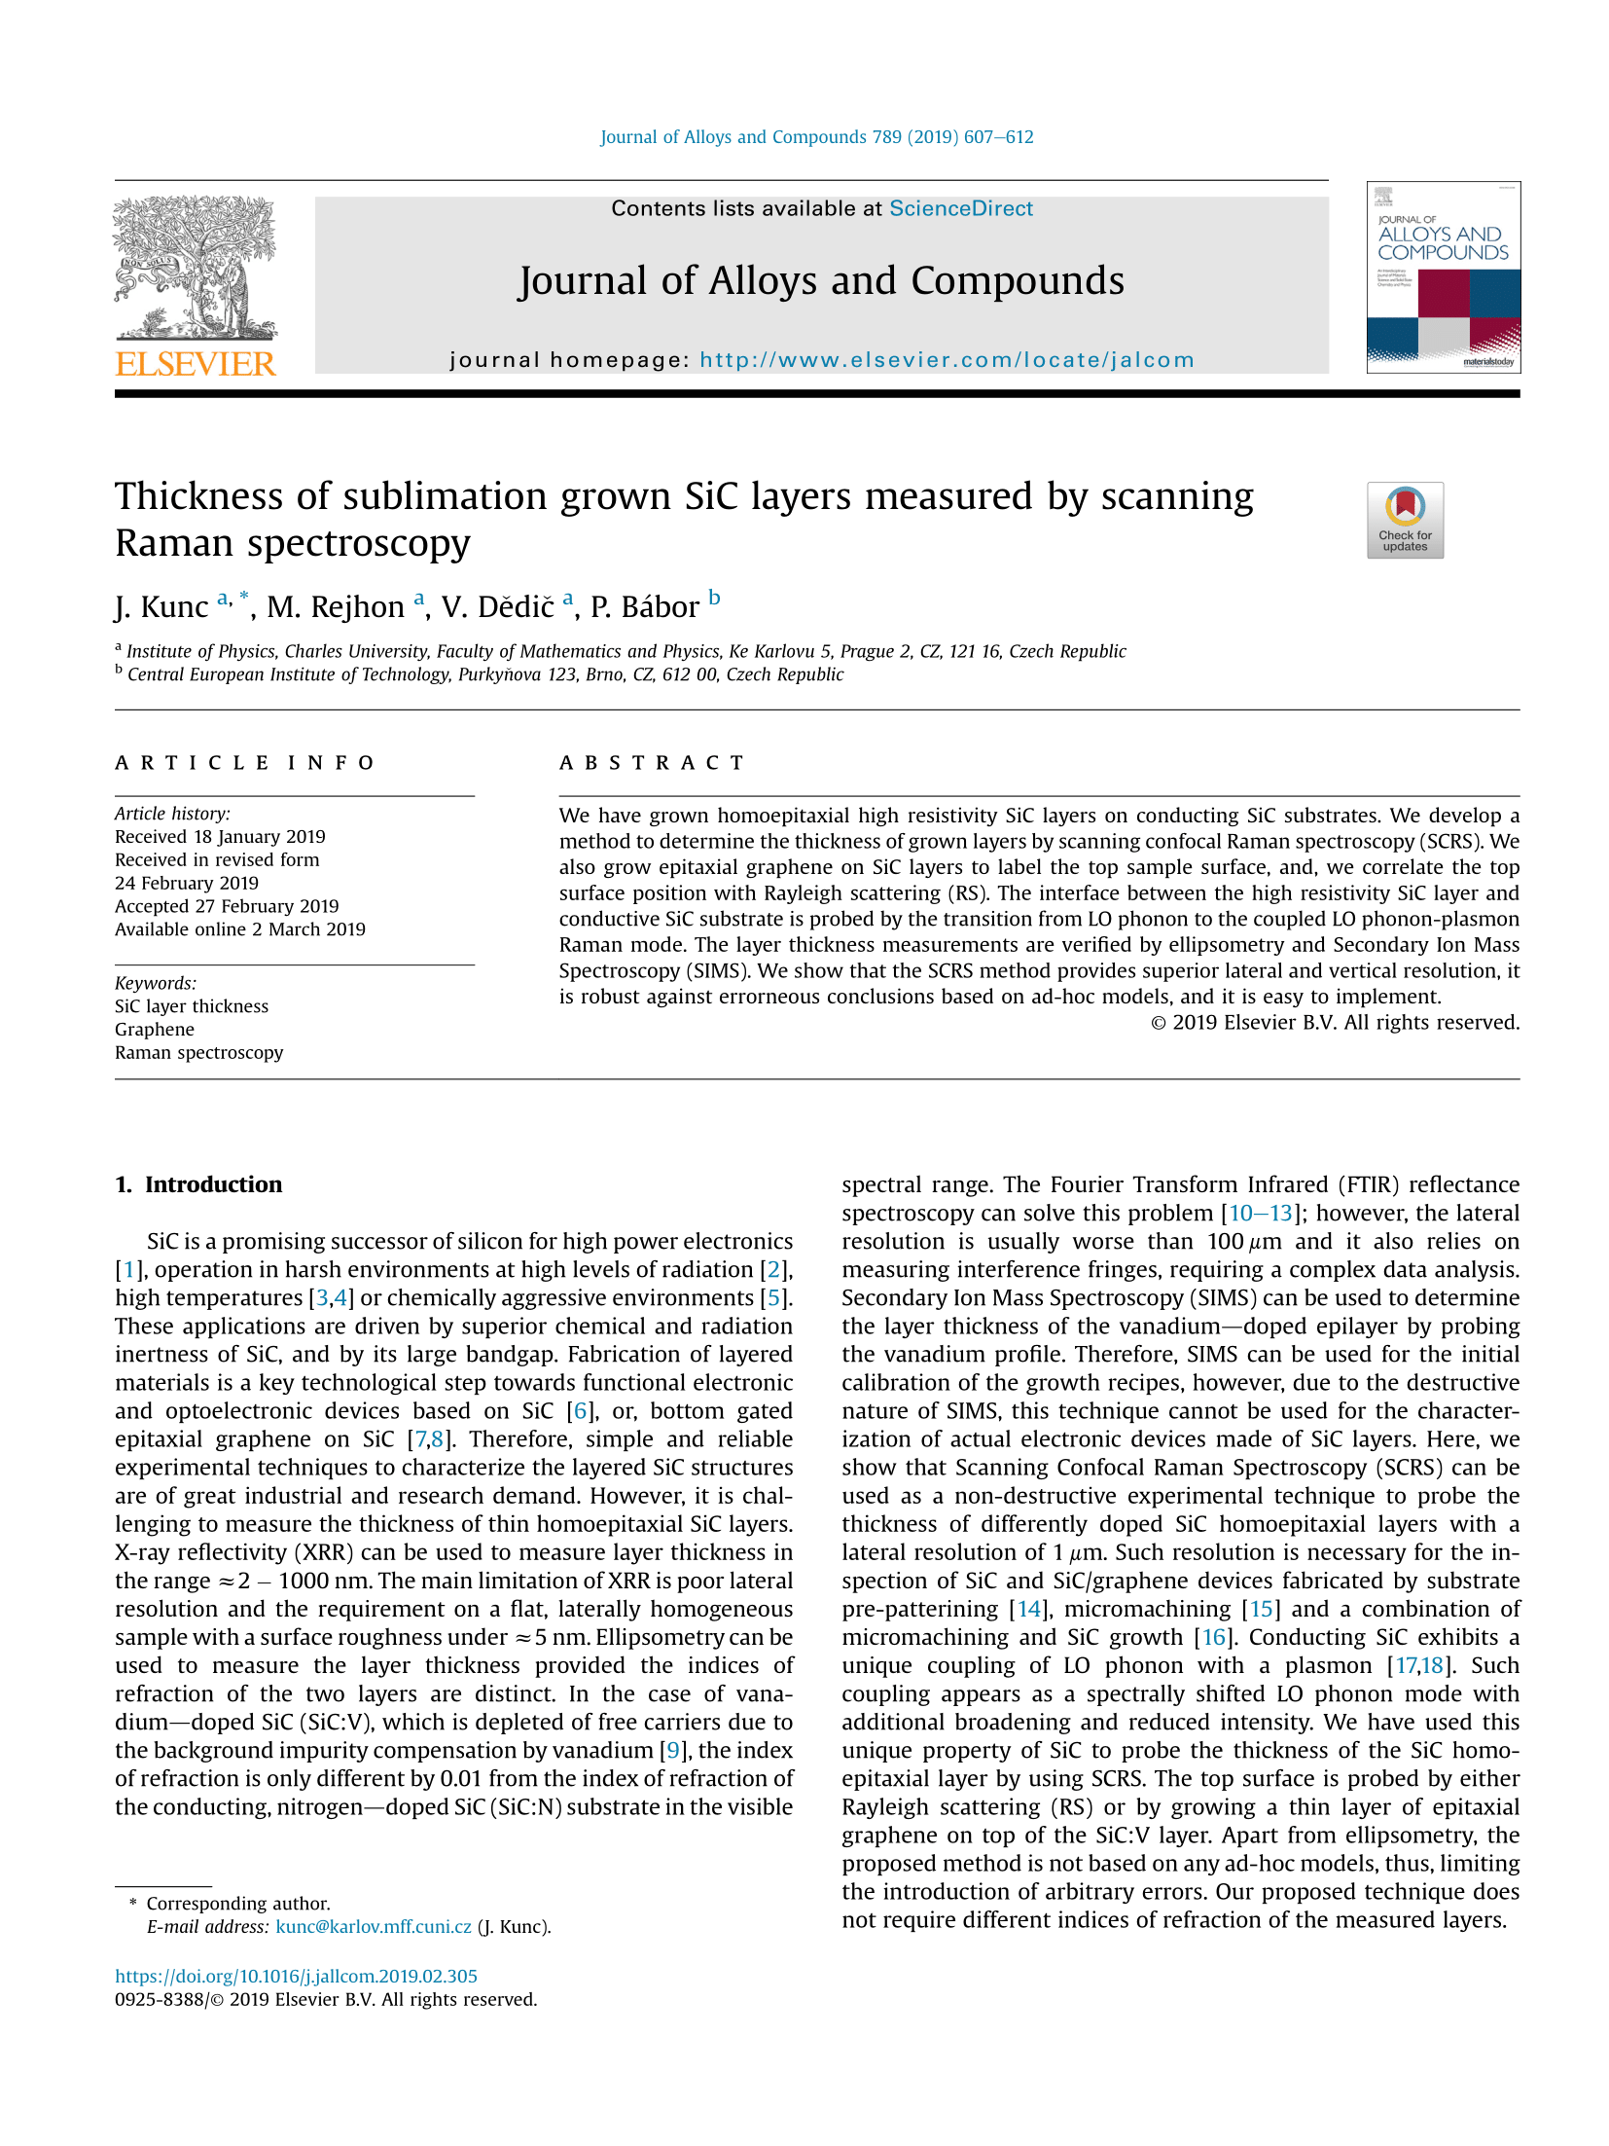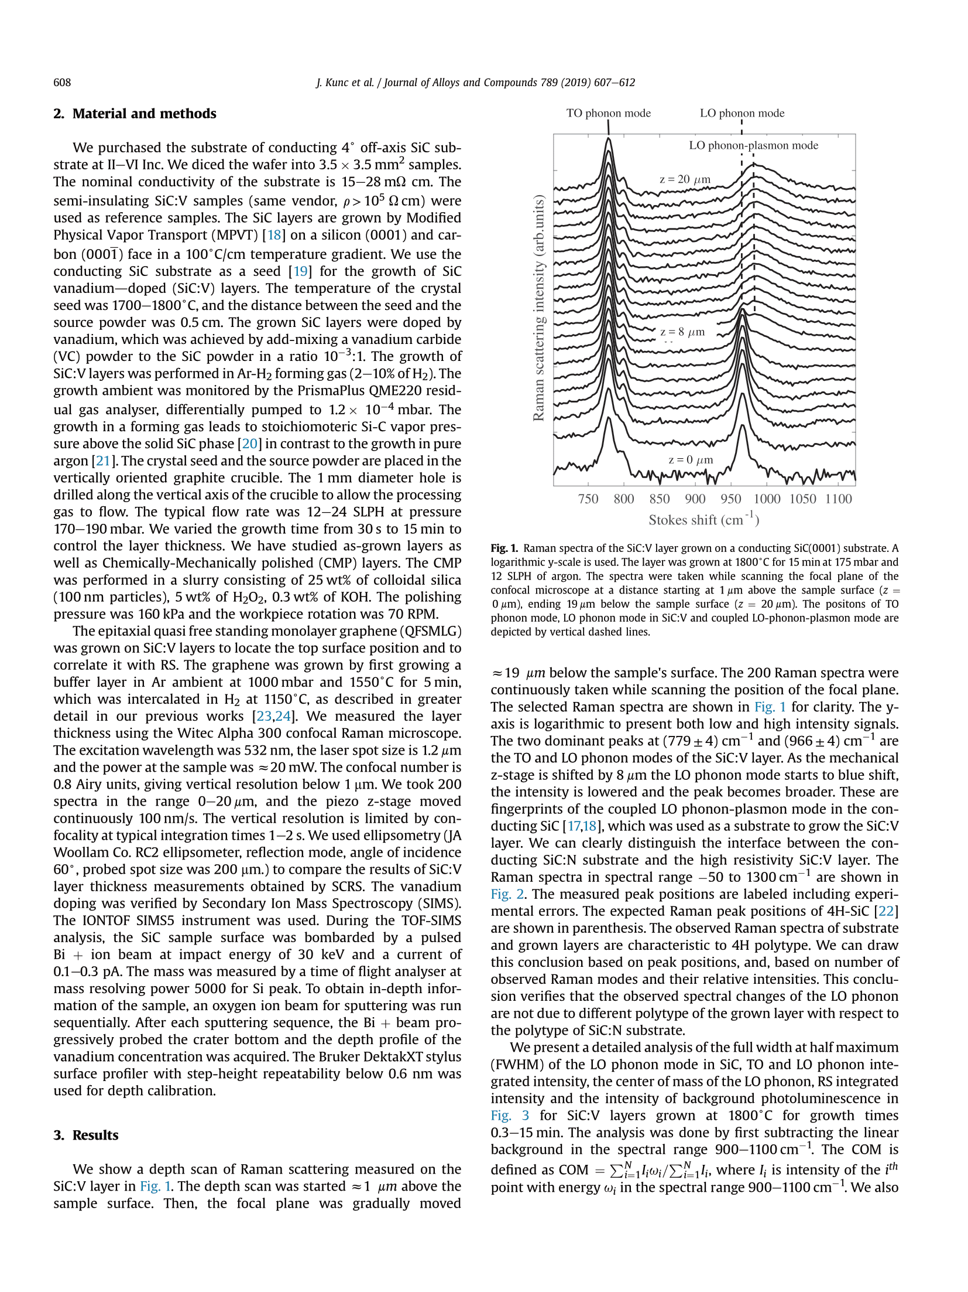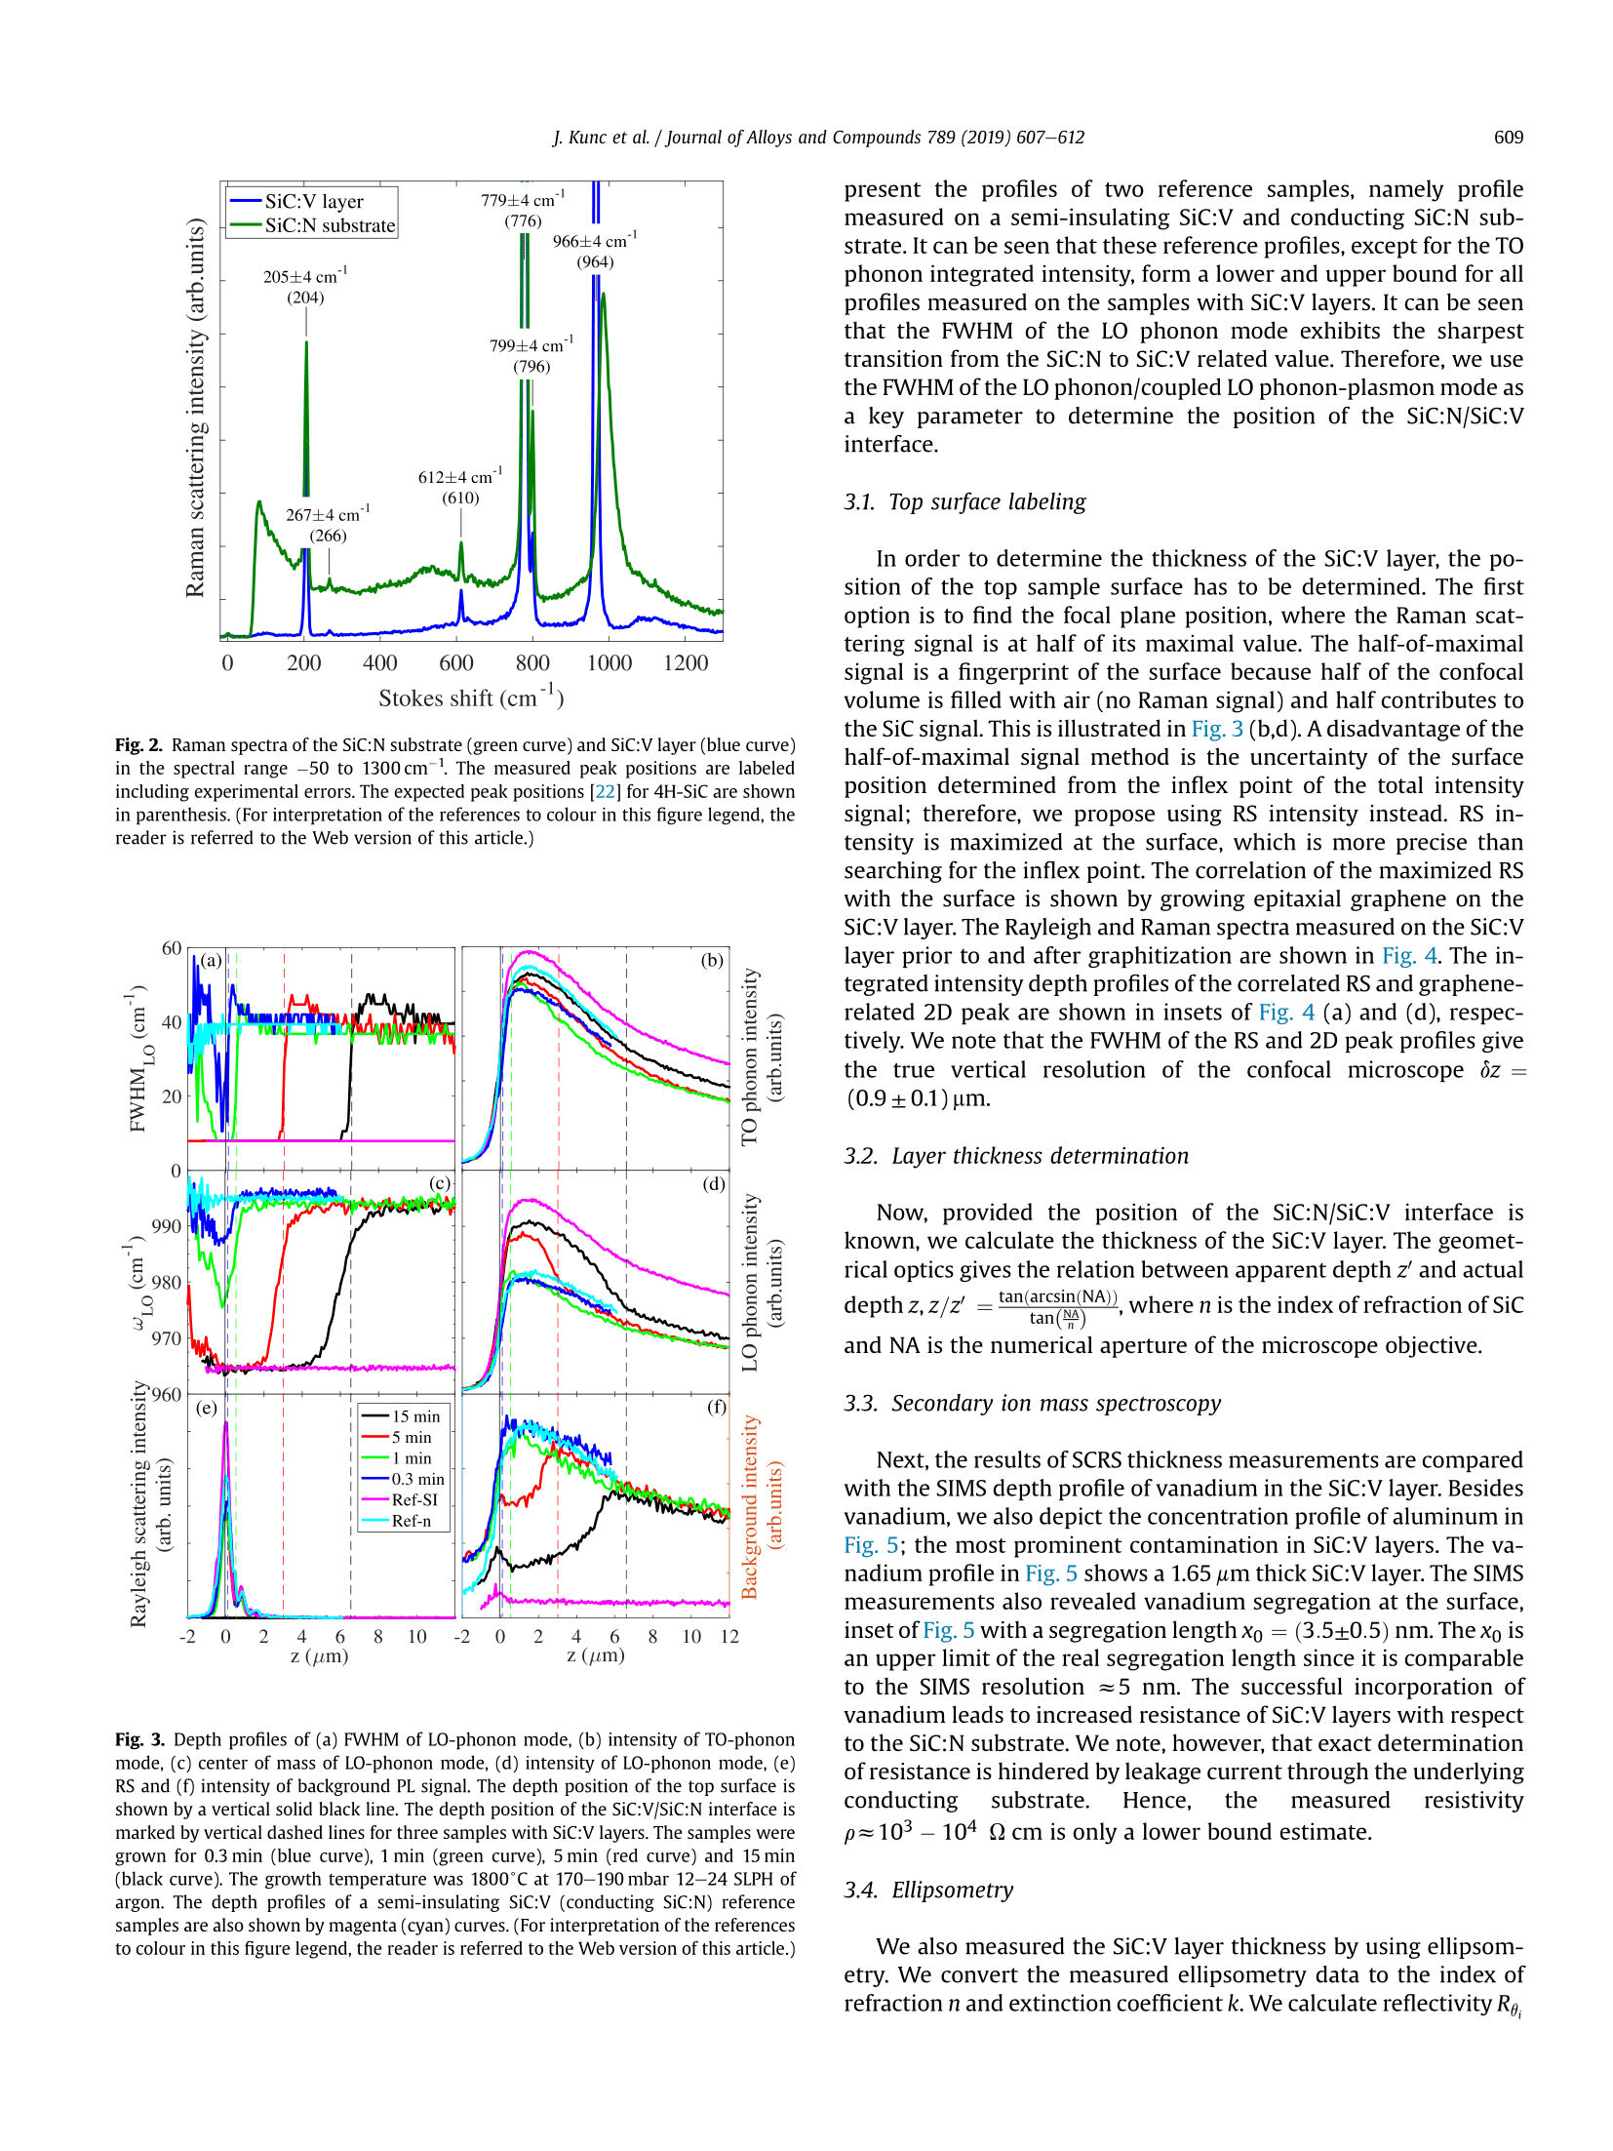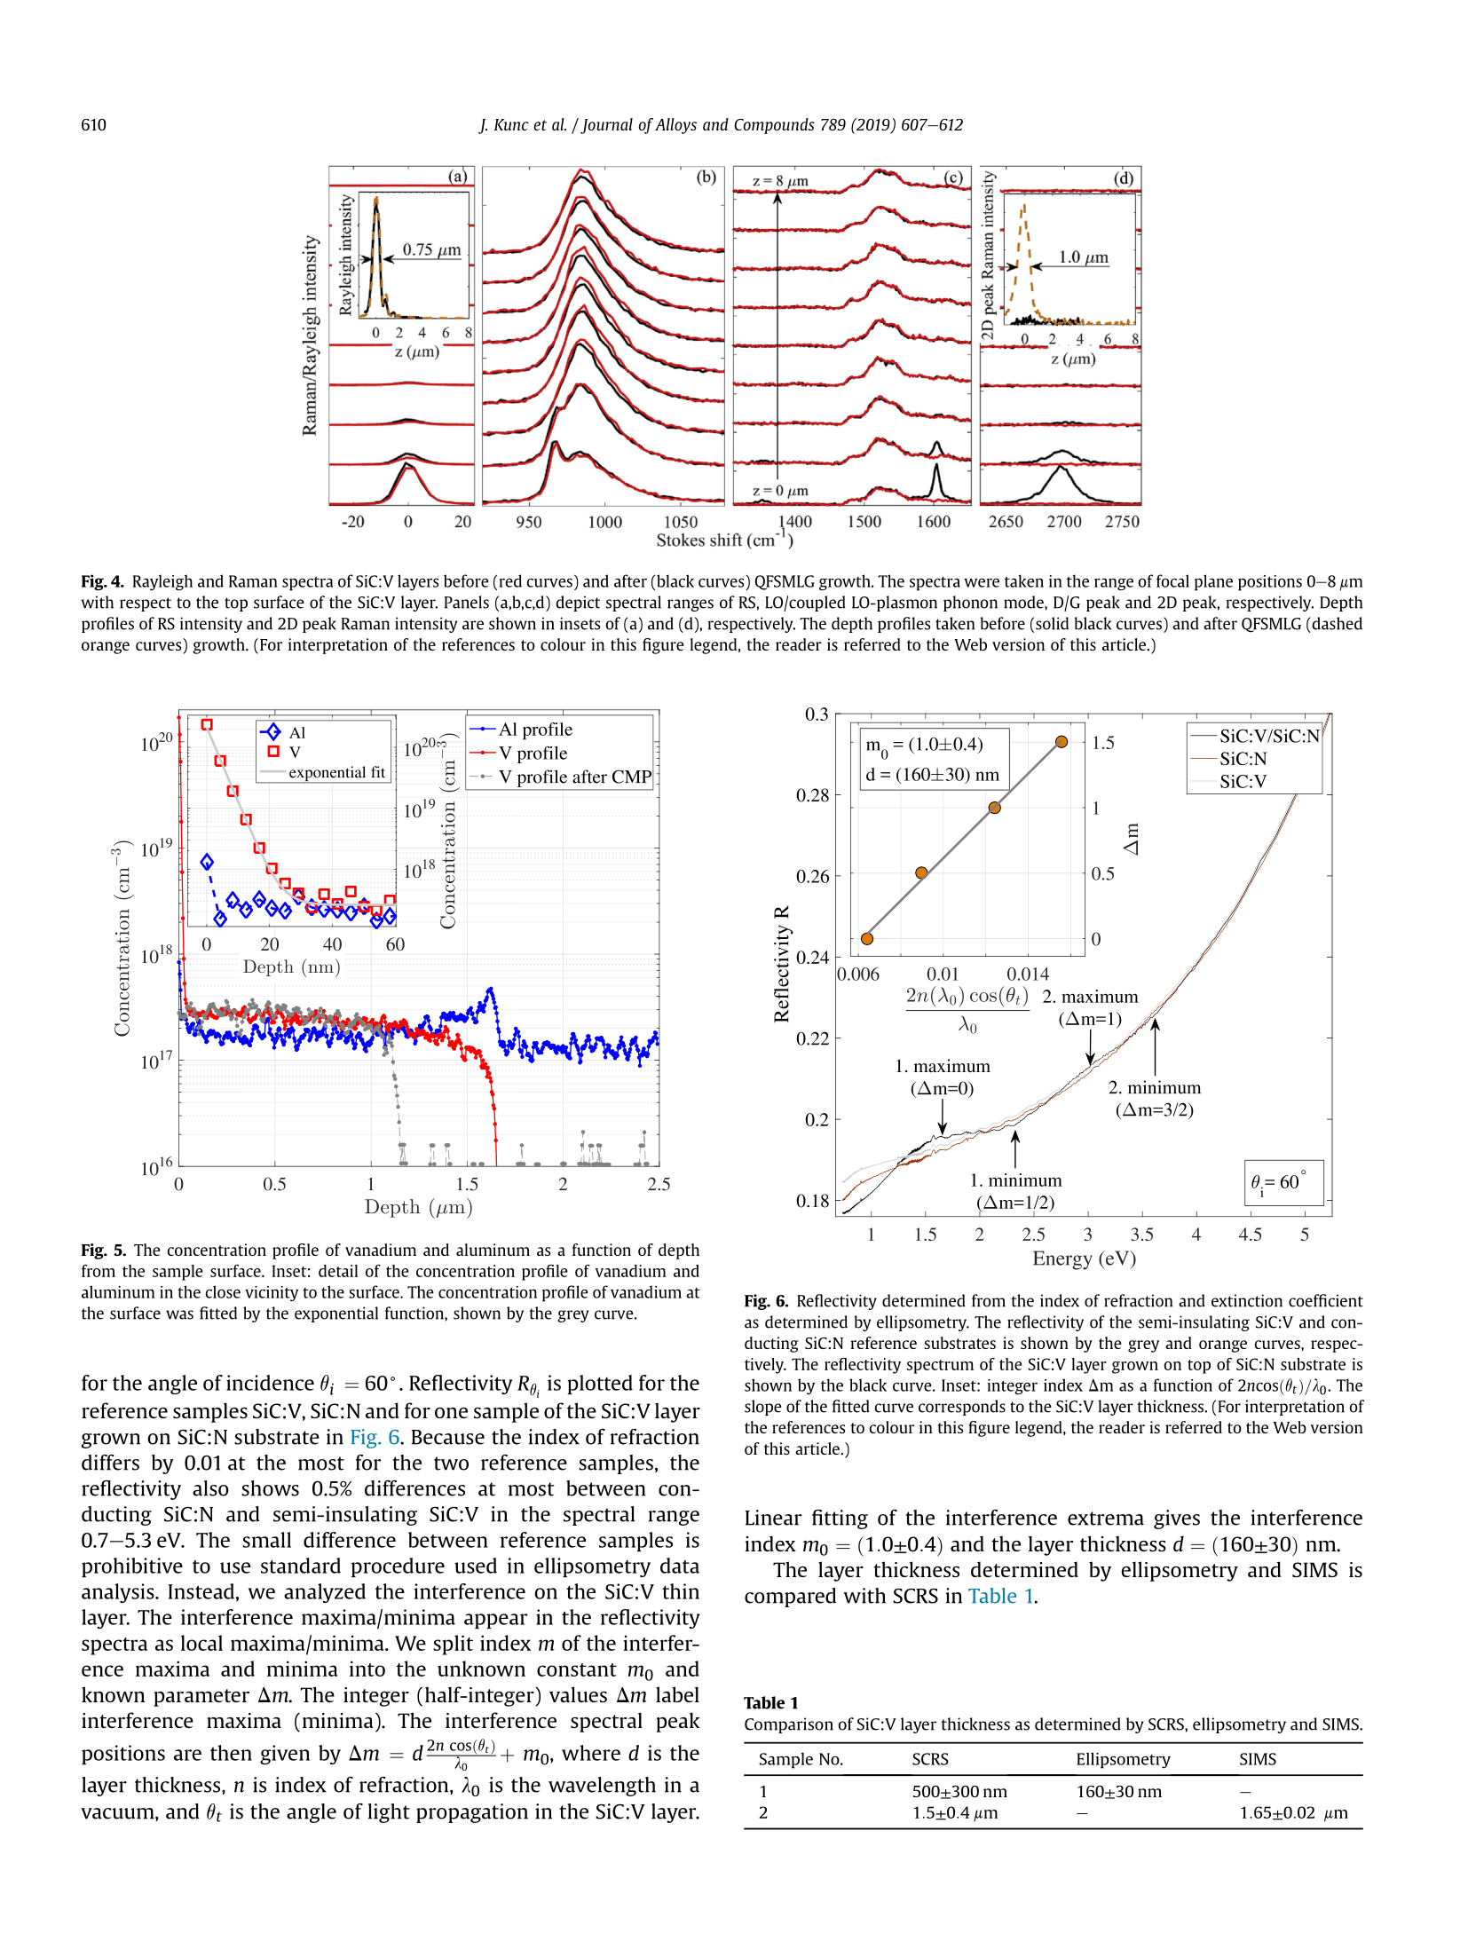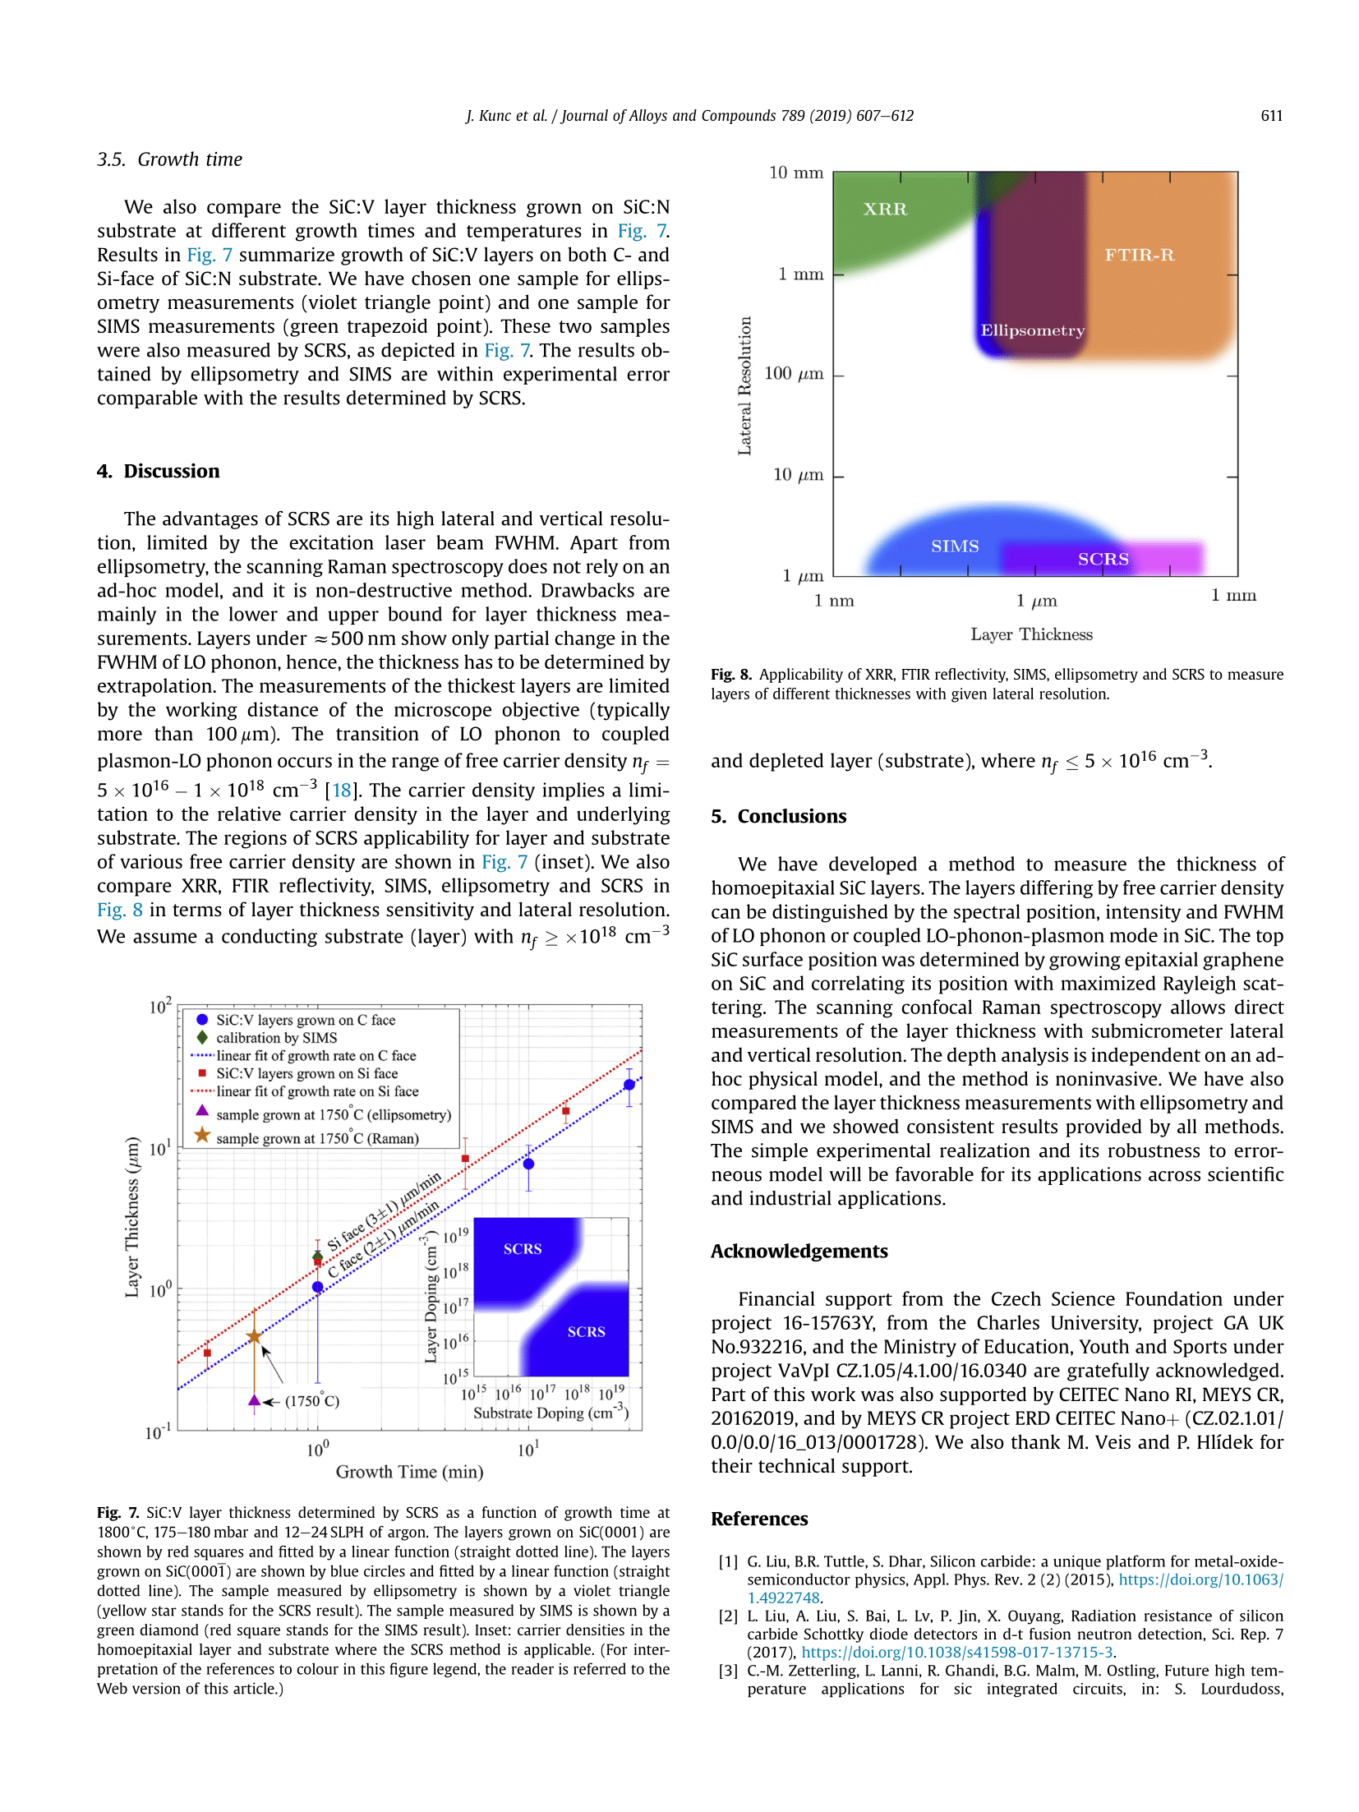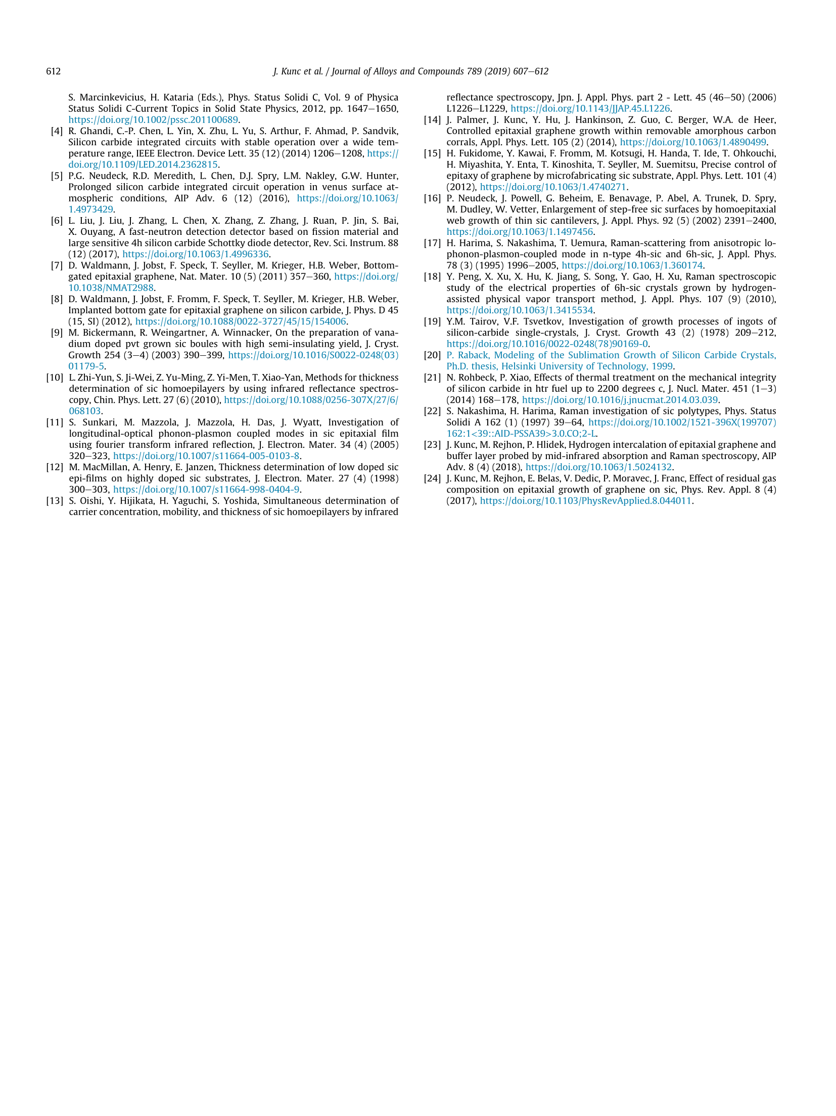

Commented paper 5

DAGHBOUJ, N., M. CALLISTI, H. S. SEN, M. KARLIK, J. ČECH, M. VRONKA, V. HAVRÁNEK, J. ČAPEK, P. MINÁRIK, P. BÁBOR and T. POLCAR. Interphase boundary layer-dominated strain mechanisms in Cu+ implanted Zr-Nb nanoscale multilayers. Acta Materialia [online]. 2021, 202, 317–330. ISSN 13596454. Available at: doi:10.1016/j.actamat.2020.10.072

(IF = 7.6, Citations 10)

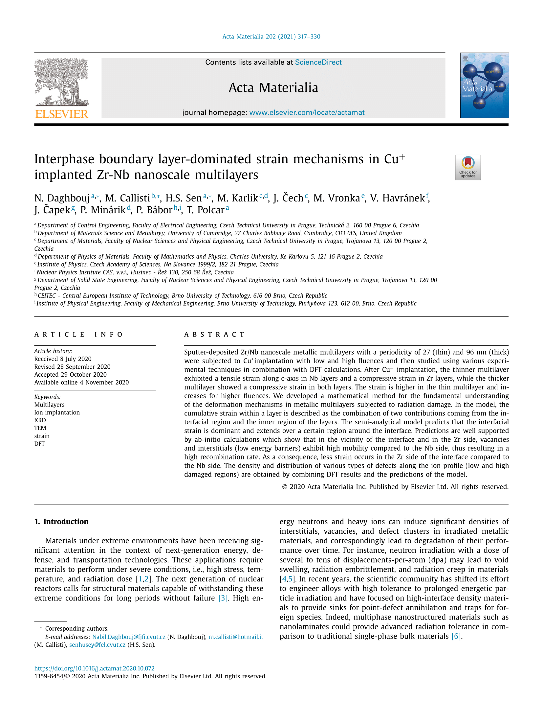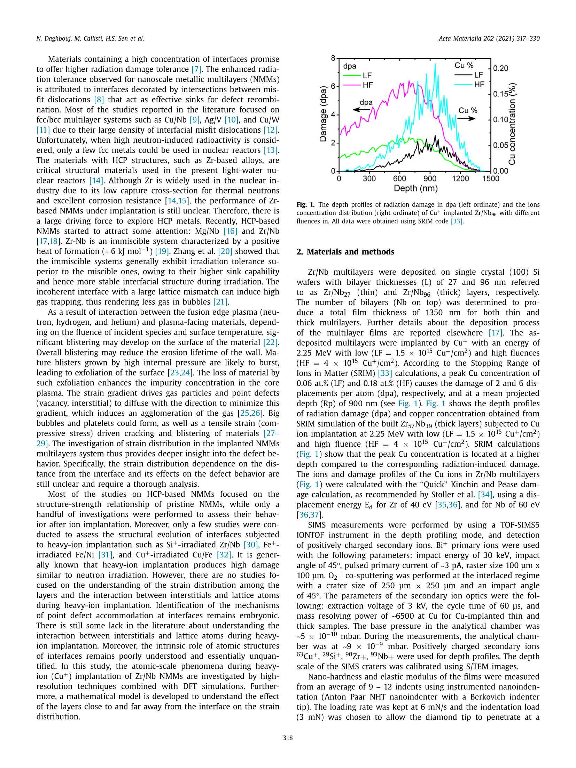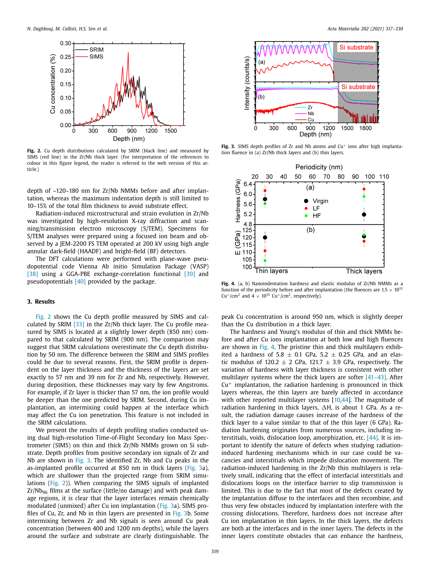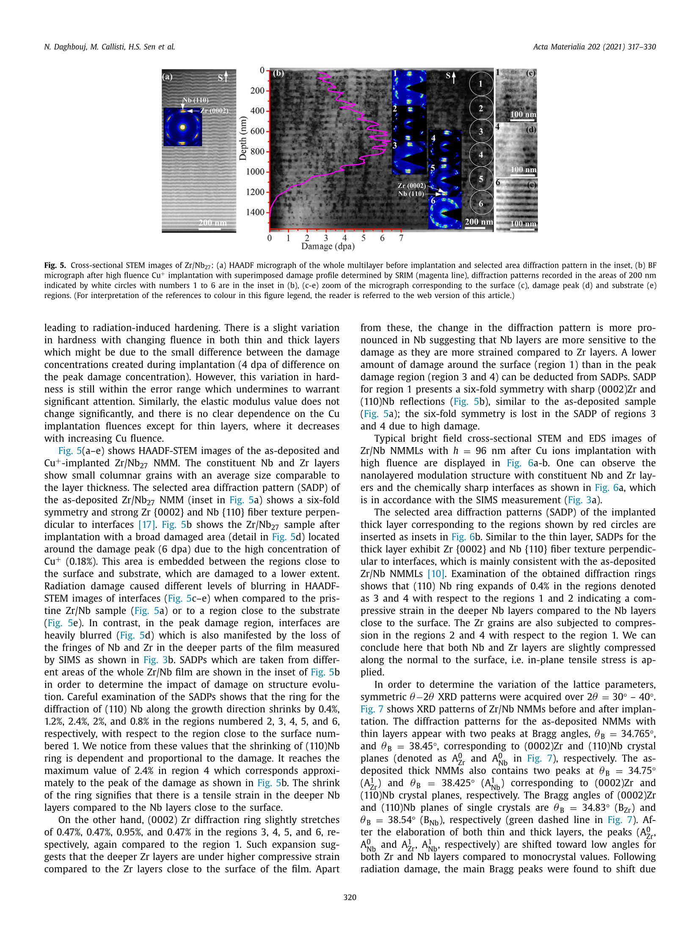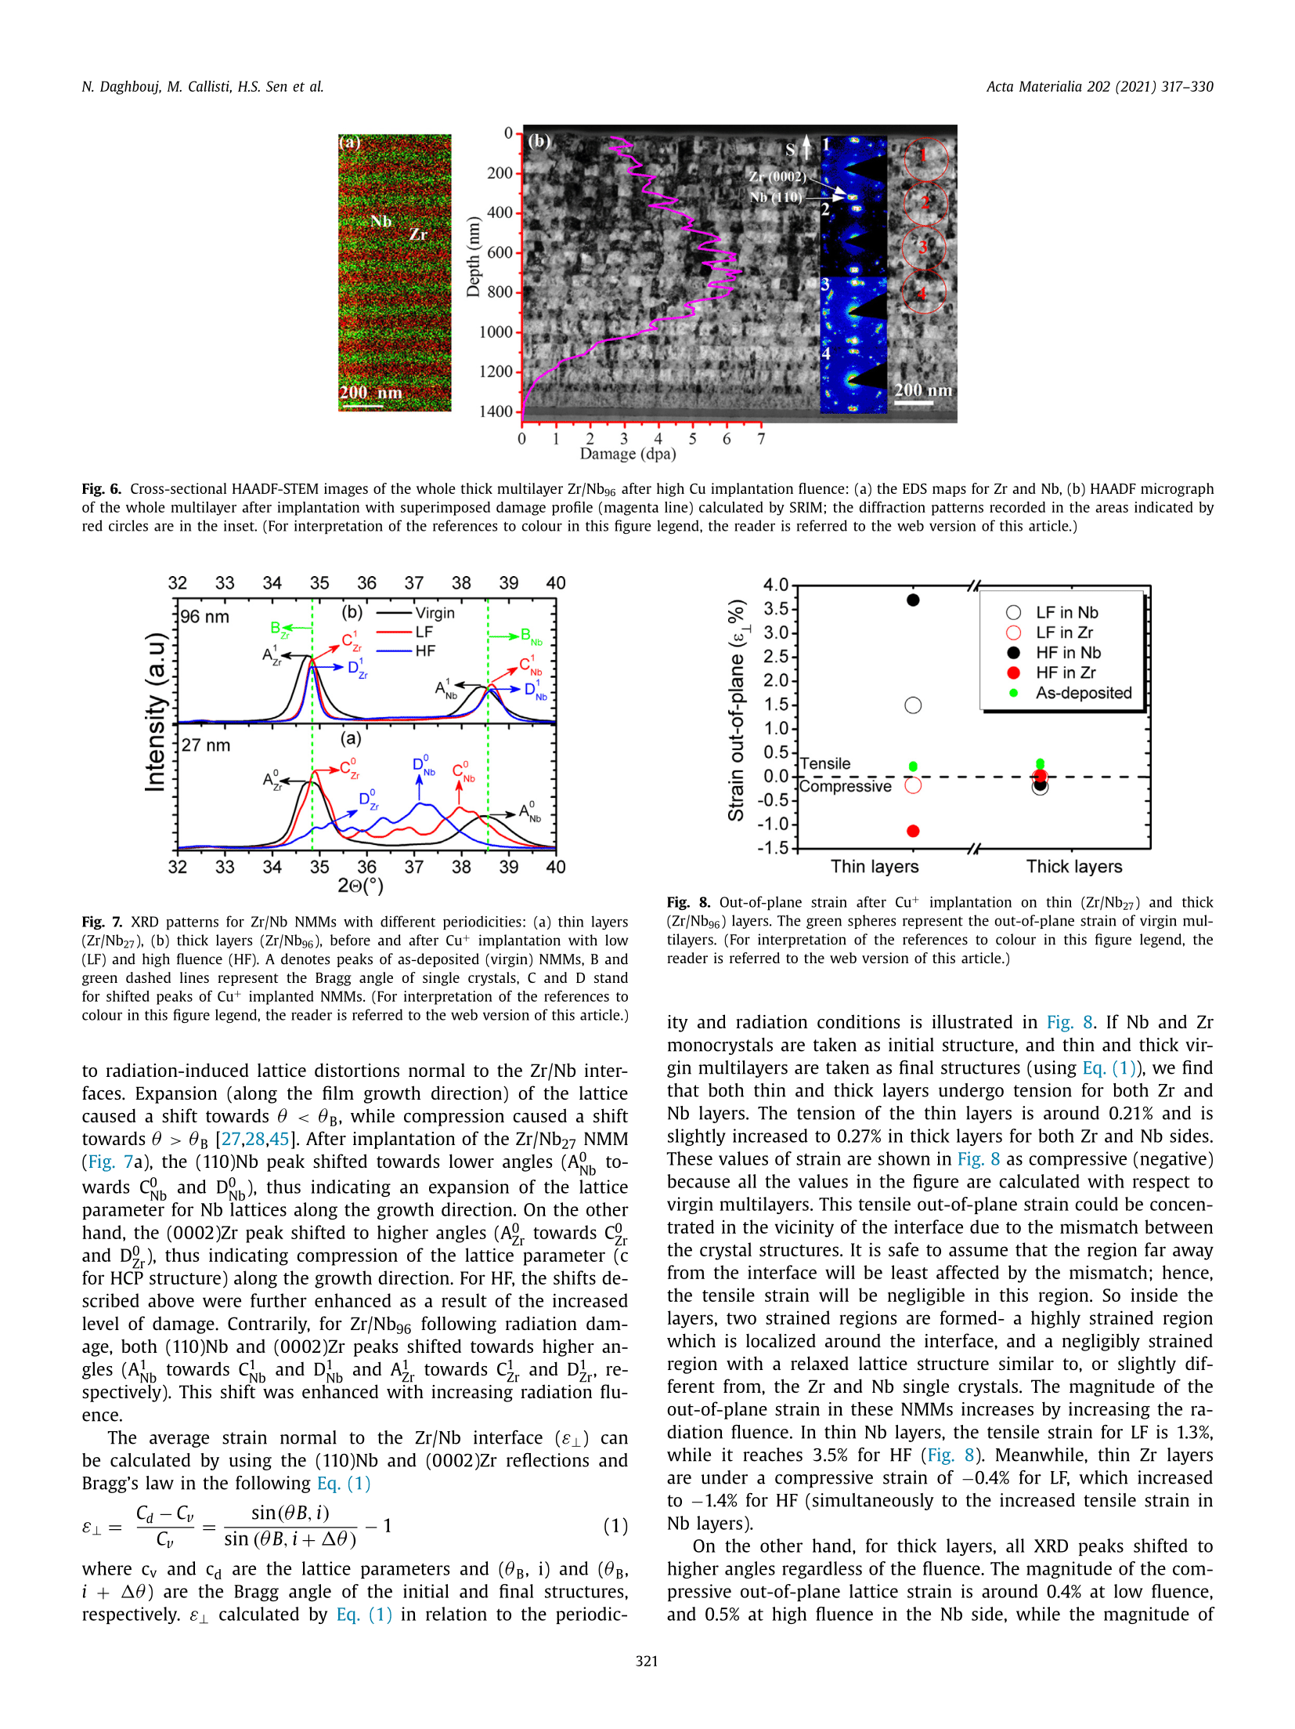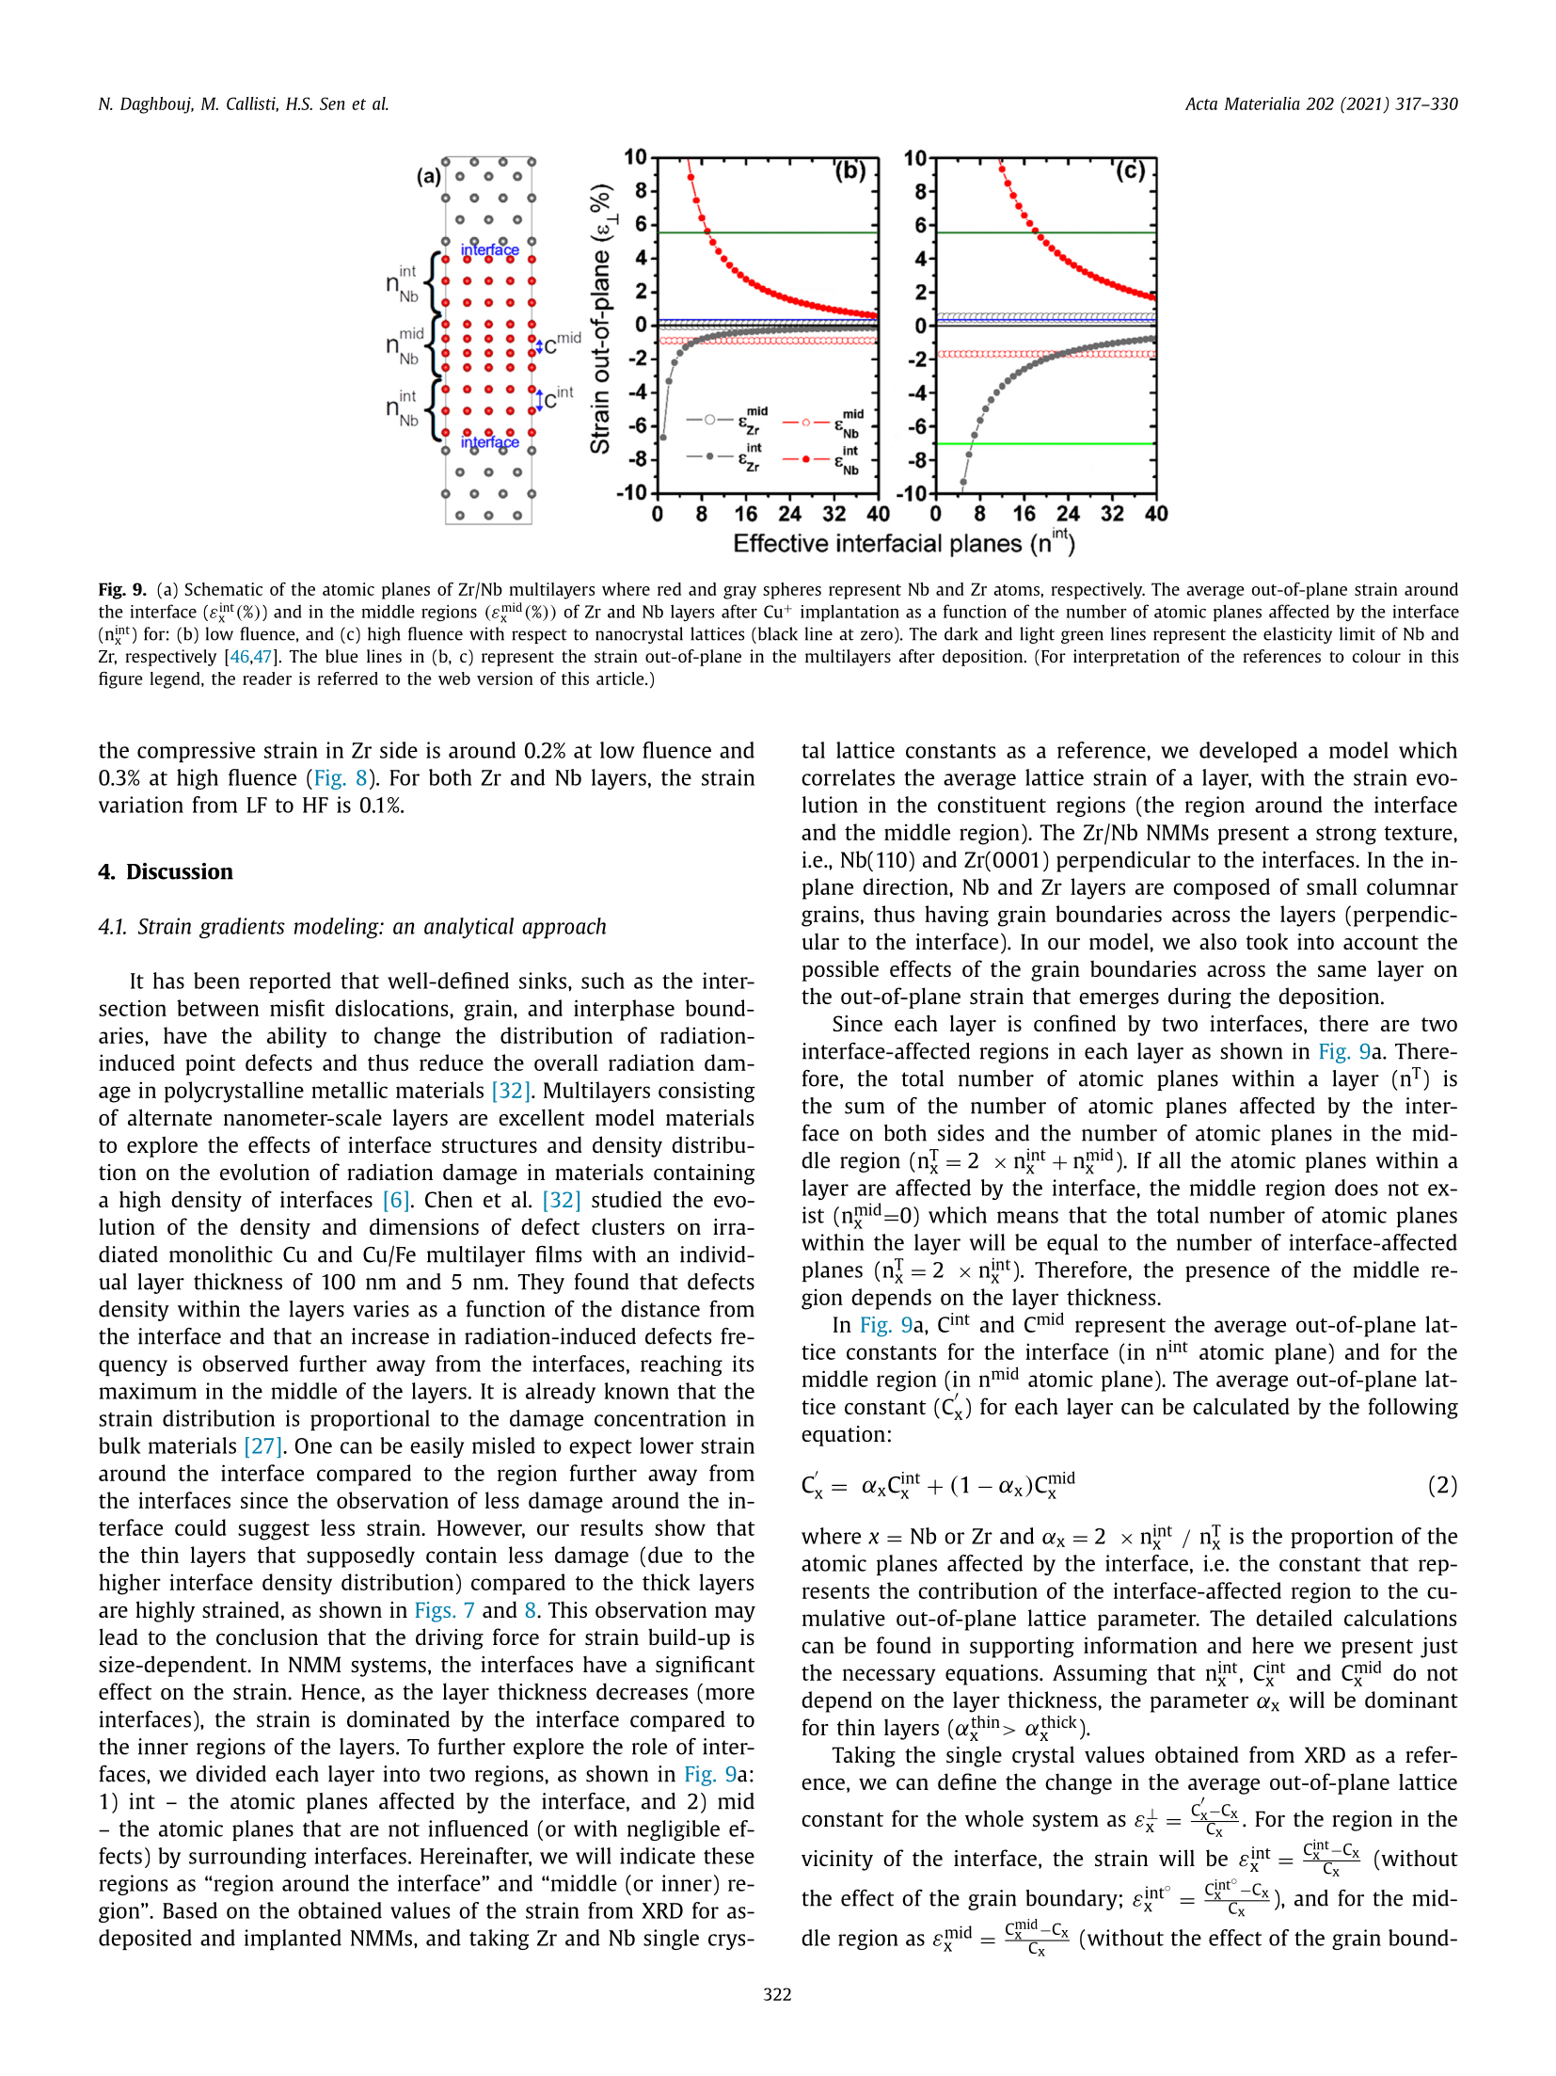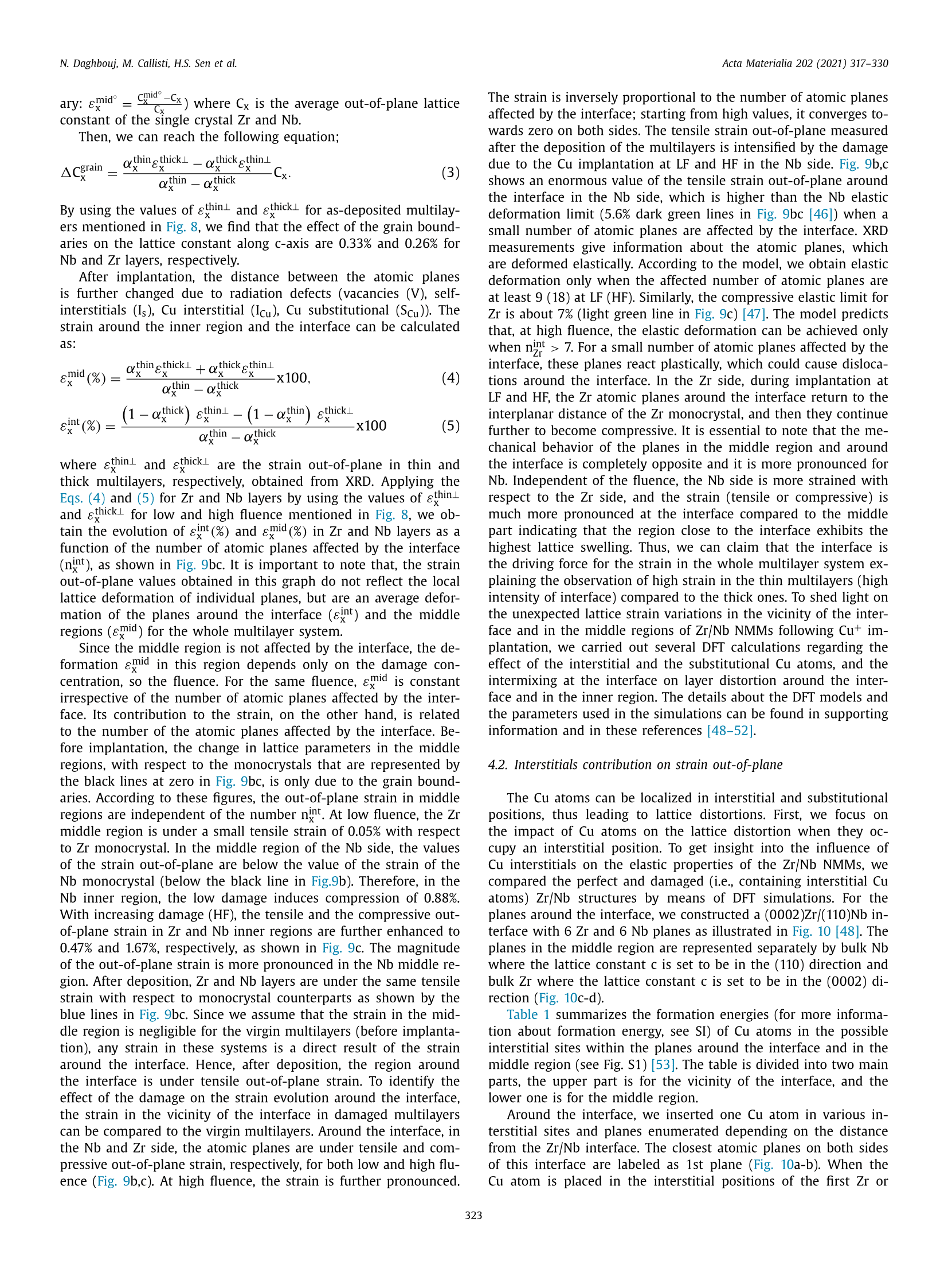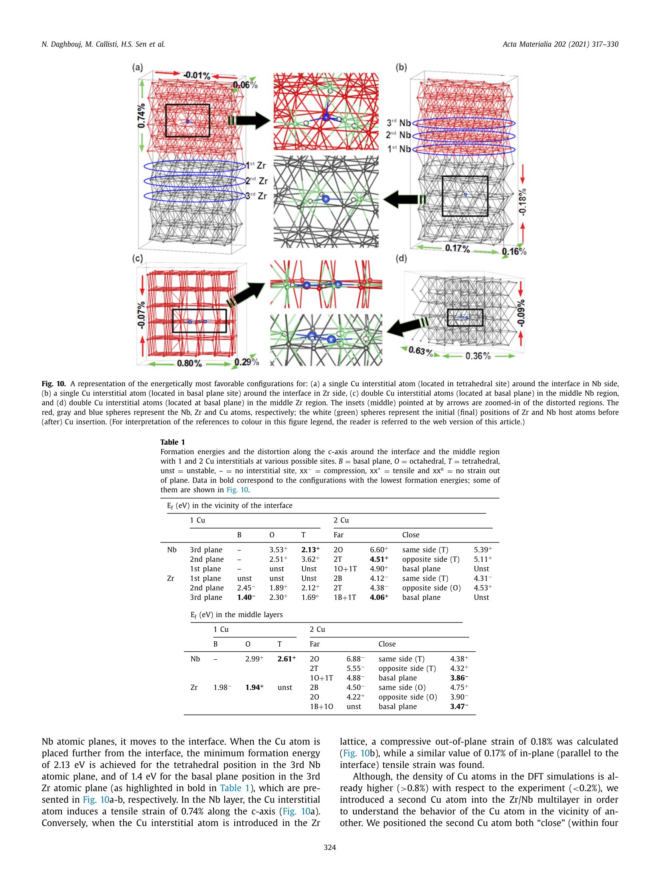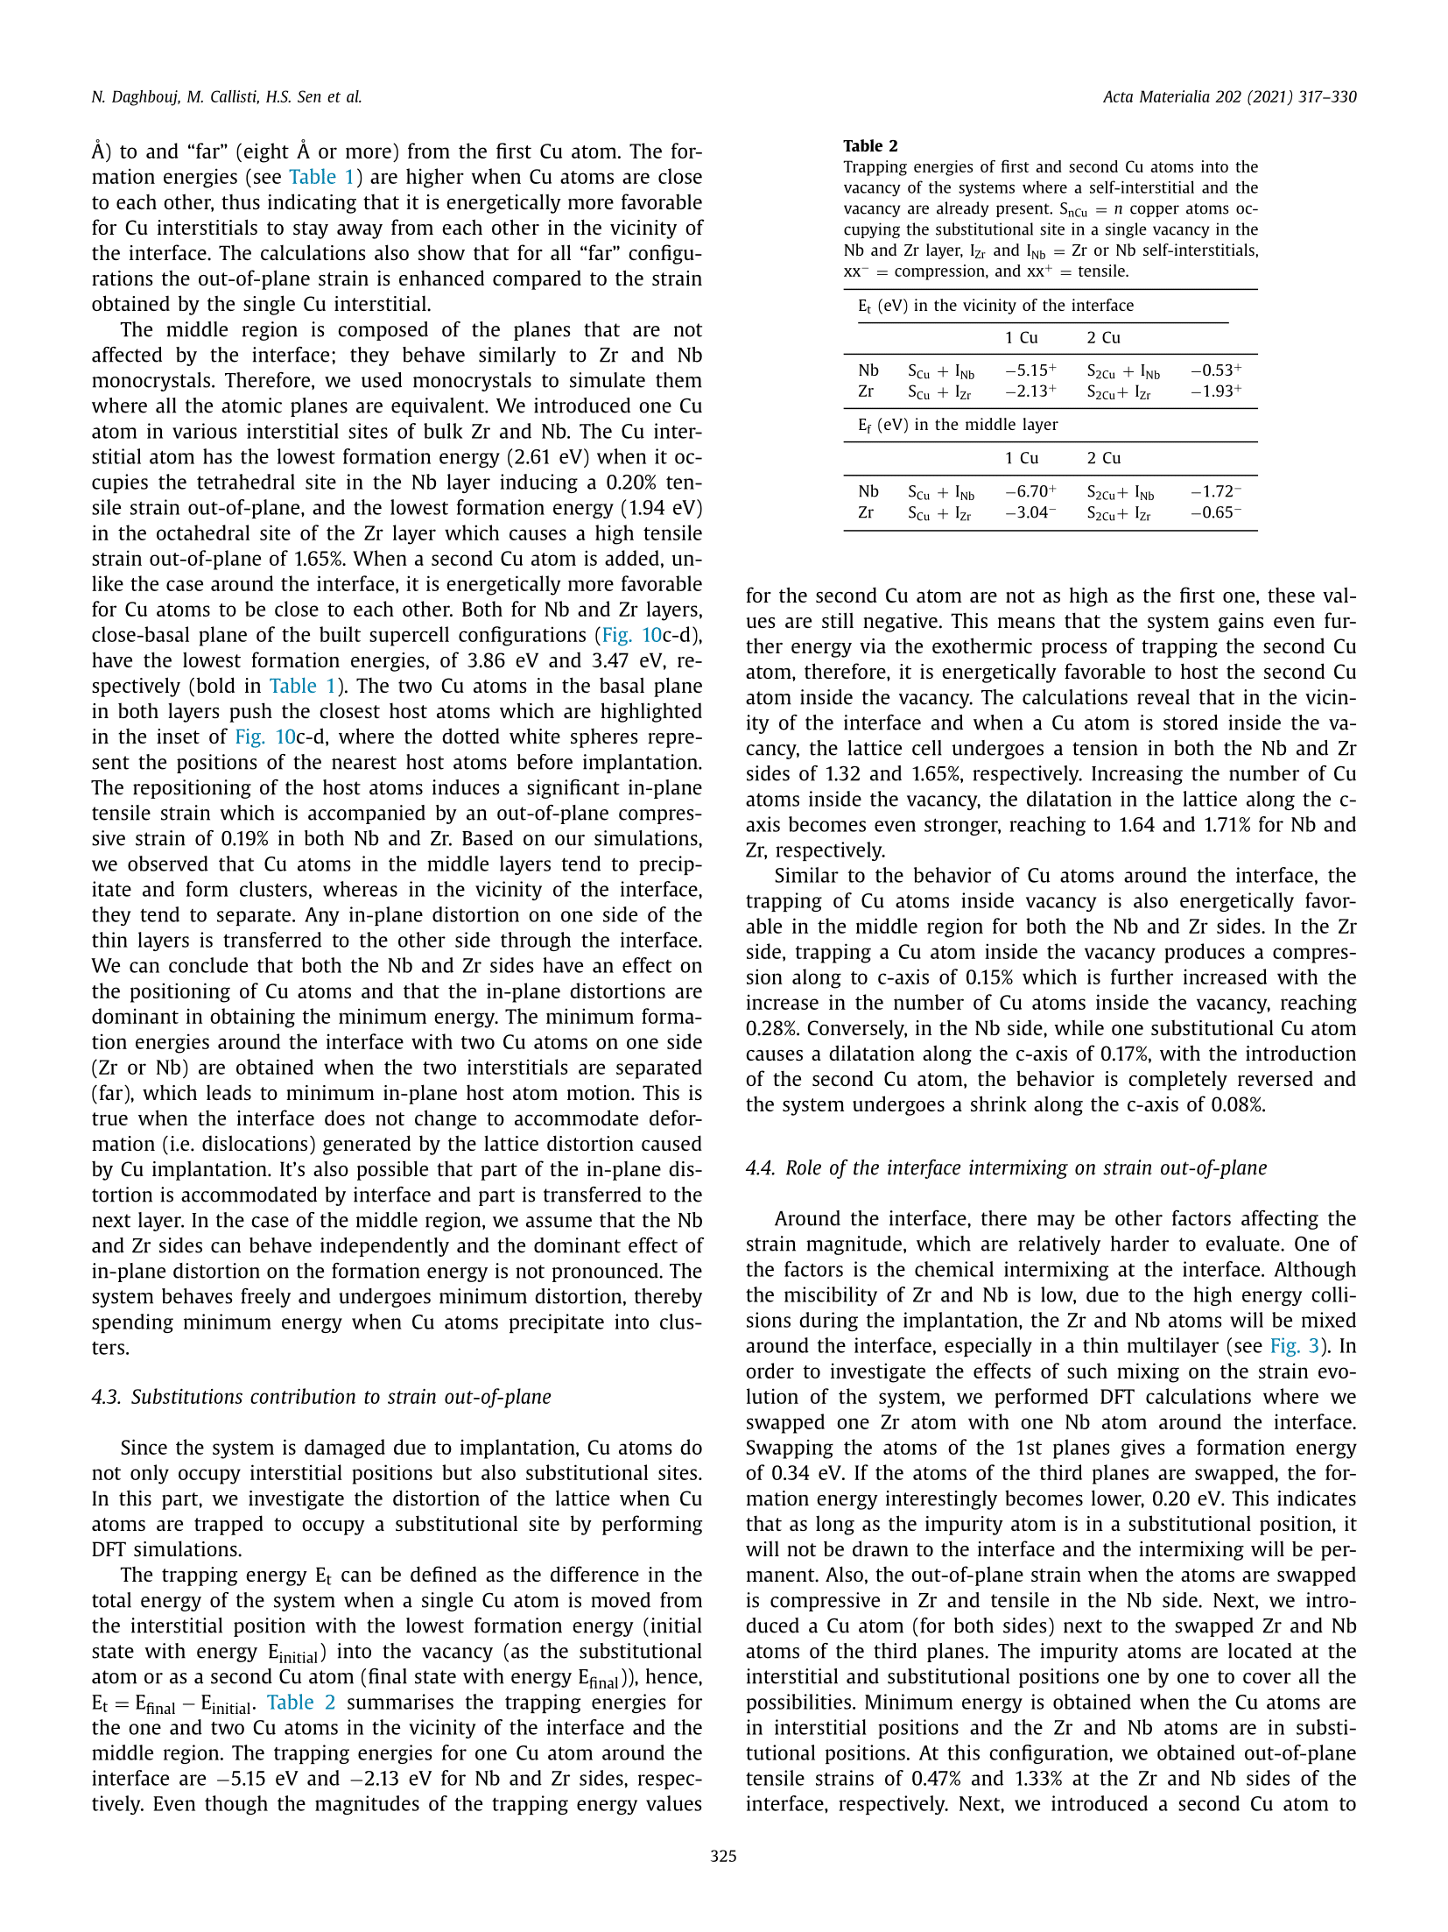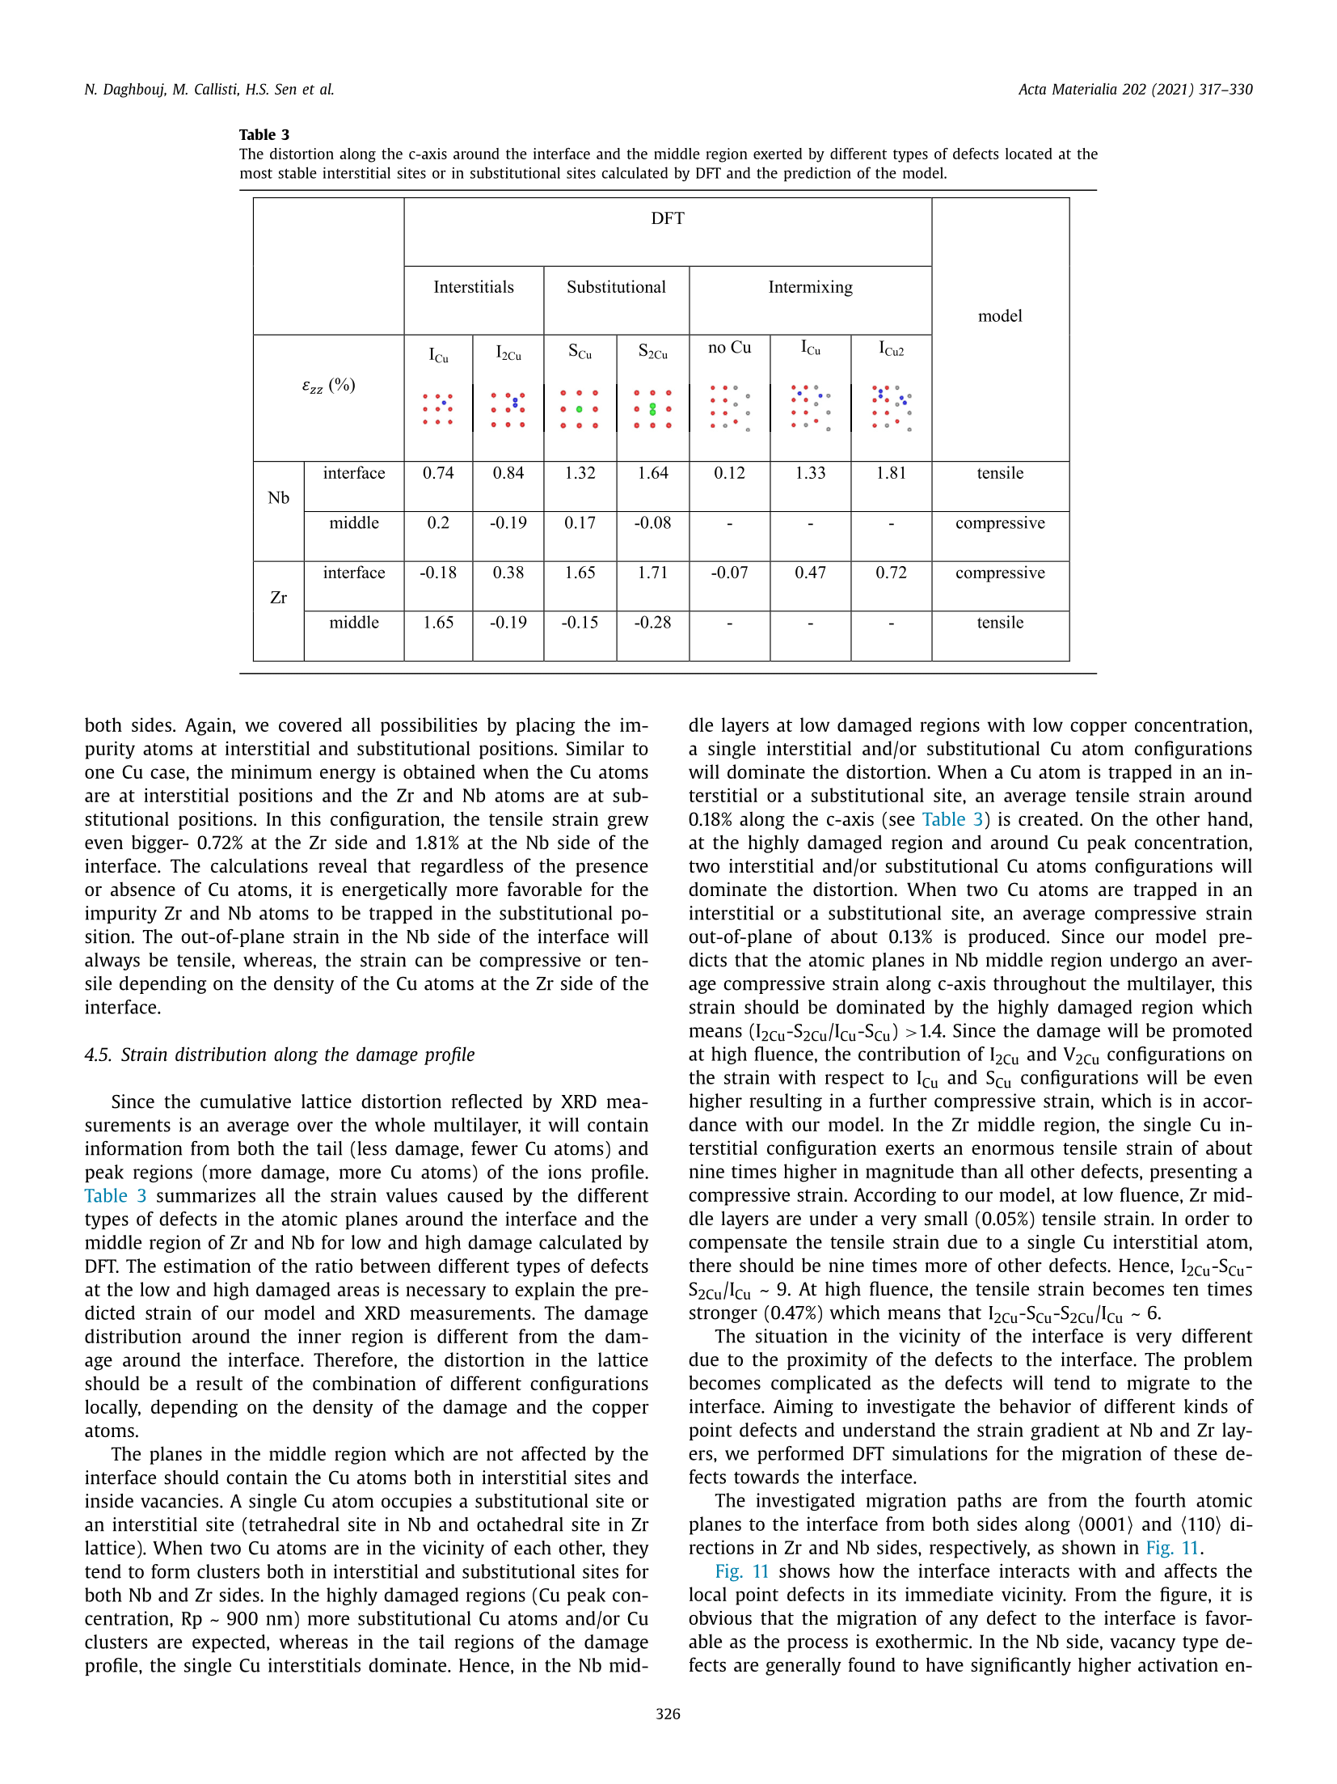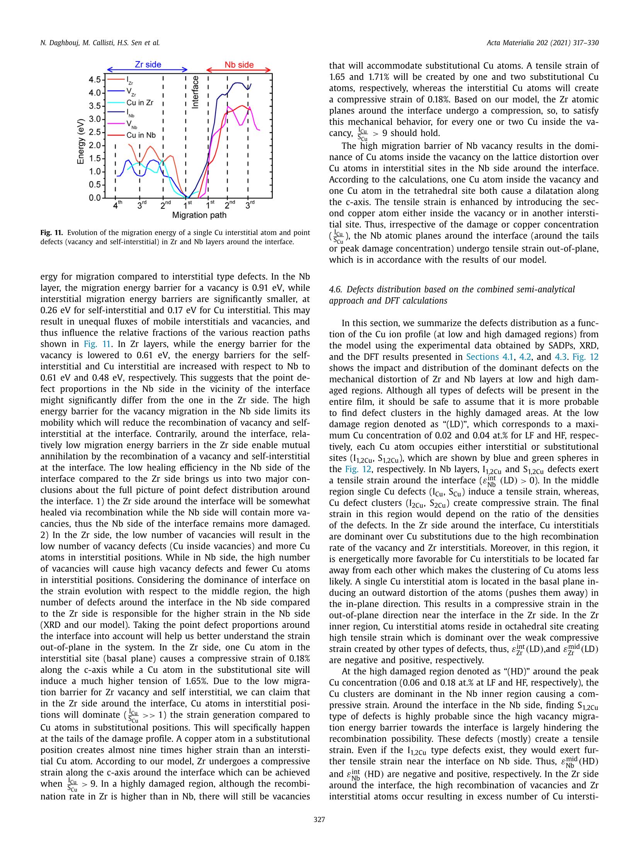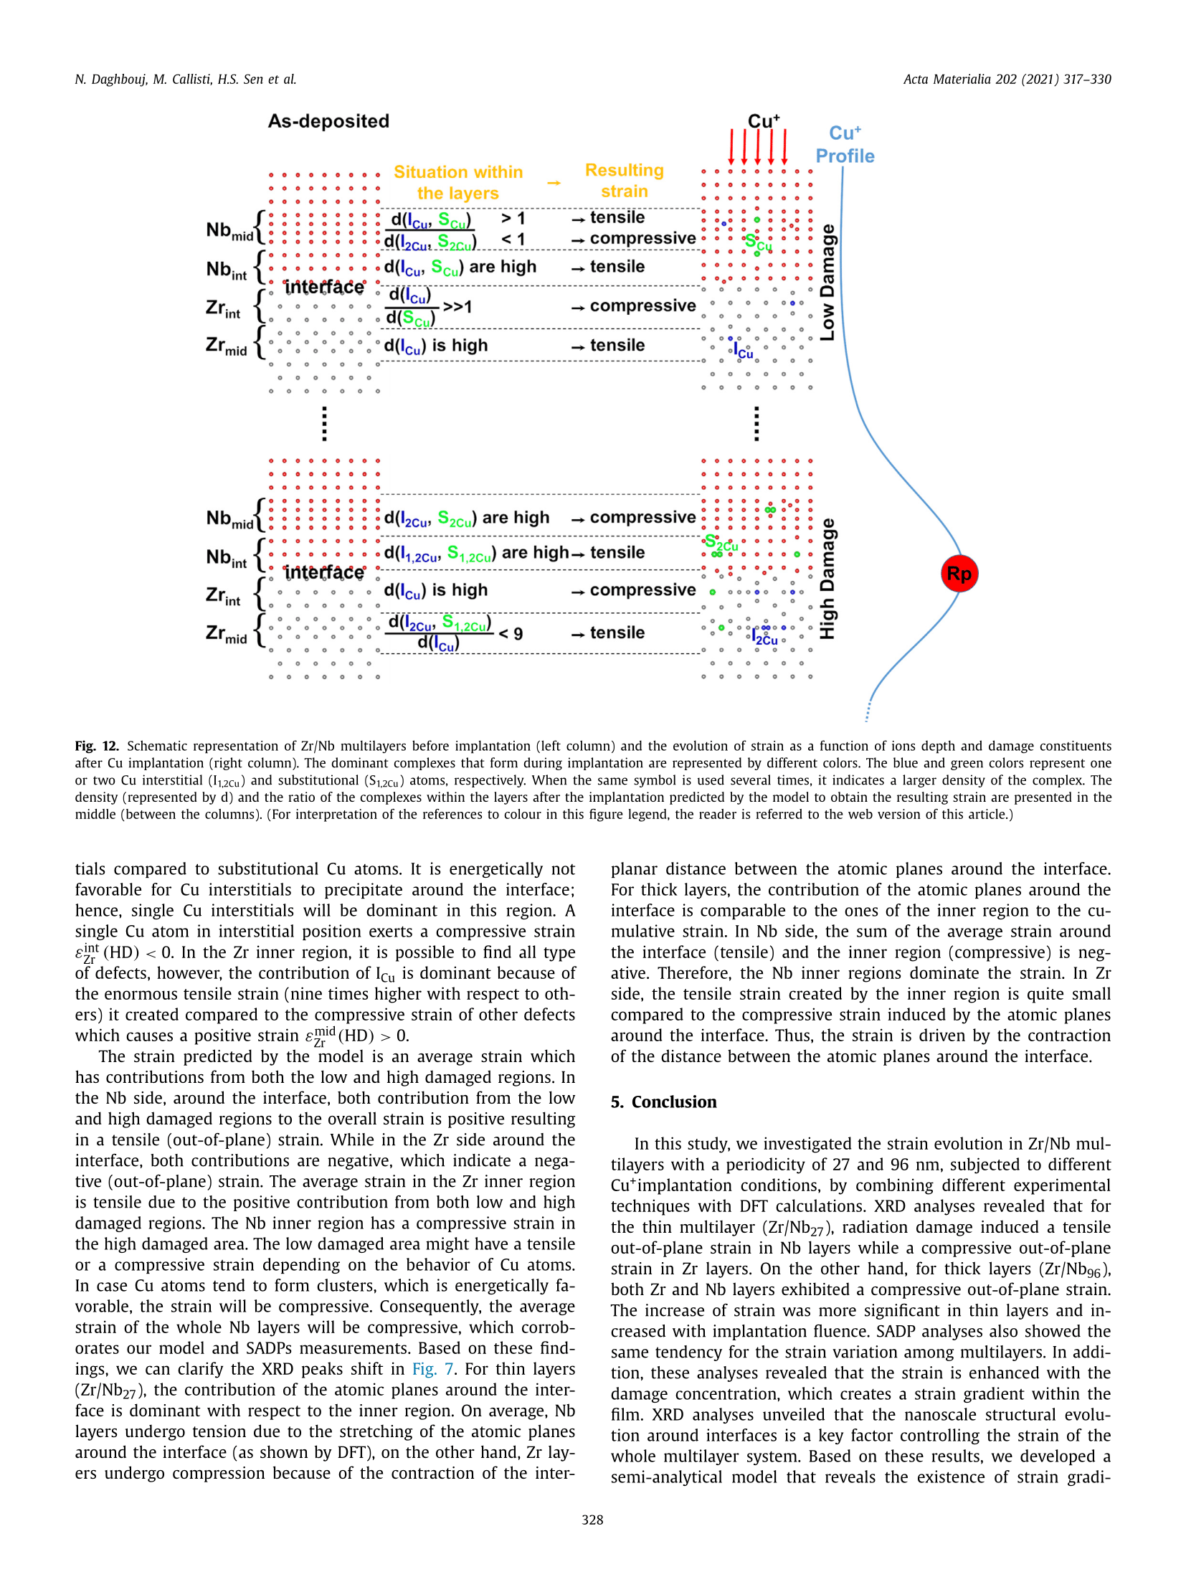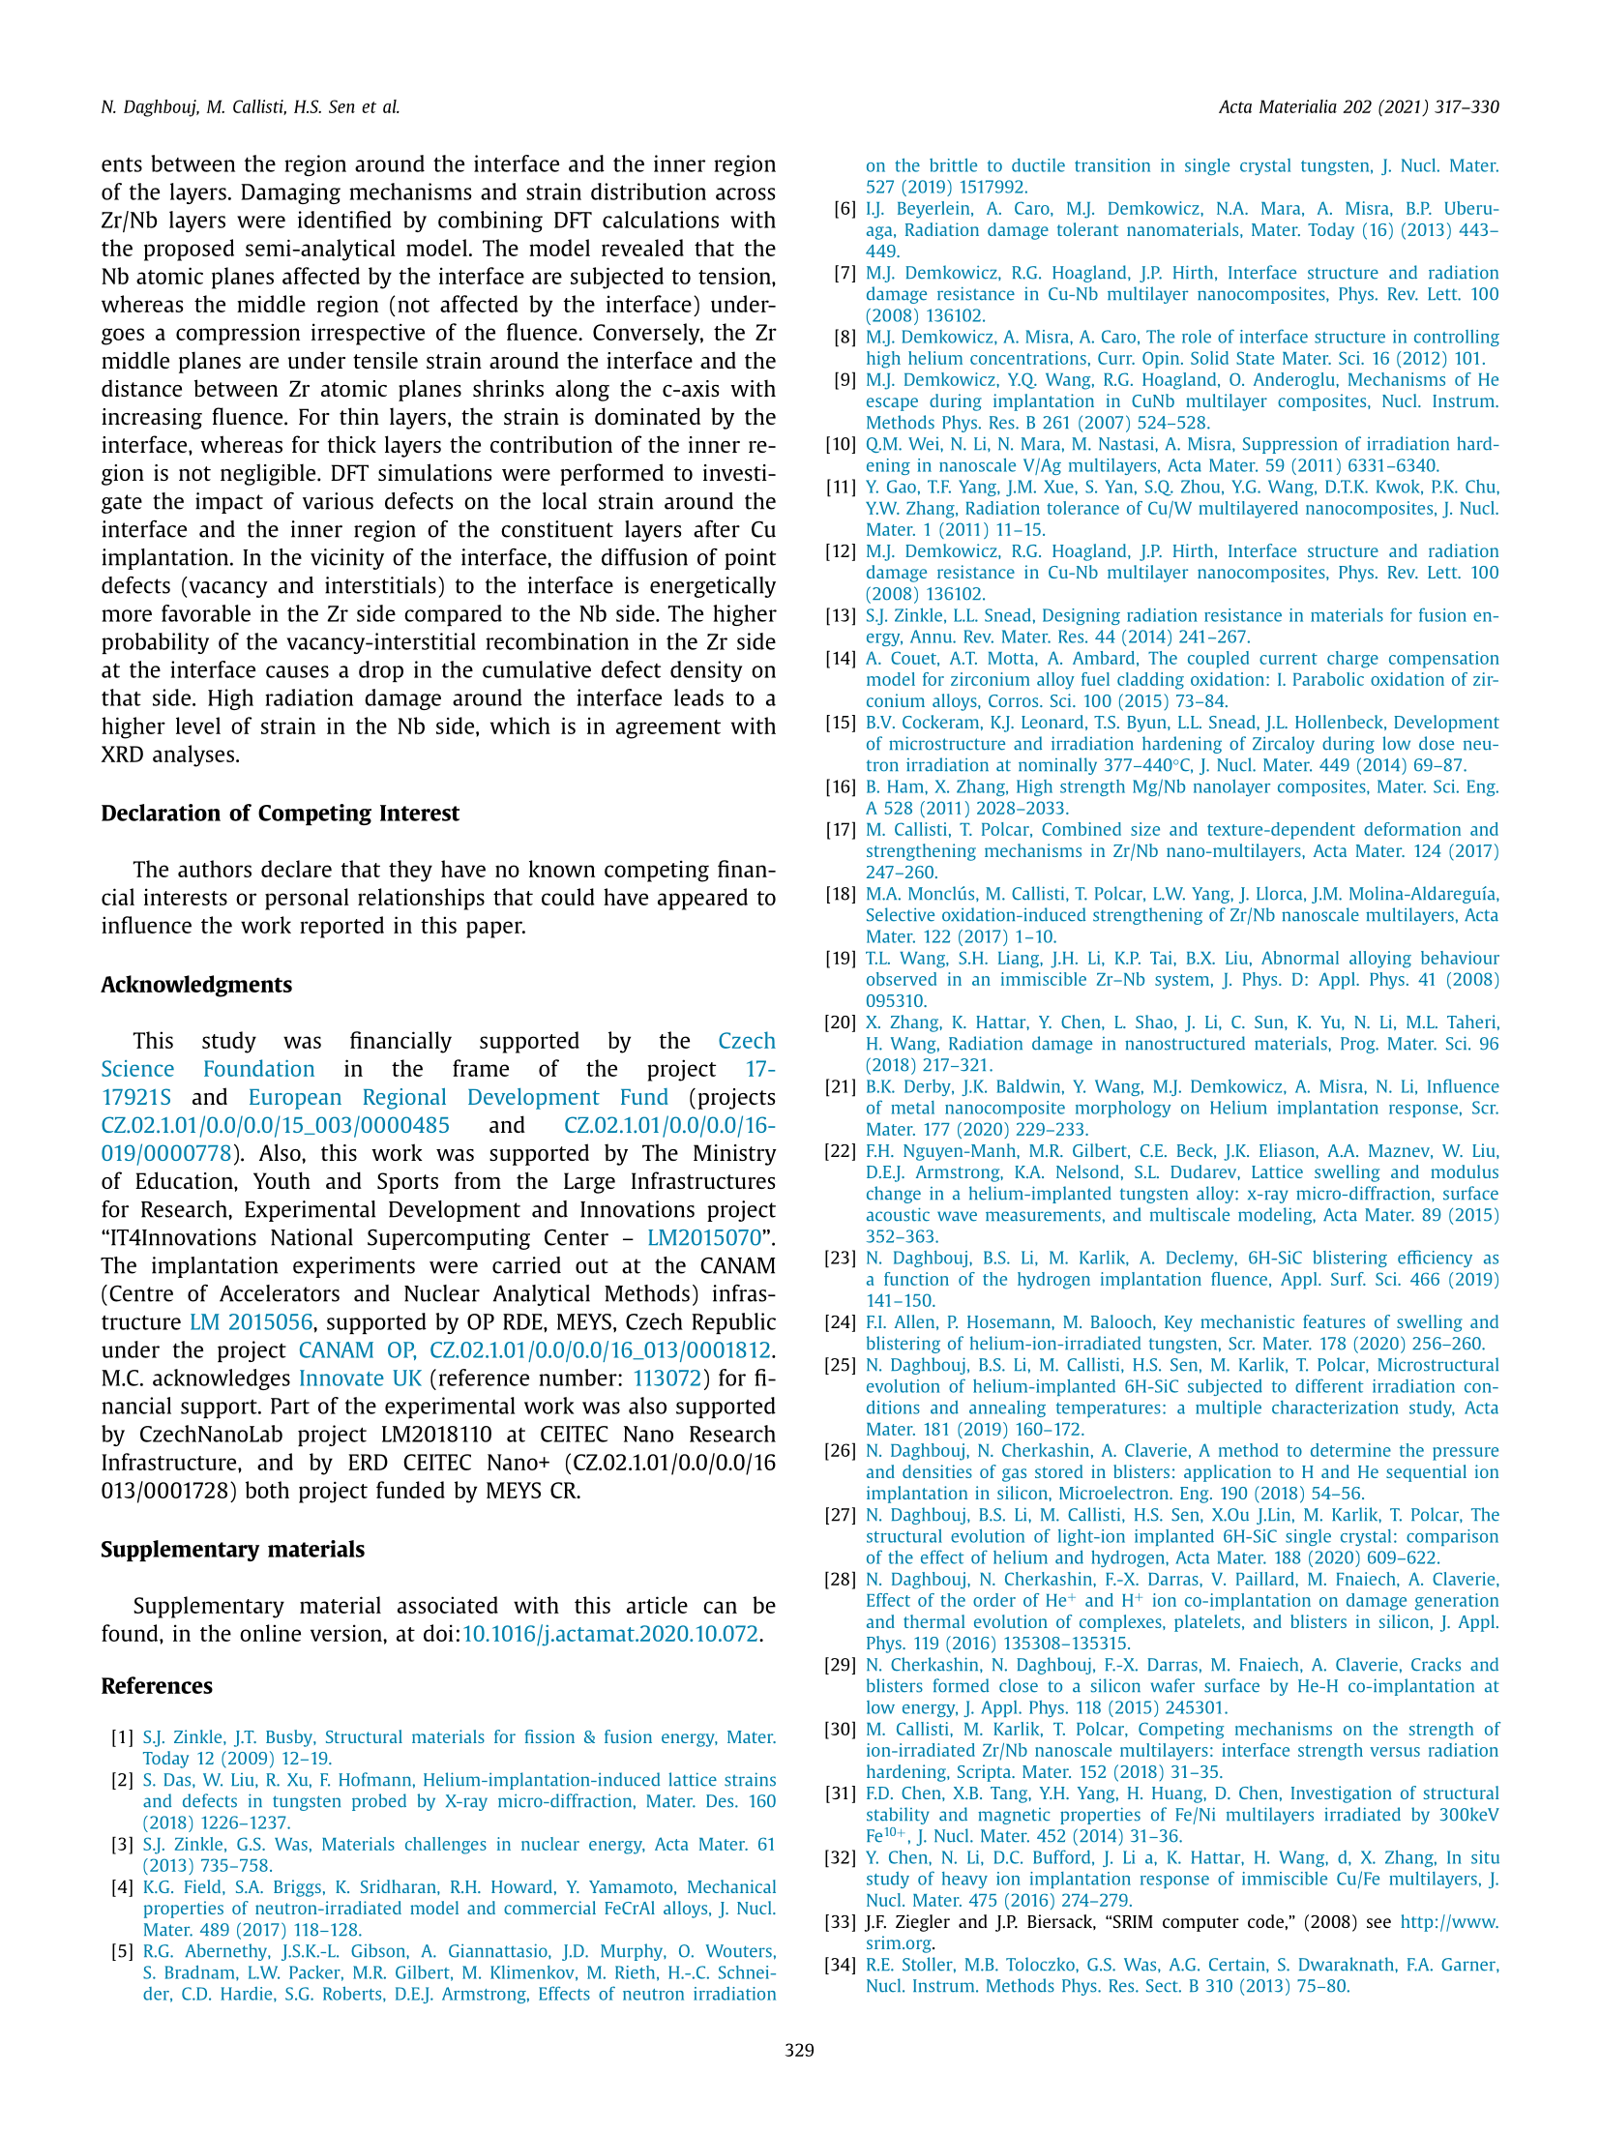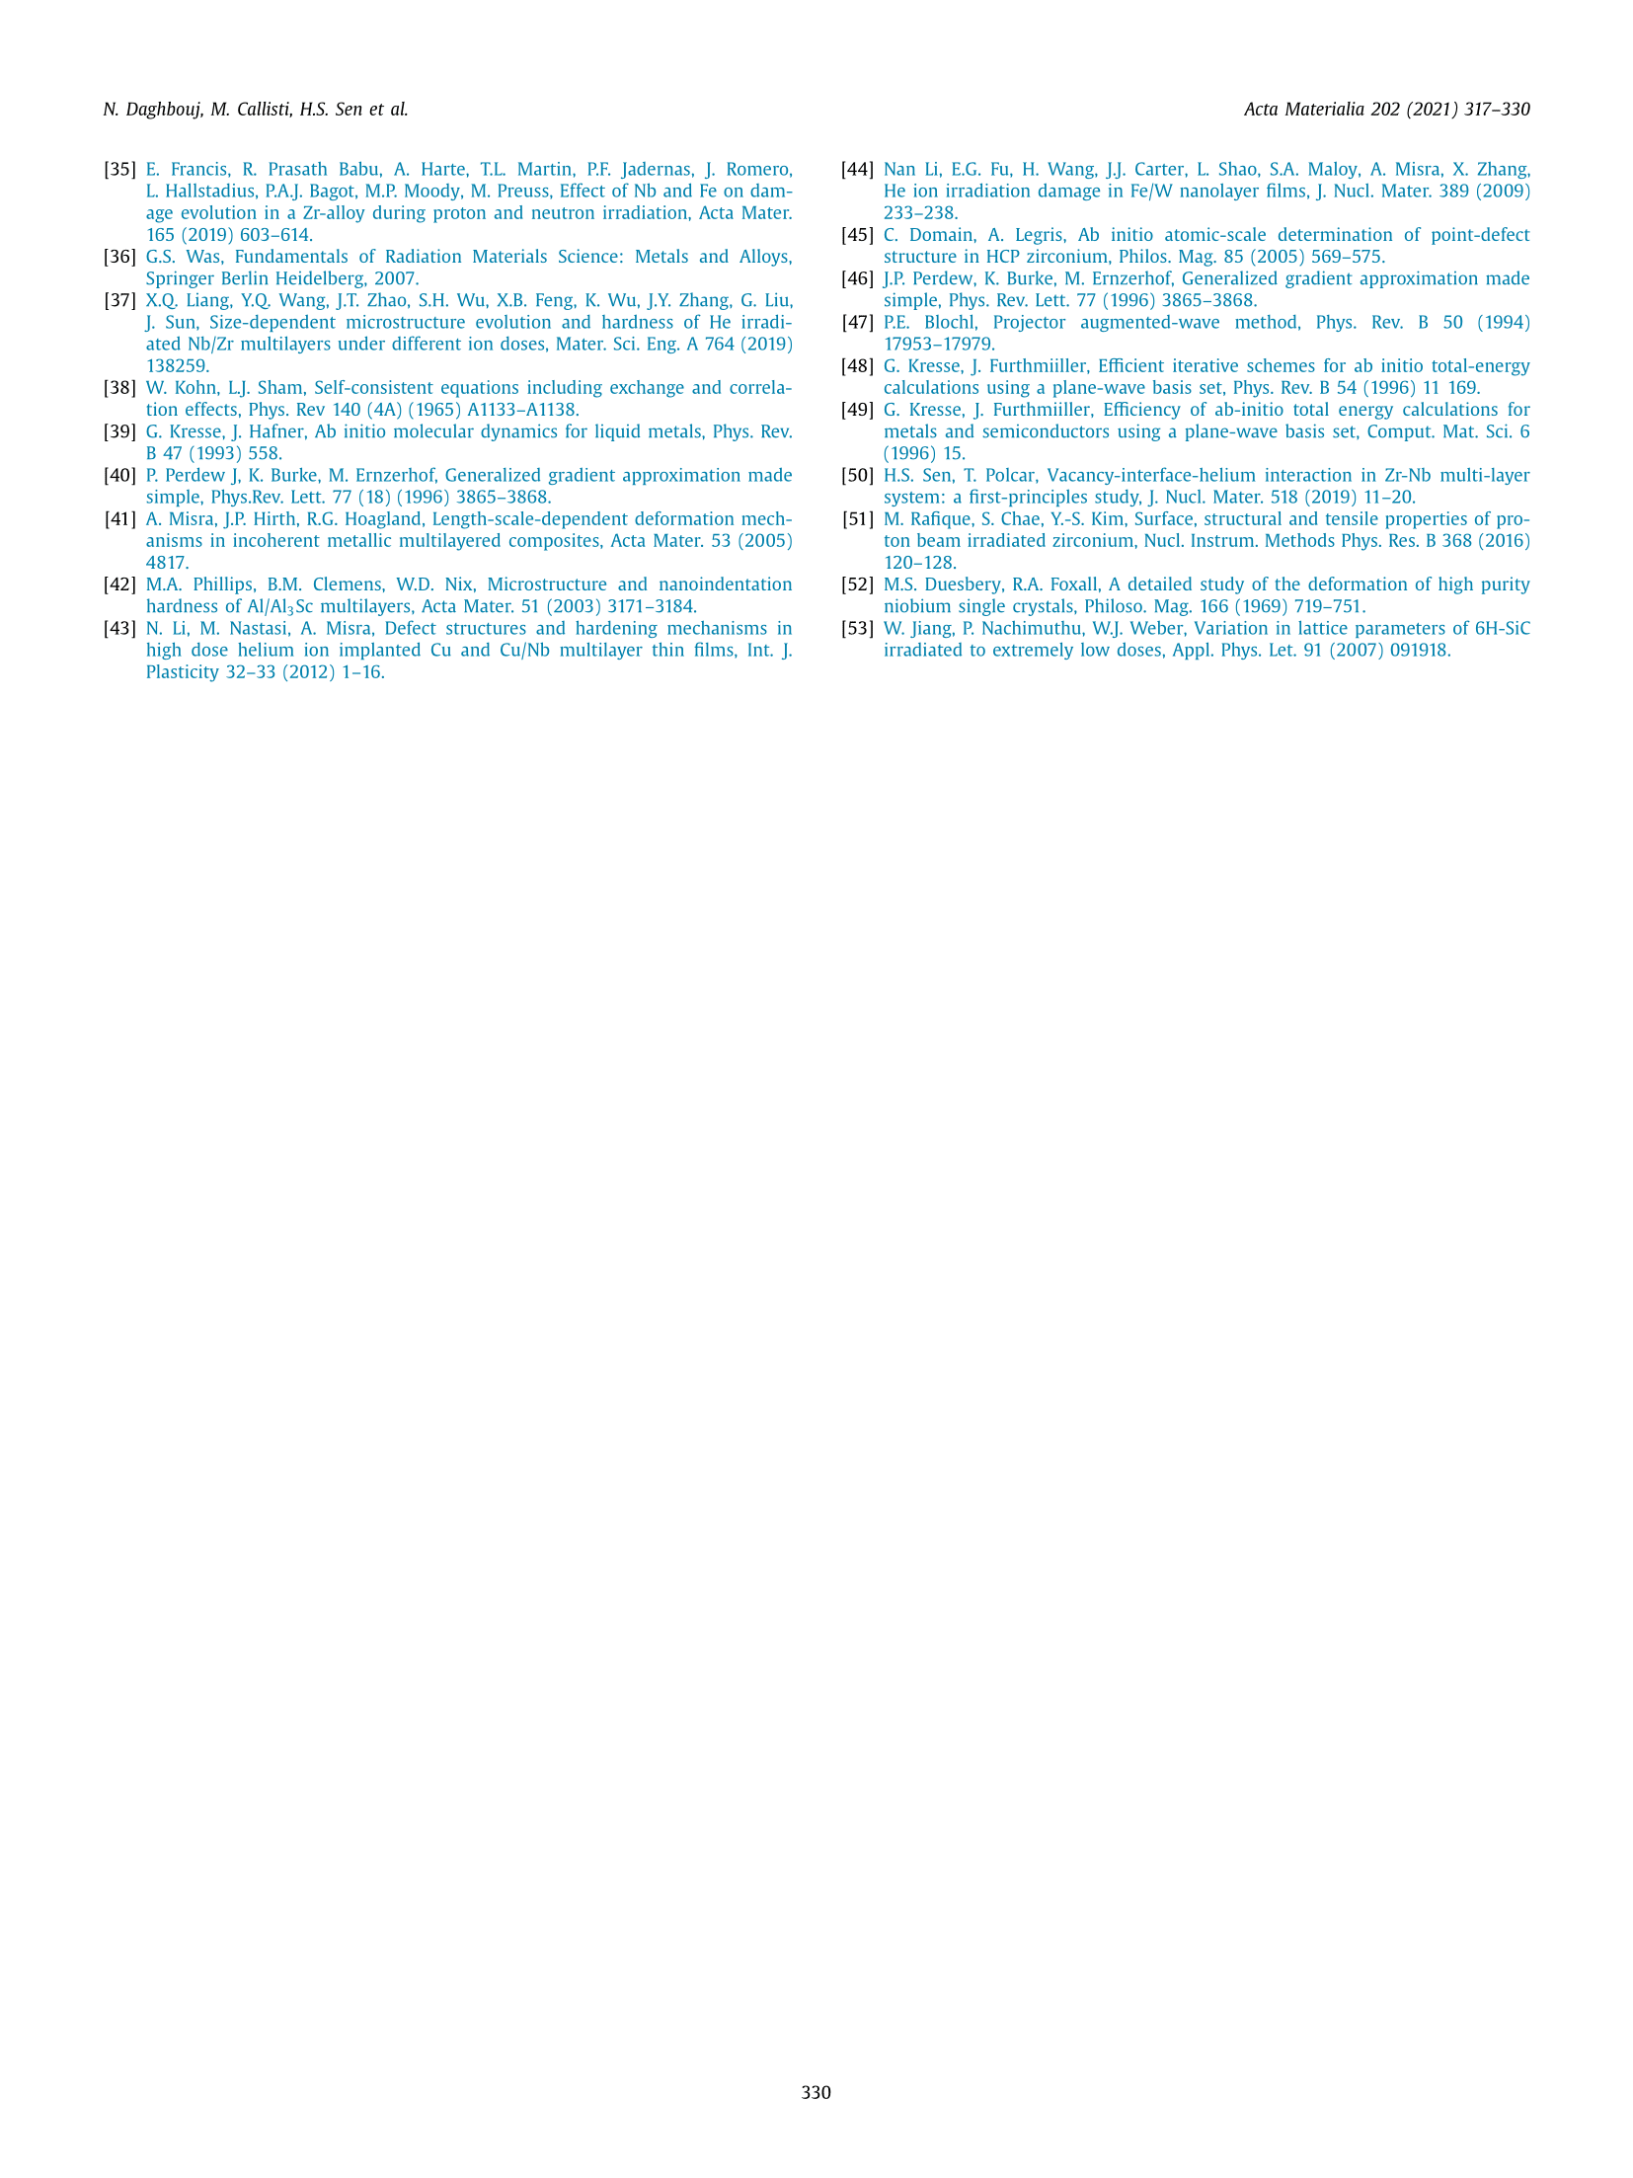

Commented paper 6

UKRAINTSEV, E., A. KROMKA, W. JANSSEN, K. HAENEN, D. TAKEUCHI, P. BÁBOR and B. REZEK. Electron emission from H-terminated diamond enhanced by polypyrrole grafting. Carbon [online]. 2021, 176, 642–649. ISSN 00086223. Available at: doi:10.1016/j.carbon.2020.12.043

(IF = 8.8, Citations 2)

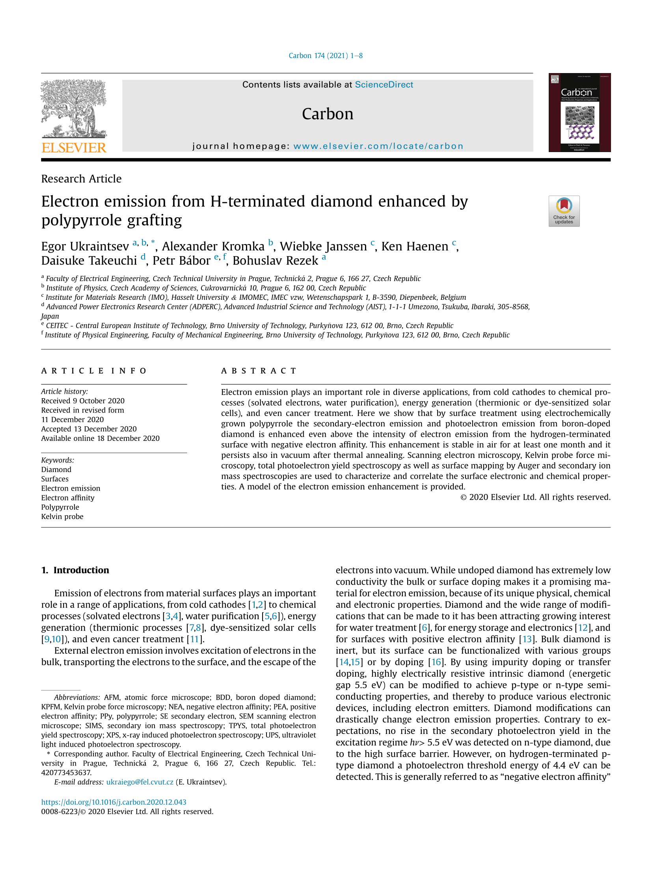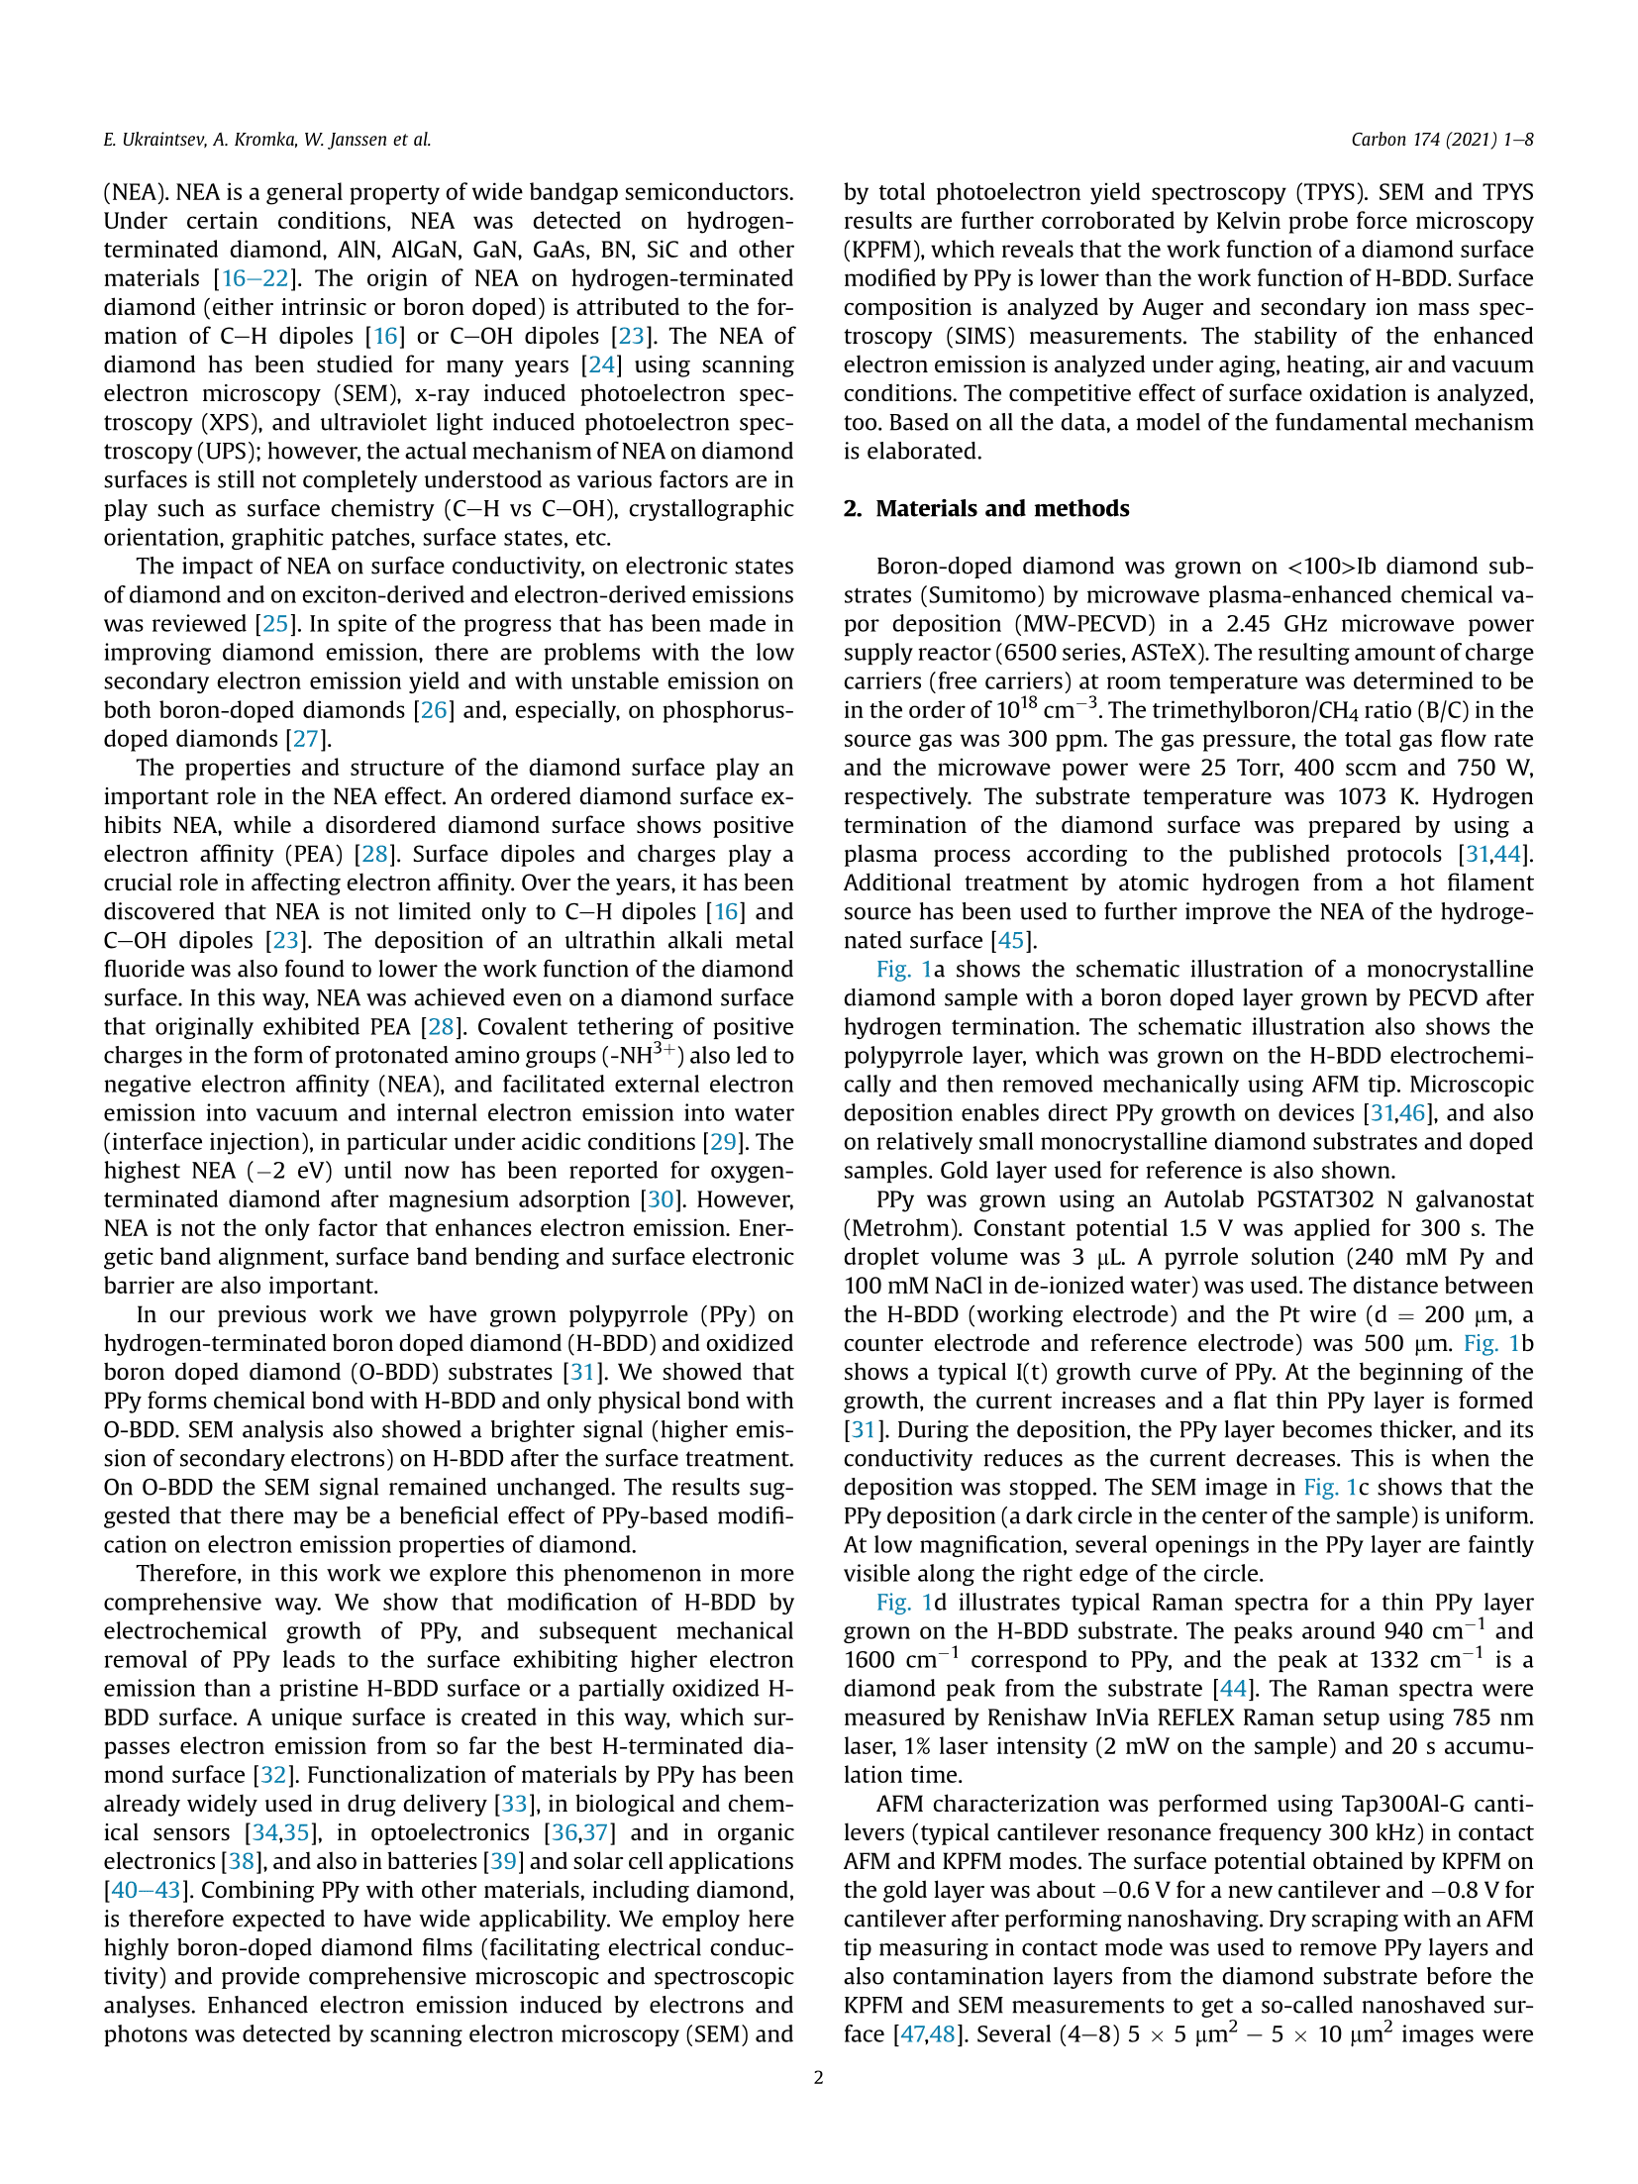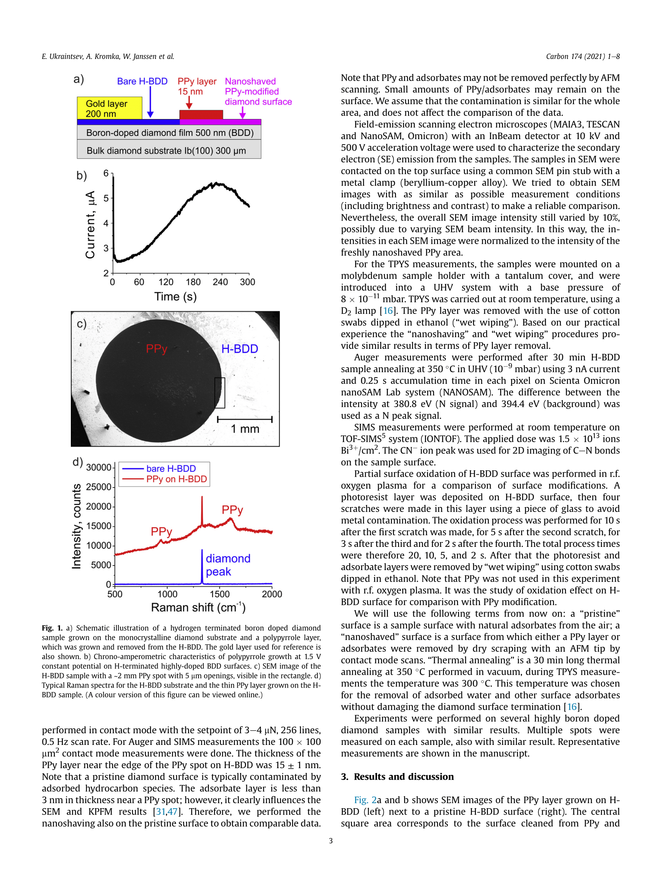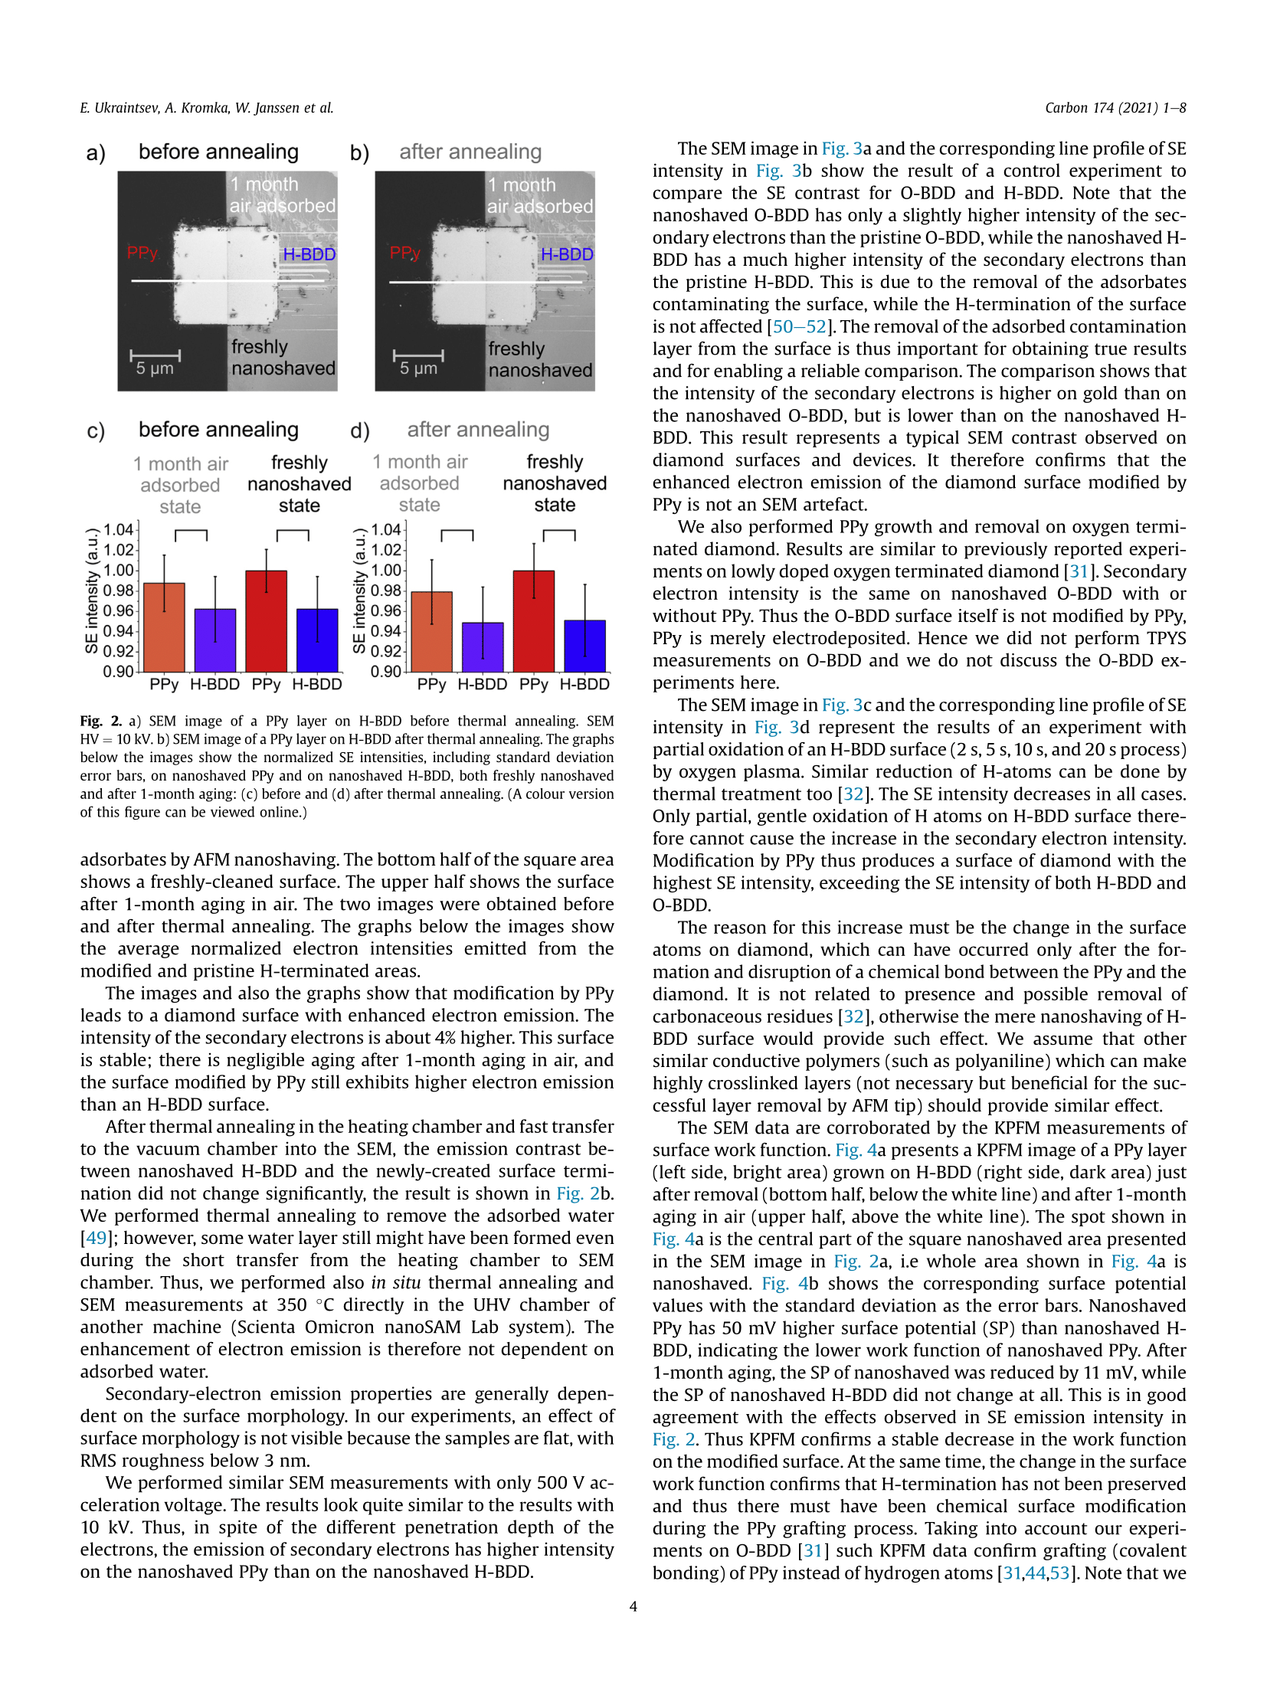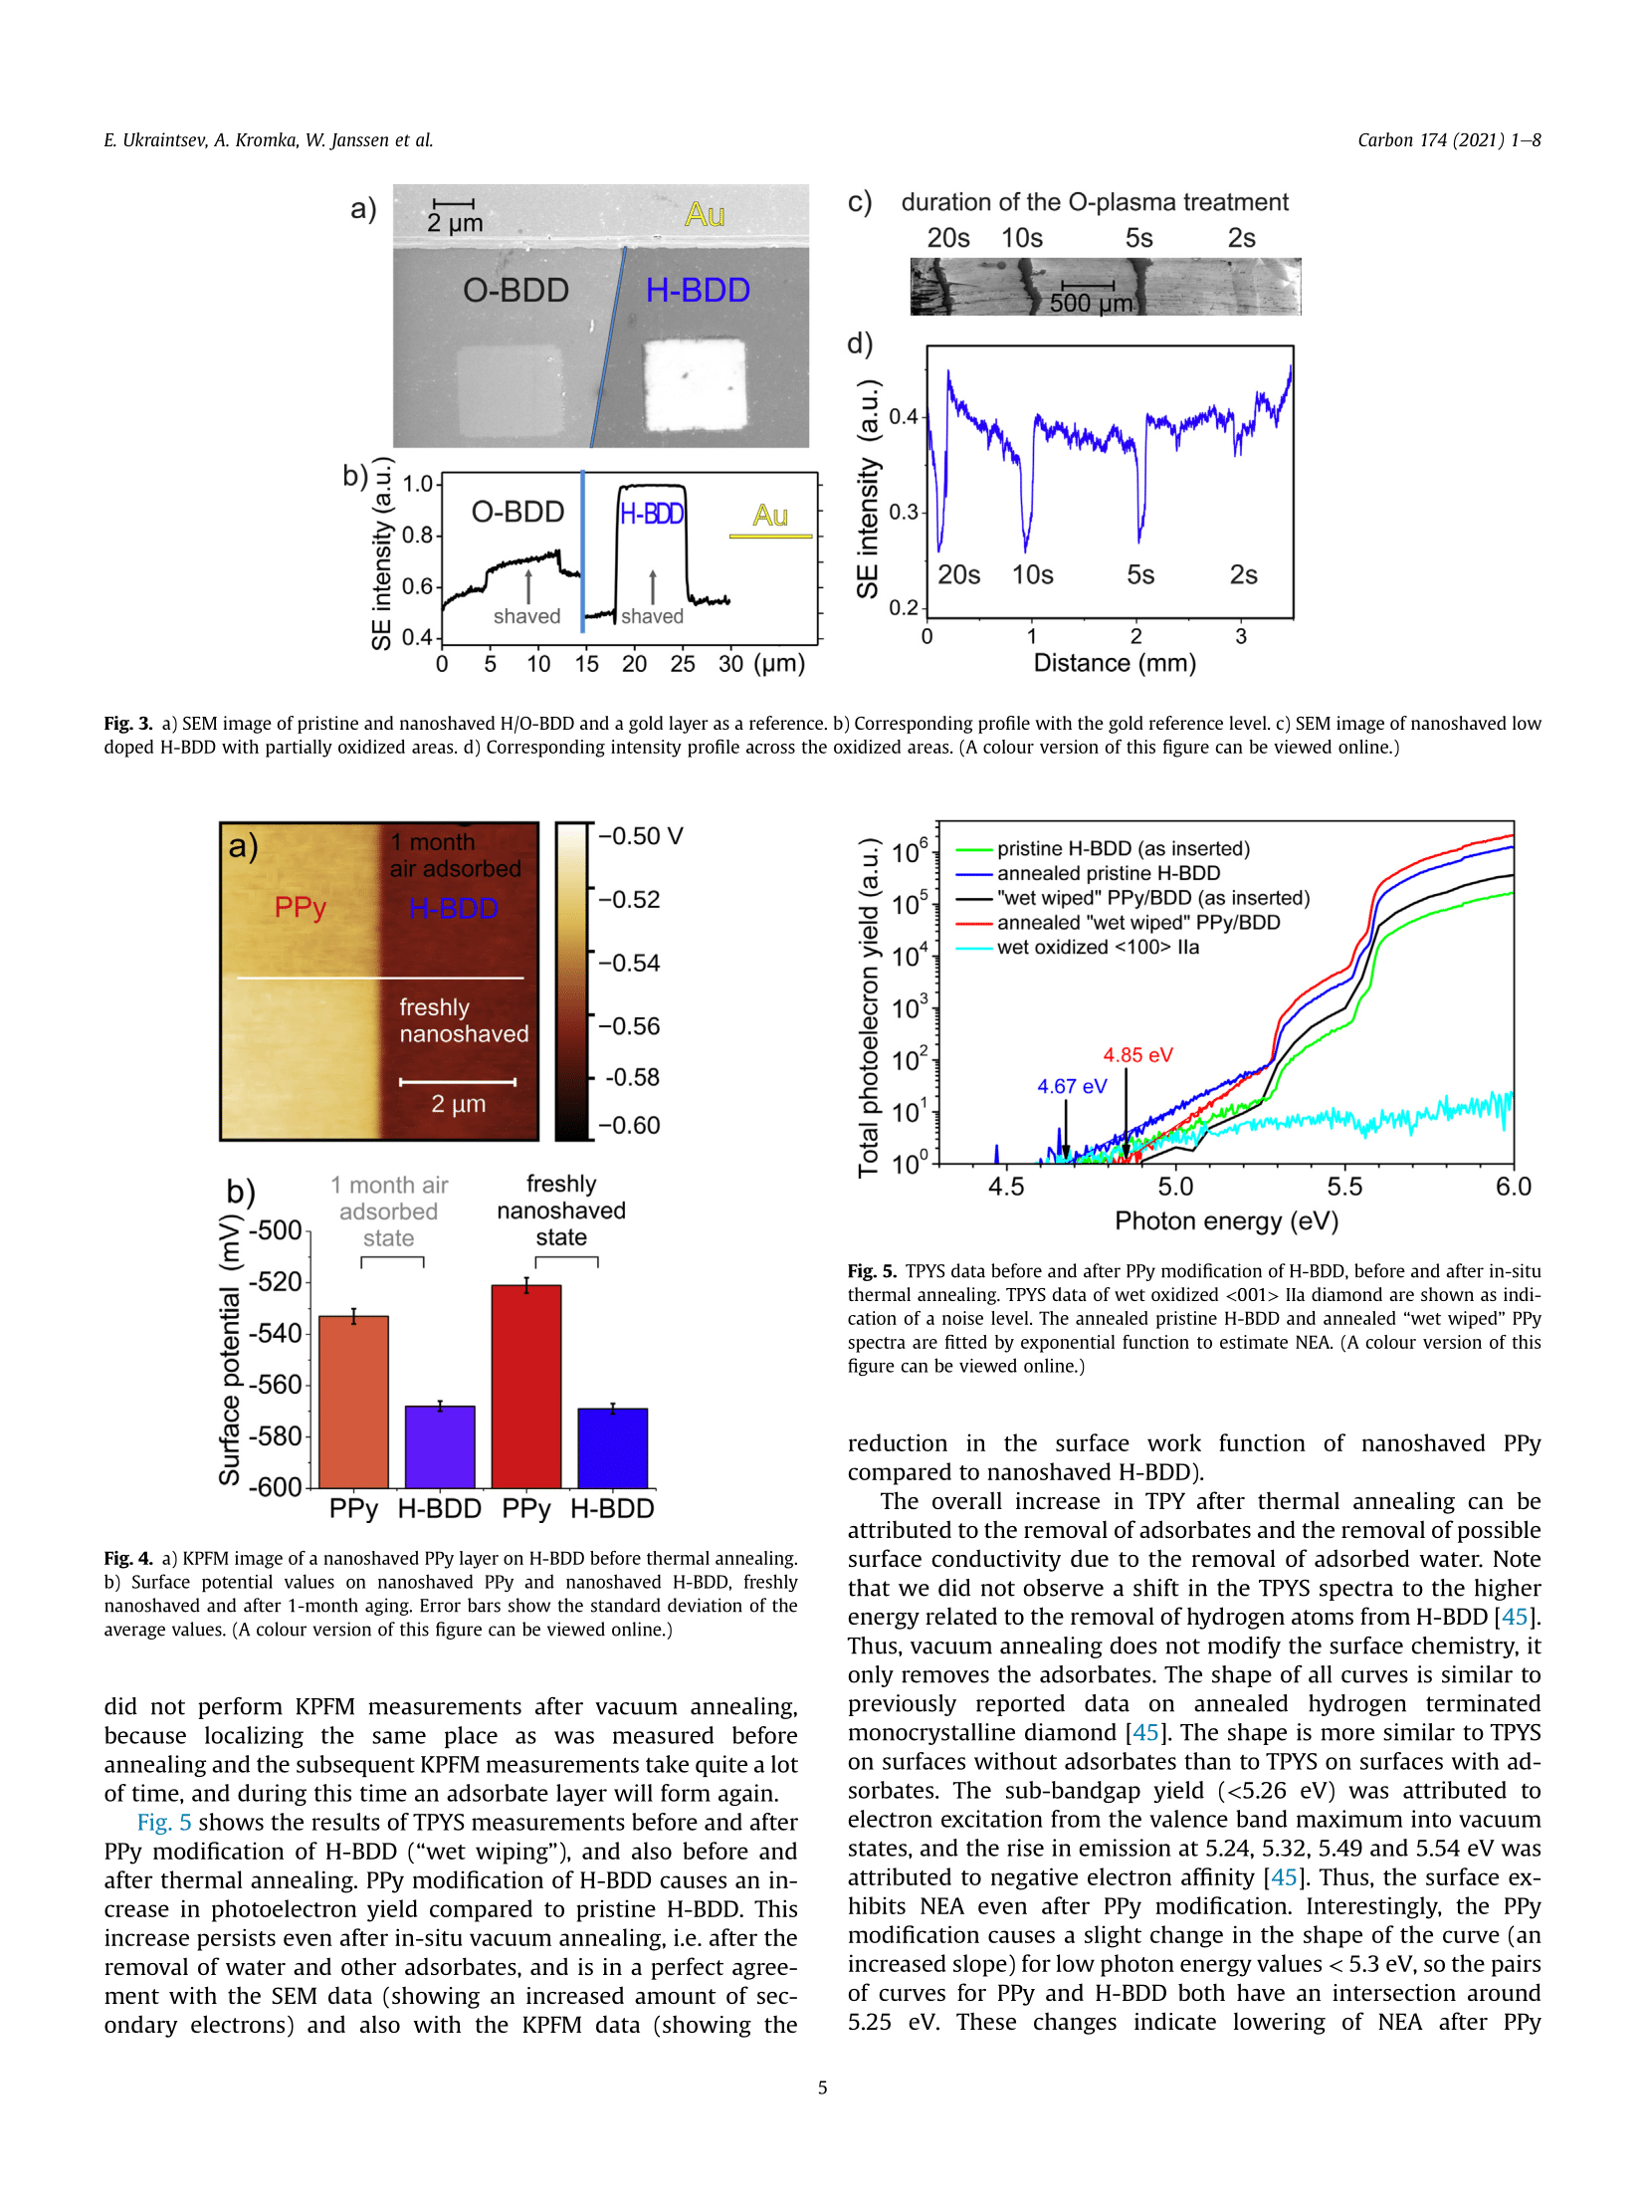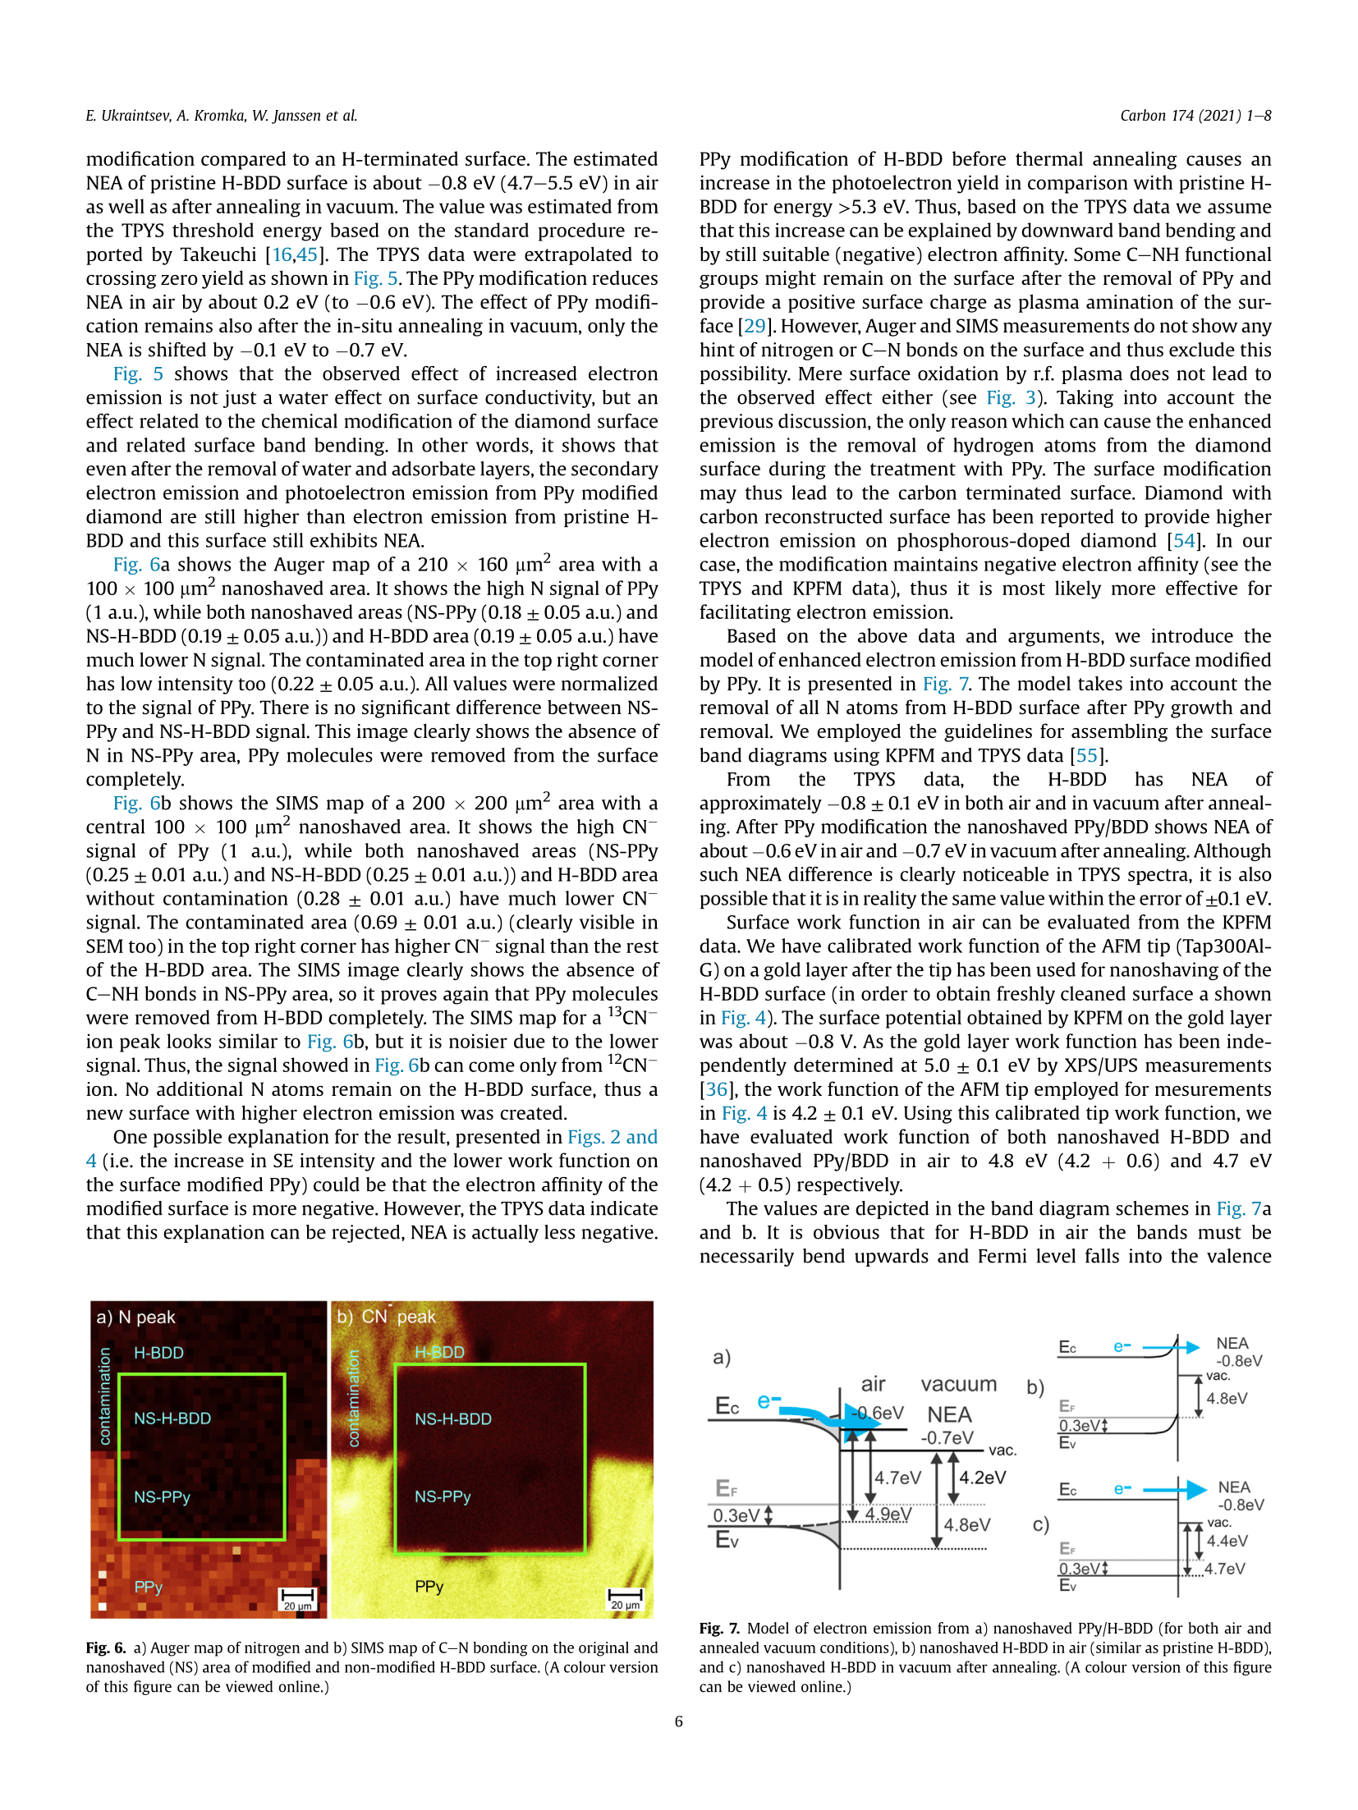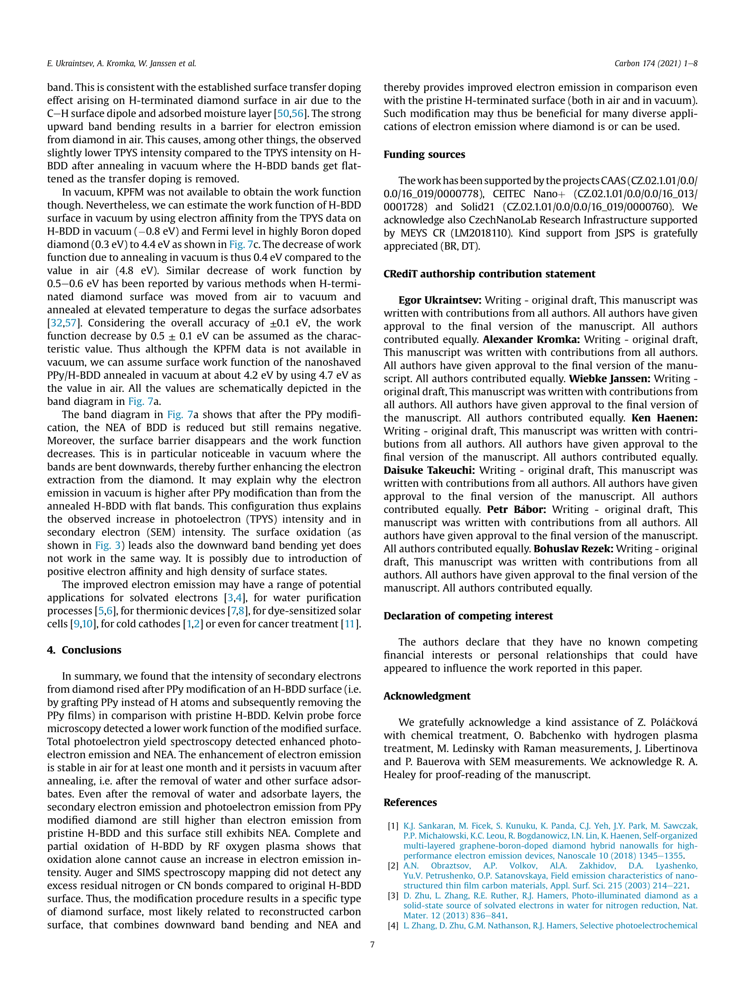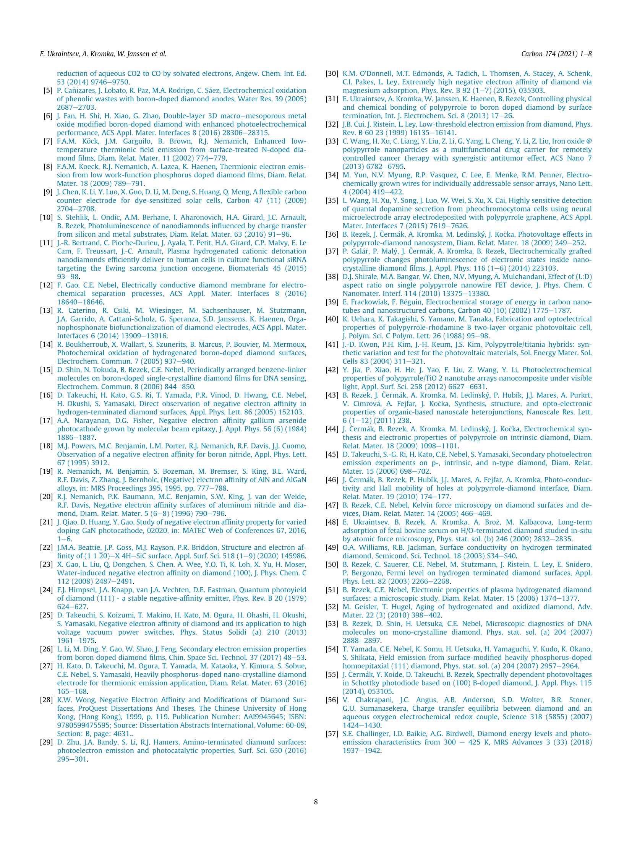

Commented paper 7

JIANG, L., N. XIAO, B. WANG, E. GRUSTAN-GUTIERREZ, X. JING, P. BÁBOR, M. KOLÍBAL, G. LU, T. WU, H. WANG, F. HUI, Y. SHI, B. SONG, X. XIE and M. LANZA. High-resolution characterization of hexagonal boron nitride coatings exposed to aqueous and air oxidative environments. Nano Research [online]. 2017, 10(6), 2046–2055. ISSN 19980000. Available at: doi:10.1007/s12274-016-1393-2

(IF = 8.1, Citations 16)

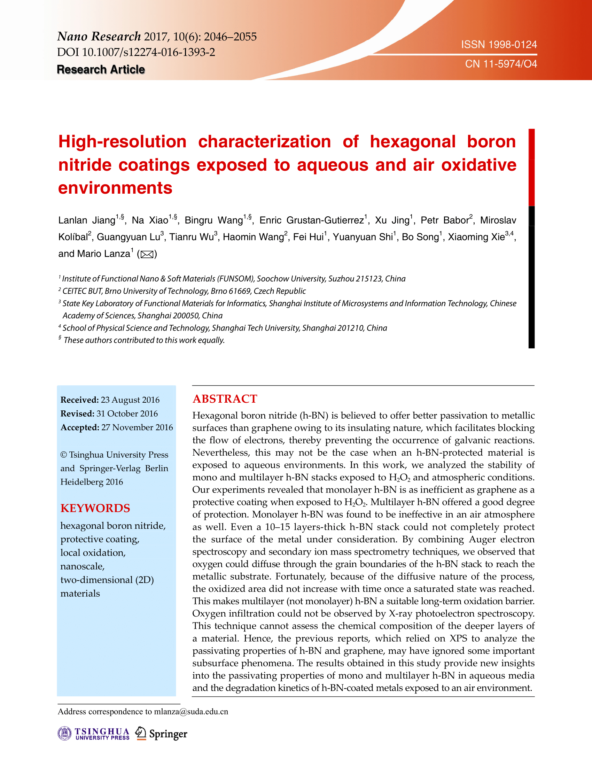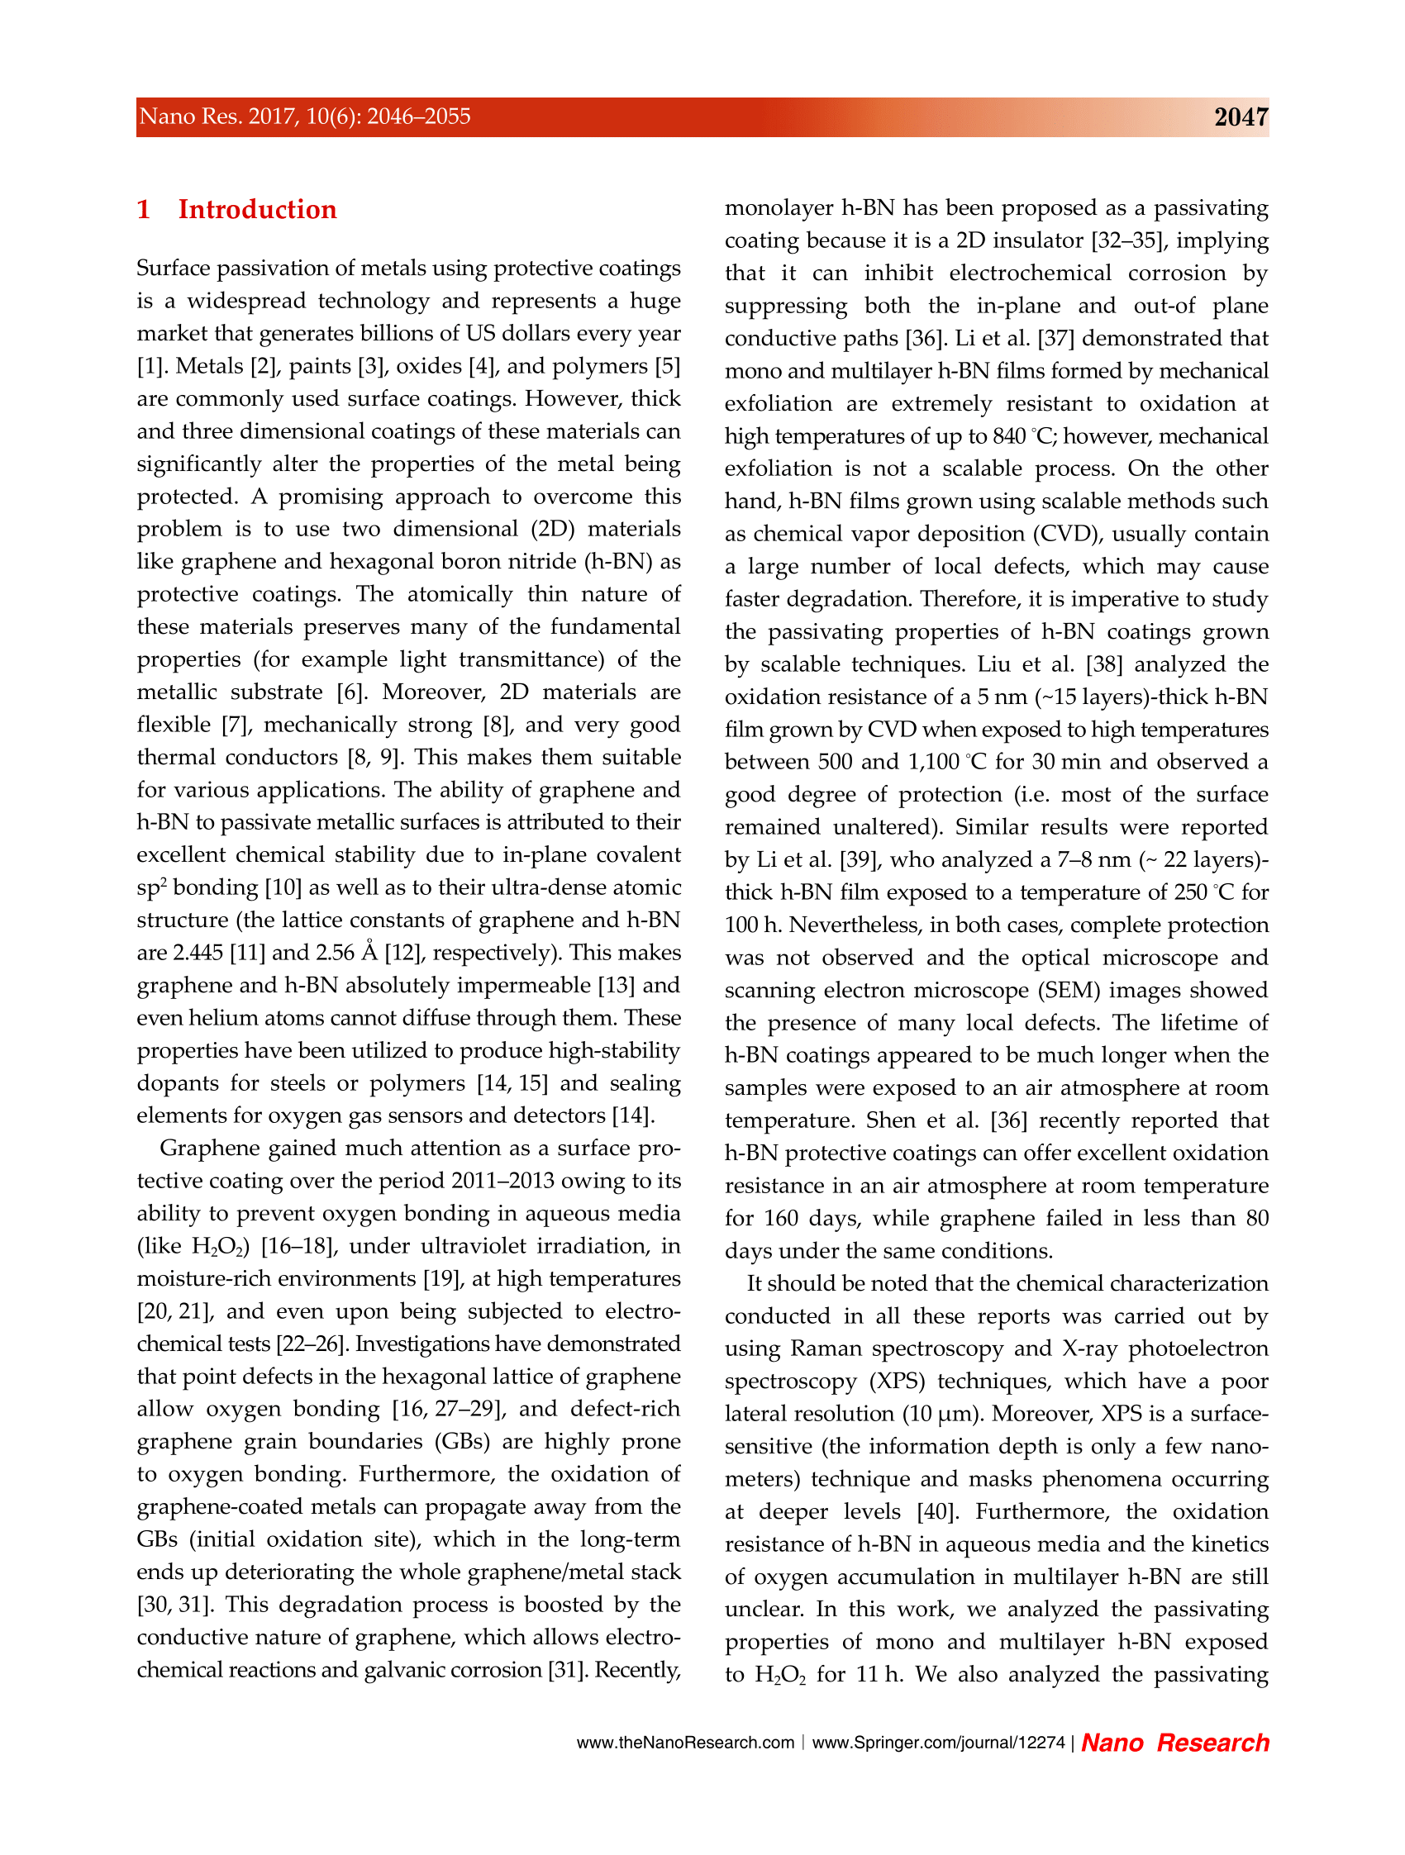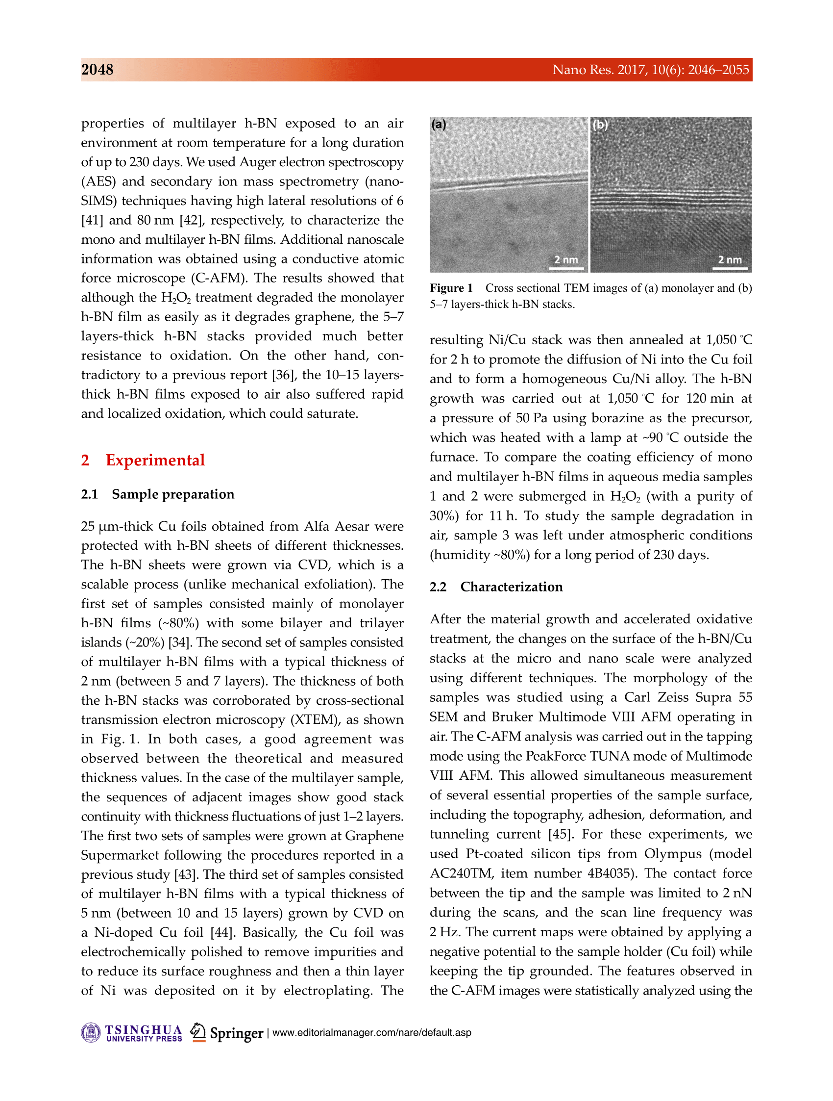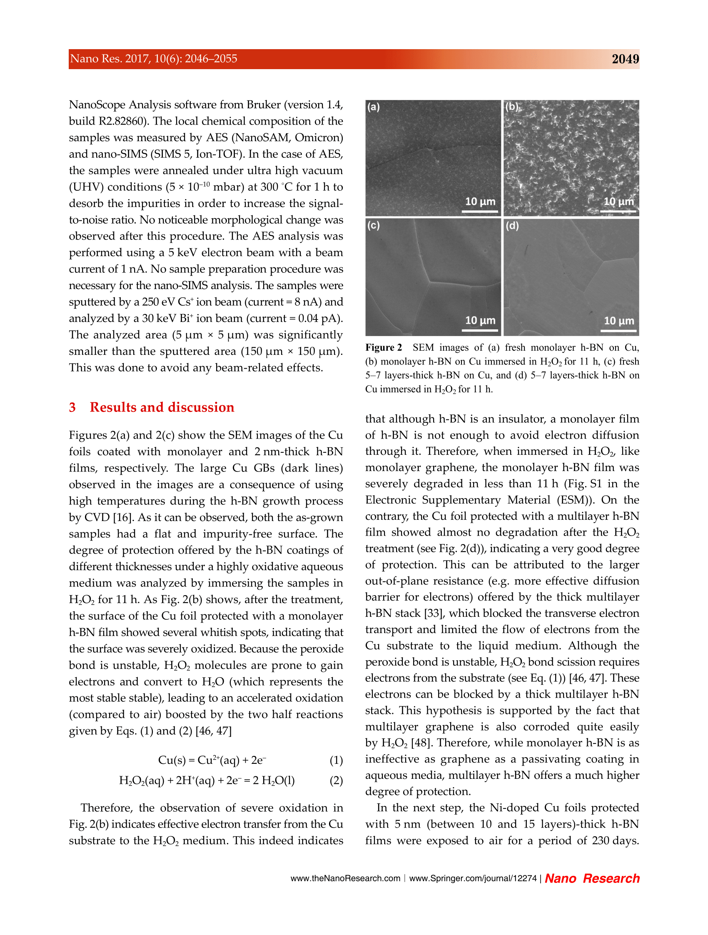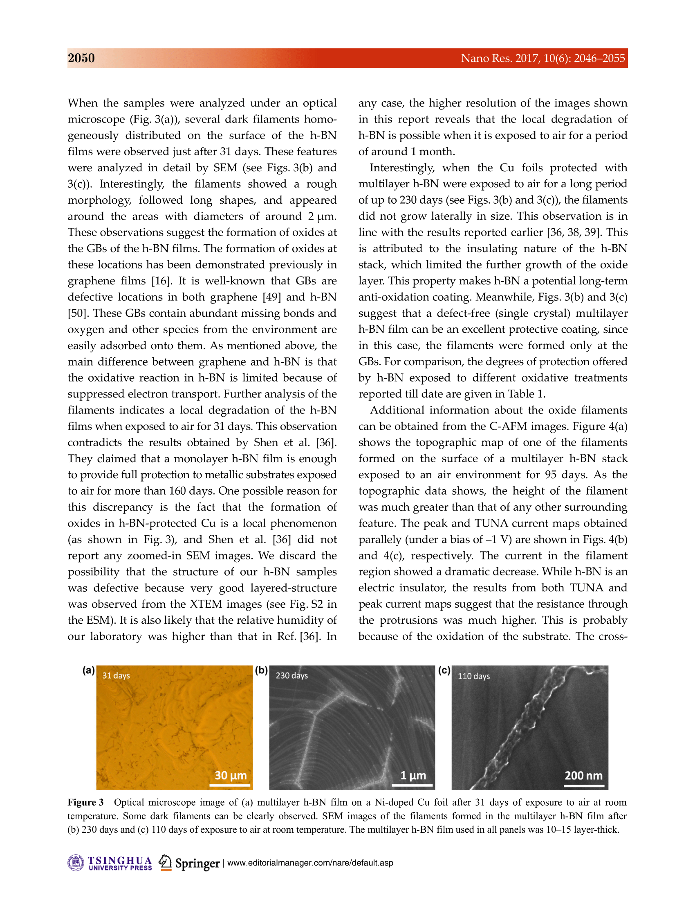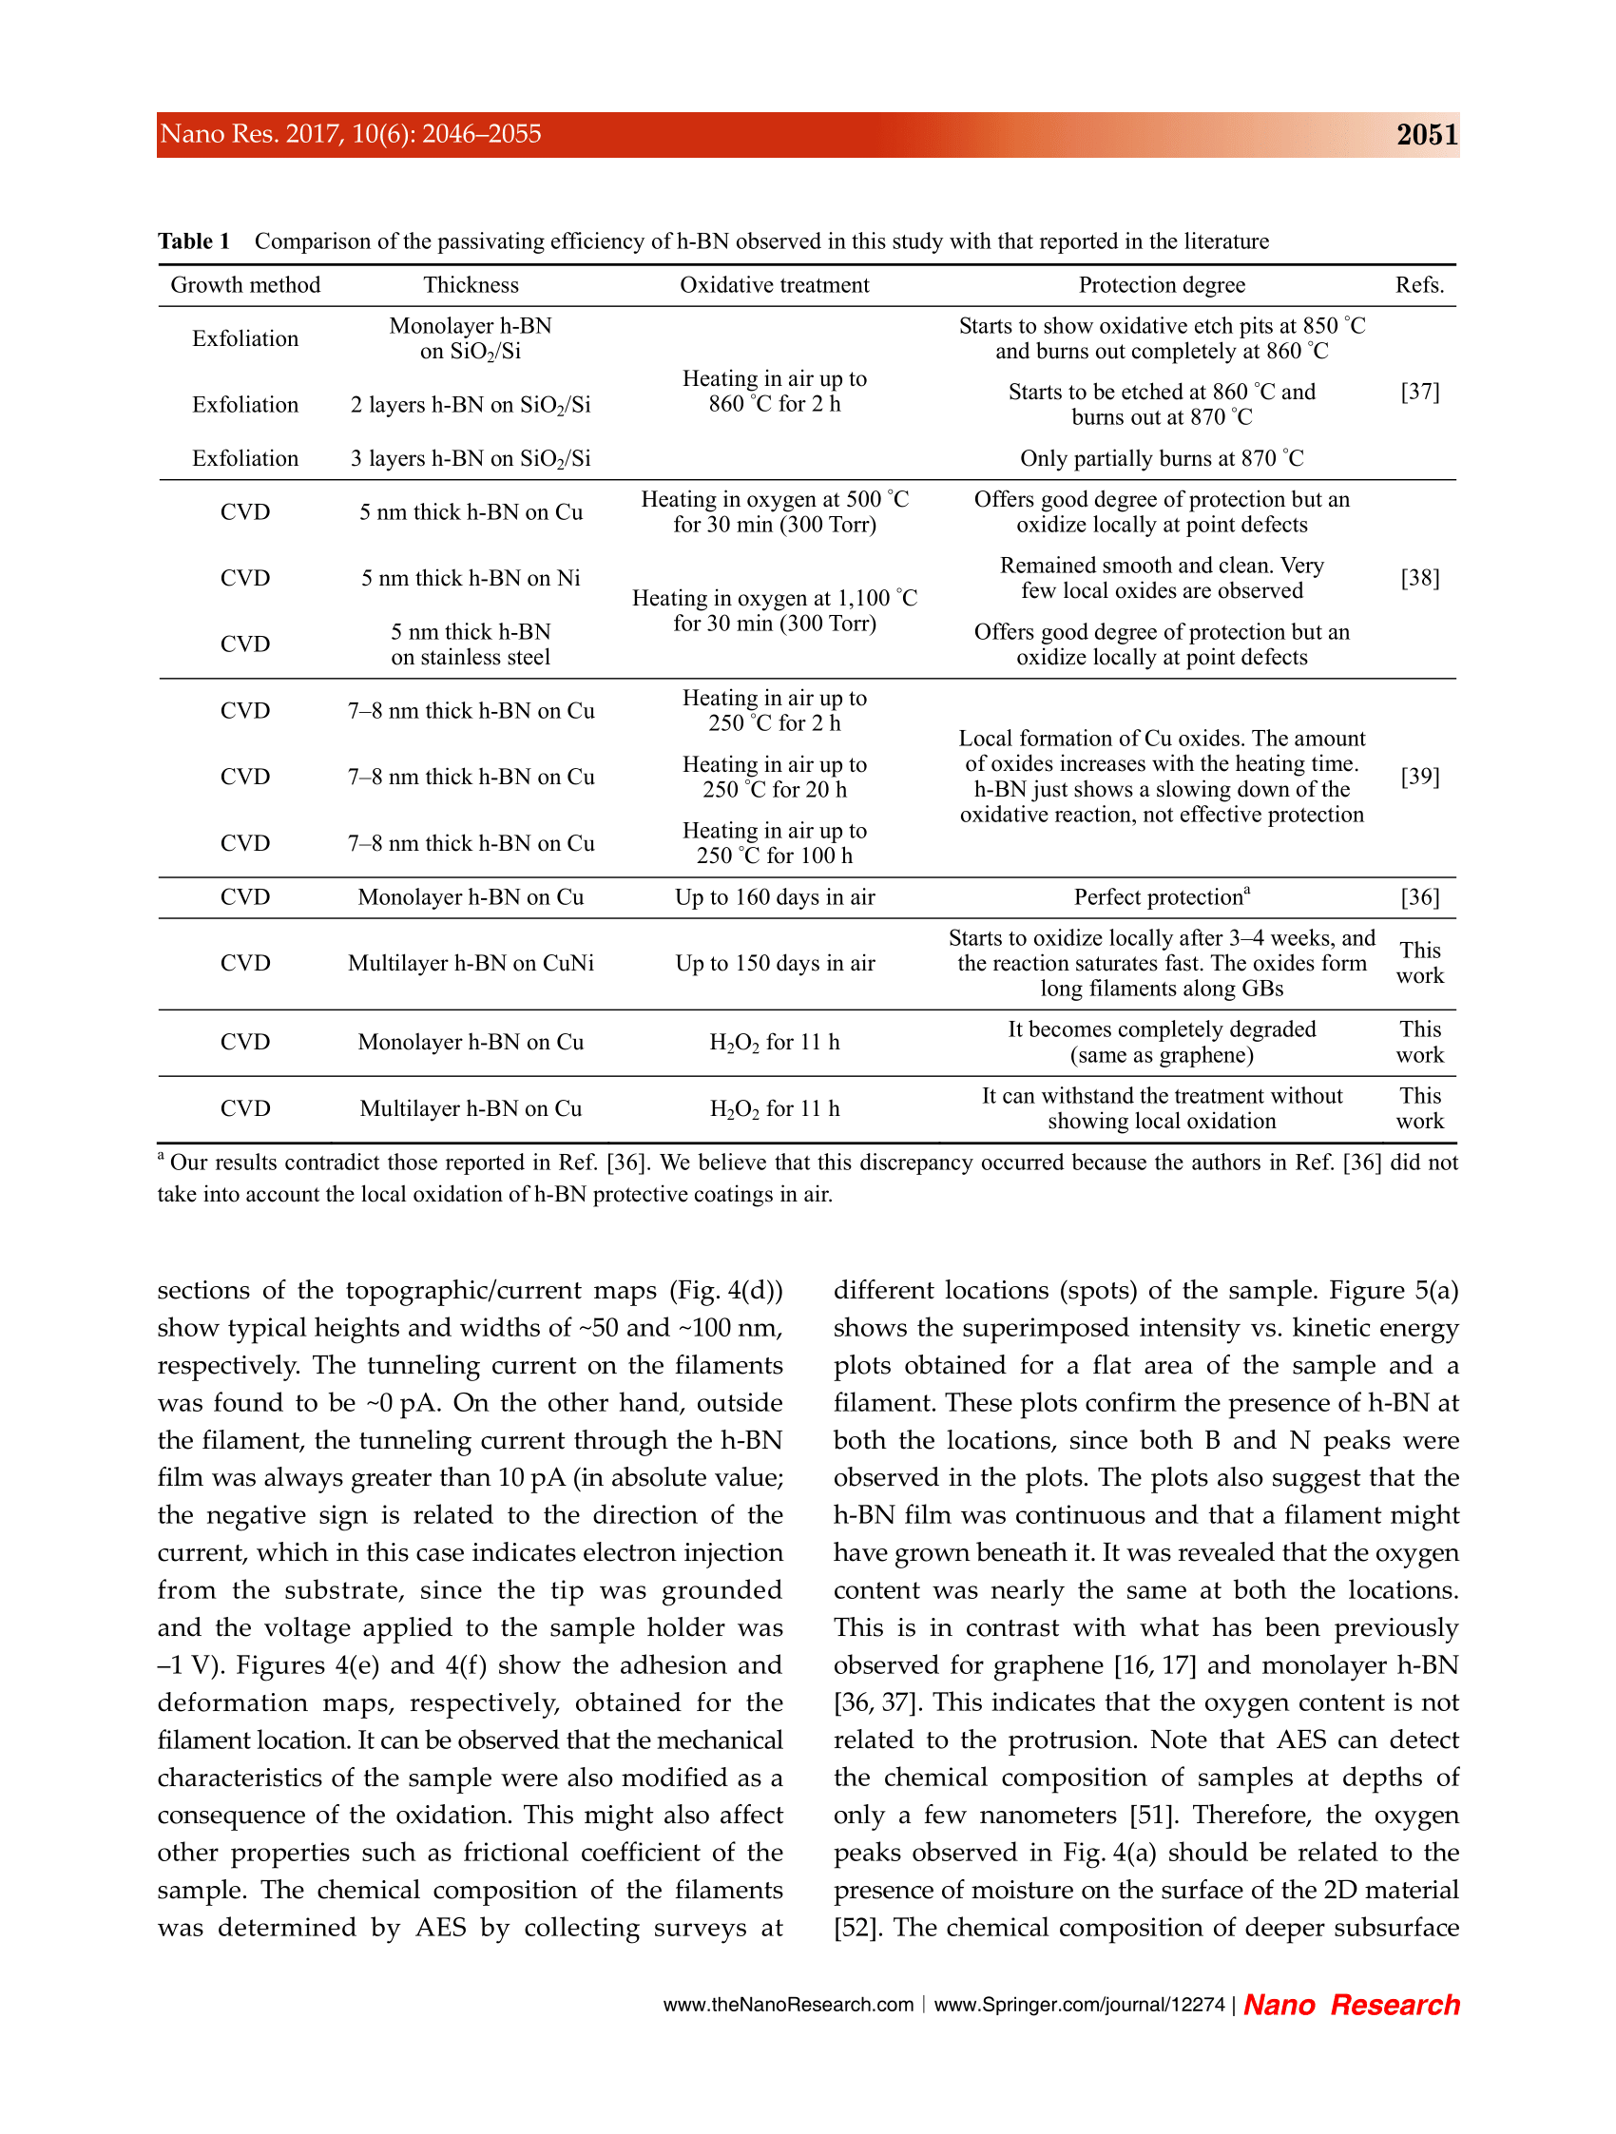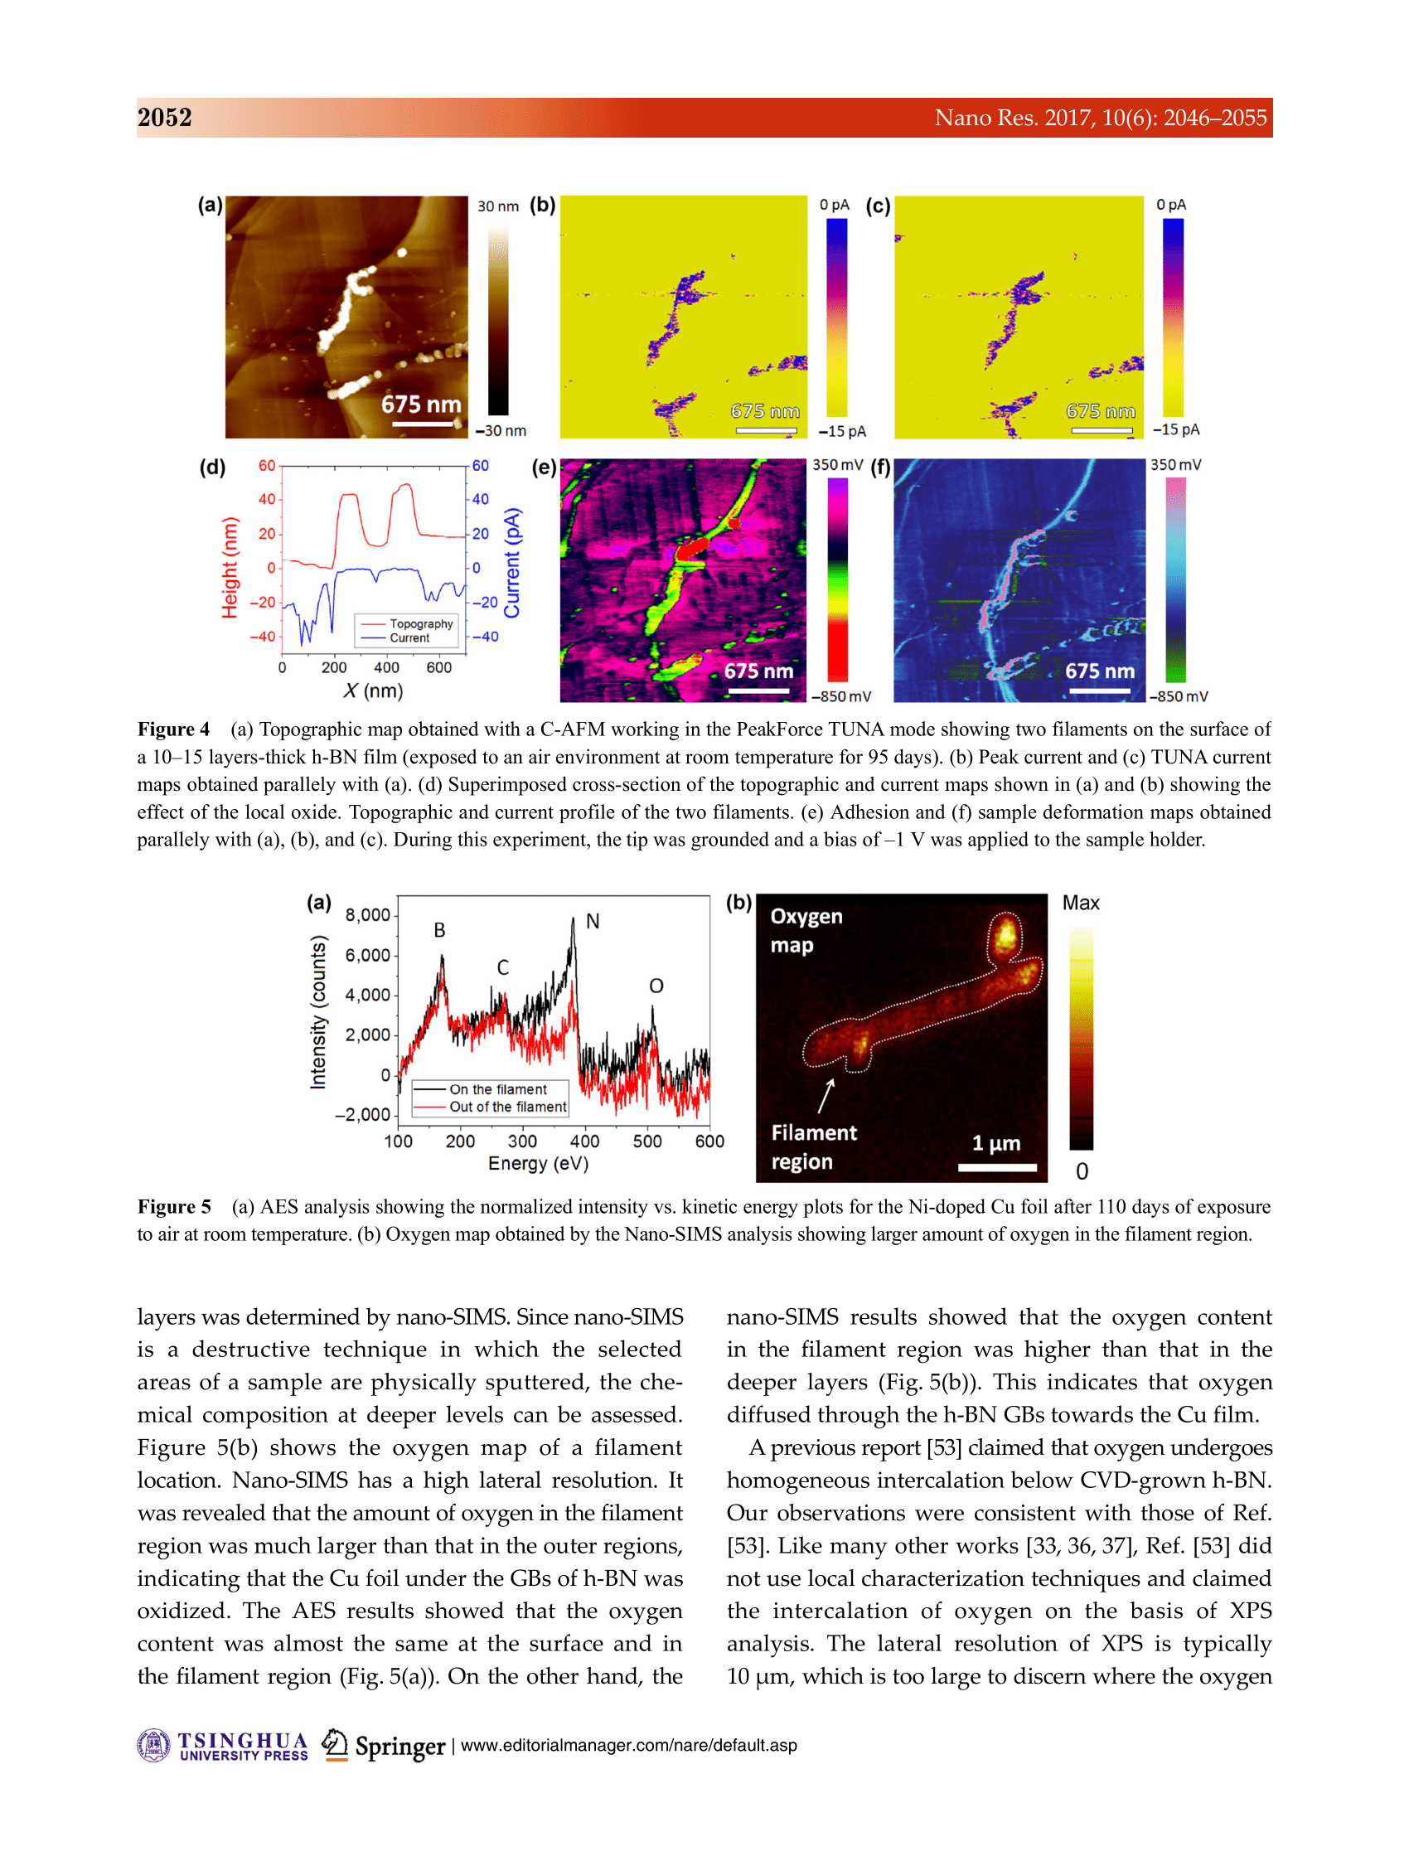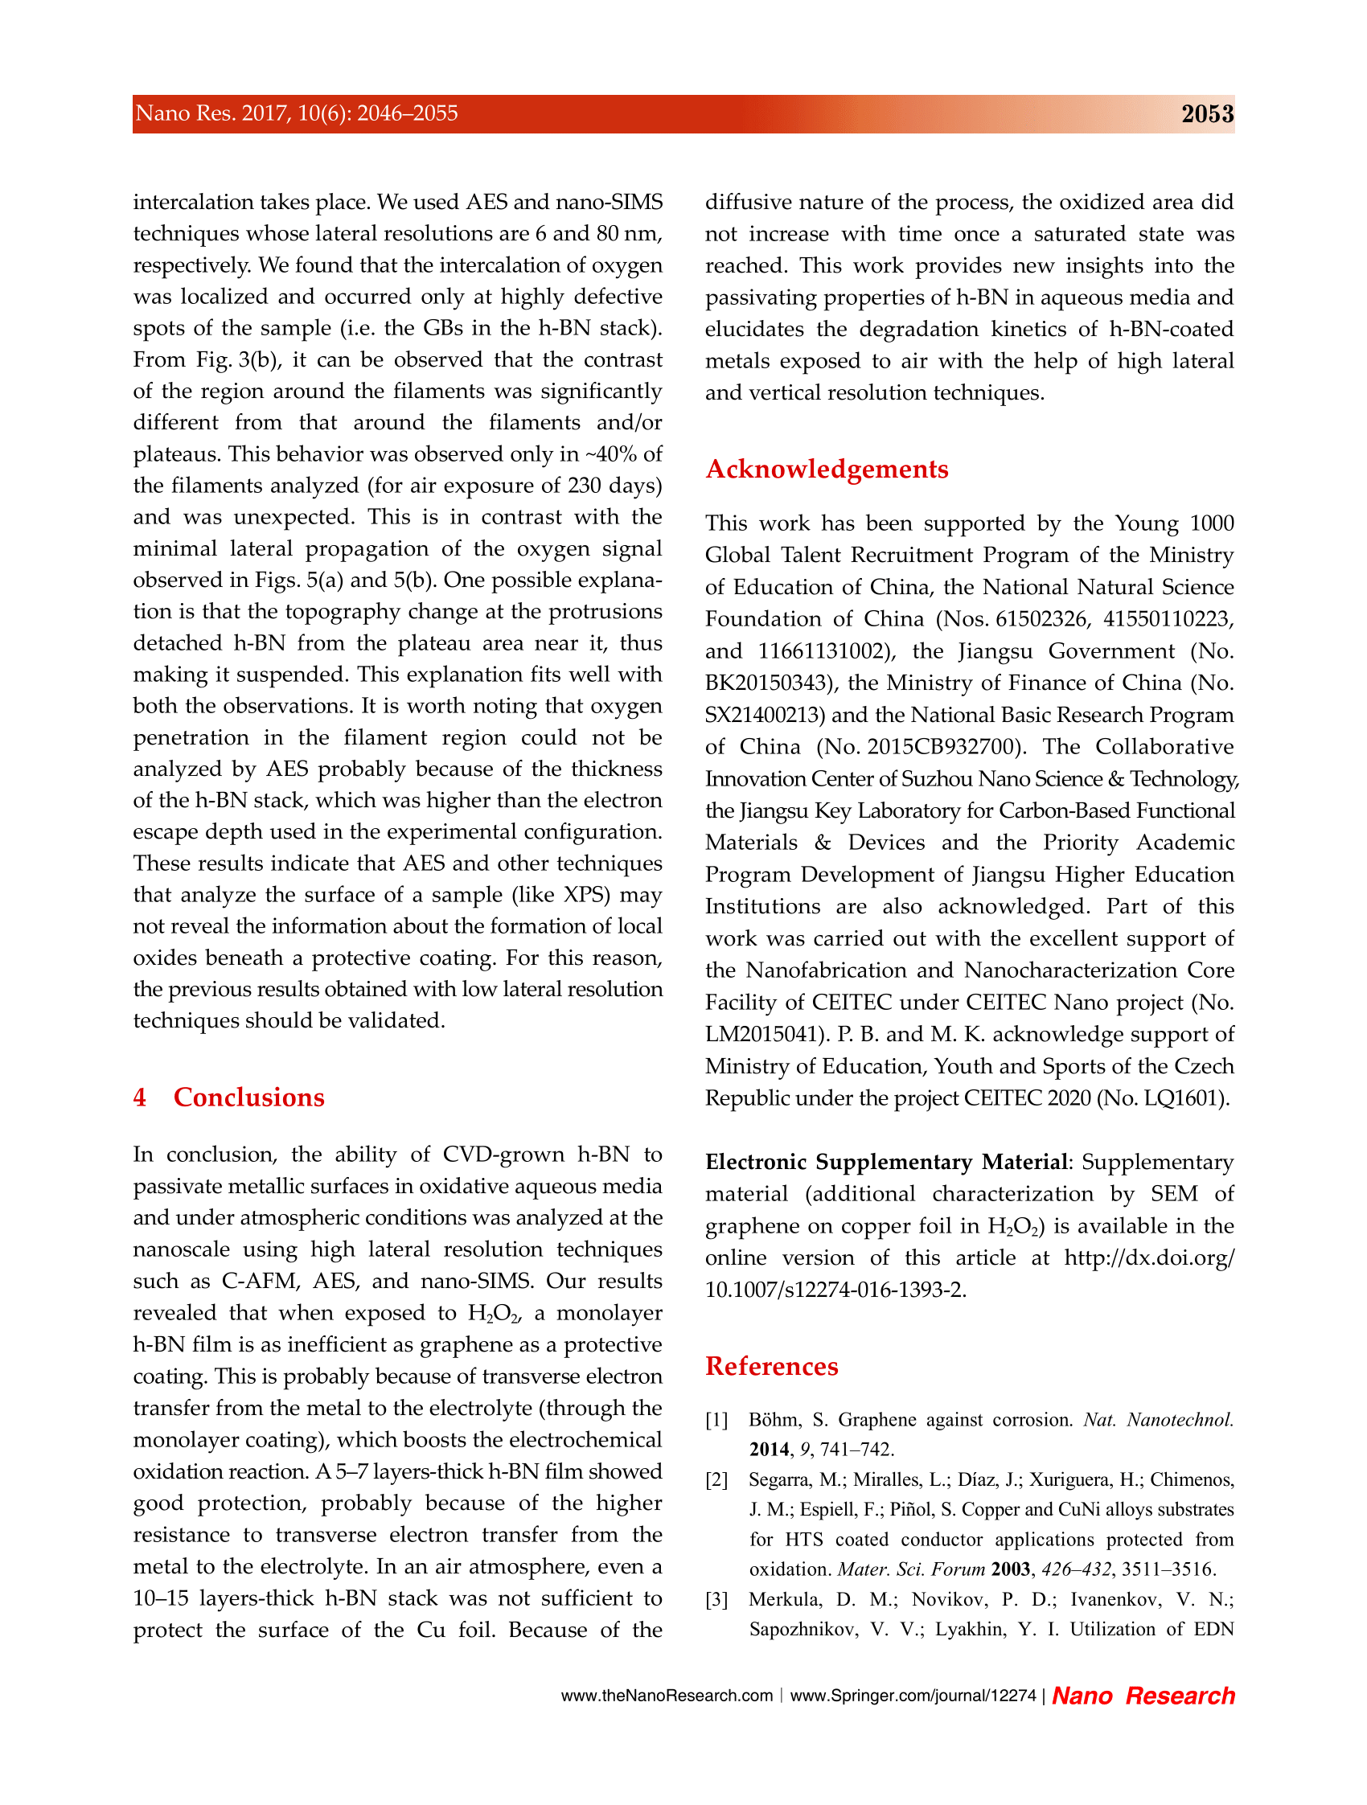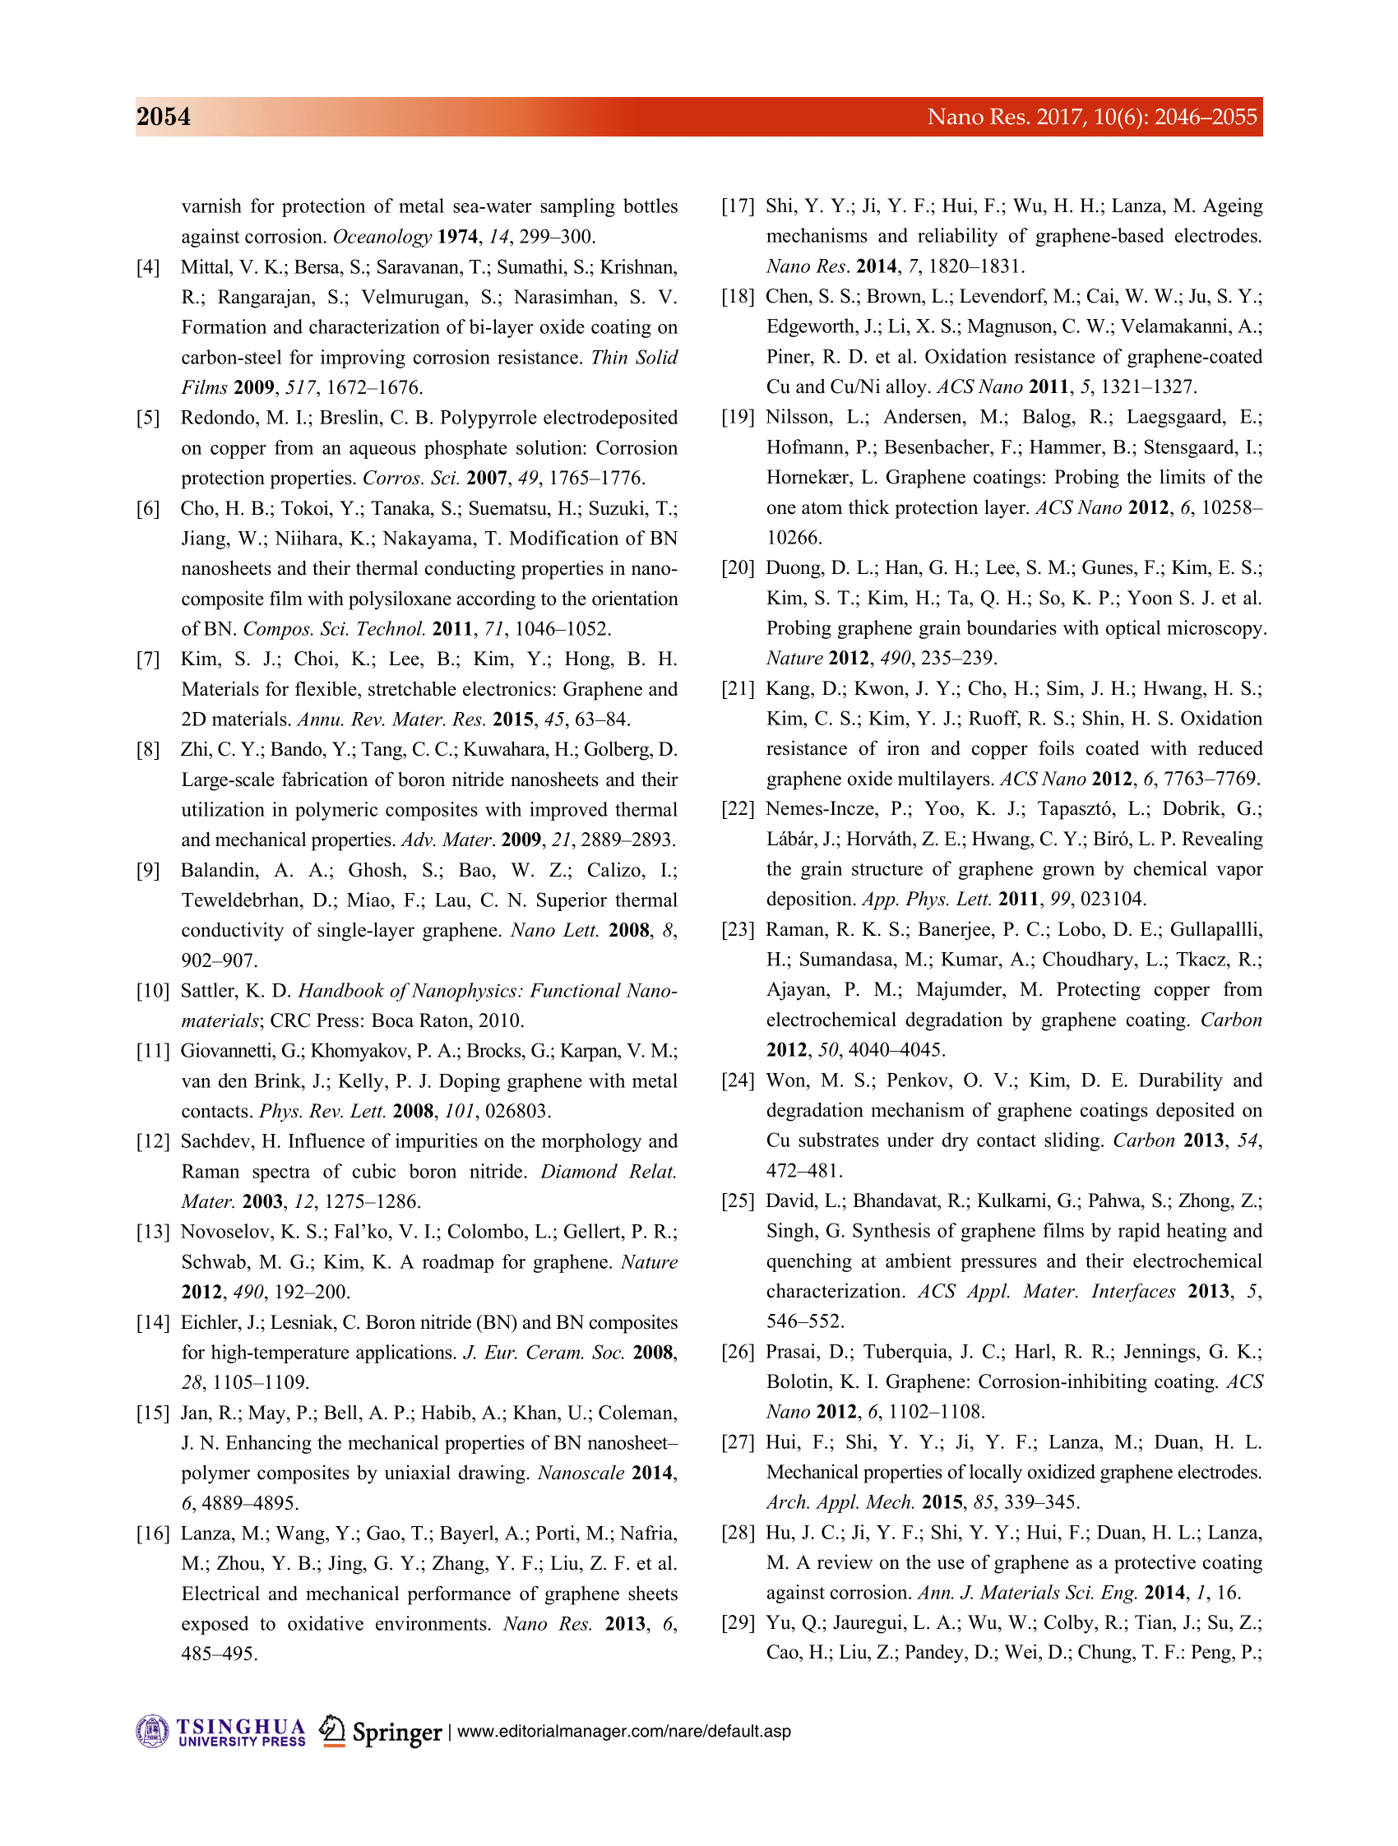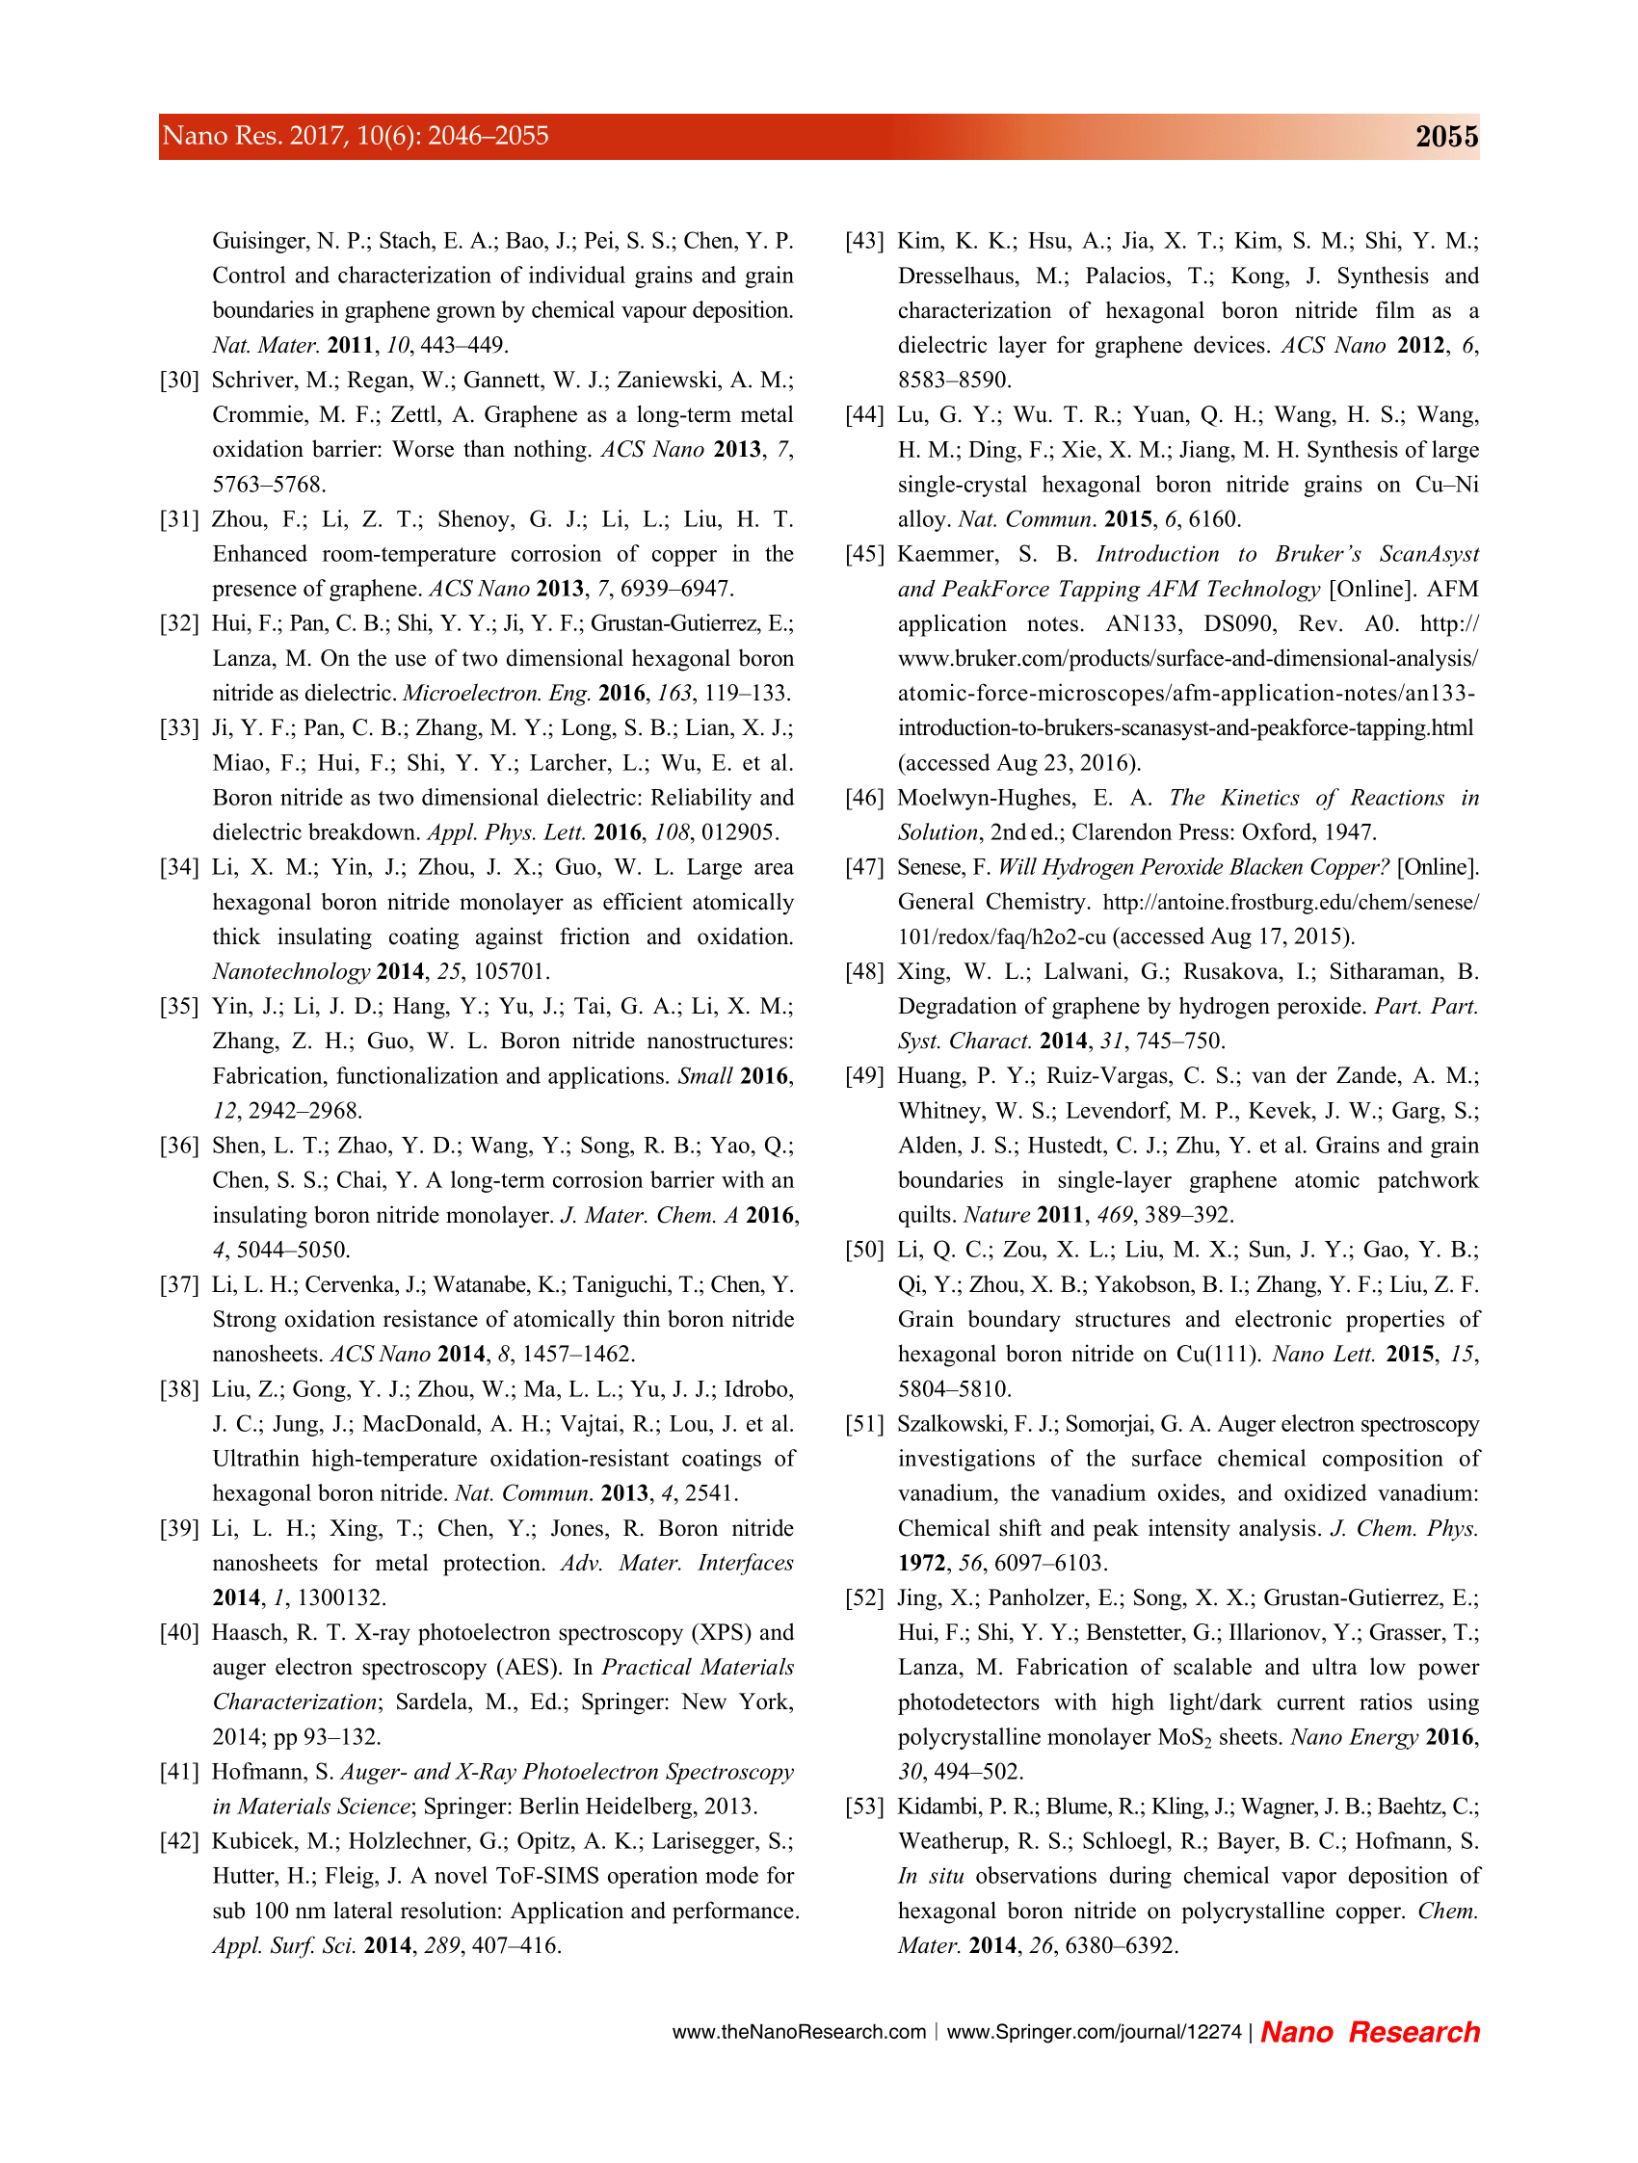

Commented paper 8

HOLEŇÁK, R., T. SPUSTA, M. POTOČEK, D. SALAMON, T. ŠIKOLA and P. BÁBOR. 3D localization of spinel (MgAl₂O₄) and sodium contamination in alumina by TOF-SIMS. Materials Characterization [online]. 2019, 148(April 2018), 252–258. ISSN 10445803. Available at: doi:10.1016/j.matchar.2018.12.019

(IF = 3.5, Citations 1)

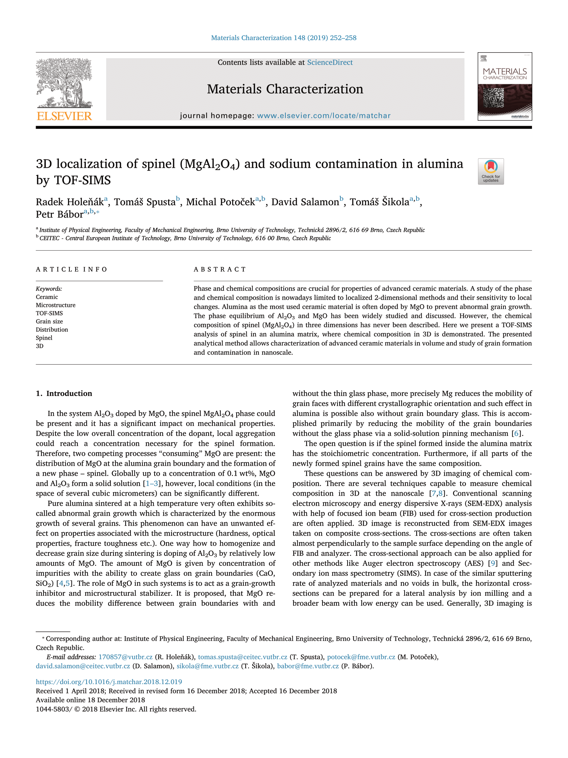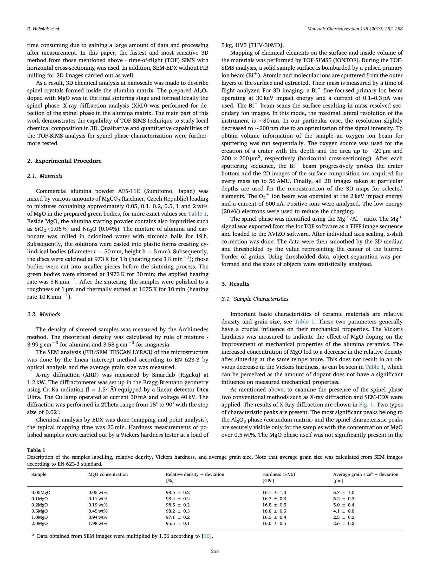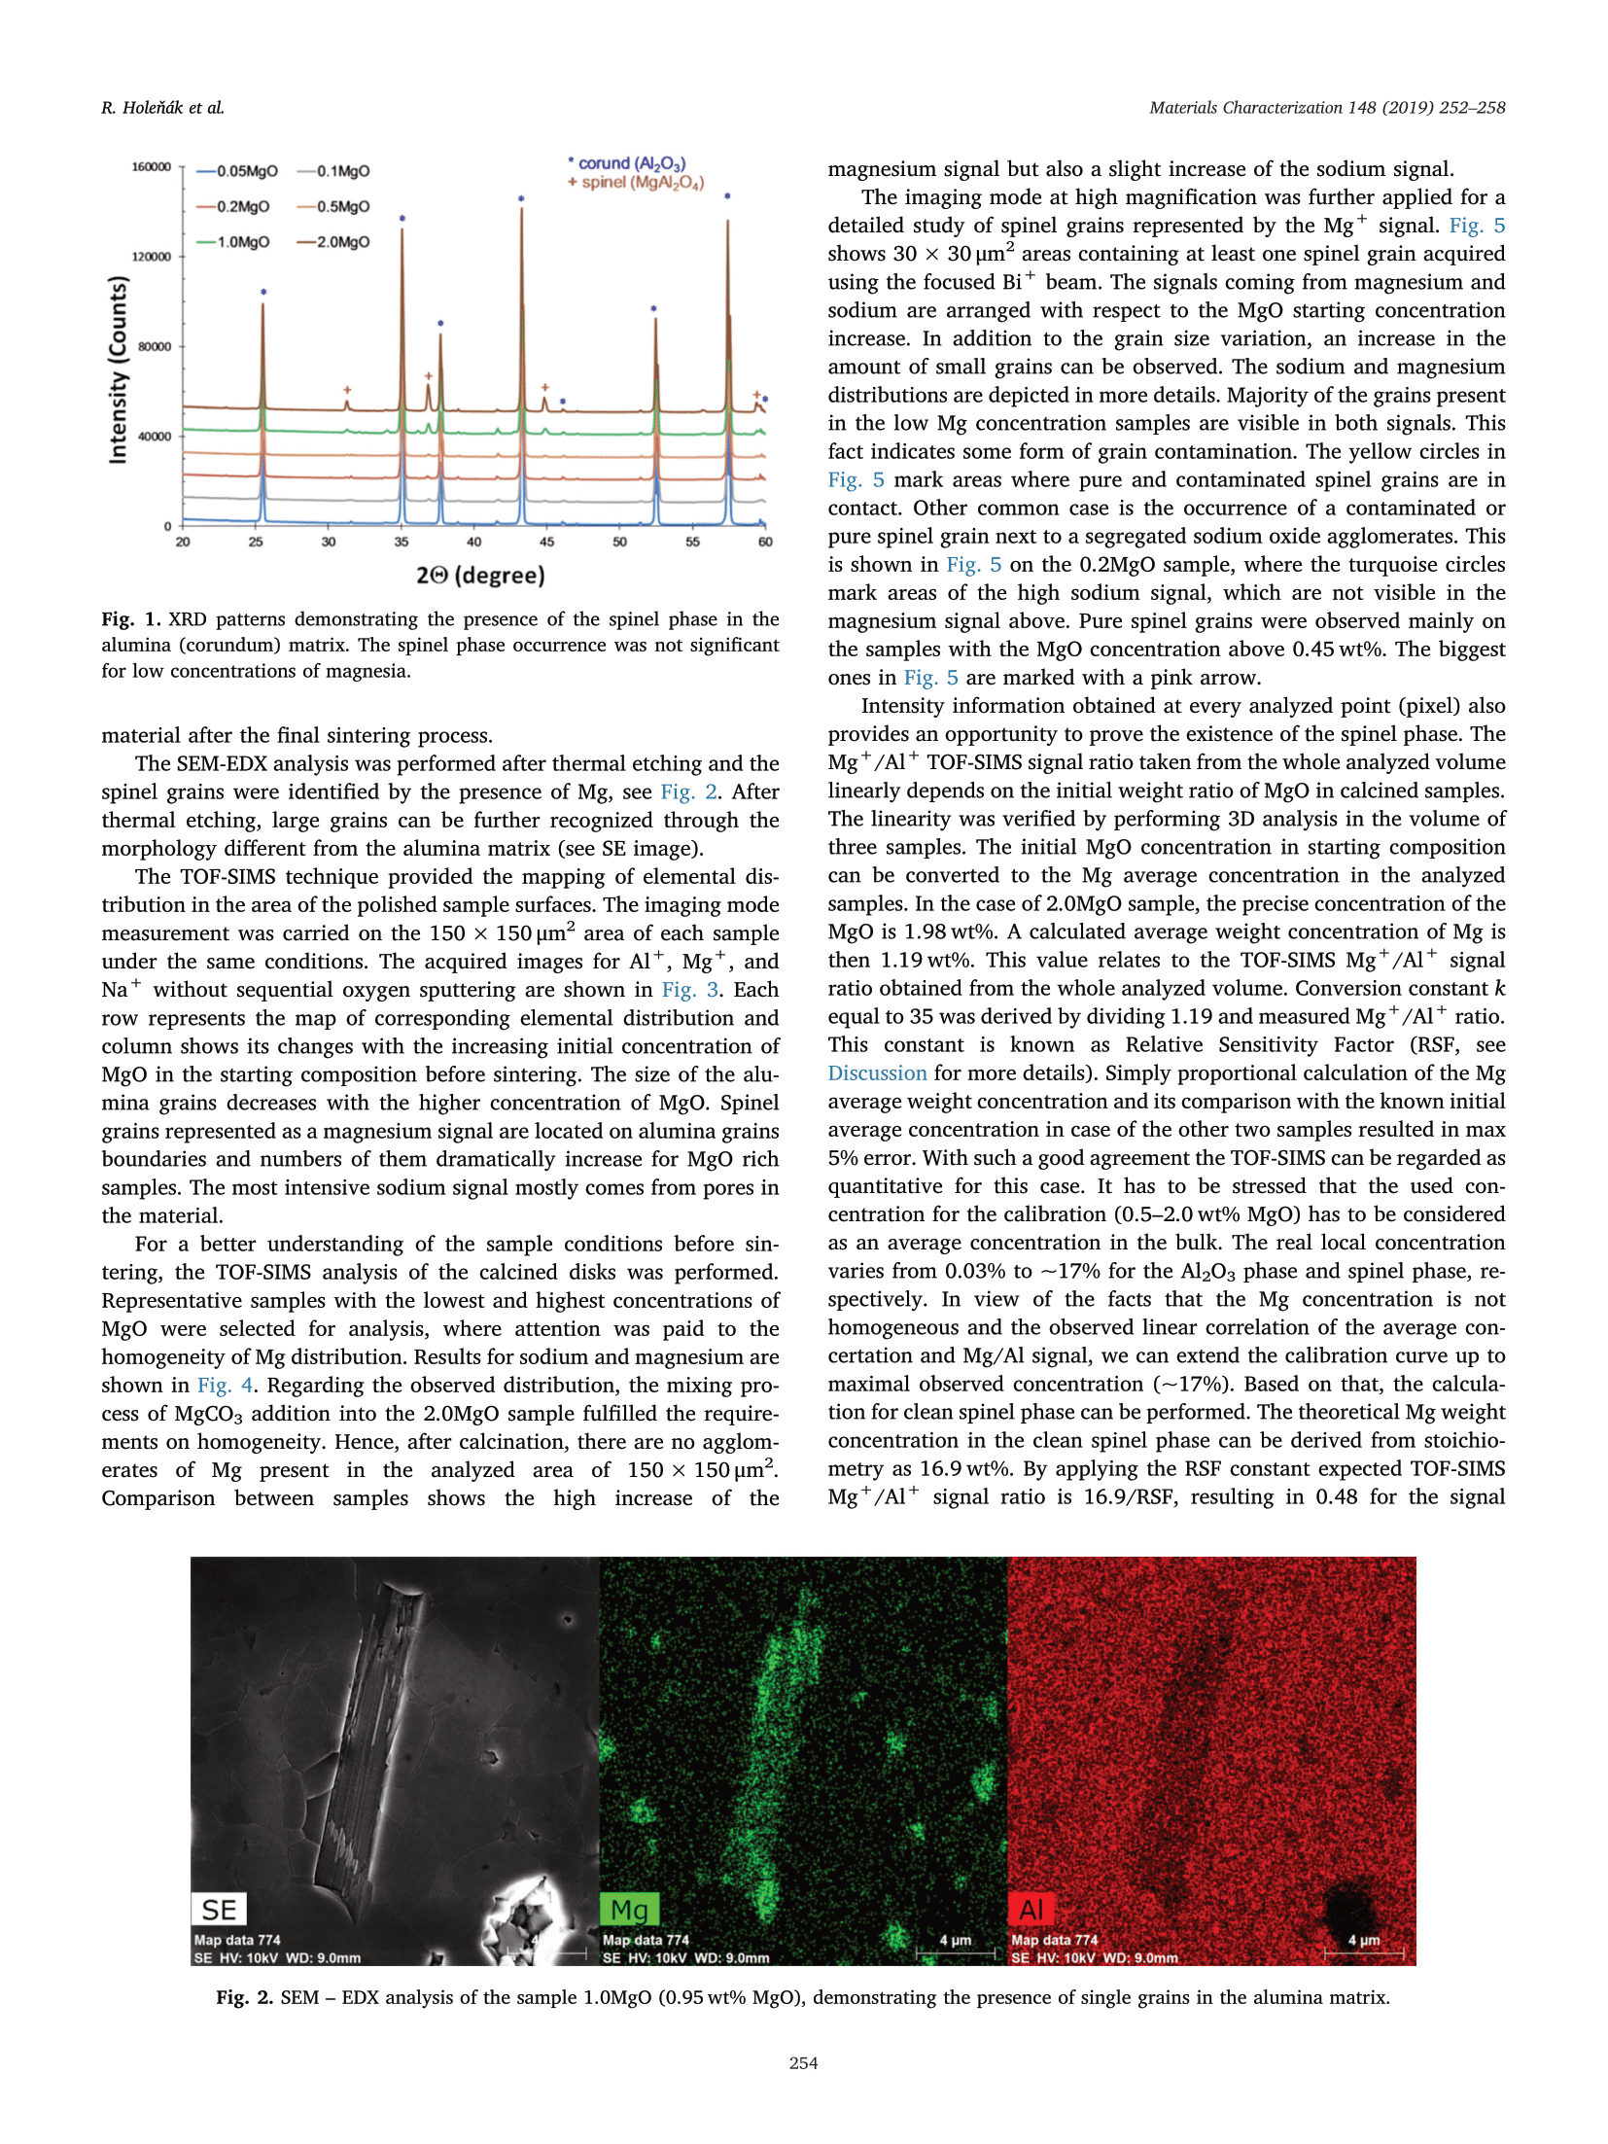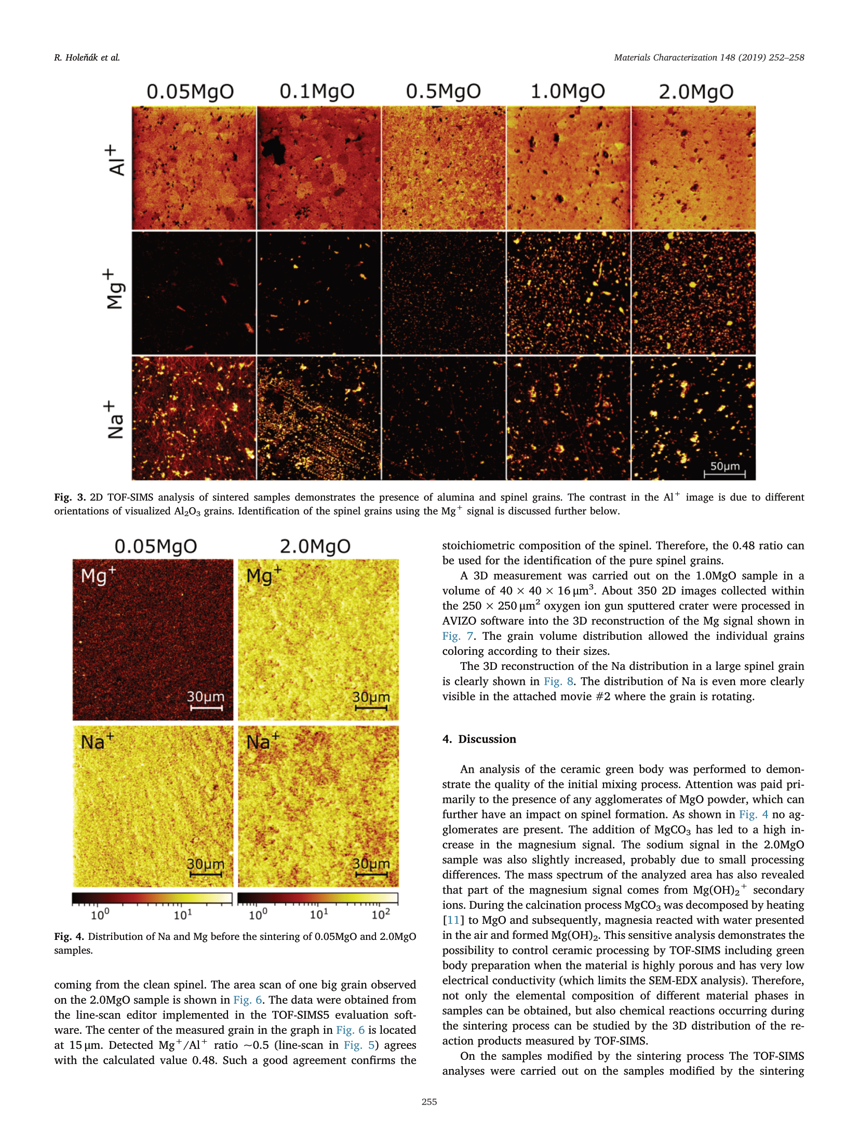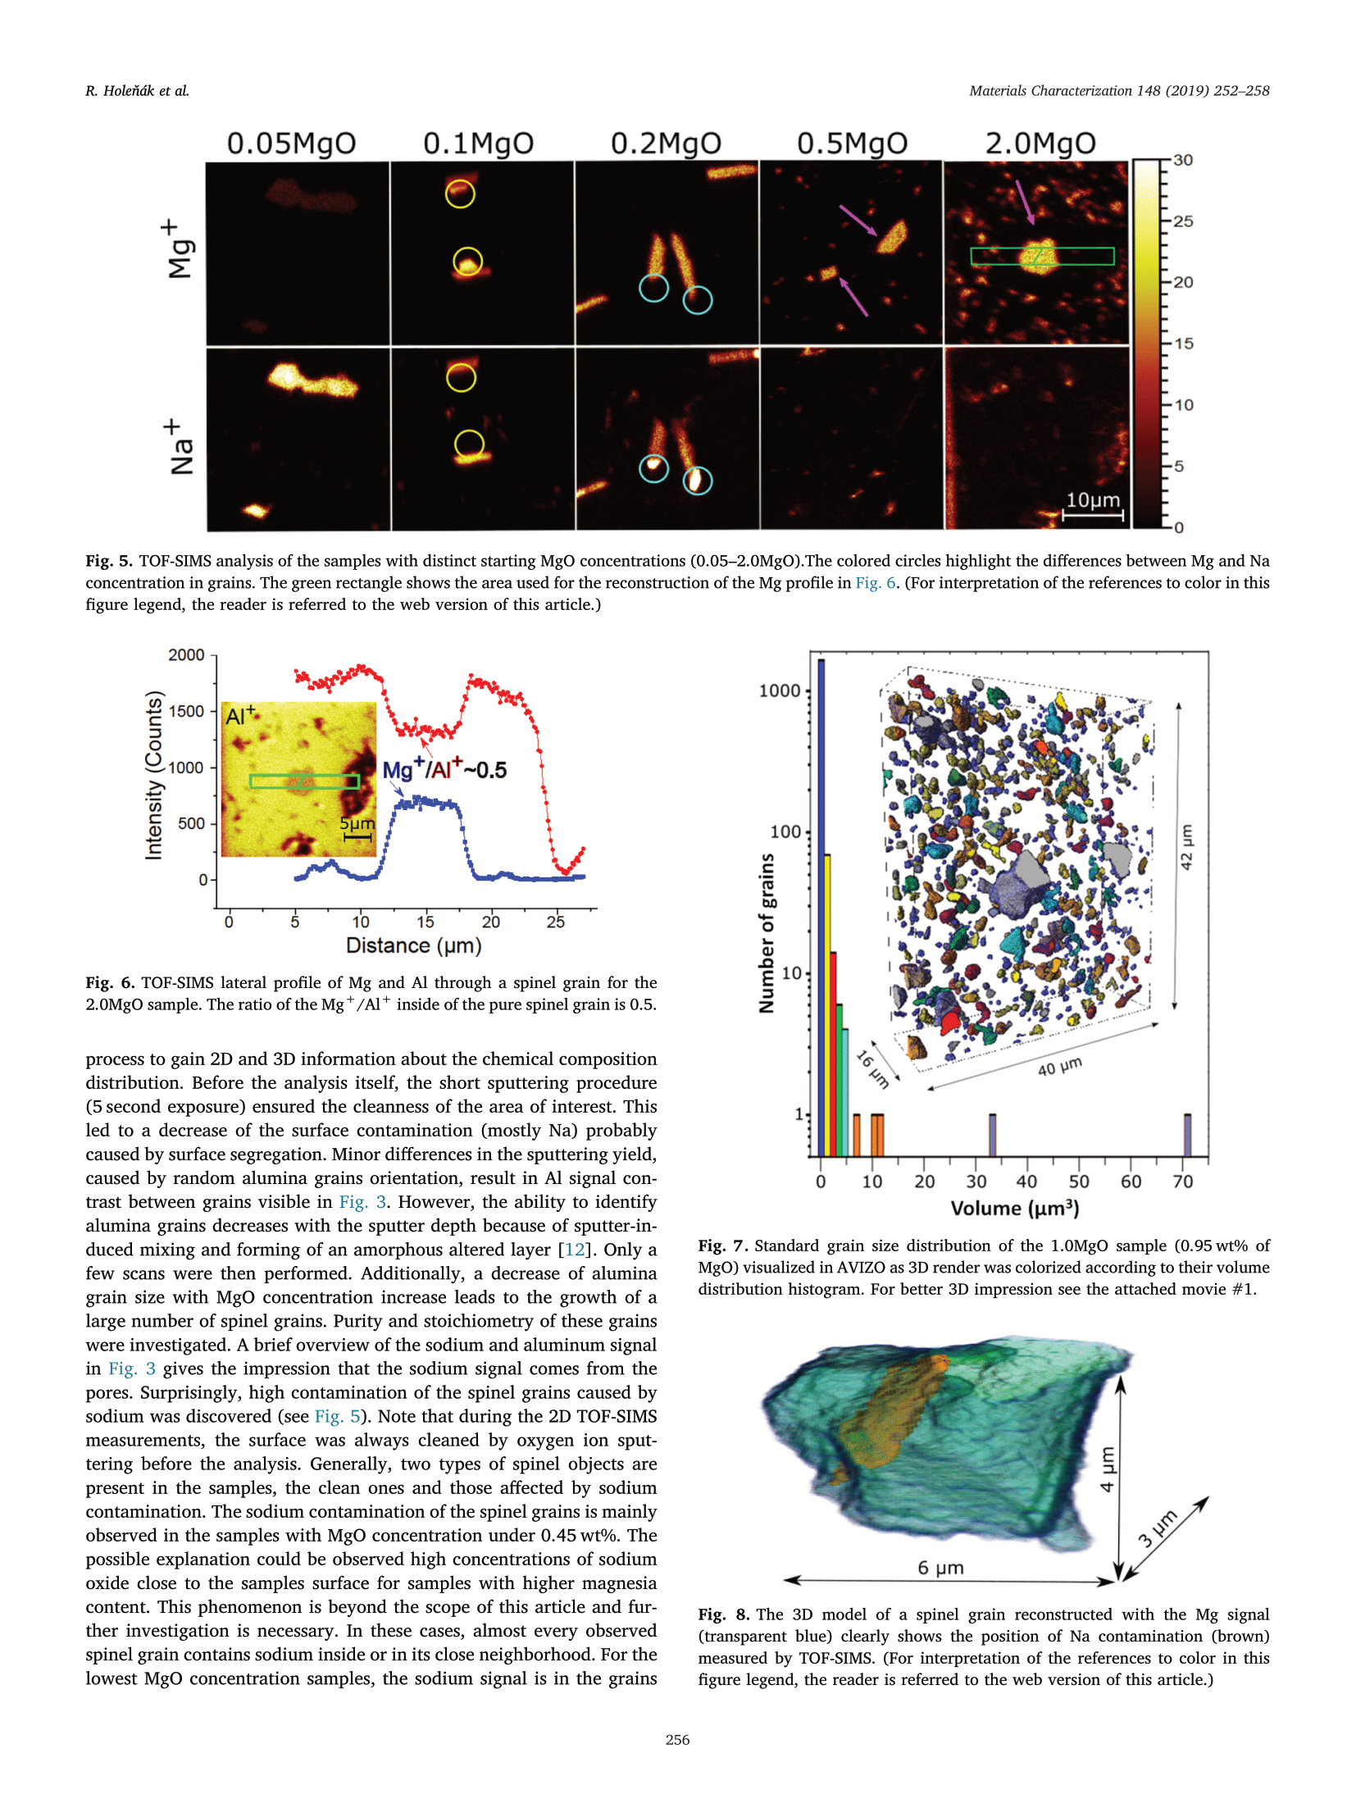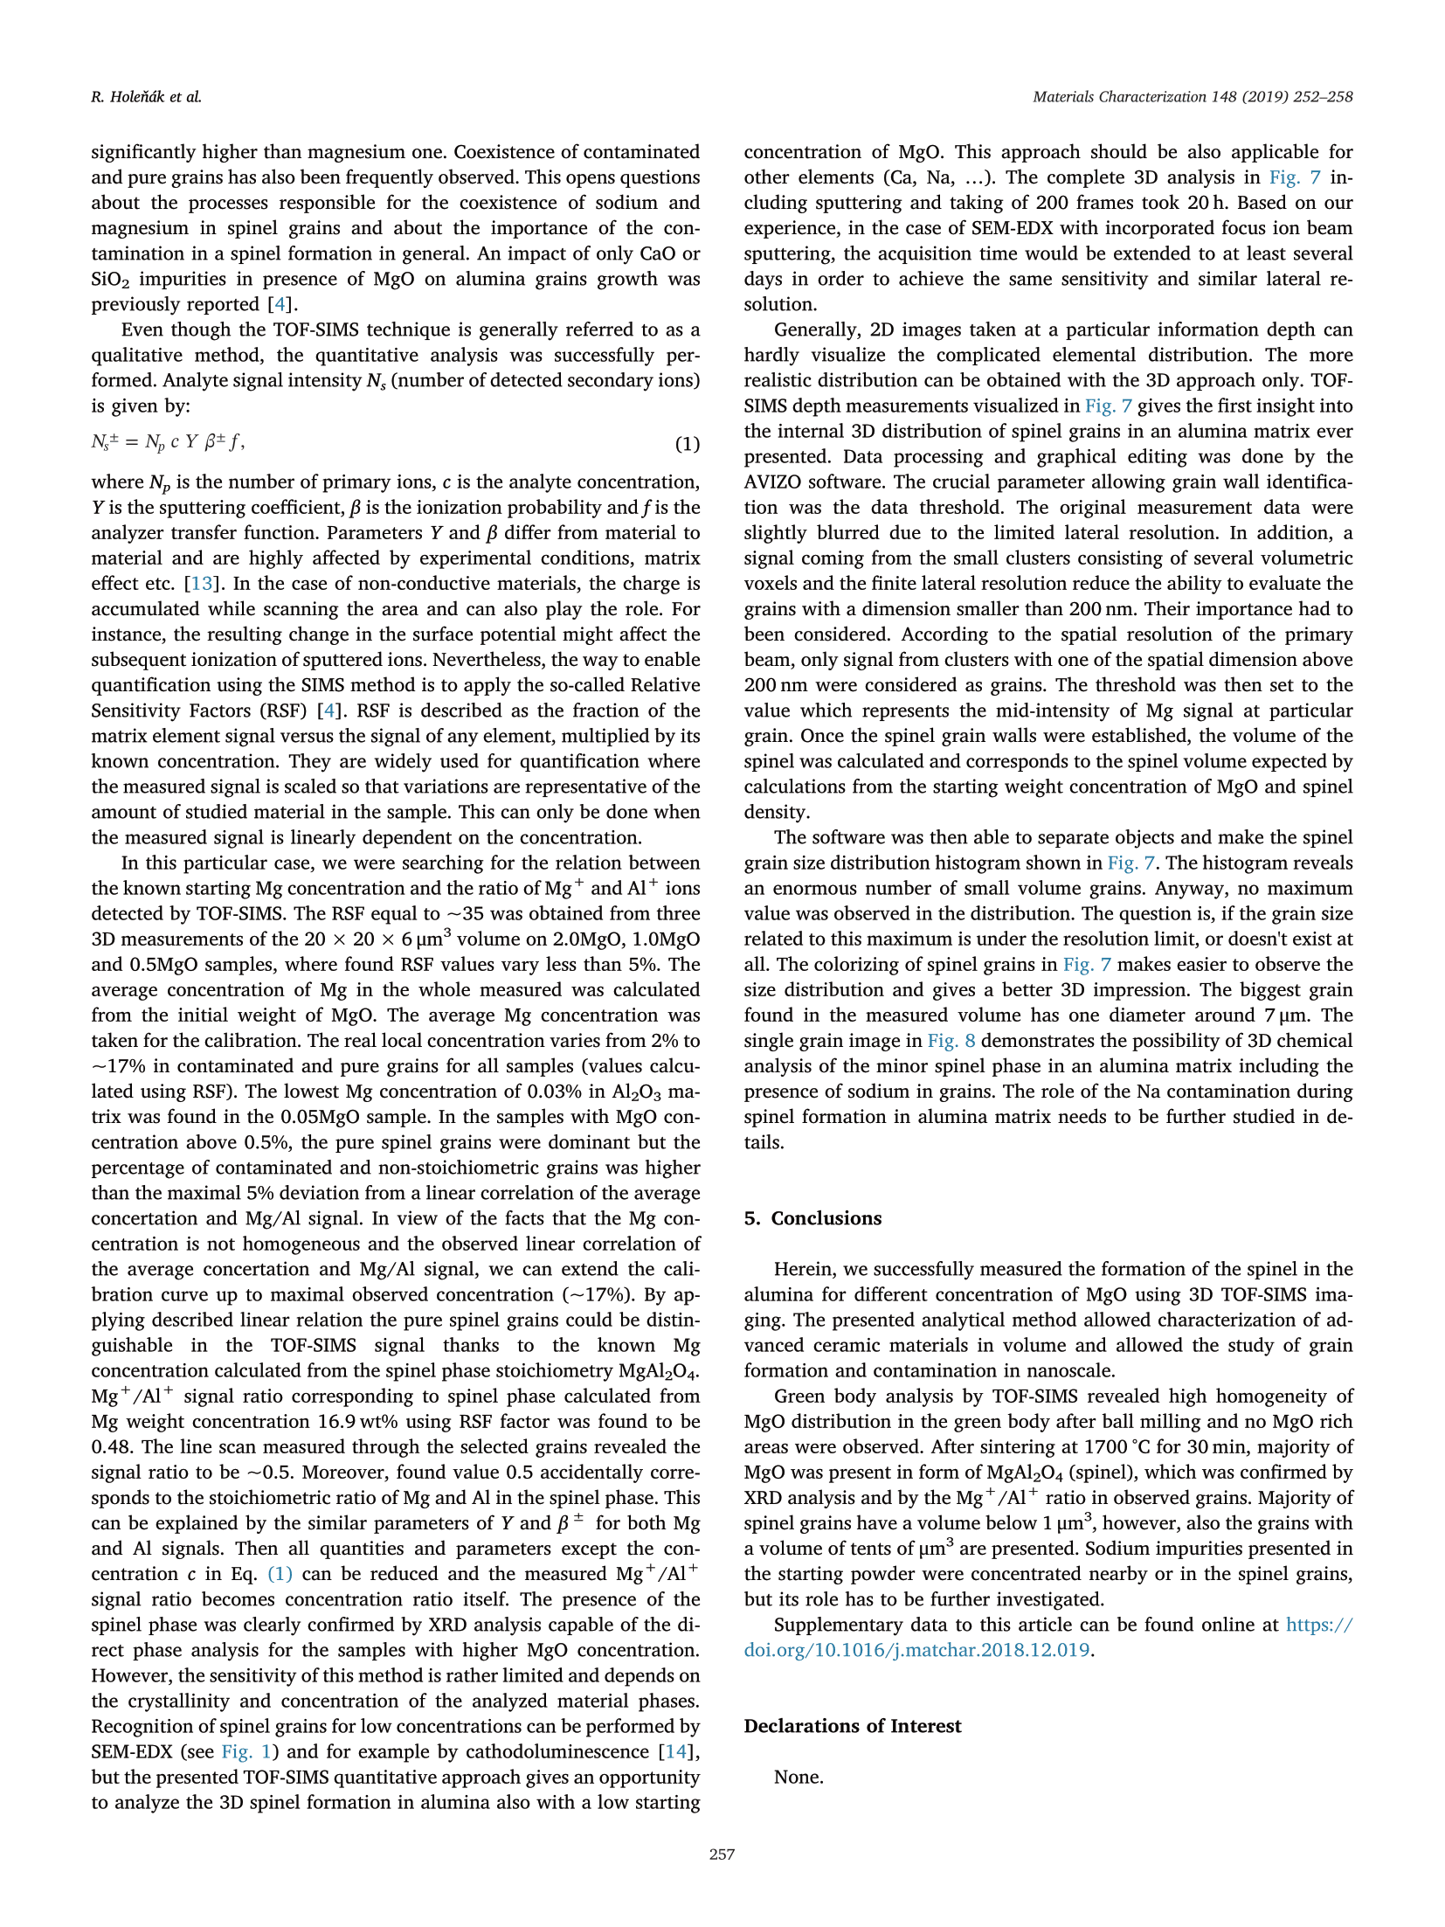

Commented paper 9

BÁBOR P., R. DUDA, J. POLČÁK, S. PRŮŠA, M. POTOČEK, P. VARGA, J. ČECHAL and T. ŠIKOLA. Real-time observation of self-limiting SiO 2 /Si decomposition catalysed by gold silicide droplets. RSC Adv. [online]. 2015, 5(123), 101726–101731. ISSN 2046-2069. Available at: doi:10.1039/C5RA19472E

(IF = 3.3, Citations 9)

