**DOUBLE DEGREE PROGRAMMES**



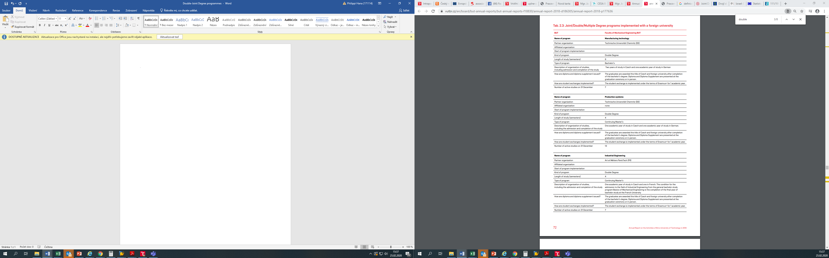

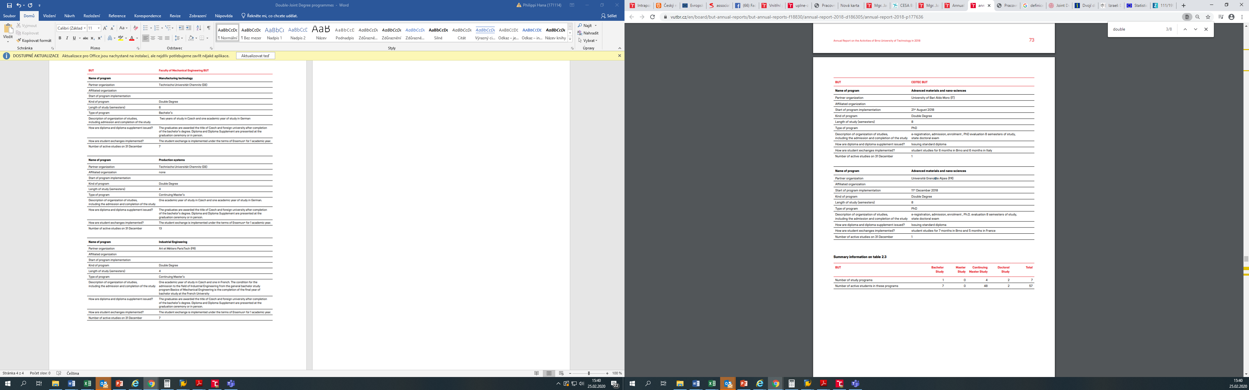

**DOUBLE DEGREE PROGRAMMES**



**JOINT DEGREE PROGRAMMES**

